Course Project

Course Number: SEC285
Module 6: Asymmetric Key Encryption and Password Policy Enforcement

Submission Due: End of Week 8

Objectives
In module 3, we learned the critical role that identification and access management (IAM) (e.g., multi factor authentication) play in protecting computing resources. In module 5, we integrated physical security with the use of sensors and intelligent software.

This week we continue to address technical and administrative controls regarding encryption and password policy enforcement. We will implement secure file management and password policies to mitigate risks to enterprise data assets.
Deliverable for Module 6
The PowerPoint project deliverable template should include the following content
- A screenshot that shows the content of the plaintext and encrypted file, respectively.
- A screenshot that shows a single encrypted file, the process of decrypting the encrypted file, and the list of both the encrypted file and the original plaintext file after decryption.
- A screenshot that shows the “Account locked” message on the logon screen.

Prerequisite
This module assumes that you have successfully completed Modules 1 through 5.
Equipment and Software Needed
- laptop
- Ubuntu VM
- Kali VM

Procedure
To address security vulnerabilities of a Linux Operating System environment, a Linux administrator needs to complete various tasks such as:
- Disable unnecessary services
- Enhance user management
- Implement a stateful firewall to allow access from approved hosts only
- Enhance logging and network time management
- Implement an effective patch management system
- Encrypt data at rest and in transit
- Enforce logging of activities on the server
- Implement security controls to protect against dictionary and bruteforce attacks
- Enforce forensic deletion of files
In Module 6, we will implement three of the above recommendations: encryption of data at rest, forensic deletion of files, and password policy enforcement.
Specially, we will
- Implement asymmetric key encryption (using the Public and Private key pair) using GPG.
- Permanently delete files using the shred command.
- Modify configuration files to enforce password policies.
Part 1. Asymmetric Key Encryption
Requiring a strong password during log in is a good practice, but it could be easily bypassed with some tools or using bootable recovery drives. Using encryption to secure your important files and folders adds a layer of security.

Among various symmetric and asymmetric encryption standards & tools available to password protect your important documents, Gnu Privacy Guard (GPG) is an open source implementation of Pretty Good Privacy (PGP) asymmetric encryption protocol. It generates a pair of Public and Private keys to encrypt and decrypt your files.

1. Open a terminal window in Kali Linux VM and type gpg --help | more to view the options available to the gpg command. Press the space bar to go over the remaining pages. Notice the “--generate-key” option displayed on the second screen capture below.

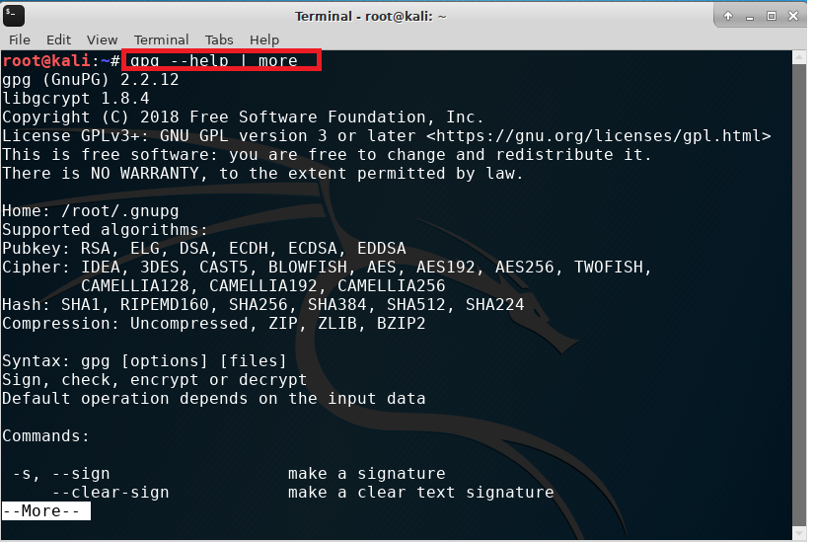
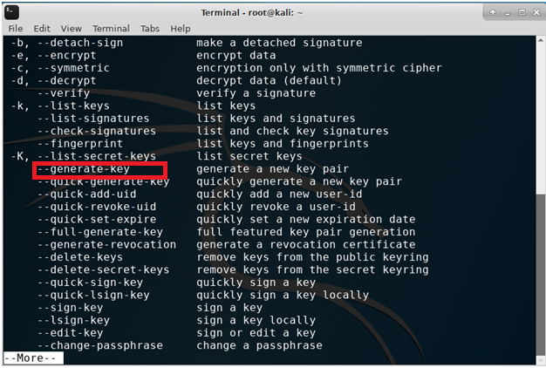

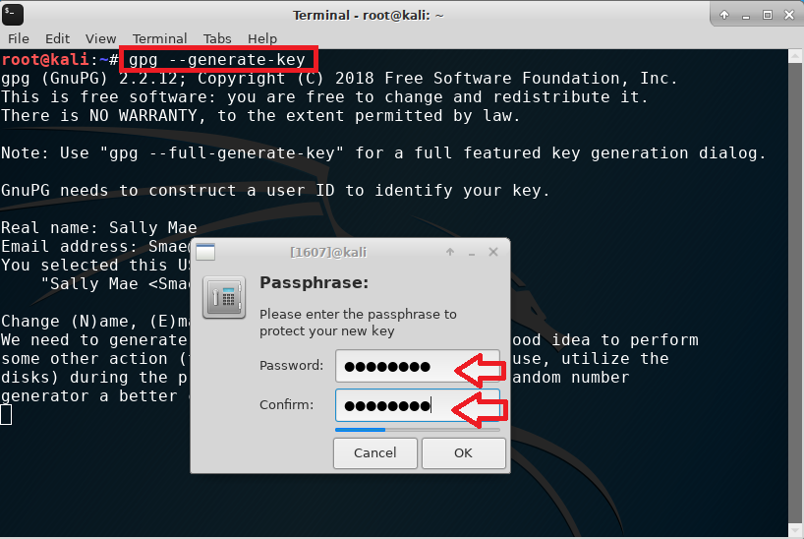
2. As shown in the screen capture above, type gpg --generate-key in the terminal window to generate a new public and private key pair. Enter the required information: real name and email address. Enter capital letter O to confirm and proceed. Supply a password you will remember and confirm.
3. You may be prompted to re-create the passphrase if what you entered was too simple. You can keep the same weak passphrase by clicking on Take this one anyway. This is not the best practice in a production environment.
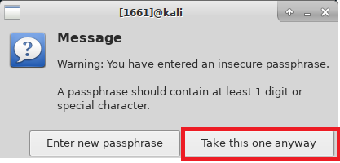
4. Upon completion of the public and private key pair generation, you see a screen like the one below. Pay attention to a few key pieces of information as highlighted.
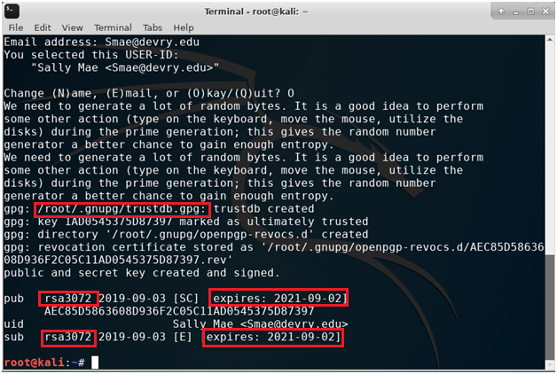
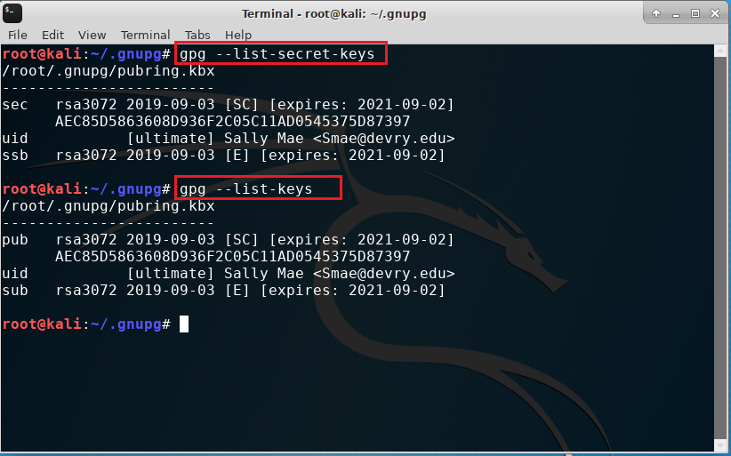
5. Type gpg --list-secret-keys and gpg --list-keys to view the key pair you have just created. Note that the commands we will use going forward were listed earlier in Step 1 (type gpg --help | more). See the screen capture below for more information regarding the commands.
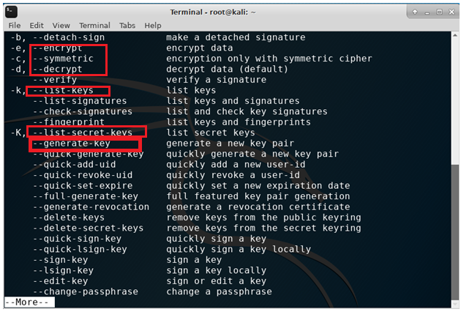

6. Now we are ready to encrypt and decrypt files using gpg. In the terminal window, enter nano testfile.txt to open a blank document. Type the “This is a test file that we will encrypt with gpg.” sentence as shown below. Press CTRL+O and Enter to save, and then CTRL+X to exit the nano editor.
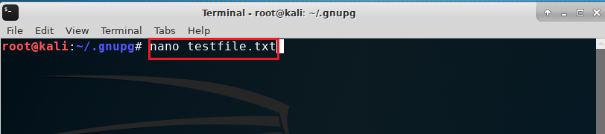
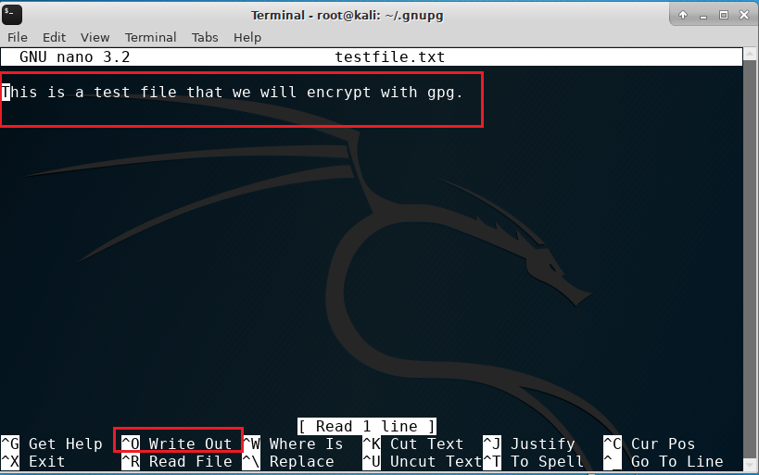

7. Type cat testfile.txt in the terminal window to display and view the content of the file you just created. In plaintext, this file is visible to anyone who is not authorized to view its content. This is a violation of data or information confidentiality.
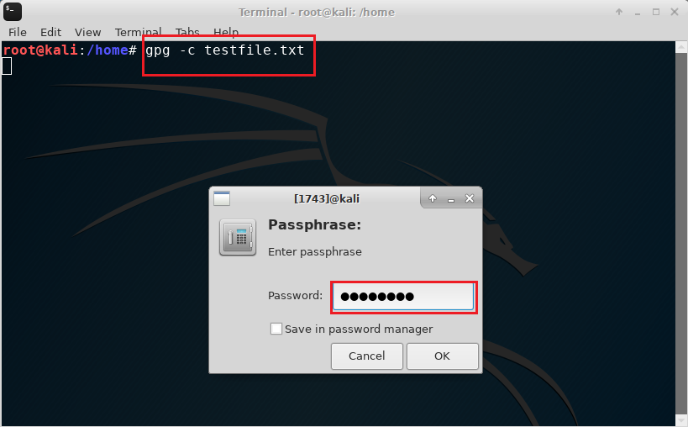
8. Type gpg -c testfile.txt to encrypt the file, as shown in the screen capture above. Type ls test* to view or list the plaintext file with txt extension and the encrypted file with gpg extension.
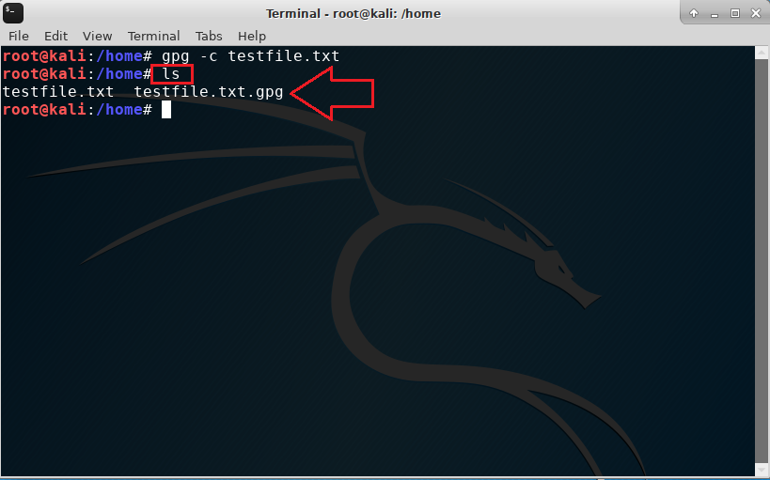
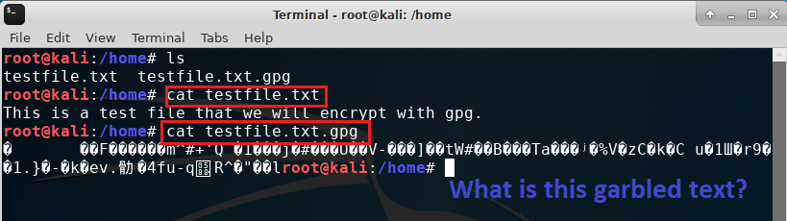
9. Use the cat command to display both the plaintext and encrypted files, respectively, as shown in the screen capture above. Take a screenshot of your output and paste it in the PPT deliverable template for Module 6.
10. As part of best practice, we will now permanently delete the original plaintext file after the encryption process. At the command prompt, type shred --help | more to browse through various options available to the shred command as shown in the two screen captures below.
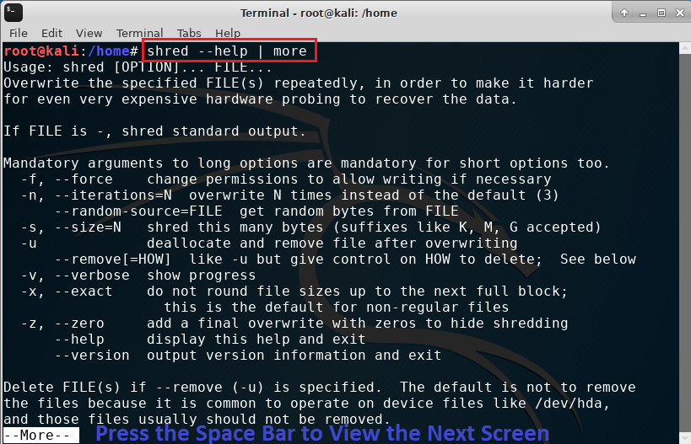

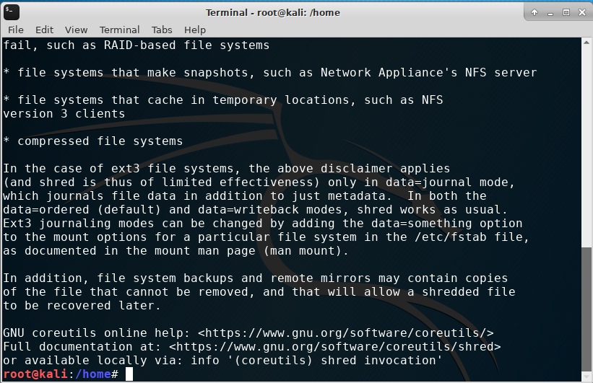
11. Type shred -v -n 30 -u -z testfile.txt to permanently remove the plaintext testfile.txt from the computer. See explanation of each option used in the shred command below.
-v: Verbose (show progress)
-n: Overwrite n times (varies from the default 3 iterations)
-u: Truncate and remove file after overwriting
-z: Add a final overwrite with zeros to hide shredding

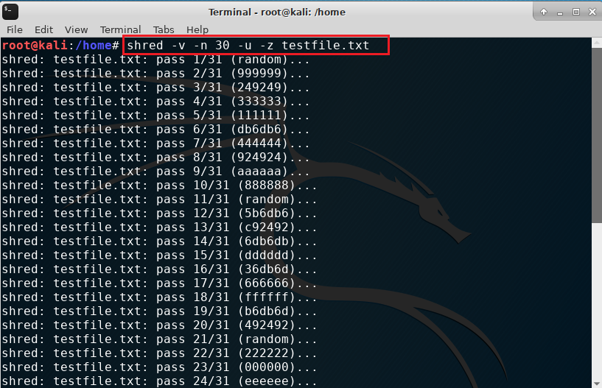

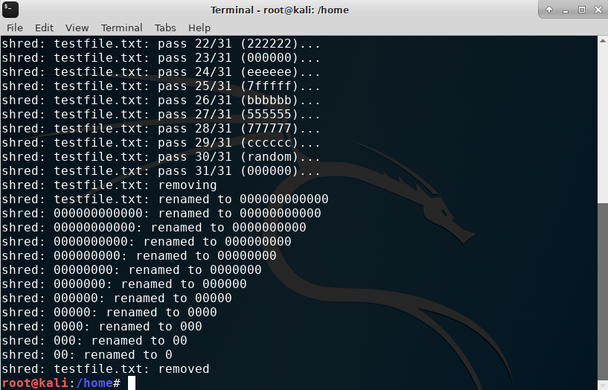
12. With the original plaintext file permanently removed, the file owner needs to decrypt the now encrypted file before reading its content. Type ls test* command to list the encrypted file, type gpg testfile.txt.gpg to decrypt the file, and type ls test* again to list encrypted and plaintext files as shown in the screen capture below. Take a screenshot of your output. Paste it in the PPT deliverable template for Module 6.
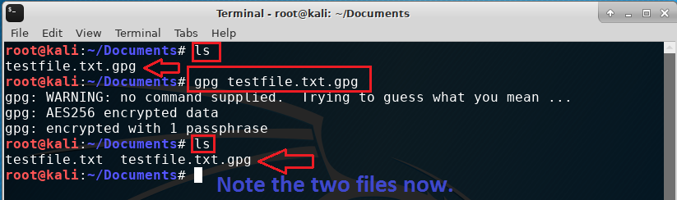
13. Type cat testfile.txt to view the content of the decrypted file.
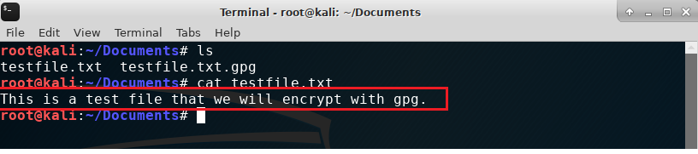

Part 2. Password Policy Enforcement
In dictionary attacks, attackers use a file with hundreds of thousands of well-known passwords to attempt to guess a user's password. While a dictionary attack is not guaranteed to find an end user's password (if the password is not in the dictionary file), a bruteforce attack attempts to guess the password by using all possible combinations of characters. Given enough time, a bruteforce attack will always be successful.
To harden a Linux operating system, one technique is to make it impossible for attackers to carry out such attacks.
- Login to the Ubuntu VM.

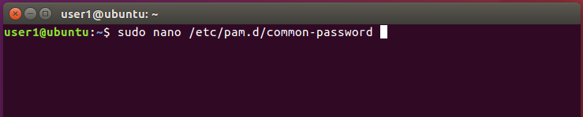

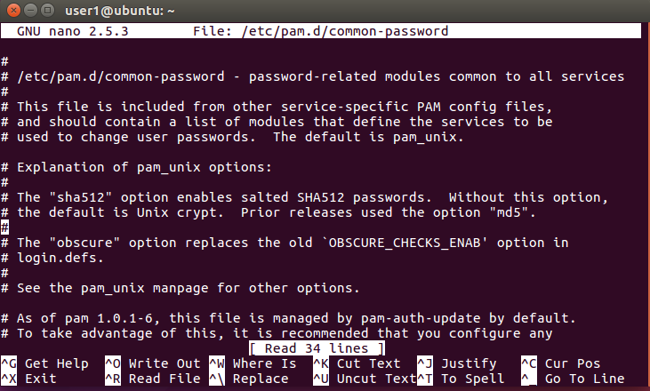

- Open a terminal window and type sudo nano /etc/pam.d/common-password to edit the
file, as shown above.

- Use the down arrows to navigate to the end of the file. Add the following two lines at the end of the document to keep track of password history and stop users from reusing last five passwords.
auth sufficient pam_unix.so likeauth nullok
password sufficient pam_unix.so remember=5
Your screen should look like the screen capture below. Press CTRL+O and ENTER to save, and then CTRL+X to exit.
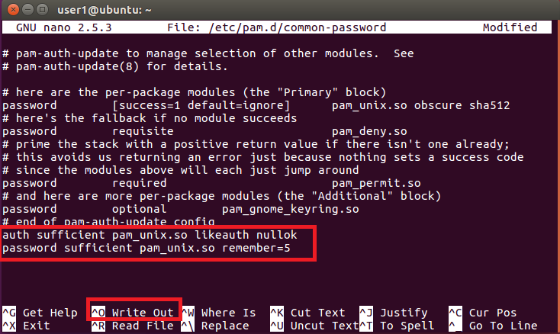
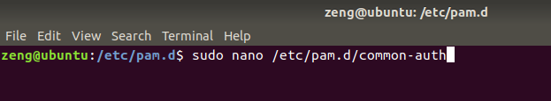
- In the terminal window, type sudo nano /etc/pam.d/common-auth, as shown in the screen capture above. Press CTRL+O and ENTER to save, and then CTRL+X to exit.

- Add the line below at the beginning of the file, as shown in the screen capture below.
auth required pam_tally.so onerr=fail deny=3 unlock_time=300
This enforces a lockout policy. After three failed attempts to access a user account, the user account is blocked for 300 seconds (i.e., 5 minutes).
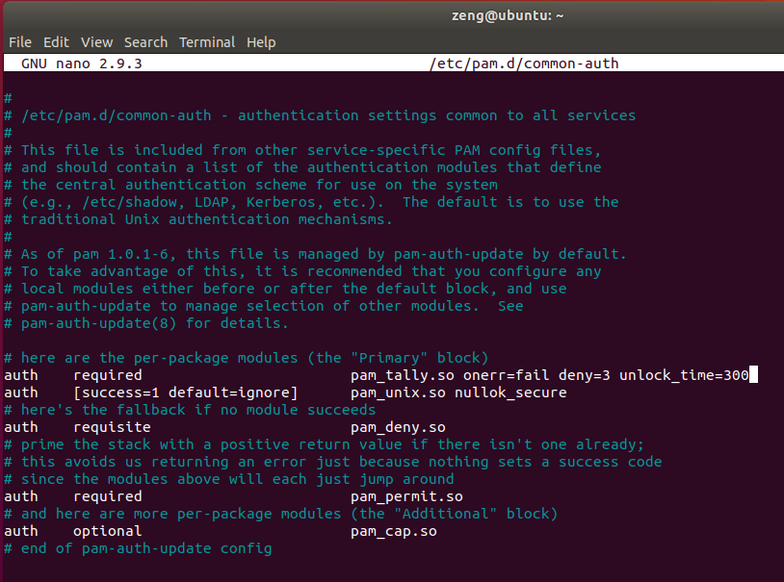
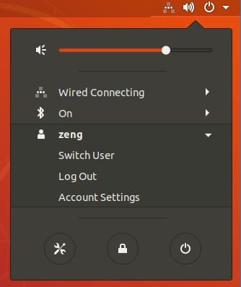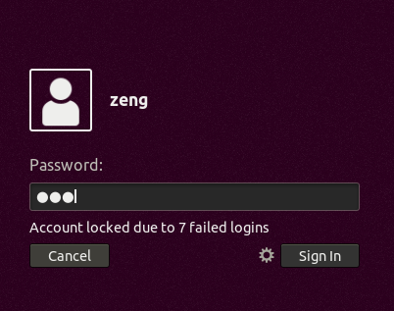
- Log out of your user account as shown above. On the logon screen, enter an incorrect password more than three times to trigger the “Account locked due to x failed logins” message as shown above. Take a screenshot of your logon screen with the message and paste it in the PT deliverable template for Module 6.
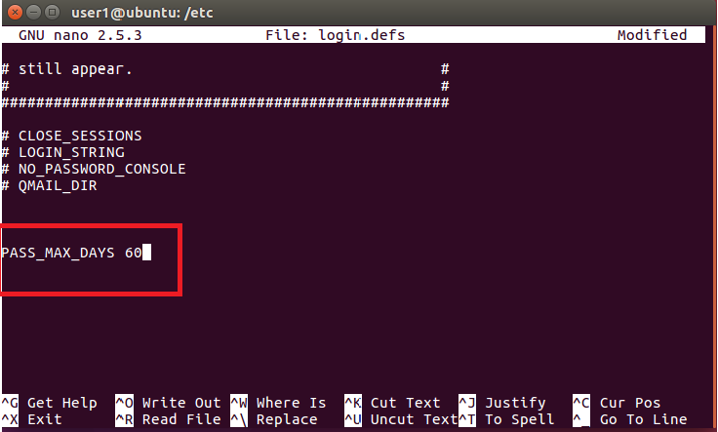

- Another good practice is to set the password to expire after 60 days. In the terminal window, type sudo nano /etc/login.defs. As shown in the screen capture above, enter the following line at the end of the file:
PASS_MAX_DAYS 60
Press CTRL+O and ENTER to save, and then CTRL+X to exit.
Note that there are many more configuration options available to enforce an enterprise password policy and mitigate data breach risks.

