Course Project

Course Number: SEC285
Module 5: Home Security System

Objectives
The objective of Module 5 is to connect two buzzers and one motion sensor to the ESP32 controller to detect motion from different sources. This is like a home security system that identifies the location of a detected motion.
Part List
- laptop
- ESP32 microcontroller
- Breadboard
- Wires
- Active buzzer
- Passive buzzer
- PIR motion sensor

Part 1: Alarm With Passive Buzzer
1A: Hardware Setup
- Seat the ESP32 microcontroller on the two inner sections of the breadboard carefully (toward one end of the board and toward the right side of the inner section), leave the first “a” row open.
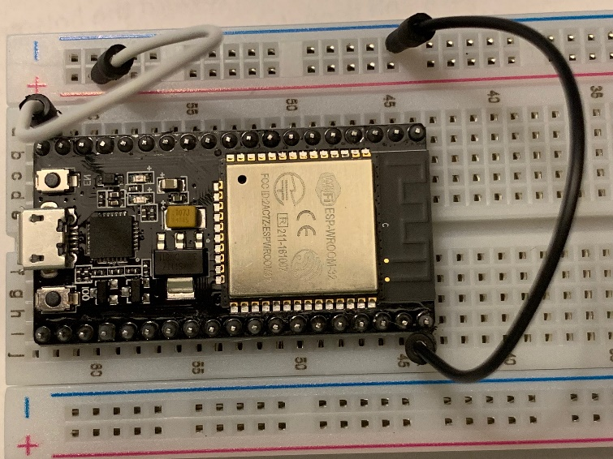

- As shown in the diagram above, connect the GND pin of the controller (on the bottom right) to a socket on the left ground rail in light blue. Connect the VIN pin the first pin on the top left to a socket on the left power rail in red.

- Use a jumper wire to connect pin P12 to any (narrow) row of the breadboard. Locate the passive buzzer (the one with the bottom part uncovered) and check the + and – signs next to its two legs. Use two male-to-female jumper wires to connect the positive leg to the same (narrow) row and connect the negative leg to a socket of the ground rail in light blue, respectively.

- Connect pin P14 to any available (narrow) row of the breadboard. Locate the PRI motion sensor. When facing the three pins with the dome on top, they are ground, digital out, and power pines. Attach three male-to-female jumper wires to the three pins of the sensor. Connect the digital out pin to the same (narrow) row, the ground pin to a socket of the ground rail in light blue, and the power pin to a socket of the power rail in red, respectively.
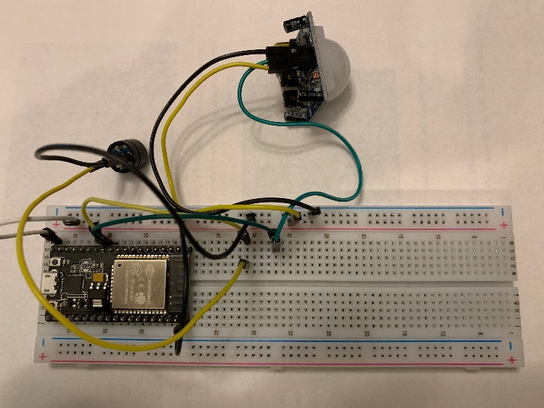
- Take a screenshot of your breadboard with all components and connections (like the diagram above). Paste it into the course project PPT template for Module 5.

1B. Software Setup
- Go to micropython.org/downloads/ and click on the ESP32 box on the page. In the Standard firmware section, click and download the esp32-xxxxxxxx-vx.x-xxx-xxxxxxxx.bin (latest) file on your computer. If you still have the firmware downloaded in Module 1, skip this step.

- Type uPyCraft in the Type here to search field on the bottom left of your computer screen to launch the software.
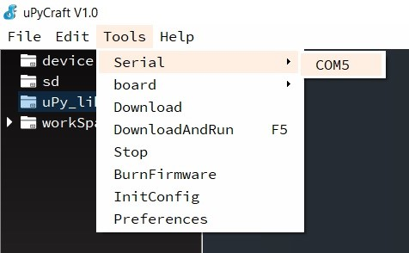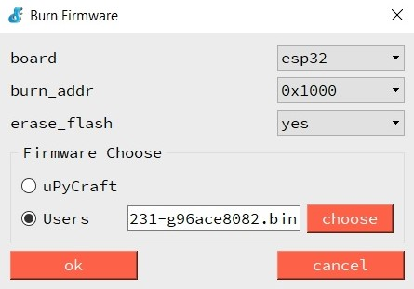

- Connect the breadboard to the USB port of your laptop. In the IDE window as shown above (left), click Tools, Serial, and then COM5. In the Burn Firmware window, choose esp32 on the board drop down menu. Choose 0x1000 on the burn_addr drop down menu. Check the Users radio button and then the choose button. Navigate the file explore window and locate the firmware you downloaded in Step 1. By default, the file is saved in the Downloads directory. Highlight the firmware and click on the Open button. All parameters should be set as shown in the diagram above (right).
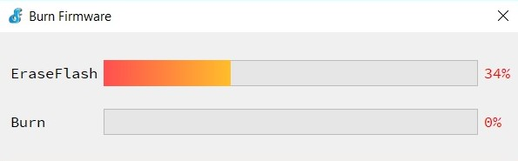

- Use the flat side of a pencil or pen to press down the BOOT button of the ESP32 microcontroller board. While pressing the BOOT button down, click on ok in the Burn Firmware window. Once the process starts as shown above, you may release the BOOT button.

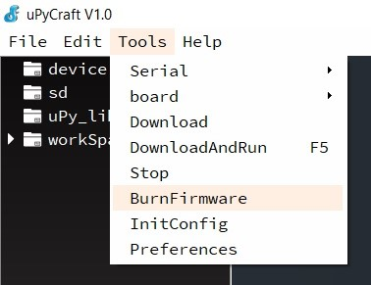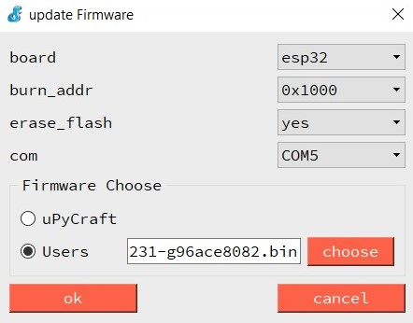

- If an “erase false” error message pops up, close the error message window. In the IDE environment, click on Tools and then BurnFirmware to open the update firmware window as shown above. Repeat Steps 3 and 4. Make sure to press down the BOOT button on the ESP32 board before clicking ok in the update Firmware window.

1C. Test and Troubleshooting
- In the uPyCraft IDE window, click on Tools, Serial, and COM5 to connect the ESP32 board.

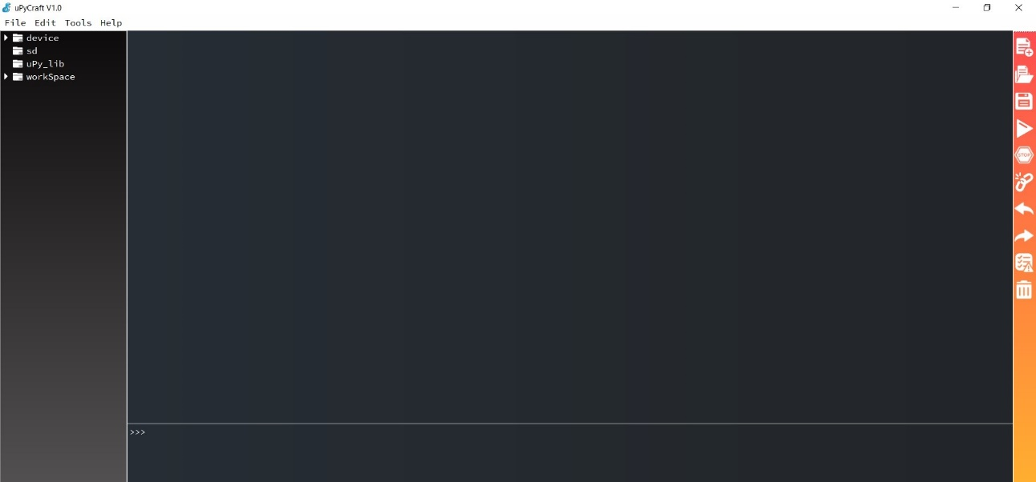

- If the connection is established successfully, a >>> prompt is displayed toward the bottom half of the window as shown above. Otherwise, go back and repeat Section 1B.
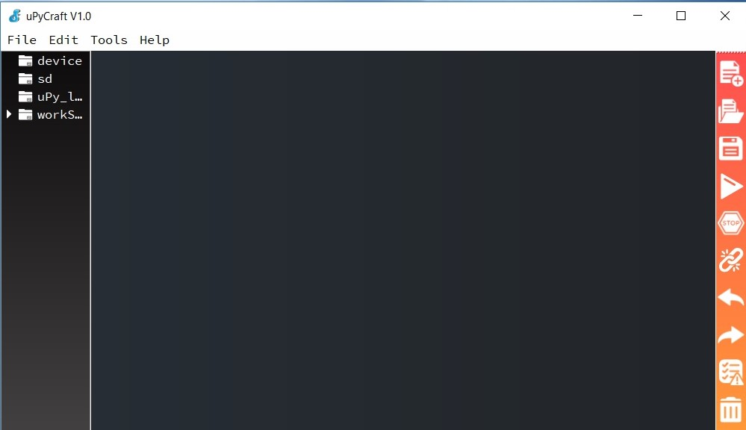

- On the right side of the IDE windows, click on the New icon (the first one on the list) to open a new file.

- Click on the Save icon (the third one on the list), enter main in the save at your workSapce window, and click ok. All your codes will be saved in the workSpace folder on Desktop.

- Go to the Project Files section of your course shell. Locate the HomeSecurityPassiveBuzzer.text. Copy and paste the code into the main.py file.

- On the right side of the IDE window, click on the Save icon (the third one on the list) to save the main.py file. Click on the Stop icon (the fifth one on the list) to stop any code from running. Click on the DownloadAndRun icon (the fourth one on the list) to upload the code to the ESP32 microcontroller.
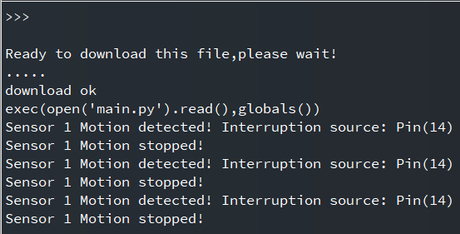

- Wave your hand near the motion senor, the passive buzzer should sound for about 5 seconds and then stop. Repeat several times, you should see output as show above. Otherwise, check your code and repeat Step 8.

- Take a screenshot of your output (like the diagram above) and paste it to the course project PPT template for this module.

Part 2. Alarm with active buzzer
2A. Hardware Setup
- Keep the components and connections on the breadboard. Make addition and adjustment as follows.

- Connect pin P26 to any available (narrow) row of the breadboard. Locate the active buzzer (the one with the bottom part covered). Use two male-to-female jumper wires to connect the long, positive leg to the same (narrow) row, and connect the short, negative leg to a socket of the ground rail in light blue, respectively.
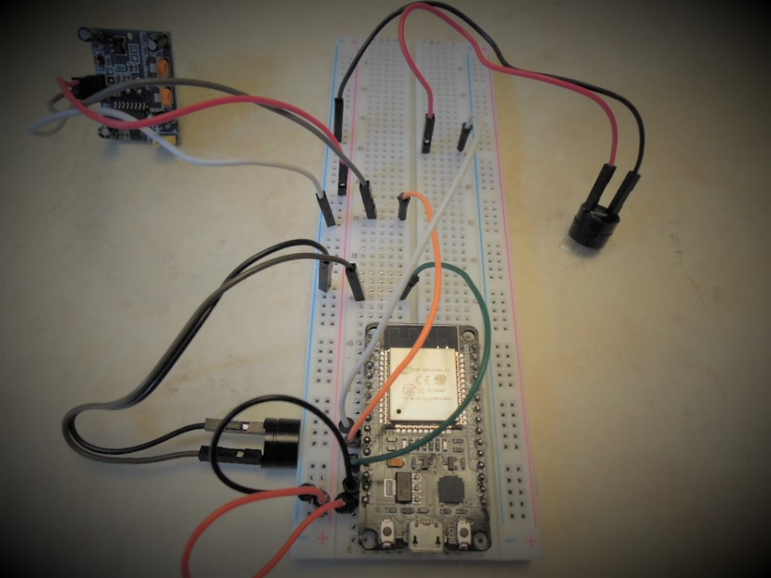

- Disconnect the jumper wire from pin P14 and connect to pin DP27 instead.

- Take a screenshot of your breadboard with all components and connections (like the diagram above). Paste it into the course project PPT template for this module.

2B. Software Setup
- Go to micropython.org/downloads/ and click on the ESP32 box on the page. In the Standard firmware section, click and download the esp32-xxxxxxxx-vx.x-xxx-xxxxxxxx.bin (latest) file on your computer. If you still have the firmware downloaded in Module 1, skip this step.

- Type uPyCraft in the Type here to search field on the bottom left of your computer screen to launch the software.

- Connect the breadboard to the USB port of your laptop. In the IDE window as shown above (left), click Tools, Serial, and then COM5. In the Burn Firmware window, choose esp32 on the board drop down menu. Choose 0x1000 on the burn_addr drop down menu. Check the Users radio button and then the choose button. Navigate the file explore window and locate the firmware you downloaded in Step 1. By default, the file is saved in the Downloads directory. Highlight the firmware and click on the Open button. All parameters should be set as shown in the diagram above (right).

- Use the flat side of a pencil or pen to press down the BOOT button of the ESP32 microcontroller board. While pressing the BOOT button down, click on ok in the Burn Firmware window. Once the process starts as shown above, you may release the BOOT button.

- If an “erase false” error message pops up, close the error message window. In the IDE environment, click on Tools and then BurnFirmware to open the update firmware window as shown above. Repeat Steps 3 and 4. Make sure to press down the BOOT button on the ESP32 board before clicking ok in the update Firmware window.

2C. Test and Troubleshooting
- In the uPyCraft IDE window, click on Tools, Serial, and COM5 to connect the ESP32 board.

- If the connection is established successfully, a >>> prompt is displayed toward the bottom half of the window as shown above. Otherwise, go back and repeat Section 2B.

- On the right side of the IDE windows, click on the New icon (the first one on the list) to open a new file.

- Click on the Save icon (the third one on the list), enter main in the save at your workSapce window, and click ok. All your codes will be saved in the workSpace folder on Desktop.

- Go to the Project Files section of your course shell. Locate the HomeSecurityActiveBuzzer.text. Copy and paste the code into the main.py file.

- On the right side of the IDE window, click on the Save icon (the third one on the list) to save the main.py file. Click on the Stop icon (the fifth one on the list) to stop any code from running. Click on the DownloadAndRun icon (the fourth one on the list) to upload the code to the ESP32 microcontroller.
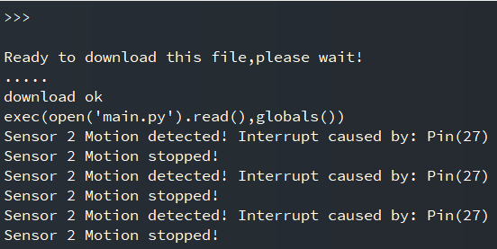
- Wave your hand near the motion senor, the active buzzer should sound for about 5 seconds and then stop. Note that it sounds differently from the passive buzzer. Repeat several times, you should see output as show above. Otherwise, check your breadboard and code.

- Take a screenshot of your output (like the diagram above) and paste it to the course project PPT template for this module.

Part 3. Challenge (optional)
Combine the HomeSecurityPassiveBuzzer code and the HomeSecruityActiveBuzzer code to implement a two-alarm home security system.
For the breadboard – you may purchase another PIR motion sensor (from amazon.com) so that two sensors and two buzzers will be connected to your breadboard. You could also decide to just use the existing PIR motion sensor. In this case, connect its signal out pin (the middle pin) to P27 to test the active buzzer, and then switch to P14 to test the passive buzzer.
For the program -- you will need to
- add a selection structure to differentiate the source of an alarm (i.e.,, sensor 1 on pin P14 or sensor 2 on pin P27), and
- display a message (e.g., “Kitchen motion detected!” or “Living room motion detected”) in the output.
Take a screenshot (optional) of your updated code and paste it to the course project PPT template for Module 5.
Take a screenshot (optional) of your output and paste it to the course project PPT template for Module 5.

Part 4. Deliverable
The PowerPoint deliverable template with four screenshots: one for the passive buzzer breadboard layout, one for the passive buzzer system output, one for the active buzzer breadboard layout, and one for the active buzzer system output.

