Course Project

Course Number: SEC285
Module 3: Stateful Firewall and Multi Factor Authentication (MFA)
Submission Due: End of Week 4

Objectives
In Module 3, you will implement effective security controls to protect enterprise computing resources from attacks. It is not enough to identify security weaknesses in computing resources. After all, an effective security report needs to include recommendations to mitigate risks to an organization's computing resources. That said, this module will introduce you to two of the most used security controls in IT security, firewall and multi factor authentication (MFA).
Deliverables for Module 3
The PowerPoint project deliverable template requires the following content.
- Screenshot of the nmap scan result after the iptables rules are applied.
- Screenshot of the user1 logon screen in Ubuntu (Before Login!) after the MFA has been activated. Capture the second screen when you are prompted for the verification code (not the one that asks you for the password!).
- Answers to the two questions below.
  - Question: In what practical use case would the command sudo iptables --policy INPUT DROP be used? What effect does this command have on access to computing resources?
  - Question: What is the difference between iptables -A and iptables -I? When would you use the -A option as opposed to the -I option?

Prerequisite
Note that this Module assumes the following:
- You have successfully completed Modules 1 and 2.
- The Host System, Ubuntu VM, MetaSploitable VM, and Kali VM obtains dynamic IP addresses from the Travel Router.

Hardware and Software Needed
- laptop
- MetaExploitable VM, Ubuntu VM, and Kali VM
- Google Authenticator app
- Wireshark (Packet Capture and Analysis)
- NMAP (Port Scanner and Network Mapper)
Network Diagram for Module 3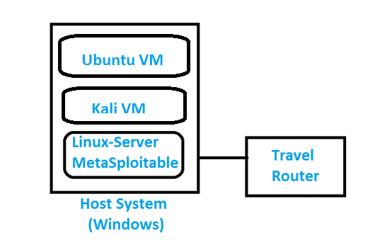
Procedure
Protecting a Linux Operating System environment requires steps to address security vulnerabilities include the following:
- Disable unnecessary services.
- Enhance user management.
- Implement a stateful firewall to allow access from approved hosts only.
- Implement encryption between management hosts and Linux server.
- Enhance logging and network time management.
In Module 4, you will follow the recommendations above to harden a Linux Server environment and implement
- A stateful firewall by using iptables
- Multi Factor Authentication (MFA) by adding a time-based one-time password (OTP)
Network administrators are required to effectively patch both their server operating systems and applications to mitigate risks of data breaches. Because this module assumes your server is not connected to the Internet, we will skip the patch update task. However, this task must be high on our list of security controls in a server environment.
Part 1: Iptables Stateful Firewall
Most enterprise organizations use applications that fall into two special classes: Transmission Control Protocol (TCP) and User Datagram Protocol (UDP) applications. TCP is a reliable, connection-oriented protocol. TCP uses a three-way handshake in order to establish a session between a client and a server computer.
- Client initiates connection by sending a TCP SYN packet.
- Server may reply with a SYN ACK packet.
- Client then concludes the connection with an ACK packet.
Prior to the three packet exchanges above, the endpoints cannot begin data transfer. Once the server receives the last ACK packet, the TCP session is considered being in the Established state. The keyword "Established" will be used later when you configure the stateful firewall or iptables. Examples of TCP applications include file transfer (FTP), web (HTTP), and e-mail (SMTP).
UDP endpoints, on the other hand, simply send their datagrams in hope that they arrive at their destination intact. UDP is a connectionless protocol. Examples of UDP applications include name resolution (DNS) and dynamic IP address assignment (DHCP).
Before we implement a stateful firewall using one of the most popular Linux firewalls, iptables, let us familiarize ourselves with various iptables command options. Note: Linux is case sensitive. Double-check each command you enter before proceeding!
1. At the command prompt of the Linux-Server VM (MetaSploitable VM), type iptables --help | more to view various options that are available to implement, manage, and monitor the firewall.
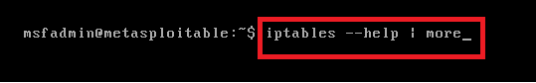
You should see a screen as shown below.
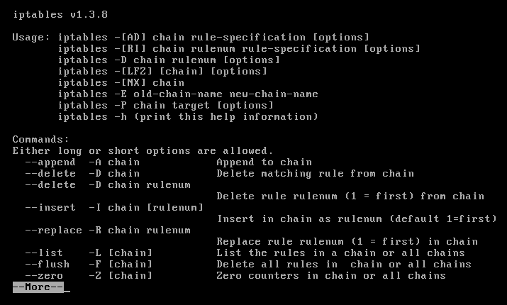
Keep pressing the space bar to view the next set of available options until you are back to the command prompt.
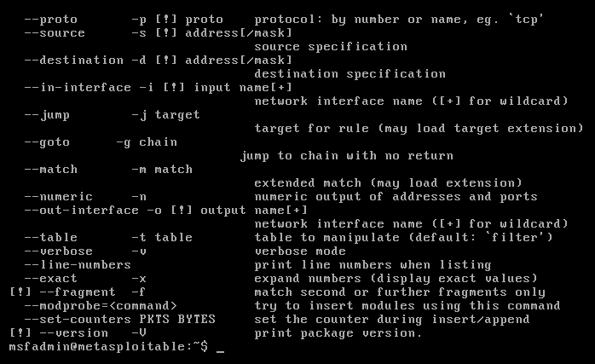
2. Before we can verify open ports on the Linux-Server VM, we need to ensure that there is connectivity between the Kali VM and the Linux-Server VM. Use a terminal to check the IP addresses of both the Kali and Linux Server VMs, as shown below. Note that your NIC name could be something else, for example, ens33.
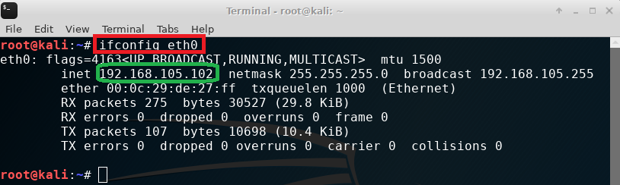
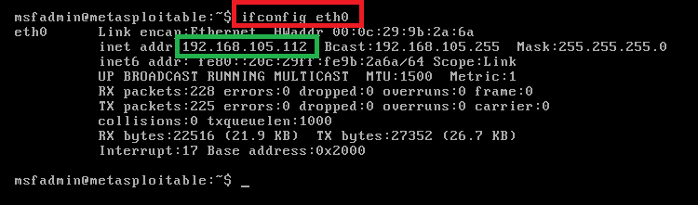
3. Verify the open ports on the Linux-Server VM with NMAP before implementing security controls. Open a terminal window on the Kali VM, type nmap 192.168.105.112 | more to scan for available ports on the Linux-Server VM. Note: Use the IP address of your Linux-Server VM!
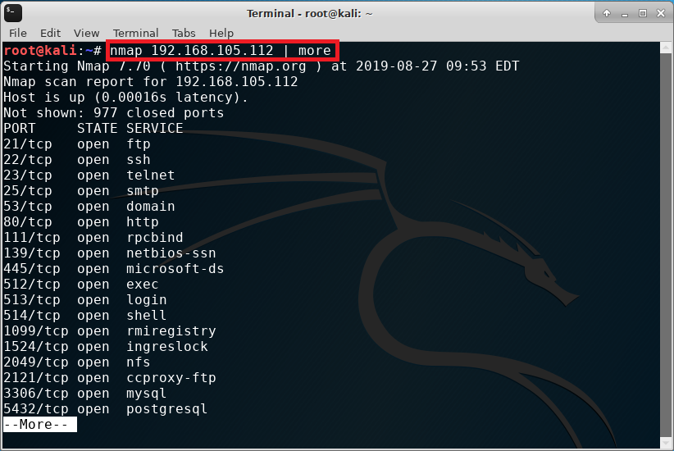
Press the space bar to view the remaining open ports on the Linux-Server VM.
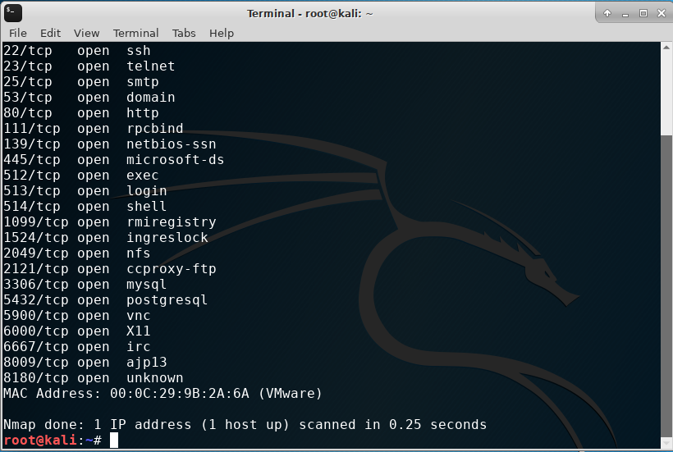
4. Before we implement the full iptables stateful firewall, let us test a simple rule that will drop all incoming connections to the Linux-Server VM. Type sudo iptables --policy INPUT DROP in the Linux-Server VM terminal window. When prompted to enter the root password, type msfadmin.
5. Use NMAP to test the impact of the command on the Linux Server. Scan the server ports again and observe the difference this time around. Note: Use the IP address of your Linux-Server VM!
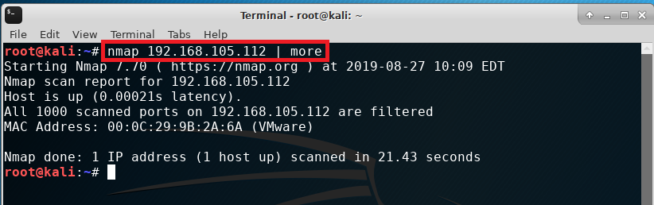
Question: In what practical use case would the command in Step 4 be used? What effect does this command have on access to computing resources? Include your answer in the PPT deliverable template for Module 3.
6. In security, each open port provides a means by which an attacker may gain access to the server. Our goal is to only allow Web (HTTP & HTTPS), email (SMTP), name resolution (DNS), and SSH services as listed below.
Rule Number | Source IP | Destination IP | Protocol/Service | Decision
0 | Any or 0.0.0.0 | 192.168.105.112 | TCP 80 && 443 | ACCEPT
1 | Any or 0.0.0.0 | 192.168.105.112 | TCP 25 | ACCEPT
2 | Any | 192.168.105.112 | UDP 53 | ACCEPT
3 | Any | 192.168.105.112 | TCP 22 | ACCEPT

7. Type the following command in the Linux-Server VM (MetaSploitable) to flush the input, output, and forward chains.
sudo iptables -F INPUT
sudo iptables -F OUTPUT
sudo iptables -F FORWARD
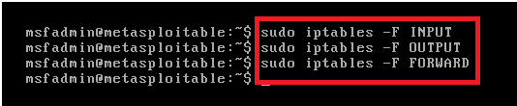
8. Enter the sudo iptables -L -- line-numbers command, and make sure that NO rules are displayed in the table. Otherwise, repeat the three commands in Step 7.
9. Type the following command to drop all invalid packets to the server.
sudo iptables -A INPUT -m conntrack --ctstate INVALID -j DROP
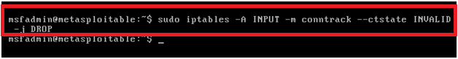
10. Type the following command to forward all incoming and outgoing traffic on the loopback interface.
sudo iptables -A INPUT -i lo -j ACCEPT
sudo iptables -A OUTPUT -o lo -j ACCEPT
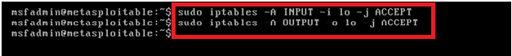
11. Type the following command to accept all packets that are part of an already established TCP connection.
sudo iptables -A INPUT -m conntrack --ctstate ESTABLISHED,RELATED -j ACCEPT
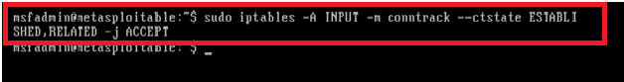
12. Type the following command to accept incoming SSH sessions.
sudo iptables -A INPUT -i eth0 -p tcp --dport 22 -j ACCEPT
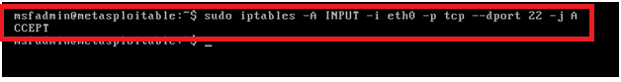
13. Type the following command to accept all incoming ICMP packets.
sudo iptables -A INPUT -p icmp -j ACCEPT
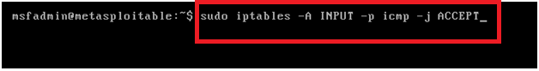
14. Add the following rules to the iptables policy to support the services we have identified in the policy table above.
sudo iptables -I INPUT 6 -p tcp --dport 80 -m state --state NEW -j ACCEPT
sudo iptables -I INPUT 7 -p tcp --dport 443 -m state --state NEW -j ACCEPT
sudo iptables -I INPUT 8 -p tcp --dport 25 -m state --state NEW -j ACCEPT
sudo iptables -I INPUT 9 -p tcp --dport 53 -m state --state NEW -j ACCEPT
sudo iptables -I INPUT 10 -p tcp --dport 22 -m state --state NEW -j ACCEPT
sudo iptables -I INPUT 11 -p udp --dport 53 -j ACCEPT
sudo iptables -P INPUT DROP
sudo iptables -P FORWARD DROP
15. Type the following command to allow locally generated packets to be forwarded.
sudo iptables -P OUTPUT ACCEPT
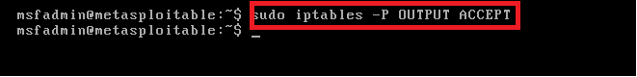
16. Save the iptables rules so that they will persist after the server reboots. Type sudo iptables-save at the terminal window. You should see a screen like what’s shown below.
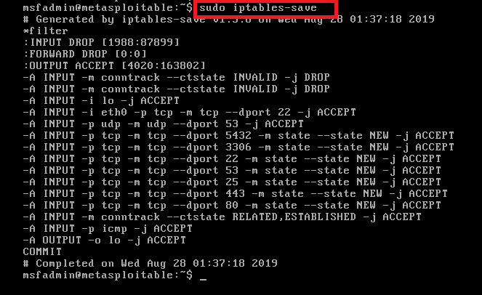
17. Type sudo iptables -L --line-numbers in the terminal window of the Linux-Server VM (i.e., MetaExploitable VM) to confirm that all rules are in place.
18. Let us scan the Linux-Server VM with NMAP from the Kali Linux VM again. As compared to the output in Step 3, the number of open ports has been greatly reduced. Take a screenshot of the nmap output and paste it into the PPT deliverable template for Module 3.
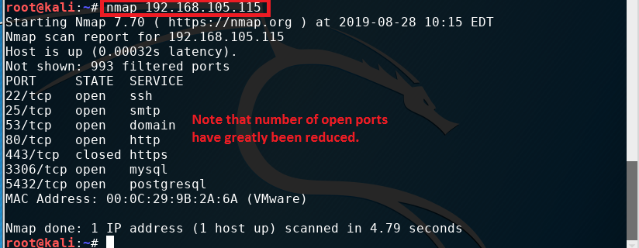
Question: What is the difference between iptables -A and iptables -I? When would you use the -A option as opposed to the -I option? Include your answer in the PPT deliverable template for Module 3.

Part 2: Multi Factor Authentication (MFA)
Many enterprise organizations require end users to use a single password in order to gain access to computing resources. This is known as single sign on or single sign-on (SSO). Although a single password makes life much easier for end users, an attacker also only needs to break one single password to gain access to all resources a user has access to. To mitigate security breaches, you are going to implement a multi factor authentication (MFA) system in a Linux environment. It uses a regular password and another time-based one-time password (OTP). The one-time password is generated by the Google Authenticator app available for Android and iOS devices.
Note: The following procedure is carried out on the Ubuntu VM, not the Kali VM, or Linux-Server/MetaExploitable VM.
- Launch another instance of VMware Workstation Player. Highlight the Ubuntu VM and click Edit virtual machine settings. Click on Network Adapter and select NAT: in the Network connection section. Click Ok to close the window.
- Disconnect the cable between your laptop and the yellow Travel Router temporarily. Connect your laptop to your home network. Make sure that your laptop gets an IP address from your home router. Your laptop and the Ubuntu VM need to be connected to the Internet (instead of the yellow Travel Router) for you to download the package in Step 6.
- Launch Ubuntu. Open a terminal window and enter the following commands:
sudo useradd -m user1
sudo passwd user1
sudo usermod -aG sudo user1
- Restart Ubuntu and log in as the new user1 user.
- Go to Play Store or App Store of your smartphone. Download the Google Authenticator app, as shown below. Leave it on the side, as we will come back to it later.

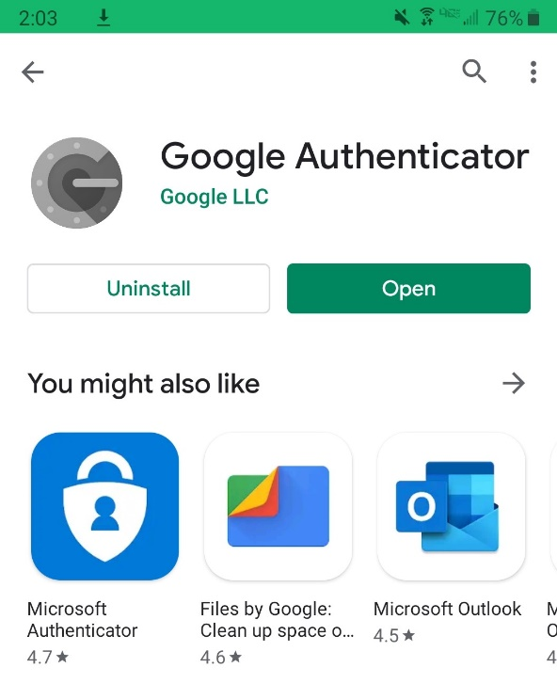
- At the terminal prompt of the Ubuntu VM, type sudo apt install libpam-google-authenticator. When prompted, enter the same password you used to login.
- As shown below, enter y when prompted if you want to continue with the installation of the package.
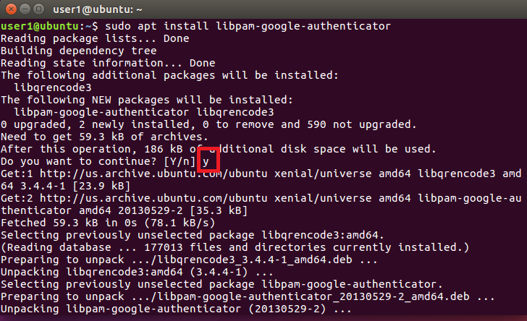
8. Use the nano editor to open the configuration file at sudo nano /etc/pam.d/common-auth. Note: If you see a blank file, stop and check the command you just typed in!
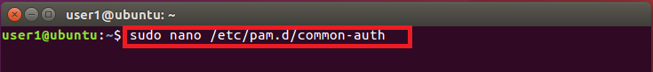

9. Use the arrow keys to navigate to the bottom of the open file. Type auth required pam_google_authenticator.so nullok at the bottom of the file.
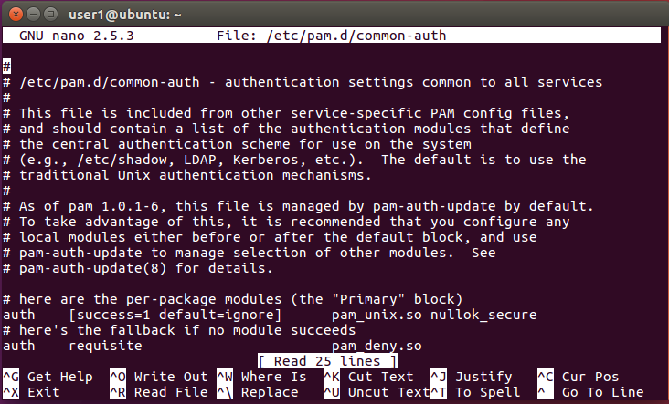
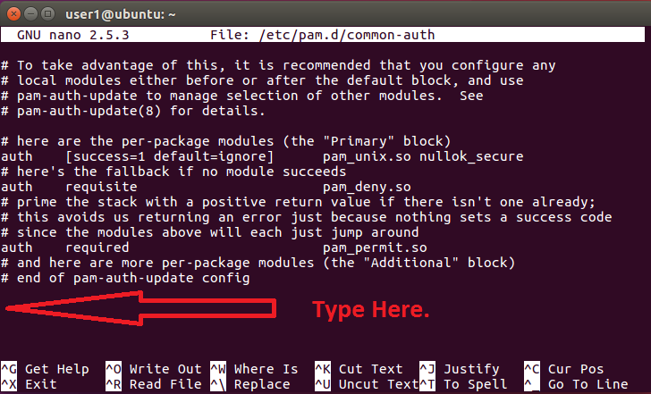
10. Your screen should look like the one below. Remember to press Control-O [CTRL+O] followed by the Enter key to save the file. Press Control-X [CTRL+X] to exit the configuration file.
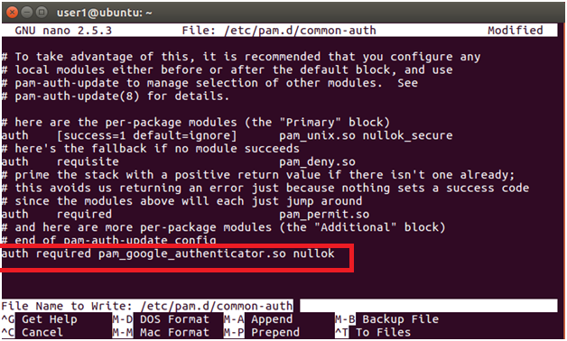
11. Let us now setup Google Authenticator. At the command prompt in the Ubuntu terminal, type google-authenticator. Answer ‘y’ to all the questions as shown below.
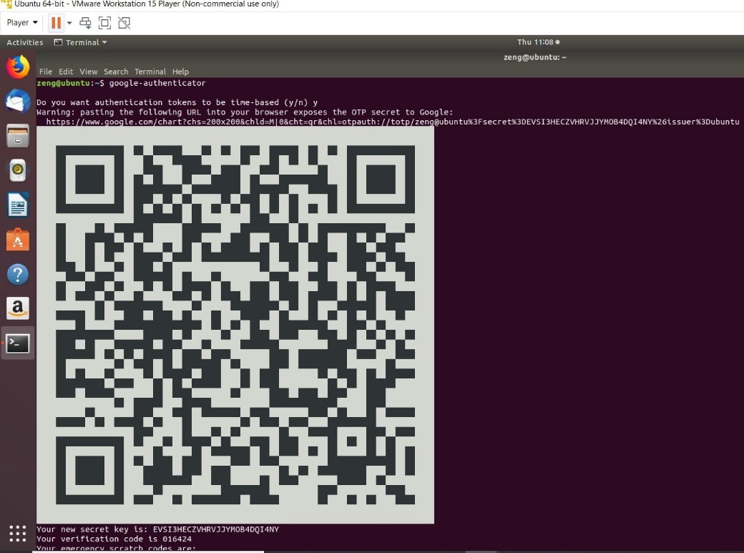

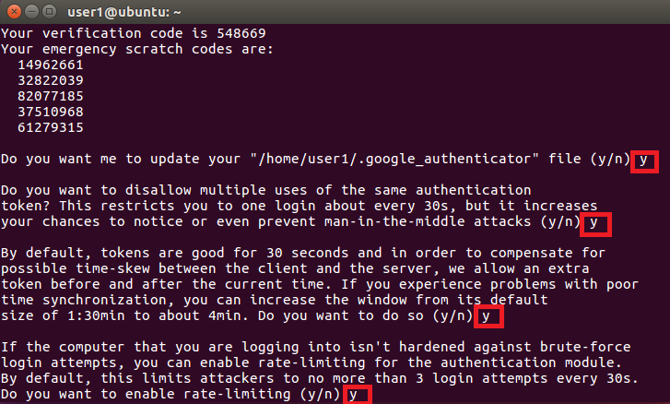
Note: Use your smartphone to take a picture of the information displayed underneath the QR code, including “Your new secret key,” “Your verification code,” and “Your emergency scratch codes.”
12. With the QR code displayed in the middle of your Ubuntu widow, go back to the Google Authenticator app on your smart phone. Click on BEGIN and then Scan a barcode as shown in the screenshots below.
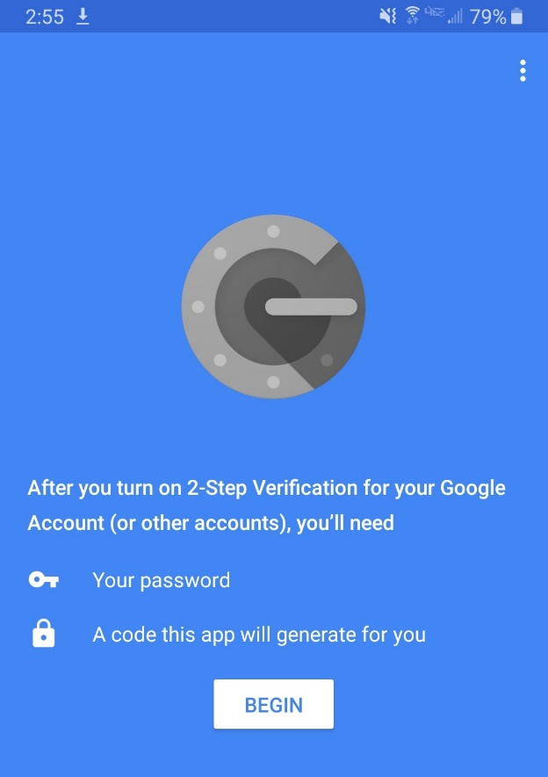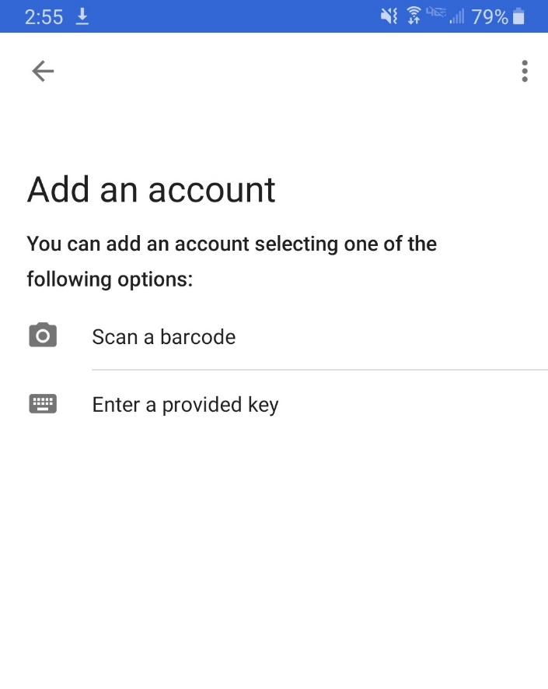
13. Point your smartphone toward the Ubuntu window and place the QR code within red lines. You should see the “Account added” window as shown below. Note that your account will be ubuntu (user1@ubuntu).
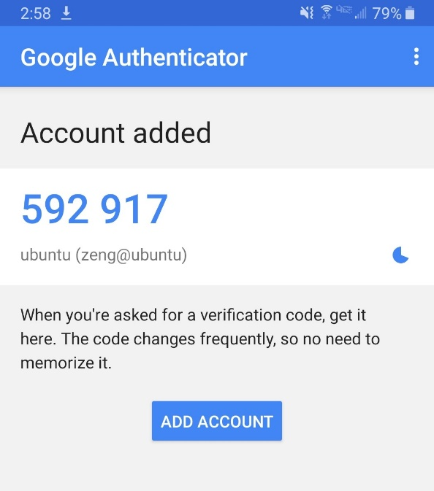
14. The six-digit code displayed on your smart phone screen changes every 30 seconds. This is your time-based one-time password (OTP)!
15. Log out or restart Ubuntu. Try to log back in as the user1 user. Note that you will need to provide the regular password and the OTP password on your smartphone.
16. Take a screenshot of the user1 logon screen in Ubuntu (Before Login!) after the MFA has been activated. Capture the second screen when you are prompted for the verification code (not the one that asks you for the password!).

17. Shut down the Ubuntu VM. In the VMware Workstation Player, highlight the Ubuntu VM and click Edit virtual machine settings. Click on Network Adapter and select Bridged: Connected directly to the physical network in the Network connection section. Click Ok to close the window.

You have now successfully completed the Multi Factor Authentication (MFA) section!

