Course Project

Course Number: SEC285
Module 2: Vulnerability Assessment

Deliverable Due: End of Week 3
Objectives
In Module 2 you will assess the security posture of the Linux Server VM (also known as the MetaSploitable VM) and examine the list of exploits available for the identified vulnerabilities. You will rank the list of vulnerabilities from Critical to Low and recommend security controls to mitigate three risks to the Linux Server VM in the following order: one Critical risk, one High risk, and one Medium risk. At the end of the module, you will generate a full security report similar to the professional report required by security practitioners after conducting a security assessment project.
Deliverables for Module 2
The PowerPoint deliverable template with the following screenshots.
- A screenshot that shows four IP addresses discovered by the nmap scan.
- A screenshot of a vulnerability of Critical severity rating.
- A screenshot of a vulnerability of High severity rating.
- A screenshot of a vulnerability of Medium severity rating.
- Answer the three questions below.
  - Question: What is the significance of ranking the vulnerabilities by severity level?
  - Question: What is the significance of the Executive Summary in the Nessus Essentials report?

Prerequisite
This Module assumes the following.
- You have successfully completed Module 1.
- The Windows Host System and Kali VM are able to obtain dynamic IP addresses from the Travel Router.
- You have successfully imported the Linux Server VM appliance into the VMware Player environment.
- You have installed the Nessus Essentials scanner on your Windows Host System.
Equipment and Software Needed
- GL-MT300N-V2 Travel Router
- One USB cable (power Travel Router)
- One UTP Straight-through Cable (connect Windows Host System to Travel Router)
- ESP32 board
- Linux Server and Kali VMs
- Nessus Essentials (Vulnerability Scanner)
- Wireshark (Packet Capture and Analysis)

Network Diagram
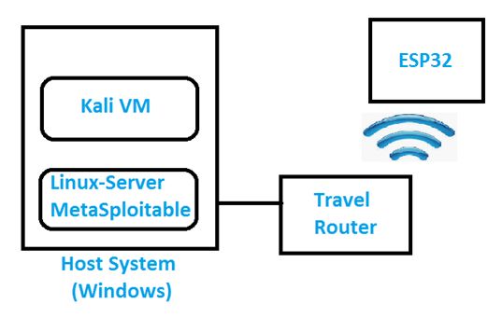

Procedure
This procedure demonstrates how to conduct a vulnerability assessment of a server in a testing or production environment. You will use several popular security tools in the industry, including NMAP (also known as the Network Mapper) and Nessus Essentials, to conduct the vulnerability assessment.
To prepare for the vulnerability scanning of the Linux Server VM (i.e., MetaSploitable VM), first complete the steps below.
- Connect the Travel Router to the host computer, using the USB cable and Ethernet cable.
- Reset the Travel Router. Change the IPv4 address of the Travel Router to 192.168.105.1 (from the default 192.168.8.1).
- On the host computer, switch on the Airplane mode to temporally disable the Wi-Fi adapter.
- Open a command window on the host computer. Issue the ipconfig /all command. Make sure that the host computer receives a 192.168.105.x IP address, and record it on a piece of paper. Otherwise, repeat Steps 1 to 3 and troubleshoot.
- Launch the VMware Player application.
- Select the Linux Server VM (do not double-click on it!). Note that it will be shown as MetaSploitable after being powered on.
- For the Linux Server to be in the same logical subnet as the Travel Router, click Edit Virtual Machine Settings.
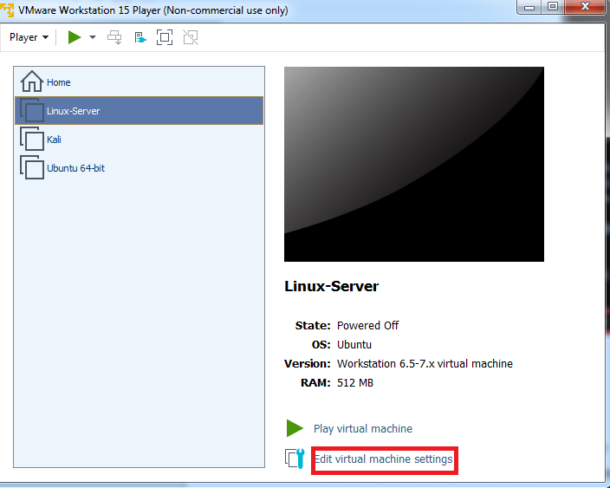

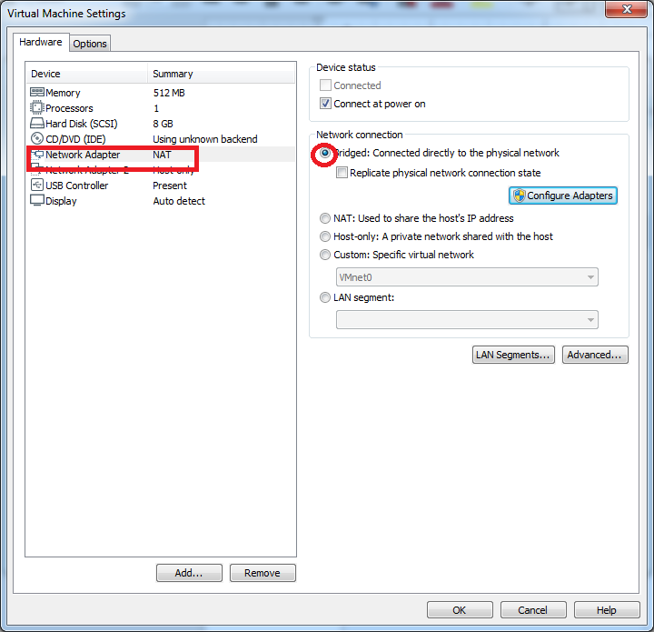
- Select Network Adapter NAT and change the setting to Bridged as shown below. Click Okay to accept the new setting. In the VMware Workstation 15 Player window, click on Play Virtual Machine to start the Linux Server VM.

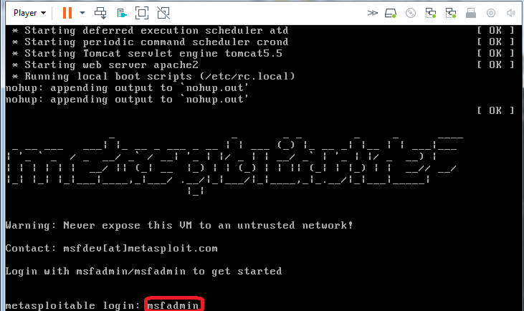
- Once the Linux Server completes the boot up process, you will be presented with a Login screen as is seen below. Enter username msfadmin and password msfadmin.

- After Login into the Linux Server VM, type ifconfig and record the VM’s IP address on a piece of paper.
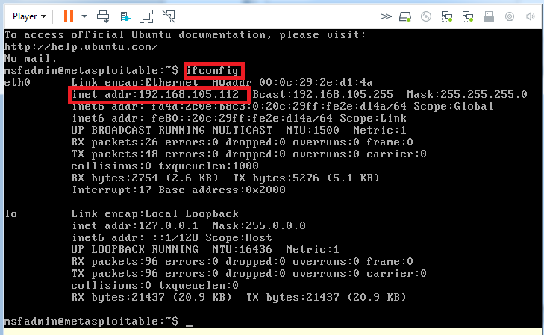

Note that your IP address may not be the same as the one in the screenshot above. This is not a problem as long as your VM receives a 192.168.105.x IP address from the Travel Router.

- On your Windows Host computer, launch another instance of WMware workstation player. Select the Kali VM and click Play Virtual Machine.
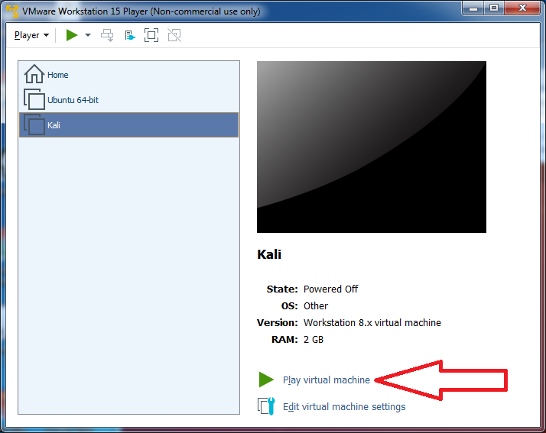

12. Enter username root and password toor, and click on Login In to log into the Kali VM.
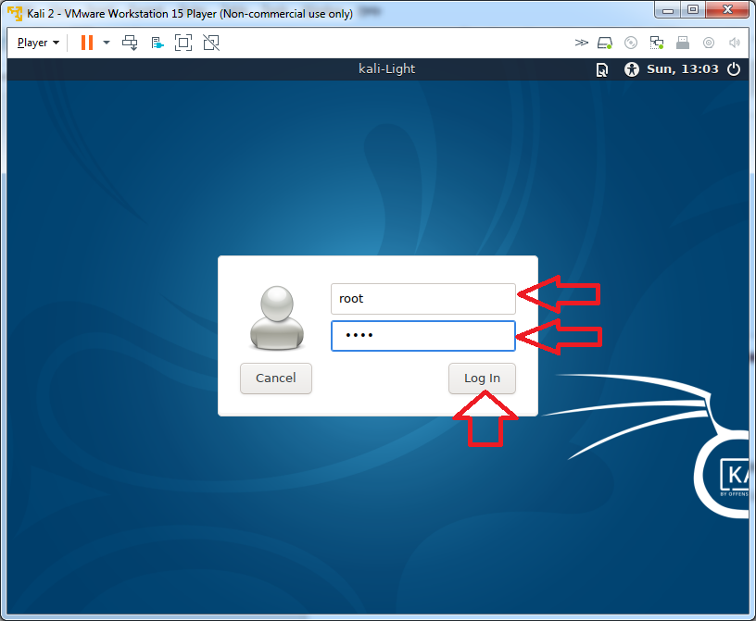

- Check the IP address of Kali VM by issuing the ifconfig command in a terminal window. Record the 192.168.105.x IP address on a piece of paper.

Next, let’s use different tools to carry out the vulnerability scanning of the Linux Server VM (i.e., MetaSploitable VM).

NMAP
NMAP identifies all IP addresses that are in use on a network segment or subnet. This scan assumes all the hosts on the 192.168.105.0/24 subnet are up.
1. On the Kali VM, click the icon shown on the taskbar to open a new Terminal window and type nmap -Pn 192.168.105.0/24.

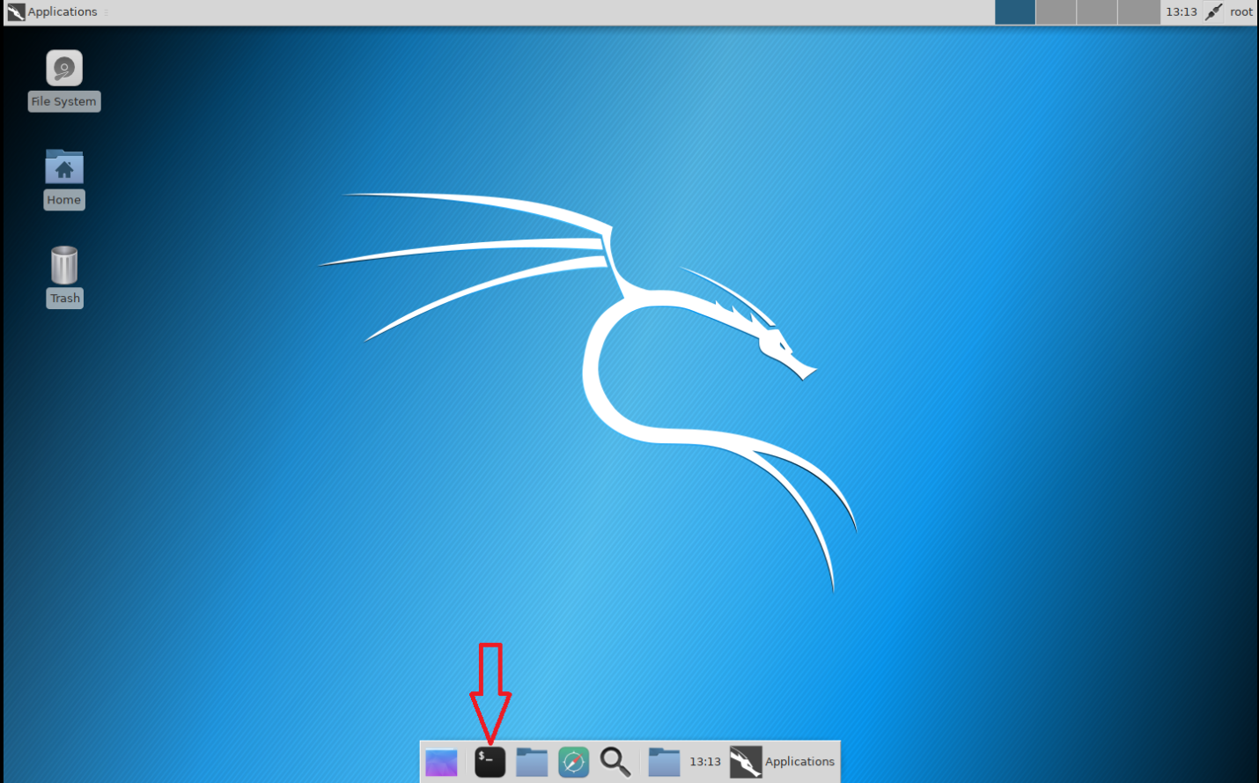

Note: The scan may take a few seconds to a few minutes depending on your computer’s processing capability.

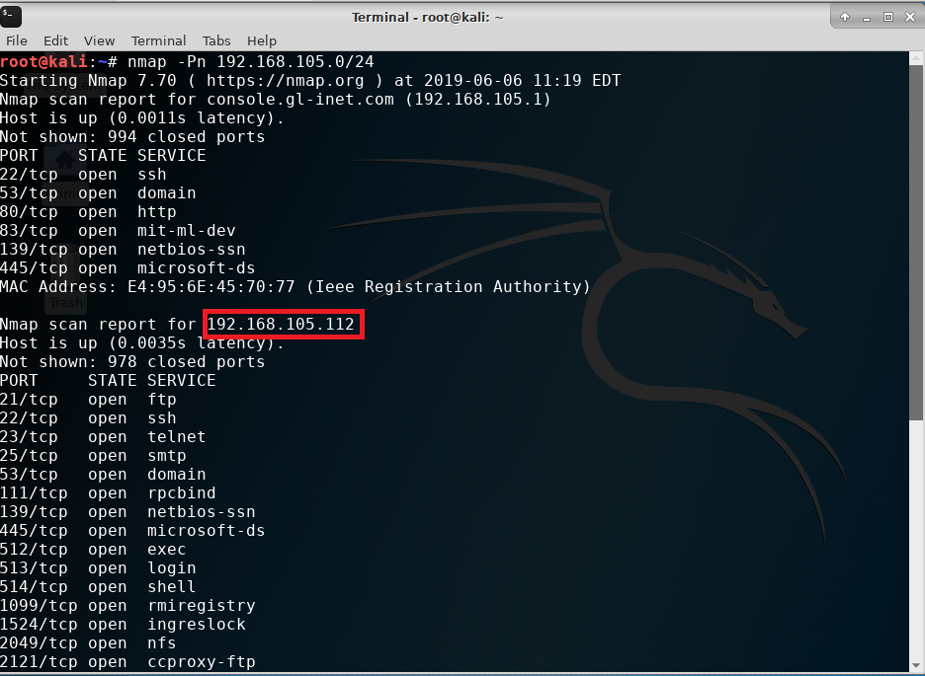
2. As shown in the screenshots below, both physical and virtual hosts with their IP addresses are identified. Your IP addresses may be different, because they are dynamically assigned by the Travel Router.

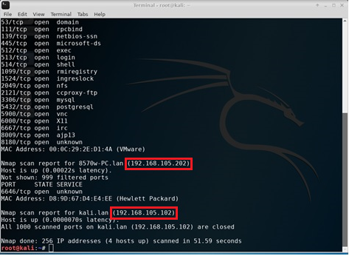

3. Take a screenshot of your screen showing all four IP addresses discovered by the nmap scan. Note that you may need to take multiple screenshots and display them in the PPT deliverable template for Module 2.

NetCat

NetCat, another scan tool, can be used to grab the banners for FTP, SSH, and SMTP applications that were discovered in the previous NMAP scan. Having knowledge of what version of application is running on the server can be a great help in the exploitation phase.

1. The command is nc followed by the -n and -w5 options and the IP address of the Linux Server or MetaSploitable VM. Note that the options -n tells NetCat to ignore name resolution (IP to Hostname) and the -w5 tells NetCat to wait no more than 5 seconds for a reply.

2. To grab the banner of the Linux Server FTP application as shown in the diagram below, type the following command in the terminal window of the Kali VM. Press Ctrl + C to return to the command prompt if needed.
nc -n -w5 192.168.105.112 21

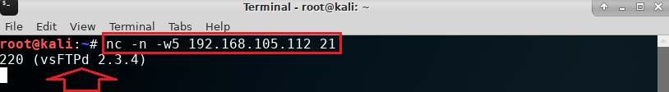
3. To grab the banner of the Linux Server SSH application as shown in the diagram below, type the following command in the terminal window of the Kali VM. Press Ctrl + C to return to the command prompt if needed.
nc -n -w5 192.168.105.112 22

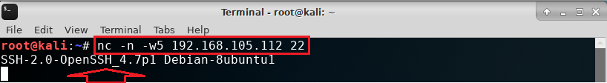

4. To grab the banner of the Linux Server SMTP application as shown in the diagram below, type the following command in the terminal window of the Kali VM. Press Ctrl + C to return to the command prompt if needed.
nc -n -w5 192.168.105.112 25

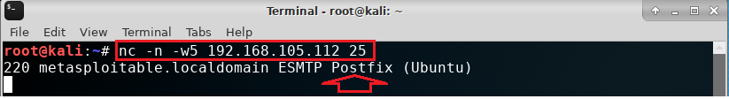

Wireshark
Wireshark is a packet capture tool that security practitioners use to analyze network traffic and gain insight into client/server applications.
1. In the terminal window of the Kali VM, type wireshark to launch the Wireshark application.
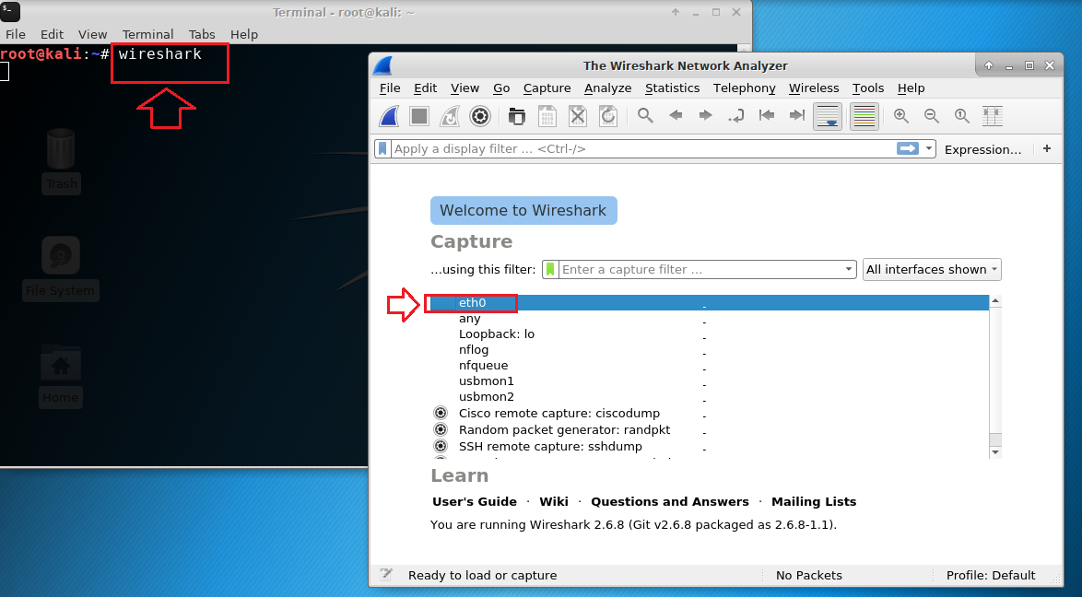
2. As shown in the diagram above, click on the leftmost icon  on the top as seen below or double click eth0 to start capturing packets.
Many packets will be scrolling on the Wireshark screen. As shown in the diagram below, type ip in the filter bar to only display IP packets. Click the blue arrow on the right of the filter bar to apply the filter.
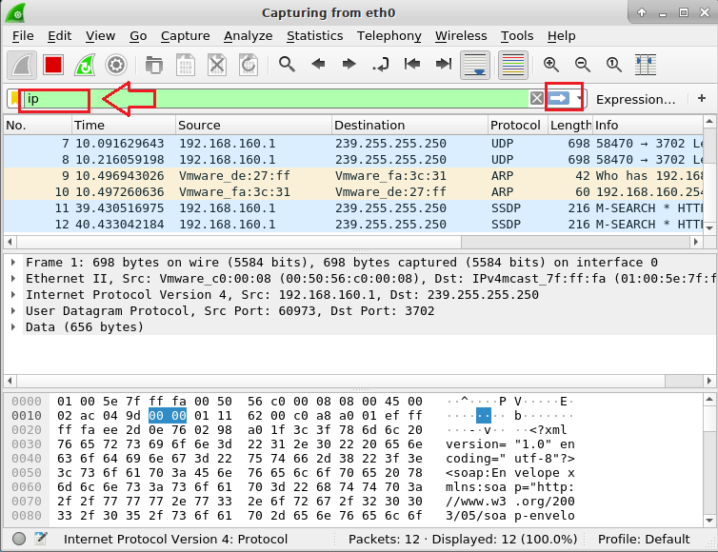

3. In the terminal window of Kali VM, type telnet 192.168.105.x. Make sure to replace 1921.68.105.x with the IP address of the Linux Server or MetaSploitable VM. You should have all three IP addresses written on a piece of paper. Otherwise, use the ifconfig command in the terminal window of the Linux Server or MetaSploitable VM to check its IP address.
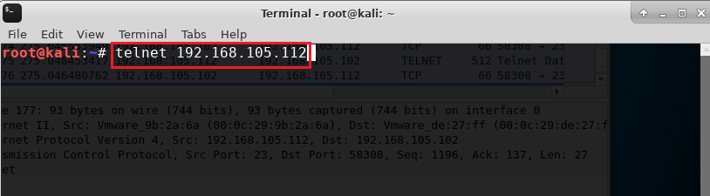
- Login by using username msfadmin and password msfadmin.
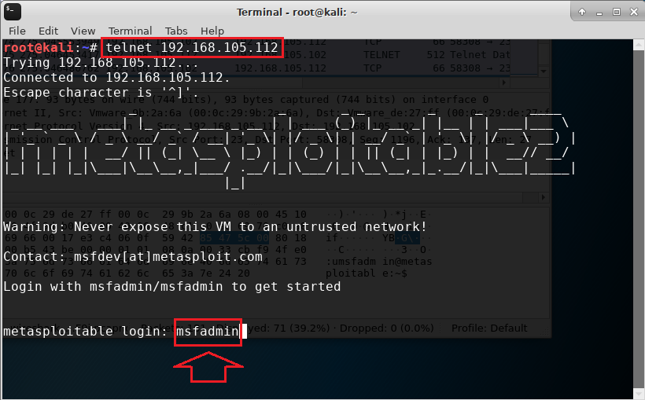
- You should see a message similar to the one below if the log in was successful.
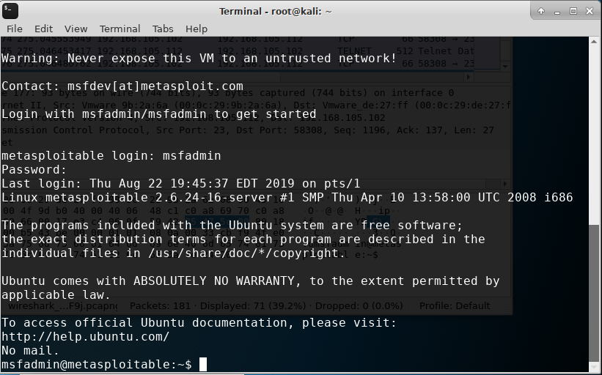
- Now you can stop capturing packets by clicking on the red square icon in the top toolbar of Wireshark.
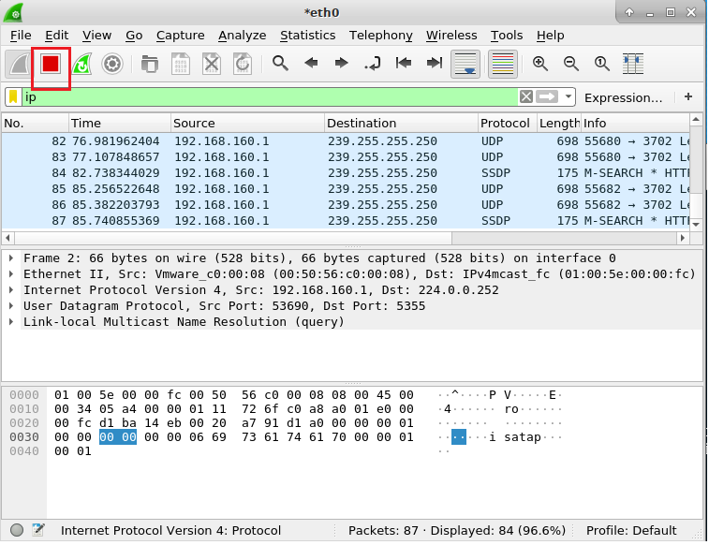
- Replace ip with telnet in the filter area, as shown in the diagram below, to analyze the Telnet packets that we just captured. Press the Enter key on your keyboard or click the blue arrow to apply the filter.
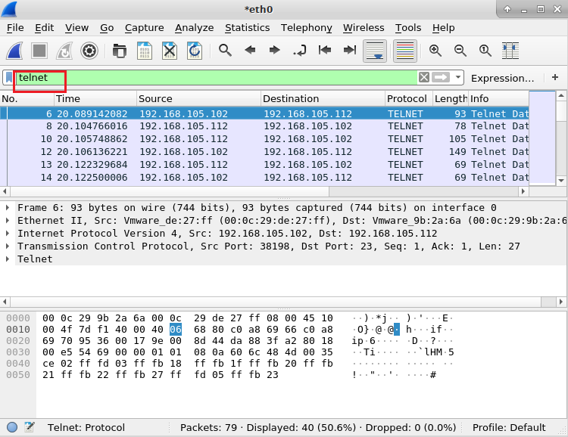
- Right click any of the packets displayed in the top portion of the window and select Follow > TCP Stream. The username and password that were used to connect to the Linux Server via Telnet are captured and displayed in a new window.
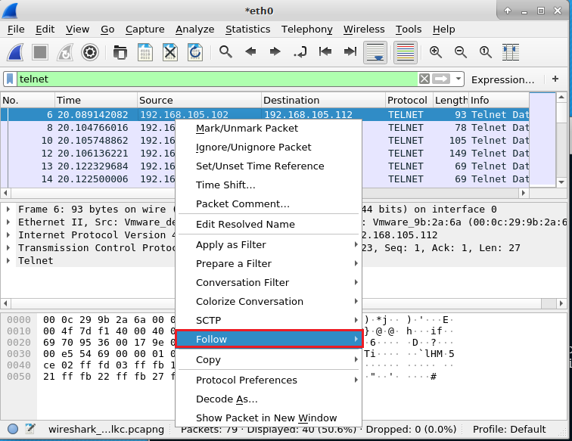

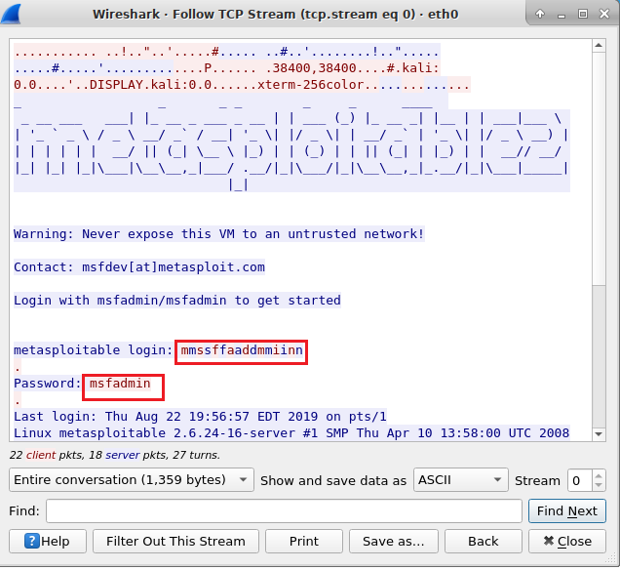
- The user credential can be captured because Telnet is an application that transfers data in plaintext. In the next module, we will discuss security controls that mitigate this issue.

Nessus Essentials
Nessus Essentials is a free vulnerability scanner that provides an entry point for vulnerability assessment. Make sure that you follow the steps in the “Nessus essentials installation” document to install it properly on your Windows Host computer.
1. On the Windows Host computer, type nessus web client in the Type here to search box on the bottom left of the window. Double click to launch the web client. In the browser window shown below, click on Details and then Go on to the webpage to open the sign in window.
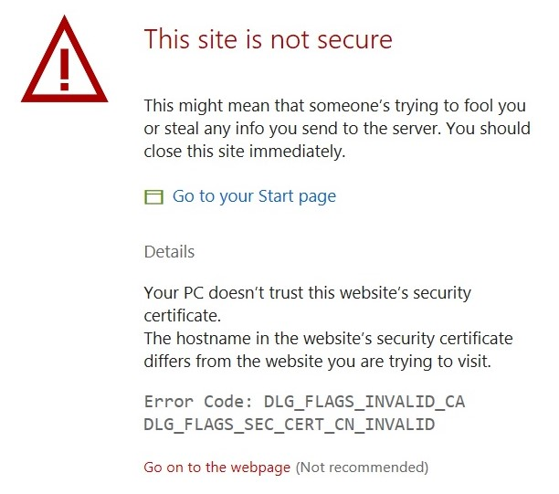

2. In the sign in window, type in username admin and password nessus to sign in.

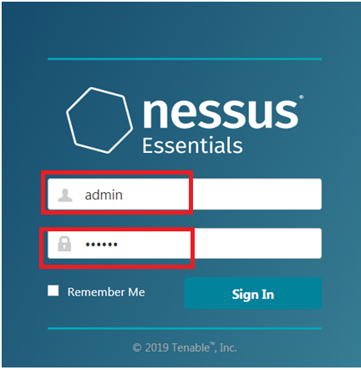
3. In the Nessus Scans window, click on the My Scans folder on the left and click on New Scan on the top right corner of the window.
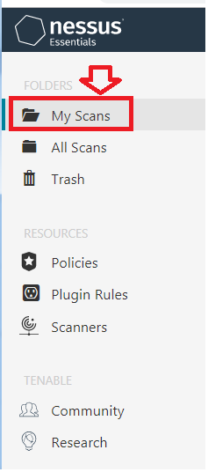

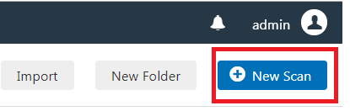

4. Various scan templates are displayed in a new window as shown below.
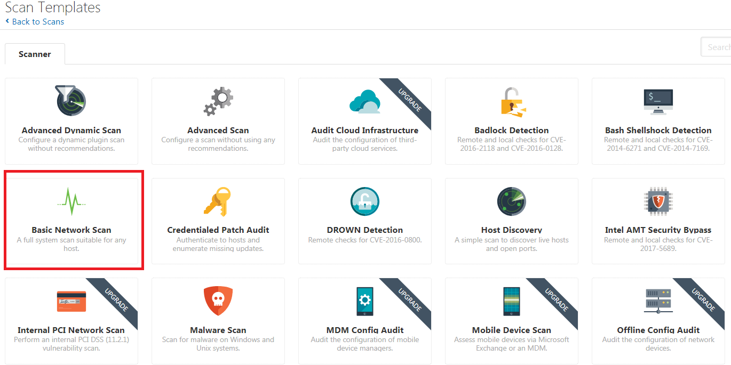
5. Select the Basic Network Scan template as marked in the diagram above. Fill out the required information as shown below, and click Save. Note that, in the Targets box, you can enter a single IP address (use the IP address of your Linux Server!), hostname, or a combination of the two including a complete subnet.
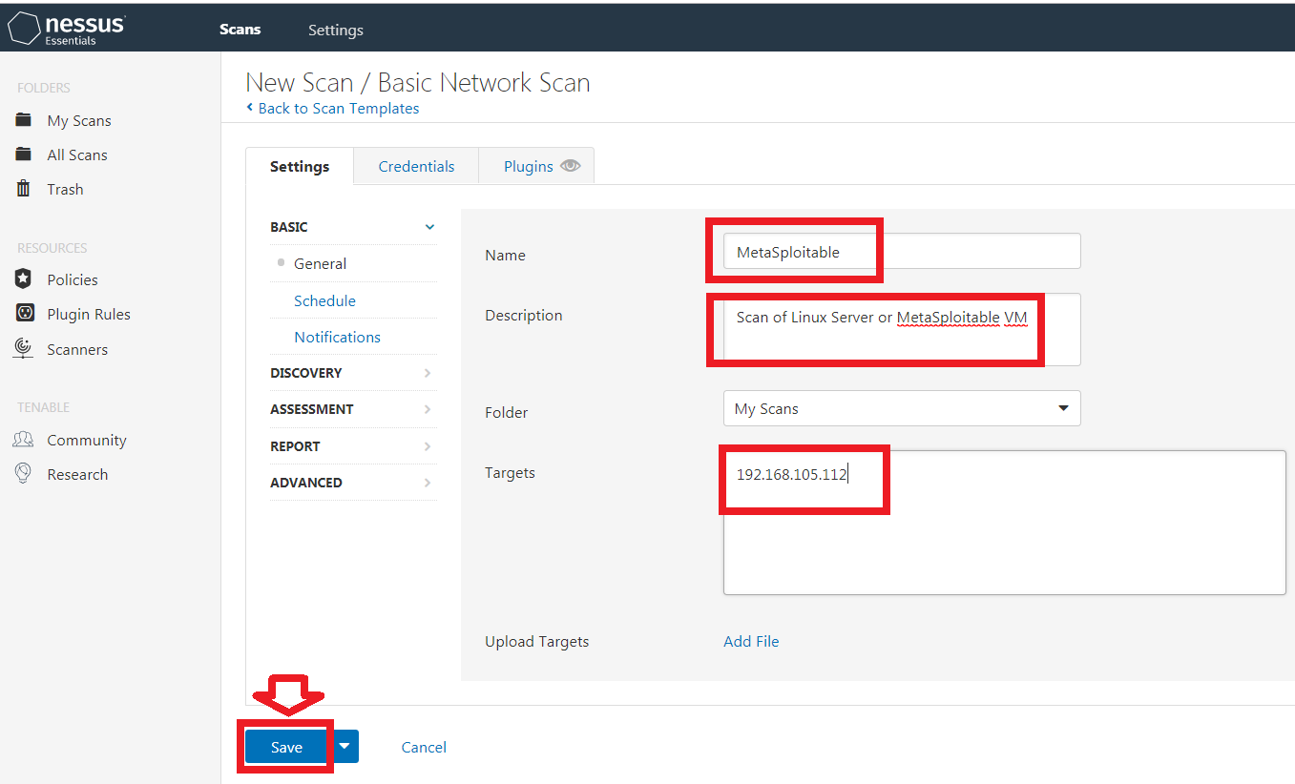

6. The new scan you just set up is listed under My Scans as shown below.
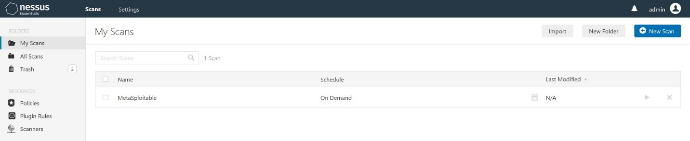
7. Highlight the scan, click the run arrow on the right to launch the vulnerability scan of the Linux Server as shown in the diagram below.
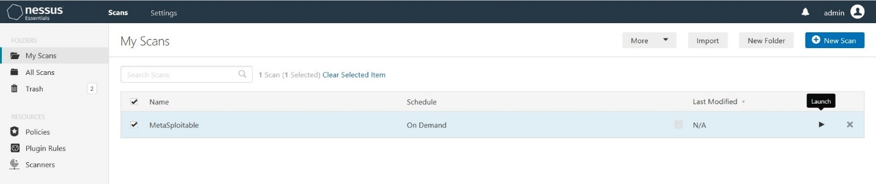
8. You will see a scan in progress as seen below. Note that the scan may take more than ten minutes. So now it’s a good time to take a coffee break!
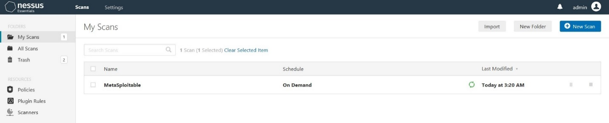
9. Once the scan is complete as shown below. Click on the name of your recent scan to open the scan result page.
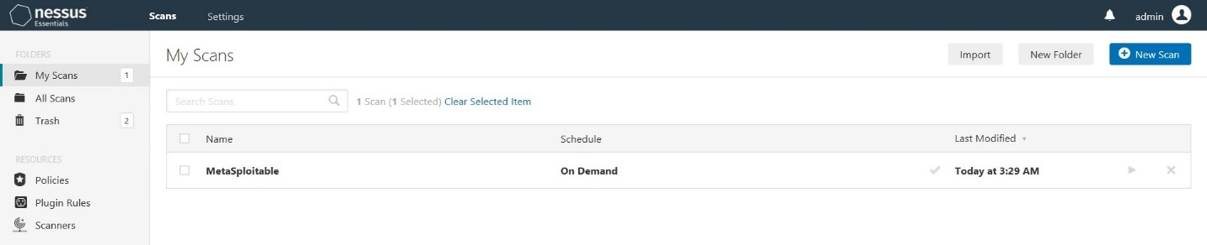
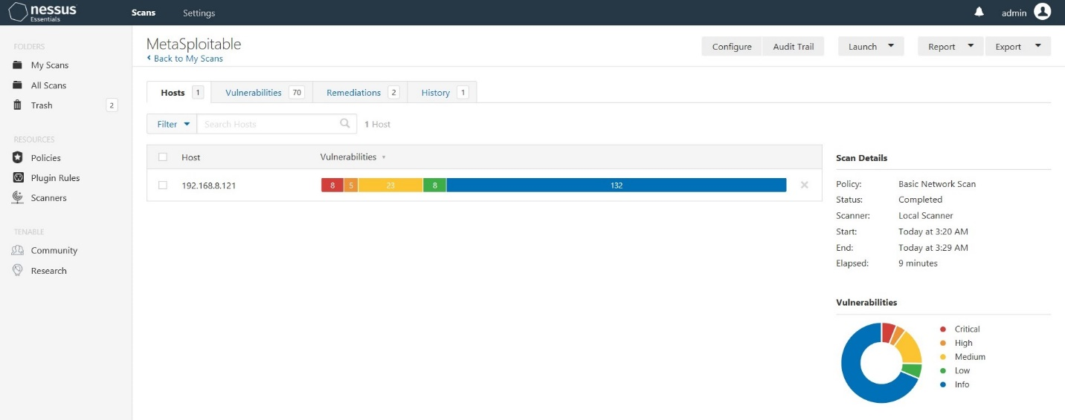
10. Click on Report on the top menu bar and select HTML. In the Generate HTMP Report window, select Custom on the drop down menu and click on Generate Report.
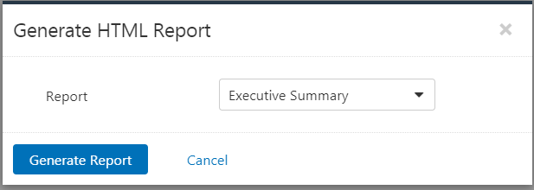

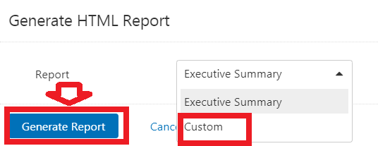

Question: What is the significance of the Executive Summary in the Nessus Essentials report? Include your answer in the PPT deliverable template for Module 2.

- This will generate an HTML file with the results of the vulnerability scan. You may choose to save it on your computer first, or open it right away as shown in the diagram below. This is a high level view of the report. We will take a closer look at it to understand various vulnerabilities in the report.
Note: The IP address seen in your own report will be different from the one shown below.
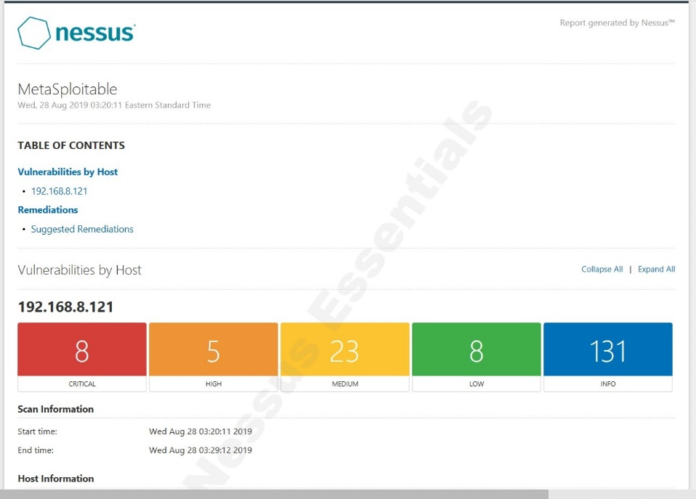
- Click on Collapse All. Notice the severity levels in the list of vulnerabilities that were identified by the Basic Network Scan, as shown in the diagram below.
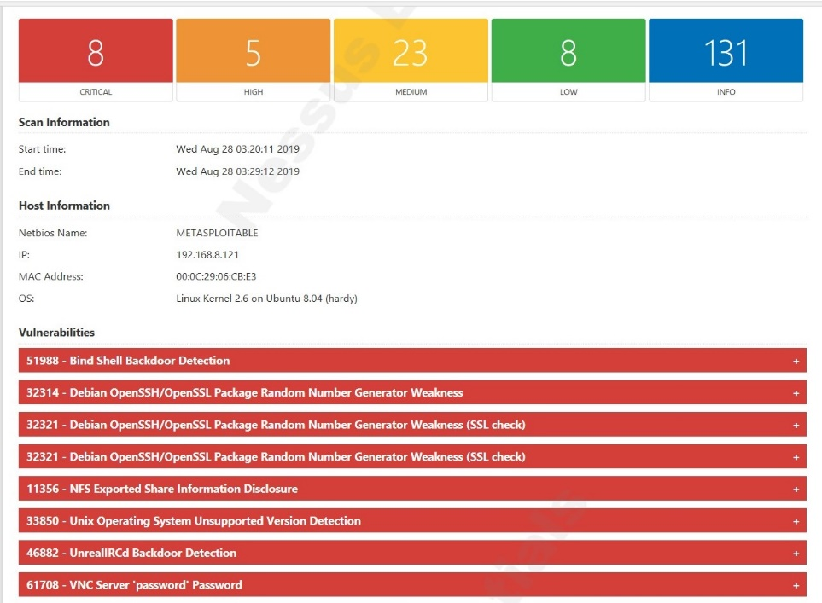
- Click on the + sign next to the Bind Shell Backdoor Detection entry to view the information on the identified vulnerability.
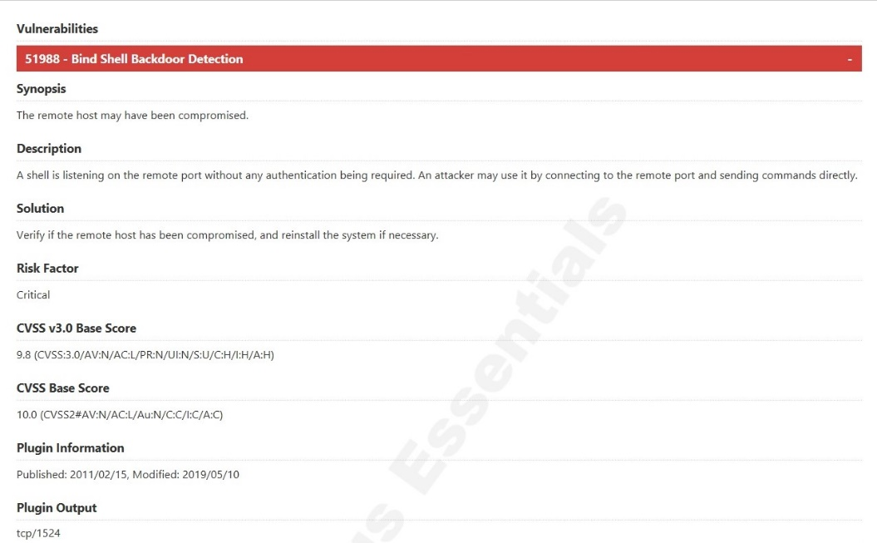
Notice the Plugin name, risk factor, and other vital information that attackers can use to exploit the system.
In vulnerability scanning, CVE stands for common vulnerabilities and exposures. The US National Vulnerability Database (NVD) uses CVEs to provide a standardized means to assess the level of security exposures in computing systems including operating systems, applications, etc.
OSVDB stands for Open Source Vulnerability Database. One of the main goals of OSVDB is to support open source projects by providing accurate, detailed security vulnerability information to the open source community.
Screenshot: Take a screenshot of a vulnerability of Critical severity rating. Paste it to the PPT deliverable template for Module 2.
Screenshot: Take a screenshot of a vulnerability of High severity rating. Paste it to the PPT deliverable template for Module 2.
Screenshot: Take a screenshot of a vulnerability of Medium severity rating. Paste it to the PPT deliverable template for Module 2.
Question: What is the significance of ranking the vulnerabilities by severity level? Include your answer in the PPT deliverable template for Module 2.

- Other than the screenshot of a vulnerability of critical security rating above, below are sample screenshots of two vulnerabilities of high and medium severity ratings, respectively, from the Nessus vulnerability scan of the Linux or MetaSploitable VM Server.

High Security Rating
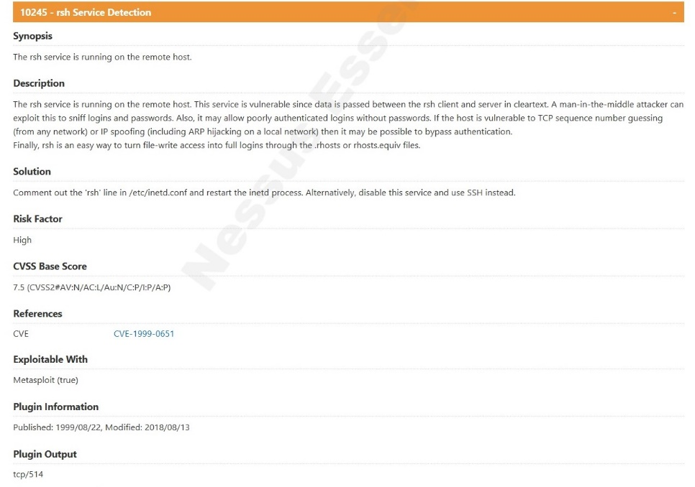

Medium Security Rating
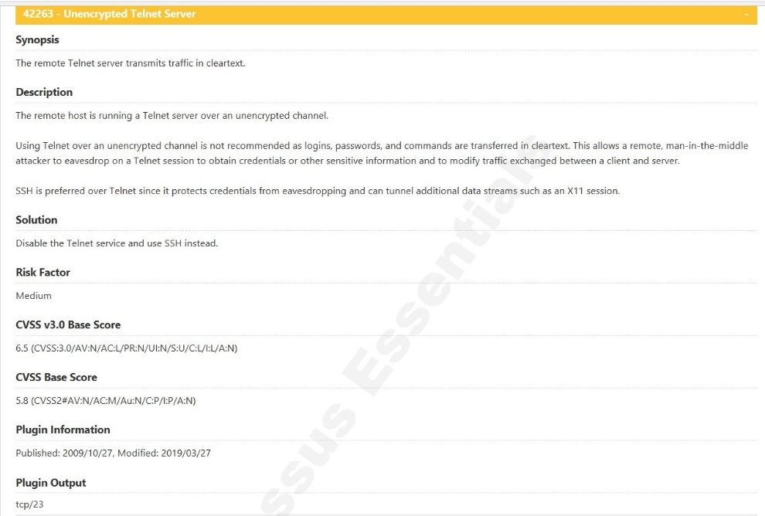

Congratulations! You are done with Module 2.

