Course Project

Course Number: SEC285
Module 1: Light Control System

Objectives
The objective of Module 1 is to connect several LED lights to the ESP32 controller and control the lights from a Web browser. This is like a smart home lighting system that provides control over your home lighting from a centralized location.
Part List
- laptop
- ESP32 microcontroller
- Breadboard
- Wires
- LEDs
- Resistors

Part 1: Hardware Setup
- Seat the ESP32 microcontroller on the two inner sections of the breadboard carefully (toward one end of the board and toward the left side of the inner section). Leave the last “j” row open.

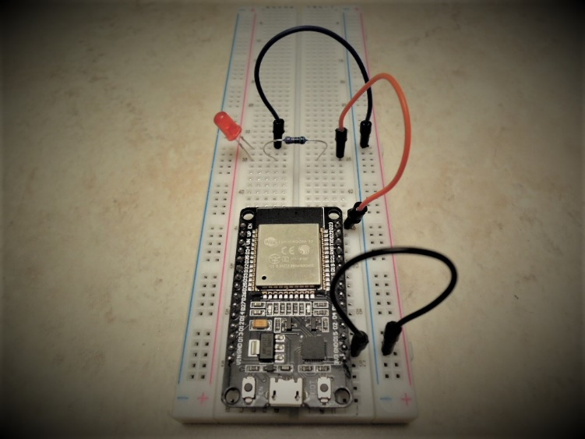

- As shown in the diagram above, connect the GND pin of the controller (on the right side) to a socket on the right ground rail in light blue.

- Use a jumper wire to connect pin D23 to any (narrow) row of the breadboard. Add a 220 Ohm resister to the same (narrow) row. Connect the long leg of a LED to the same (narrow) row and the short leg to a second narrow row. Use a wire to connect a socket of the second narrow row to a socket of the ground rail in light blue.

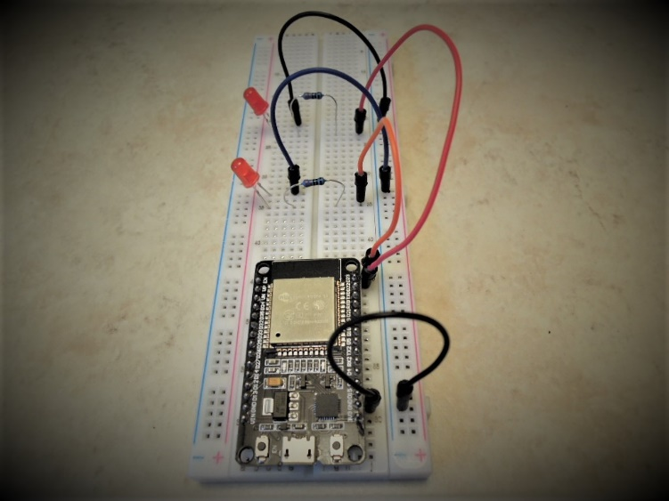
- Use a jumper wire to connect pin D22 to any available (narrow) row of the breadboard. Add a 220 Ohm resister to the same (narrow) row. Connect the long leg of an LED to the same (narrow) row, and the short leg to a second narrow row. Use a wire to connect a socket of the second narrow row to a socket of the ground rail in light blue.

- Take a screenshot of the breadboard with all components and connections. Paste it into the Course Project PPT template for Module 1.

Part 2: Software Setup
- Download Python 3.7.4 for Windows from python.org/downloads/ to your computer. It is listed under the “Looking for a specific release?” section. On the Python 3.7.4 page, locate and download Windows x86 executable installer.
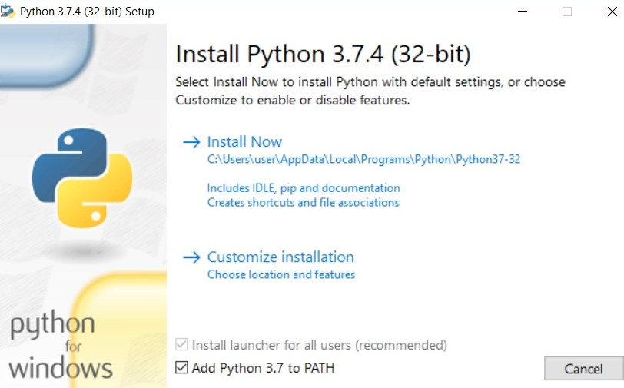

- Double-click on the application file, check the “Add Python 3.7 to PATH” option as shown in the diagram above, and install it properly.

- Download CourseCodeProFonts.zip from the Module 1 Project Files section of your course shell. Extract all files into a folder with the same name. Double-click to open the newly generated file folder. Highlight all the files in the folder, and right-click to open a drop-down menu. Click on Install to install all the fonts.

- Download CP210x_Universal_Windows_Driver.zip from the Module 1 Project Files section of your course shell. Extract all files into a folder with the same name. In the newly generated folder, double-click CP210xVCPInstaller_x64 application to install the driver package.
- Go to https://micropython.org/download/all/ and download the esp32-idf3-20191220-v1.12.bin file on your computer.
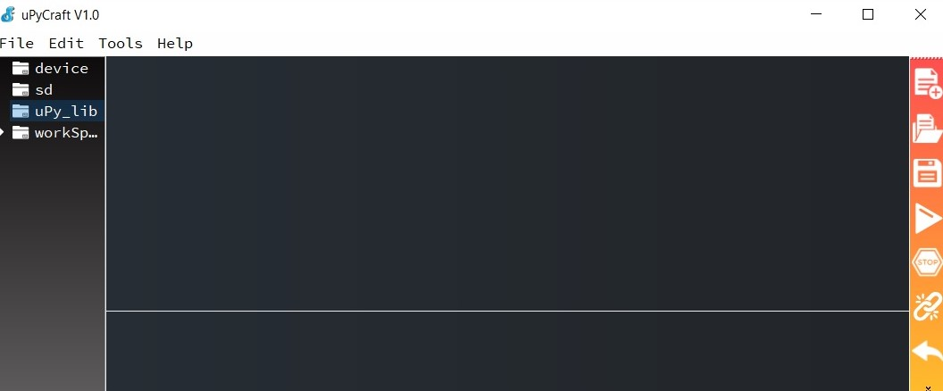

- Go to GitHub (github.com/DFRobot/uPyCraft) or Module 1 Project Files, download uPyCraft.exe file on your computer. Double-click on the file to install it. The IDE window shown above should appear.
If you see the “MSVCR100.dll was not found” error message, download the following Microsoft Visual C++ redistributable packages:
https://www.microsoft.com/en-us/download/confirmation.aspx?id=13523
https://www.microsoft.com/en-us/download/confirmation.aspx?id=5555

From here on, type uPyCraft in the Type here to search field on the bottom left of your computer screen to locate the software.
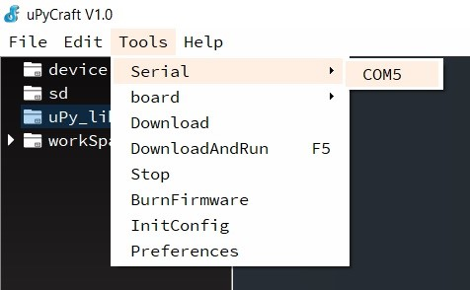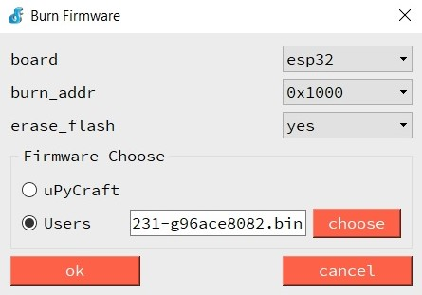

- Connect the breadboard to the USB port of your laptop. In the IDE window as shown above (left), click Tools, Serial, and then COM5. In the Burn Firmware window, choose esp32 on the board drop down menu. Choose 0x1000 on the burn_addr drop-down menu. Check the Users radio button and then the choose button. Navigate the file explore window and locate the firmware you downloaded in Step 3. By default, the file is saved in the Downloads directory. Highlight the firmware and click on the Open button. All parameters should be set as shown in the diagram above (right).

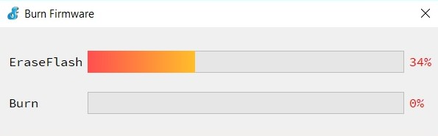

- Use the flat side of a pencil or pen to press down the BOOT button of the ESP32 microcontroller board. While pressing the BOOT button down, click on ok in the Burn Firmware window. Once the process starts as shown above, you may release the BOOT button.

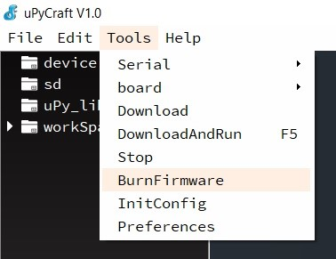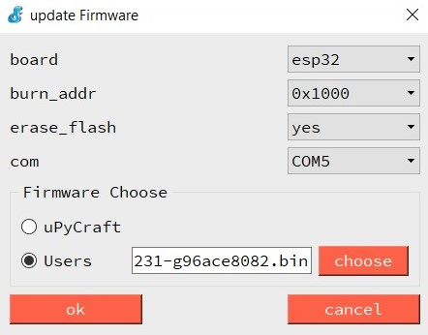

- If an “erase false” error message pops up, close the error message window. In the IDE environment, click on Tools and then BurnFirmware to open the update firmware window as shown above. Repeat Steps 5 and 6. Make sure to press down the BOOT button on the ESP32 board before clicking ok in the update Firmware window.

Part 3: Code Implementation
- In the uPyCraft IDE window, click on Tools, Serial, and COM5 to connect the ESP32 board.

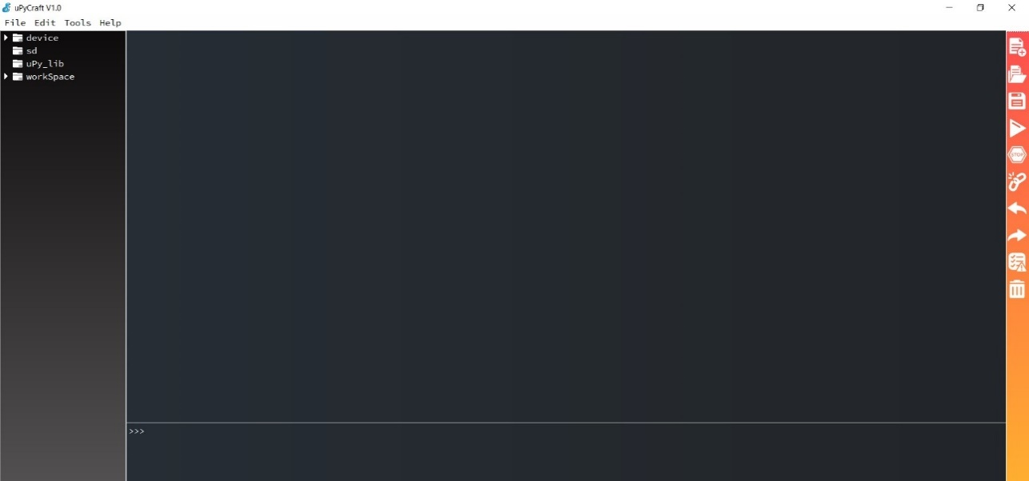

- If the connection is established successfully, a >>> prompt is displayed toward the bottom half of the window as shown above.
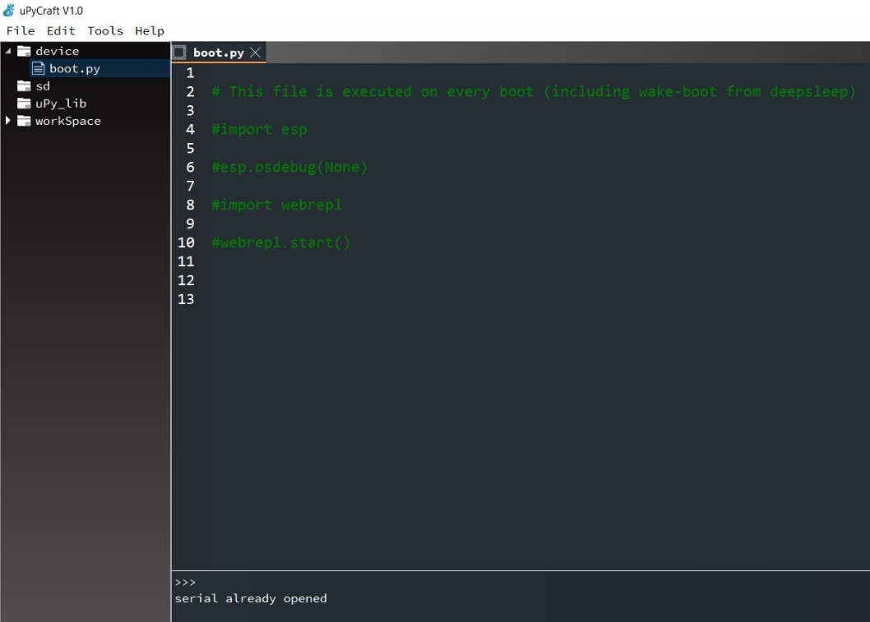

- In the left window pane, click on the arrow next to device and double-click on boot.py to open the file.

- Go to the Project Files section of Module 1 on your course shell. Locate the HomeLightSystemPart1.text. Copy and paste the code in the boot.py file, under the comment lines in green.

- Modify the boot.py file to reflect the following changes (keep the single quotation marks!):
ssid = ‘YellowRouterSSID‘
password = ‘PasswordConnectingToWiFi ’

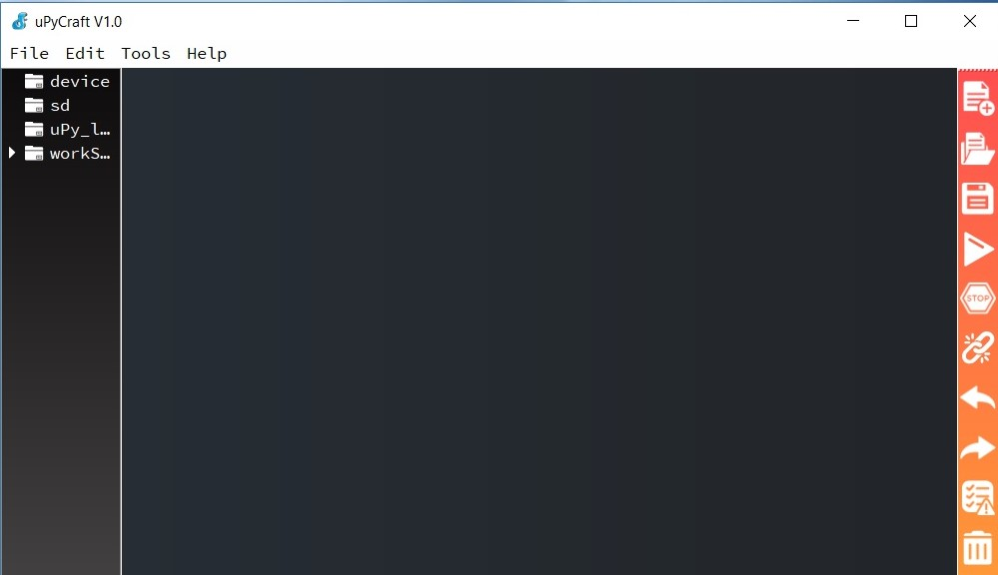

- On the right side of the IDE window, as shown in the diagram above, click on the Save icon (the third one on the list) to save the boot.py file. Click on the Stop icon (the fifth one on the list) to stop any code from running. Click on the DownloadAndRun icon (the fourth one on the list) to upload the code to the ESP32 microcontroller.

- One the right side of the IDE windows, click on the New icon (the first one on the list) to open a new file.

- Click on the Save icon (the third one on the list), enter main in the save at your workSpace window, and click ok. All your codes will be saved in the workSpace folder on Desktop.

- Go to the Project Files section of Module 1 on your course shell. Locate the HomeLightSystemPart2.text. Copy and paste the following code into the main.py file.

- On the right side of the IDE window, click on the Save icon (the third one on the list) to save the main.py file. Click on the Stop icon (the fifth one on the list) to stop any code from running. Click on the DownloadAndRun icon (the fourth one on the list) to upload the code to ESP32.

Part 4: Code Execution
- Turn on the yellow Travel Router. Make sure that you can locate the Wi-Fi network and connect your smartphone to it. Your smartphone should receive an IP address of 192.168.8.x from the yellow router.
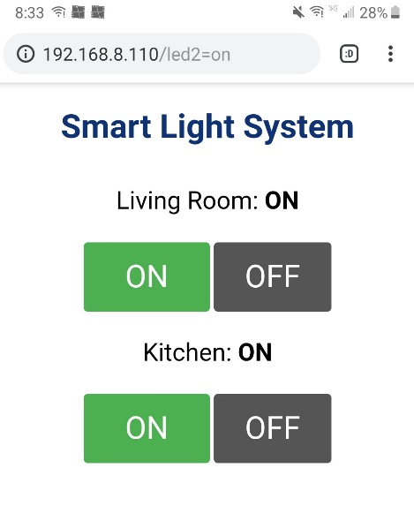
- To run the codes uploaded to the ESP32 board in Part 3, use the flat end of a pencil or pen to press the EN button of the ESP32 board and release. Look for the Connection successful message in the bottom half of the window, as shown in the diagram above, and write down the IP information of the ESP32 board.

- On your smartphone, type in the IP address from Step 2 into the web browser. Now you should be able to switch the two LEDs on and off from your smartphone.

- Take a screenshot of the Smart Light System page with both lights switched on and paste it to the Course Project PPT template for this module. Make sure that the IP address of your board is visible in the browser URL.

Part 5: Challenge (optional)
Choose another GPIO port of the ESP32 board and add another LED to the breadboard.
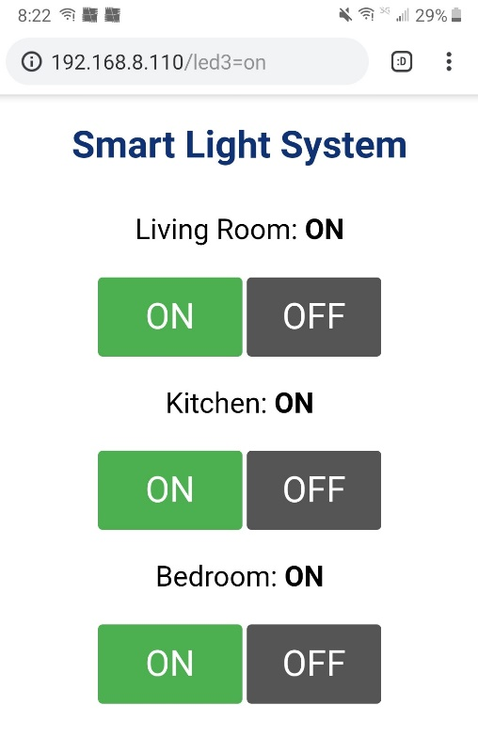
Modify the boot.py and main.py codes to add another control for the bedroom light, as shown in the diagram above.
Take a screenshot of your updated Smart Light System page with all three lights on. Paste it to the course project PPT template for this module.

Part 6: Deliverable
The PowerPoint deliverable template with four screenshots, one for the breadboard layout, one for the Smart Light System Web page, and two for the updated breadboard layout and Smart Light System Web page from Part 5.

