Course Project
Course Number: SEC285
Nessus Essentials Installation

Nessus is known as the gold standard for vulnerability assessment. Nessus Essentials is a free vulnerability scanner that provides an entry point for vulnerability assessment. It is designed for educators, students, and individuals starting their careers in cybersecurity.
Procedure:
- Connect your computer (HP laptop) to the Internet.
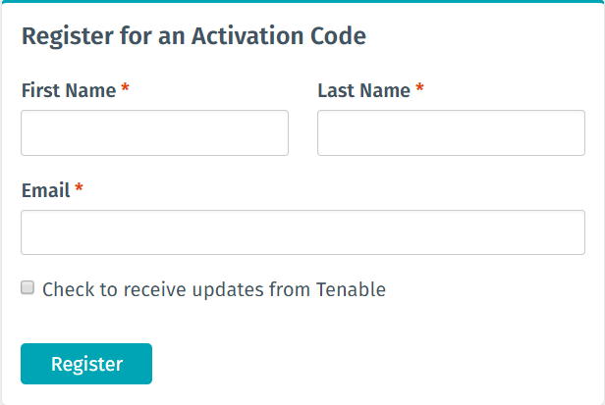
- Go to https://www.tenable.com/products/nessus/nessus-essentials and register for an activation code, as shown in the diagram above.
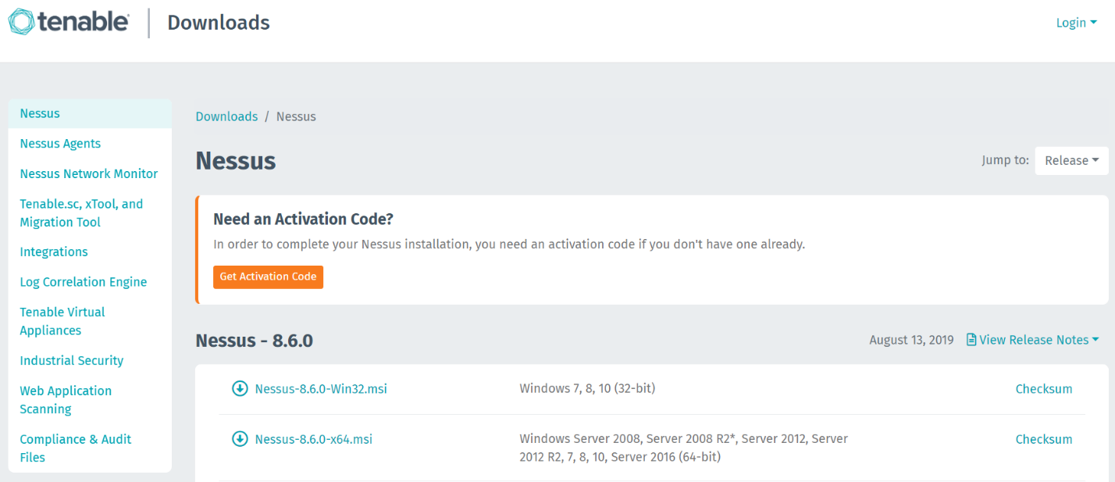

- As shown in the diagram above, download the most recent version of Nessus installer package file for Windows 10 (64-bit) and install it on your computer.
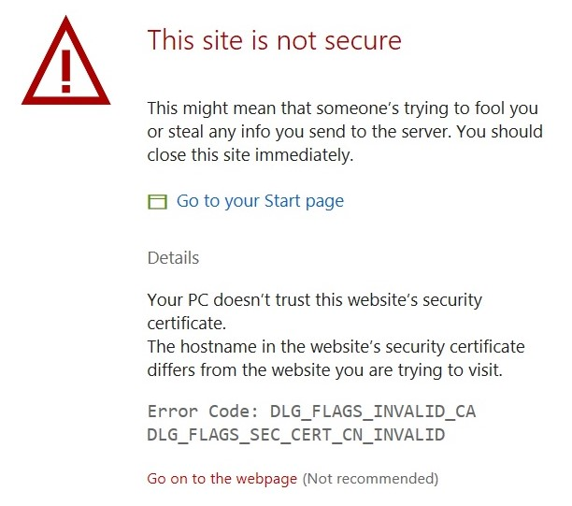

- In the browser window shown above, click on Details and then Go on to the webpage to open the Welcome to Nessus window.
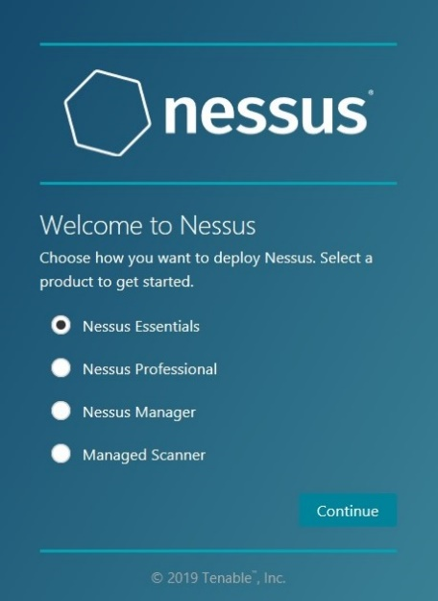

- In the Welcome to Nessus window shown above, check the radio button next to Nessus Essentials, and click Continue.
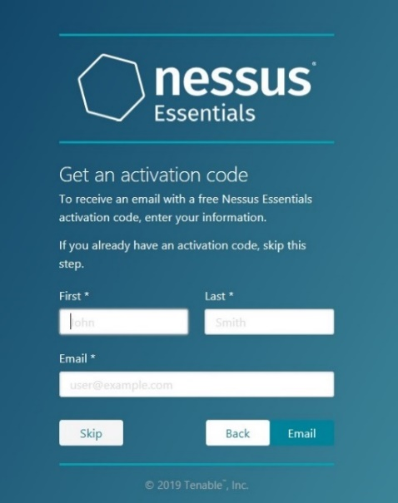
- In the Get an activation code window shown above, click on the Skip button.
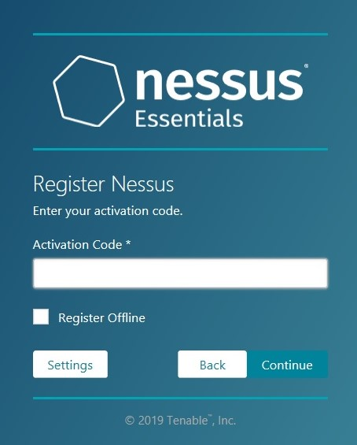
- In the Register Nessus window shown above, enter the activation code that was e-mailed to you in Step 2. Make sure that you are connected to the Internet. Type the code in carefully, along with the hyphens.

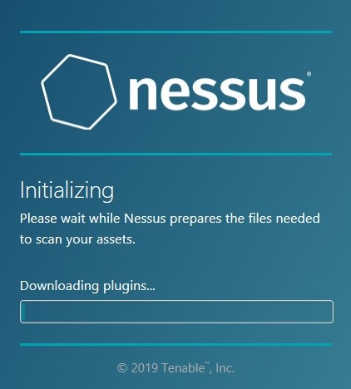

- Wait for the initializing process shown above to complete. This may take some time, depending on your Internet speed.
- Create an account with username admin and password nessus to complete the installation process.

