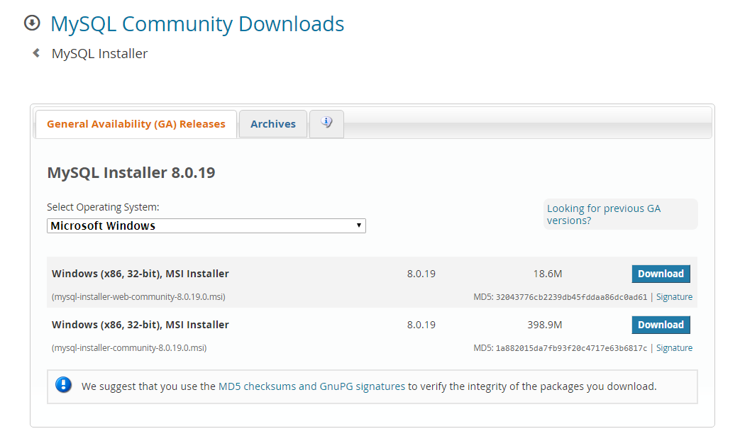
3. It will ask you for a login, pick No thanks, just start my download:
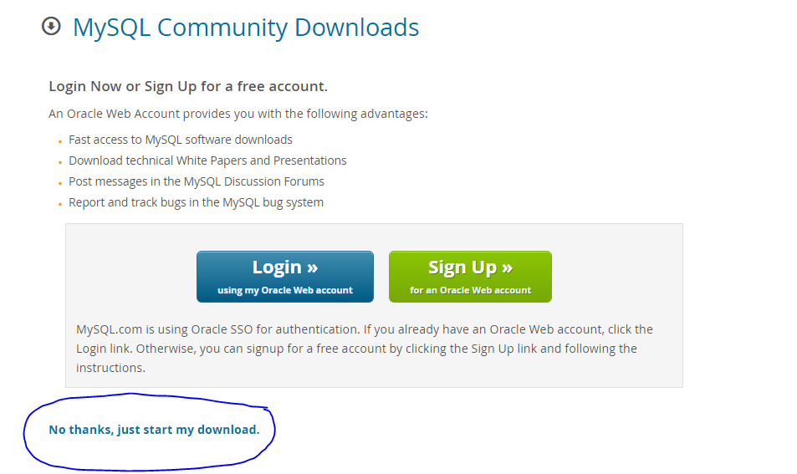

- Once it has downloaded, double click on the msi file in your downloads folder to run it.
- You will need administrator privileges on your computer to install the software and you may be asked for your password to install MySQL.
- As it is preparing to install, choose Developer Default:
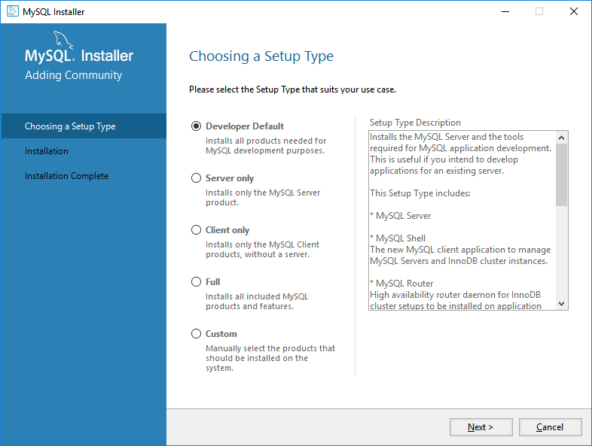
- You may get some errors about failing requirements:
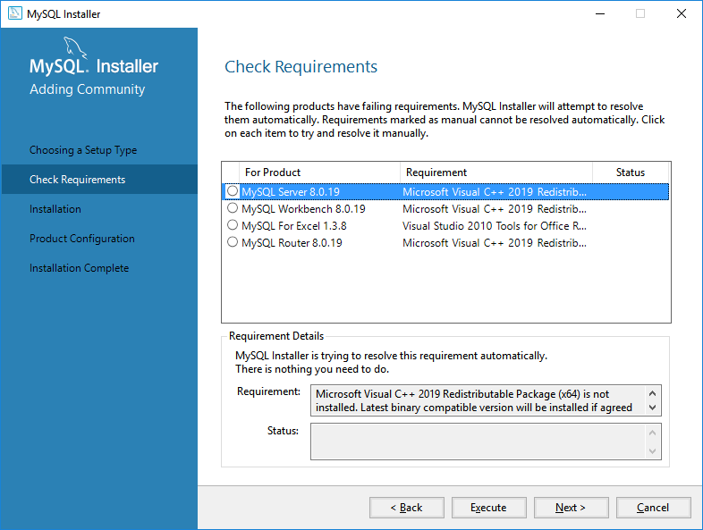
Click Execute
- Click on any requirements you are missing. For each of the requirements, click the Execute button and it will be installed for you. You may have to accept license agreements.
- Once each item is installed you will see green checkmarks. This indicates that all items were installed.
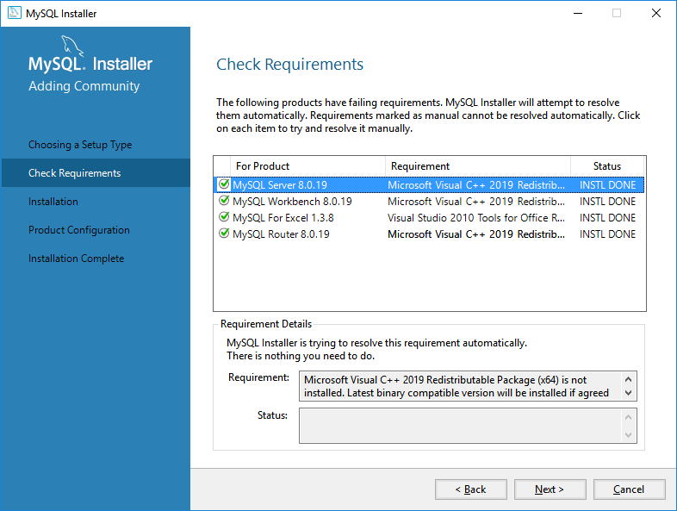
- Click Execute
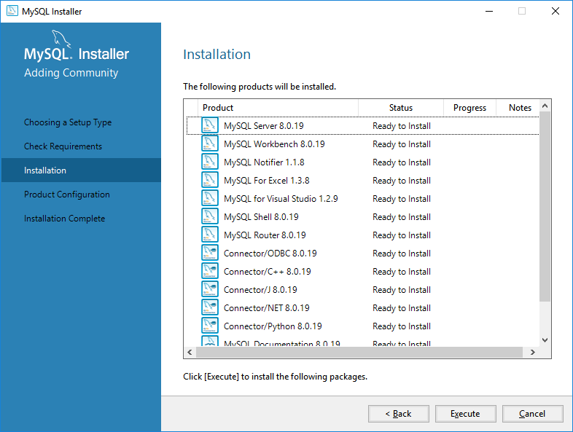
- This will take some time as it installs each component so hang tight.
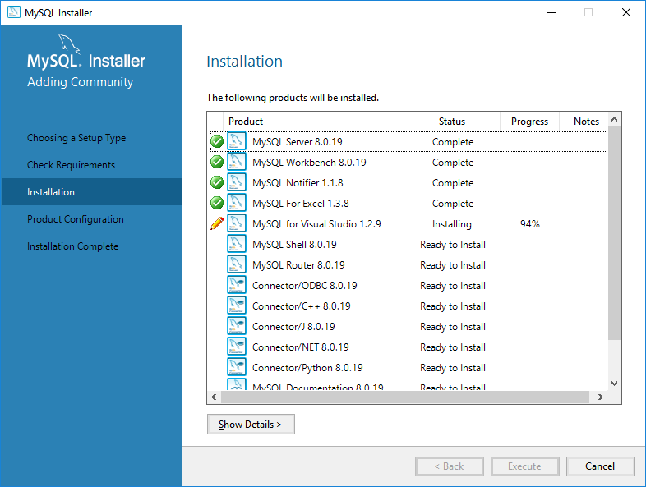

- Once it finishes, click Next
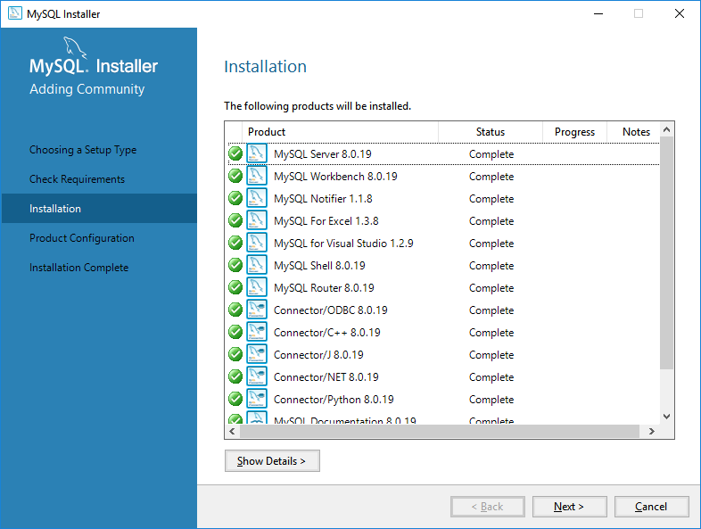
- Click Next again
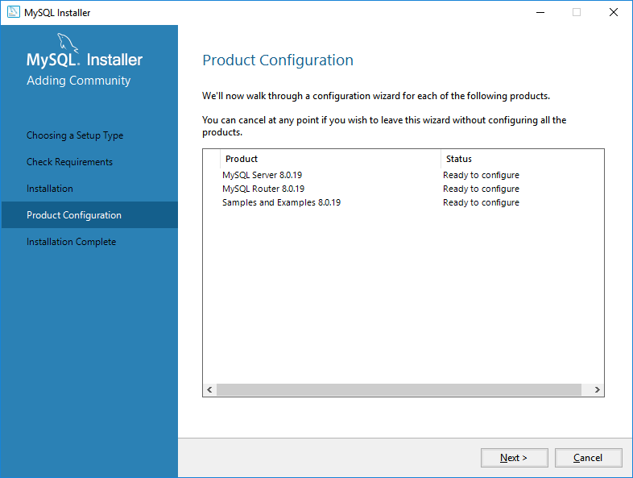
- You want a Standalone server (default), Click Next
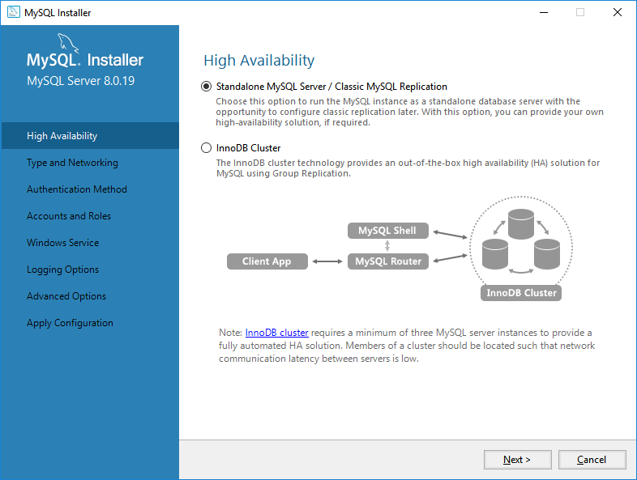
- Choose the default configuration, click Next
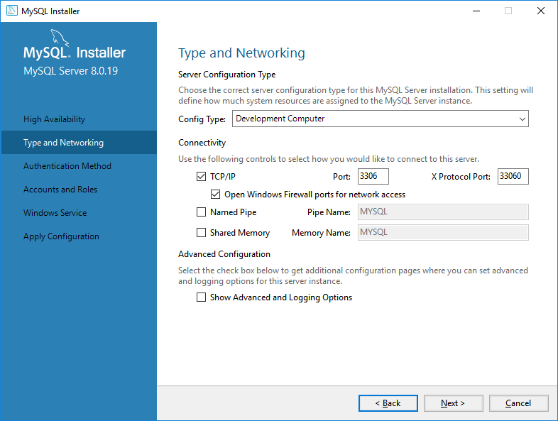
- Accept the default Authentication configuration, click Next
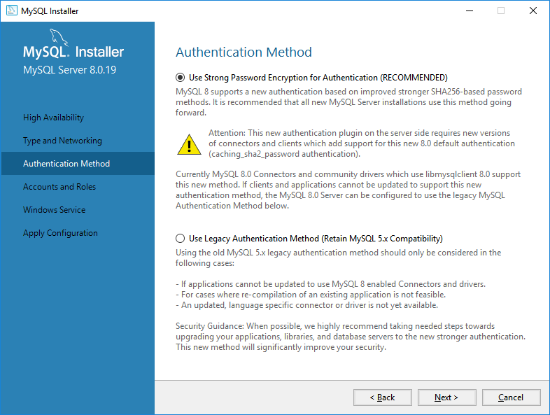
- Pick a root account password that you will remember.
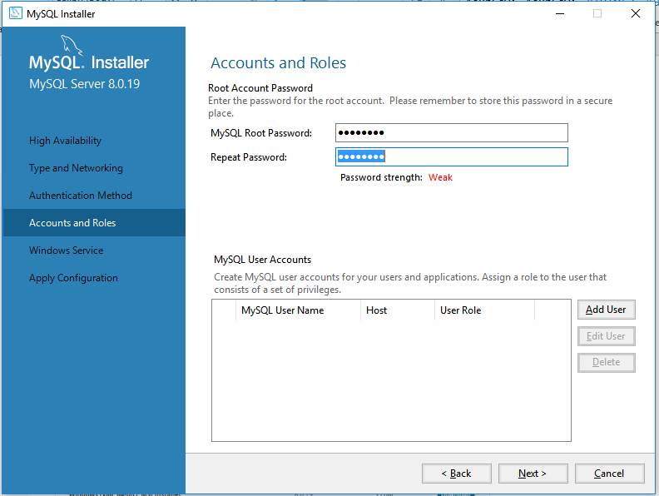
devry123
- Choose the default and pick next
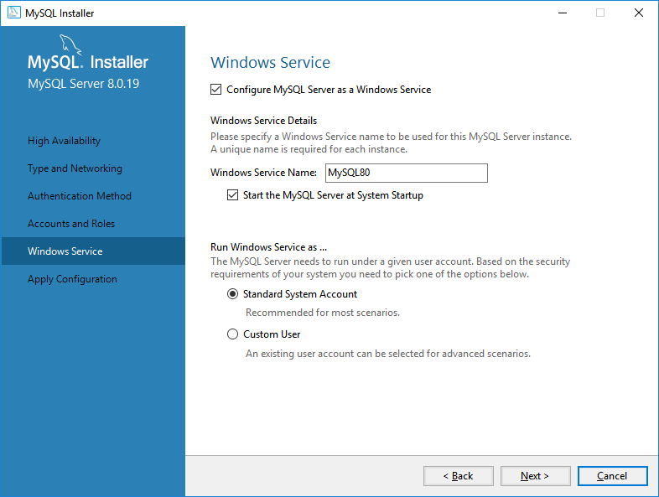
- Click Execute
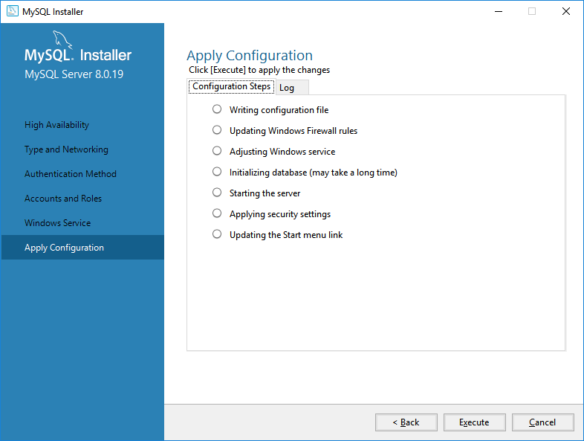
- This will take some time to apply the configuration. When the configuration is complete, click Finish
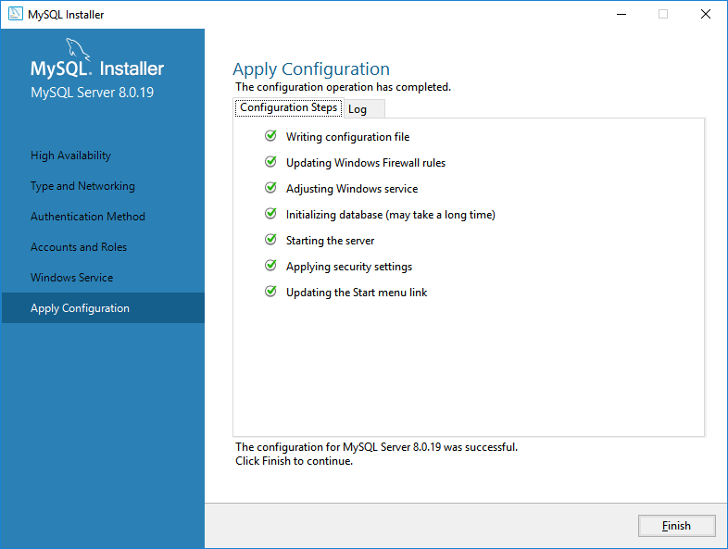
- At the product configuration page, click Next
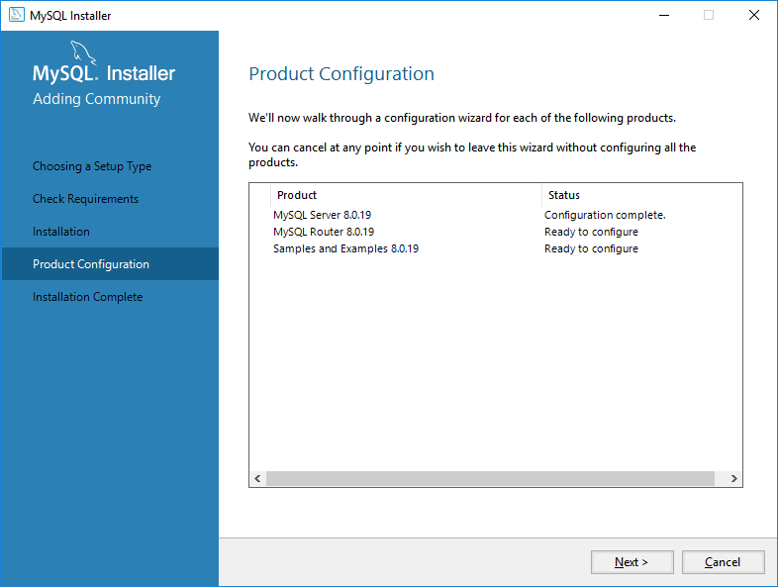
- Connect to the server and put in your password such as 123 and press check
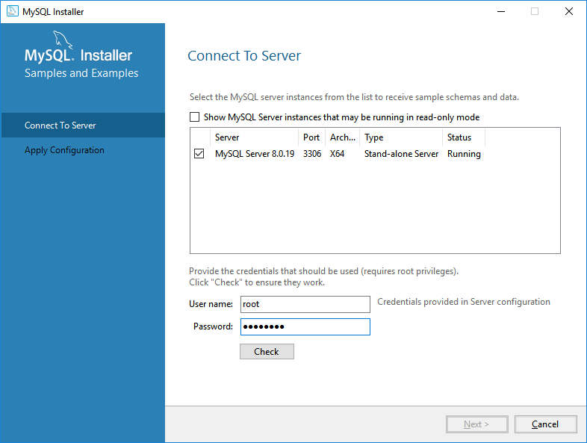
- After you press Check you should see a Connection Succeeded message
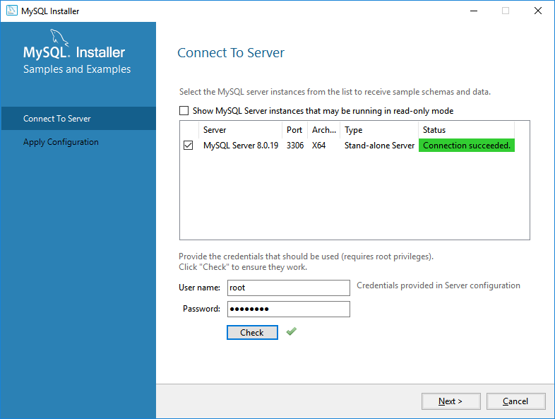
- Click Next. Then at the next screen click Execute
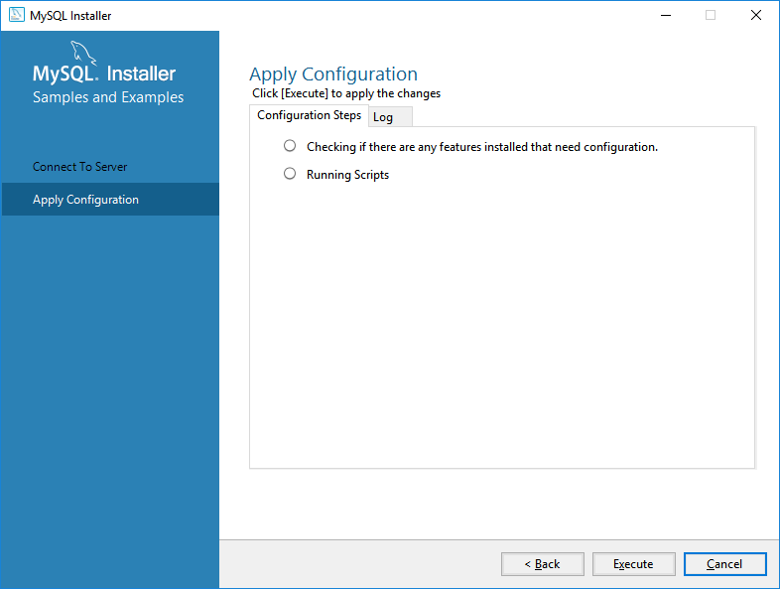
- Then click Finish
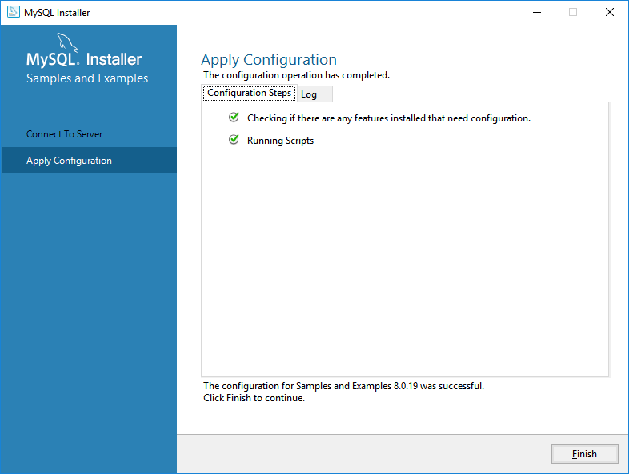
- Click Next at the next Product Configuration screen
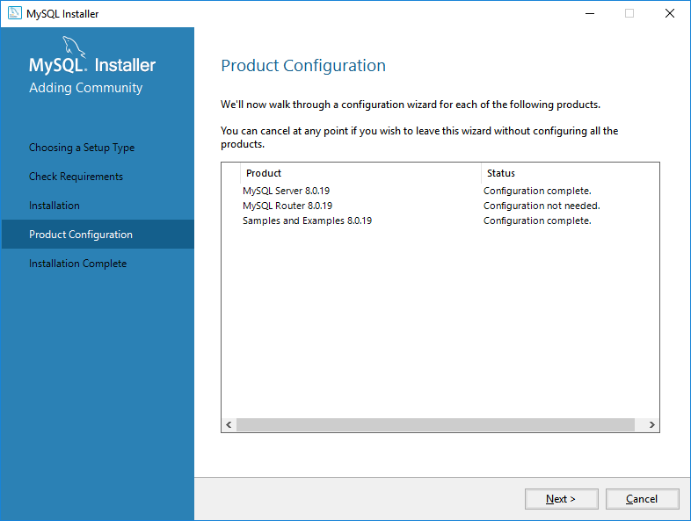
- Click Finish at the next screen
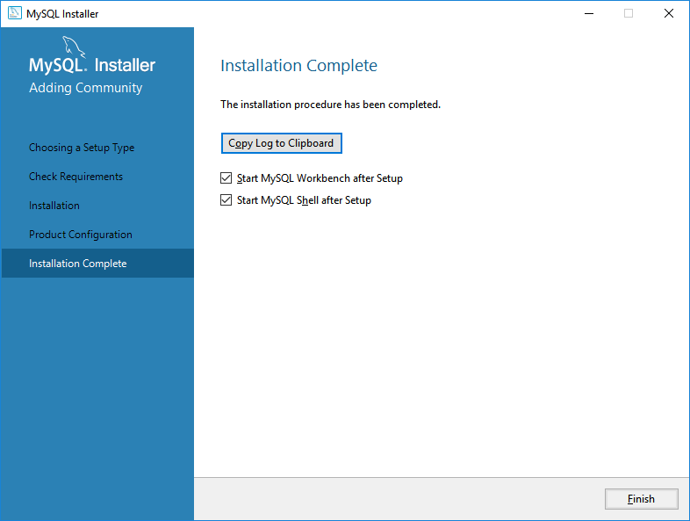
- This will open MySQL Workbench
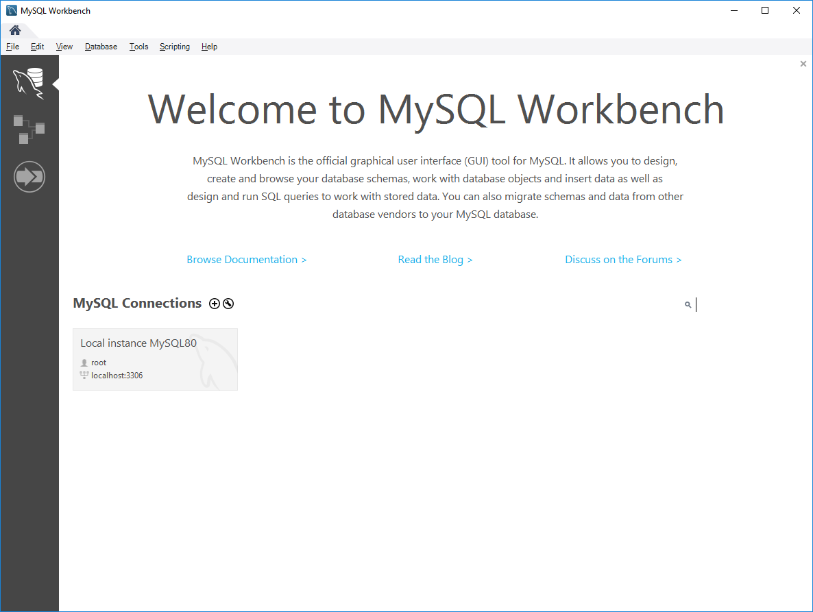
- Click on the Local Instance and type in your password (123)
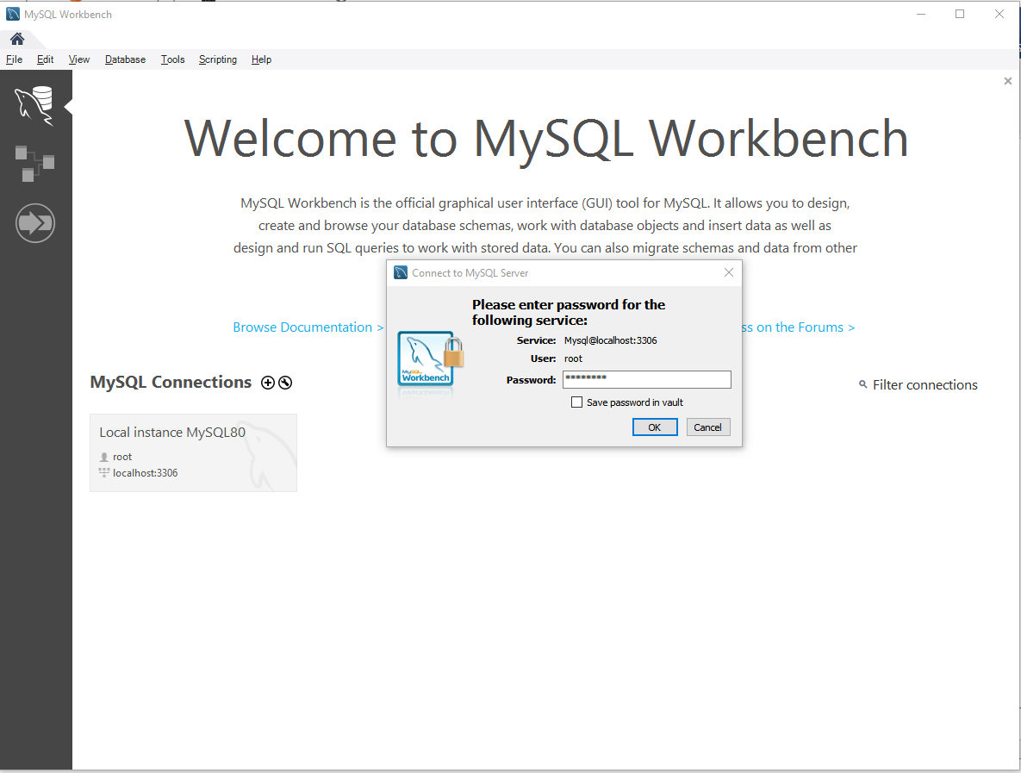
- Now you are ready to create databases! To create an example database, click On the New Schema (fourth icon) and create a database named mydb.
- 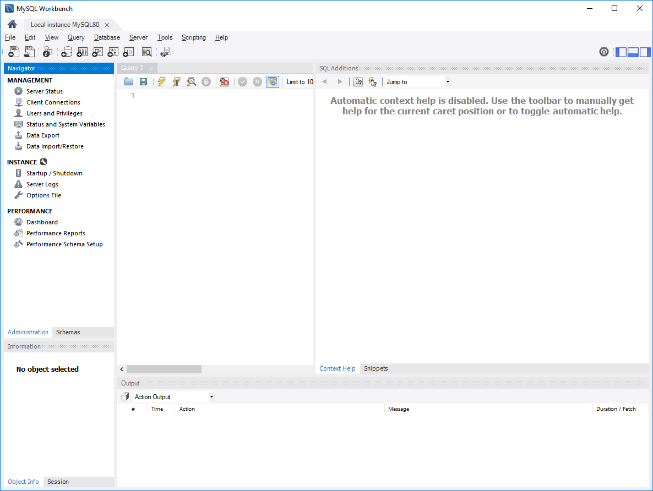
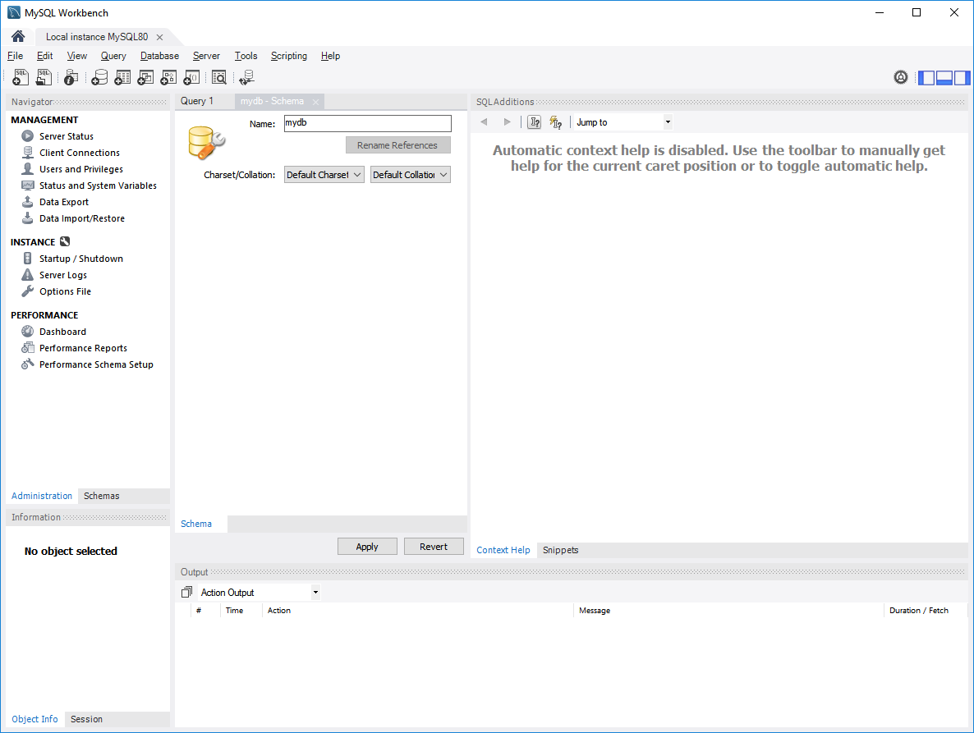
- Click Apply
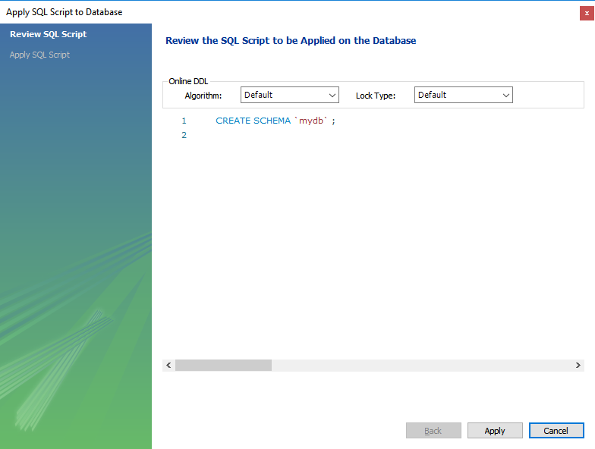
- Click on Schemas at the bottom of the pane and you should see mydb. Then click on the +SQL icon (first icon) to create an SQL script
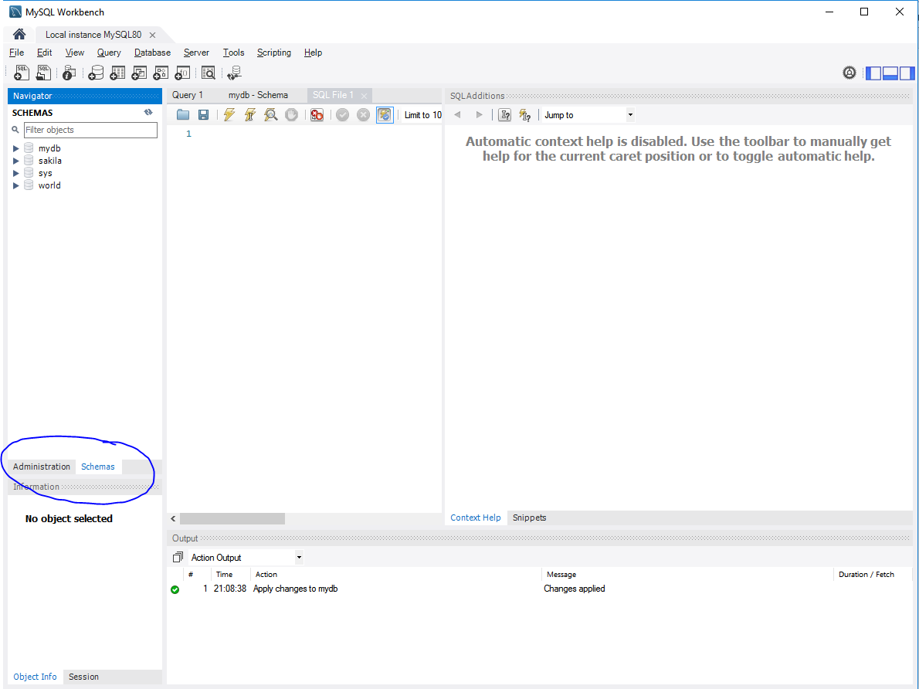
- Double click on mydb so that it is selected. It will be highlighted
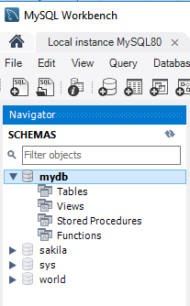
- Copy and paste the following code into the SQL script page
drop table if exists STUDENT;
create table STUDENT
(SNAME VARCHAR(6),
SNO CHAR(2) PRIMARY KEY);

insert into STUDENT values ('L Tree', 'S1');
insert into STUDENT values ('D Pond', 'S2');
insert into STUDENT values ('M Lake', 'S3');
insert into STUDENT values ('J Bond', 'S4');
insert into STUDENT values ('S Bark', 'S5');
insert into STUDENT values ('L Leaf', 'S6');

drop table if exists COURSE;
create table COURSE
(CNAME VARCHAR(6),
CNO CHAR(2) PRIMARY KEY);

insert into COURSE values ('Comp 1', 'C1');
insert into COURSE values ('Math 2', 'C2');
insert into COURSE values ('Phys 3', 'C3');
insert into COURSE values ('Comp 3', 'C4');

drop table if exists RESULT;
create table RESULT
(SNO CHAR(2),
CNO CHAR(2),
GRADE INTEGER,
PRIMARY KEY (SNO,CNO),
constraint stu_res_fk FOREIGN KEY(SNO) REFERENCES STUDENT(SNO),
constraint cou_res_fk FOREIGN KEY(CNO) REFERENCES COURSE(CNO));

insert into RESULT values ('S1', 'C1', 77);
insert into RESULT values ('S1', 'C2', 80);
insert into RESULT values ('S2', 'C2', 93);
insert into RESULT values ('S2', 'C3', 88);
insert into RESULT values ('S2', 'C4', 91);
insert into RESULT values ('S3', 'C2', 74);
insert into RESULT values ('S3', 'C3', 89);
insert into RESULT values ('S4', 'C2', 75);
insert into RESULT values ('S4', 'C3', 85);
insert into RESULT values ('S4', 'C4', 55);
insert into RESULT values ('S5', 'C1', 50);
insert into RESULT values ('S5', 'C4', 61);
insert into RESULT values ('S6', 'C2', 77);
insert into RESULT values ('S6', 'C3', 88);
insert into RESULT values ('S6', 'C4', 54);

- Click on the Lightning bolt
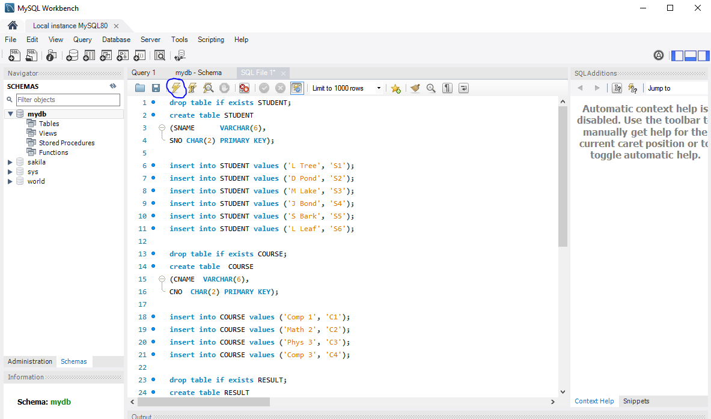
- You will see some warning messages but the code should run and insert records.
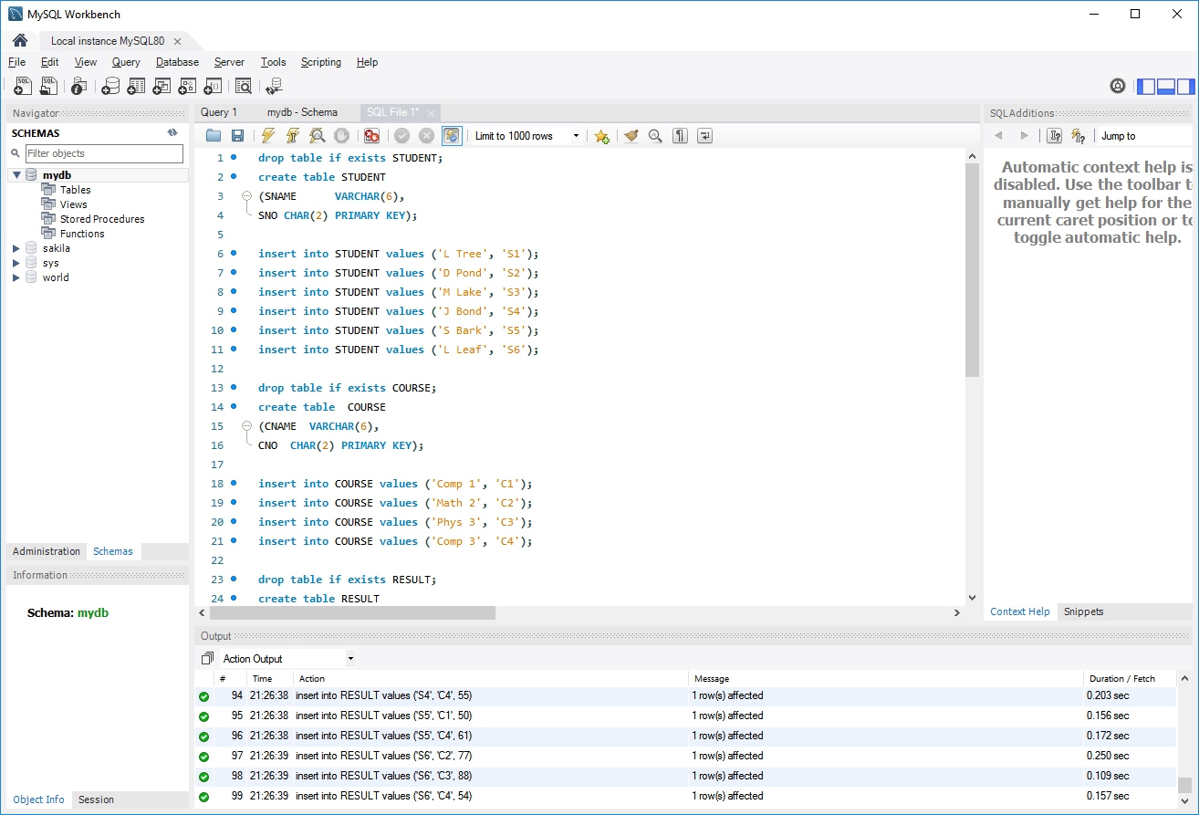
- Right click on Tables and choose Refresh all. Below the tables you should see the three tables you created
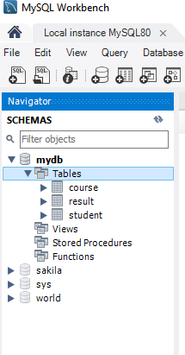
- Click the new SQL tab again and write queries against your database. For example, you can find the names of all students with grades above 75:
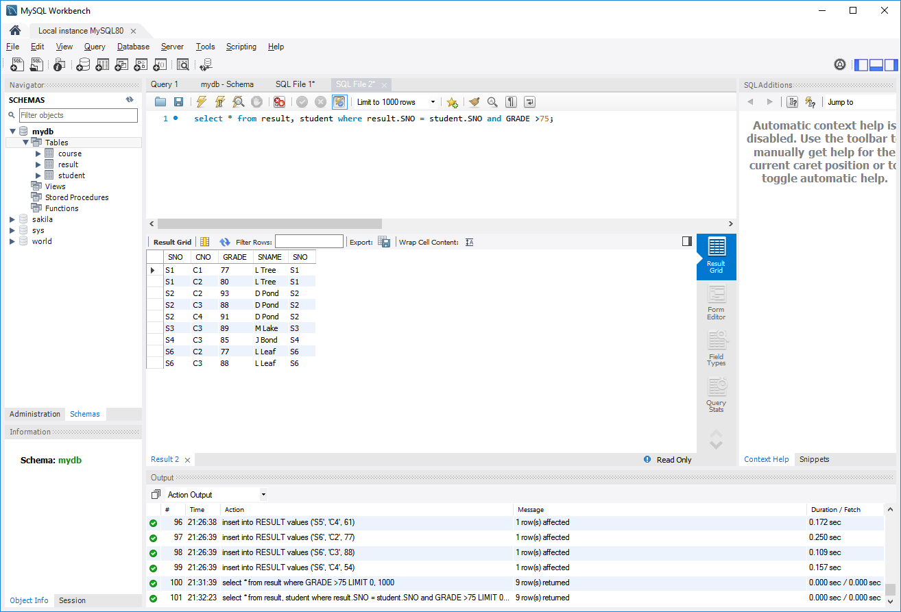
- Follow the same procedure to create new databases, tables and queries.

