Course Project

Course Number: CEIS236

Background

Modern daily life is almost inconceivable without databases. Online transactions, course catalogs, search engines, etc all use databases. We depend on databases for many aspects of our lives. It is important that these databases are designed and implemented correctly. With the increase of the Internet of Things and growth of online transactions database design, implementation, and management has many employment opportunities. This project walks through the process of design, development, and implementation of a relational database.
Scenario

Design a database system using ER diagrams and normalization. Create the database in a Relational Database Management System using SQL and create queries to retrieve data from the database.

Module 5: Inserts, Updates, and Multi-table Queries

Objectives
- To create a table
- Inserting records into a table
- Updating records in a table
- Creating multi-table queries

Steps

- Use the CEIS236courseproject database from Module 2. Please review the instructions on how to access the database. You do not need to re-run the table creation script, just be sure the database is selected.
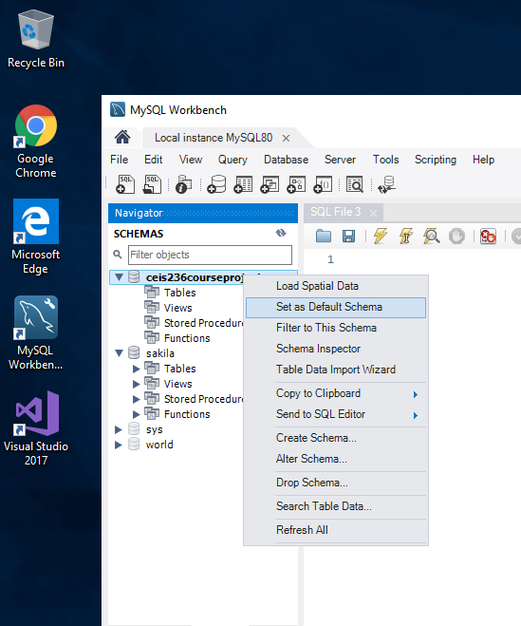

- Run the Following queries

Queries - The database ERD is below:
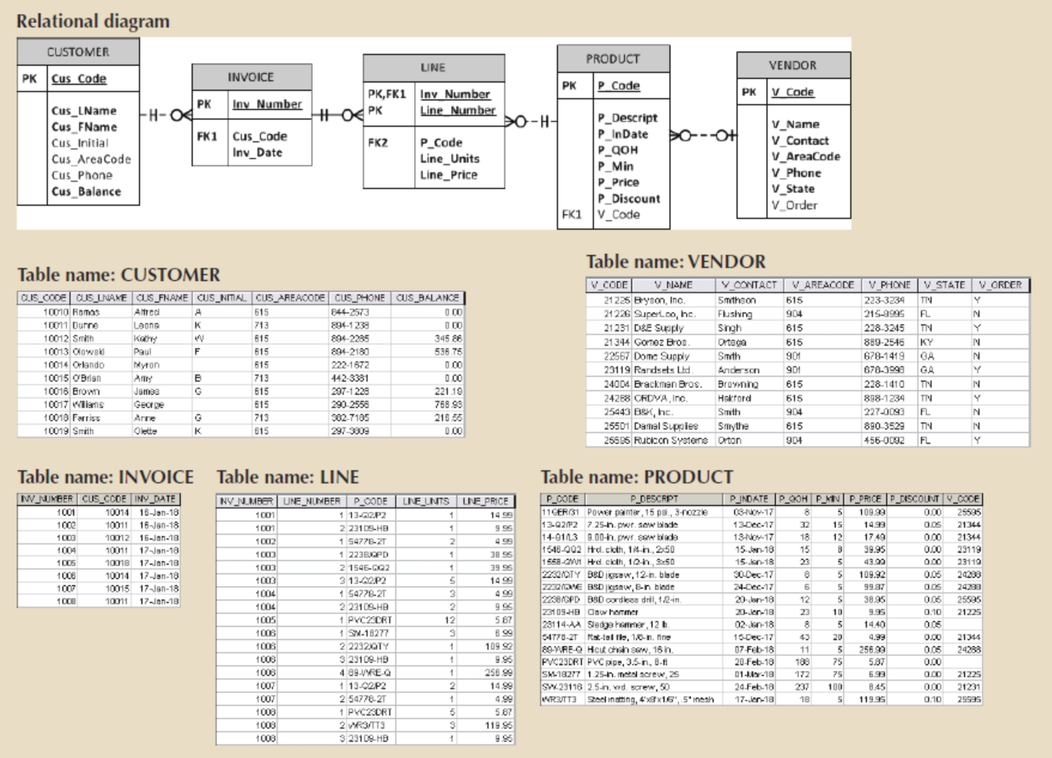

Problem 1
Write the SQL code that will create only the table structure for a table named EMPLOYEE. The basic table structure is summarized in the following table. Use EMP_NUM as the primary key. Your code should also prevent null entries in EMP_LNAME and EMP_FNAME.

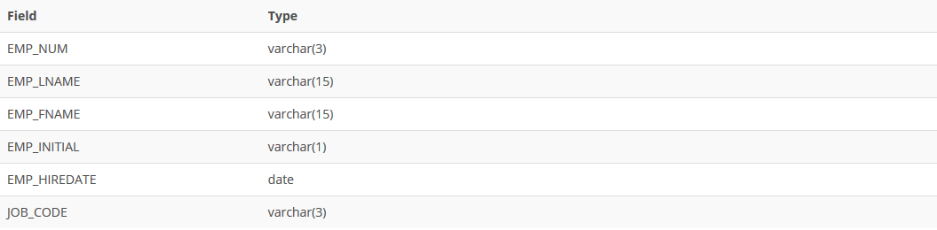

Problem 2
Having created the table structure in Problem 1, write the SQL code to enter the first five rows for the table shown in the following figure. Each row should be inserted individually, without using a subquery. Insert the rows in the order that they are listed in the figure. Take a screenshot of the code and data entered.
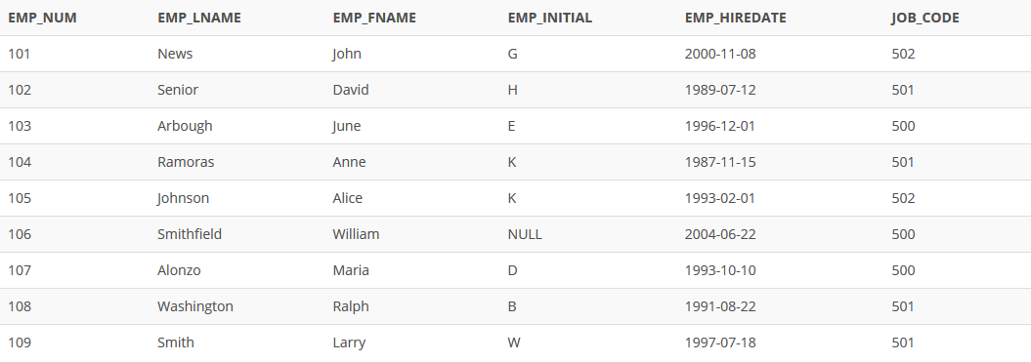

Problem 3
Write the SQL code to change the job code to 501 for the person whose employee number (EMP_NUM) is 103.

Problem 4
Write the SQL code to create a copy of EMPLOYEE, including all of its data, and naming the copy EMP_2.

Problem 5
Using the EMP_2 table, write the SQL code that will add the attributes EMP_PCT and PROJ_NUM to EMP_2. The EMP_PCT is the bonus percentage to be paid to each employee. The new attribute characteristics are:
EMP_PCT NUMBER(4,2)
PROJ_NUM CHAR(3)
Note: If your SQL implementation requires it, you may use DECIMAL(4,2)or NUMERIC(4,2) rather than NUMBER(4,2).

Problem 6
Using the EMP_2 table, write a single SQL command to change the EMP_PCT value to 5.00 for the people with employee numbers 101, 105, and 107 (hint: use the IN keyword).

Problem 7
Write the SQL code to join the PRODUCT and VENDOR tables using common attributes. Display the result sorted by price.

Problem 8
Write the SQL code to display the total inventory. Your query should retrieve the product code, description, and the calculated total inventory. This will be calculated by multiplying P_QOH by P_PRICE and rounded to two decimal places. The new field should be named TOTAL_INVENTORY. Sort by TOTAL_INVENTORY descending.

Problem 9
Write the SQL code to display the customer last name, first name, invoice date, and line price from CUSTOMER, INVOICE, LINE. Join all three tables and display only those values with a line price less than 10.

Problem 10

Write a query to count the number of customers with a balance of more than $500.

Deliverables
- Complete the Course Project Deliverable with screenshots

To submit your project, copy each query and take screen print of the each running output, pasting both into a single word document. Here is an example:

SELECT *
FROM EMPLOYEE
WHERE JOB_CODE > 500;

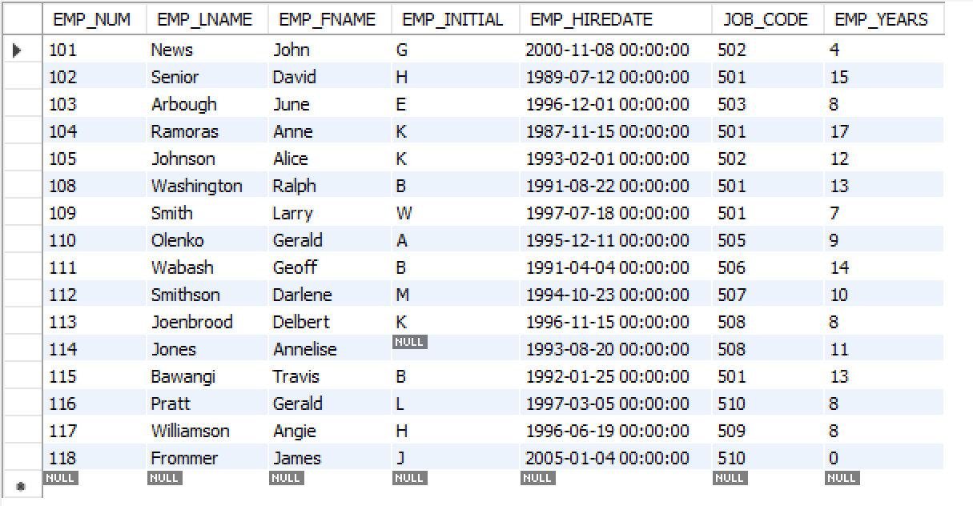

Refer to the grading rubric below to ensure you incorporate the essential elements into your project.

