Course Project

Course Number: CEIS236

Background

Modern daily life is almost inconceivable without databases. Online transactions, course catalogs, search engines, etc all use databases. We depend on databases for many aspects of our lives. It is important that these databases are designed and implemented correctly. With the increase of the Internet of Things and growth of online transactions database design, implementation, and management has many employment opportunities. This project walks through the process of design, development, and implementation of a relational database.
Scenario

Design a database system using ER diagrams and normalization. Create the database in a Relational Database Management System using SQL and create queries to retrieve data from the database.

Module 4: Normalization Concepts

Objectives
- To understand normalization concepts
- To understand entity integrity and referential integrity

Steps
PART I – Answer the questions below
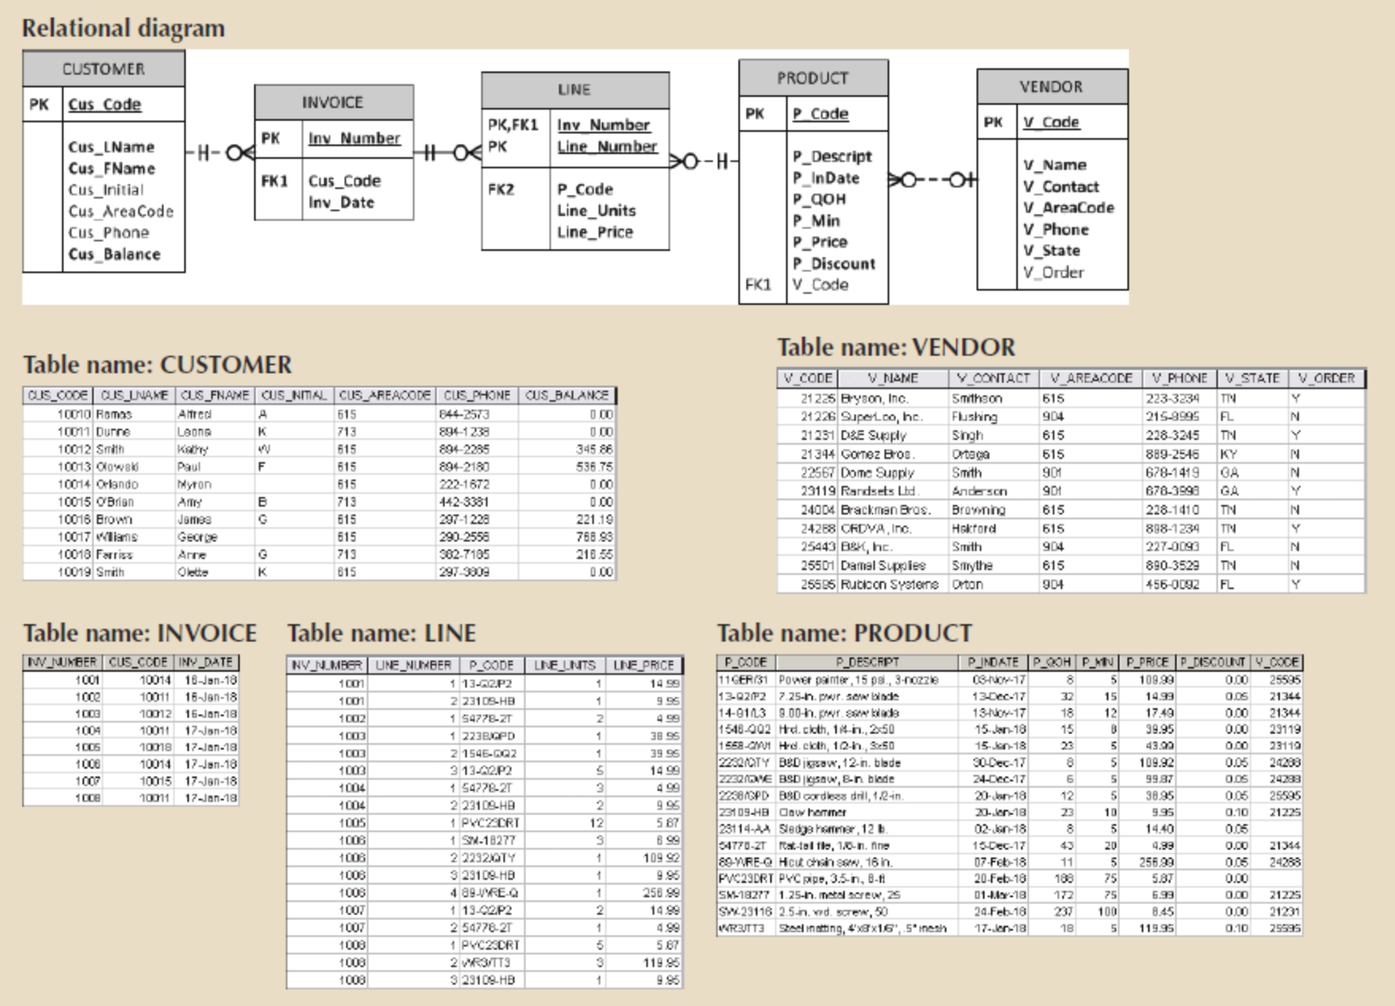

Question 1. For each table, identify the primary key and the foreign key(s). If a table does not have a foreign key, write None.
Question 2. Do the tables exhibit entity integrity? Answer yes or no, and then explain your answer.
Question 3. Do the tables exhibit referential integrity? Answer yes or no, and then explain your answer. Write NA (Not Applicable) if the table does not have a foreign key.
Question 4. Describe the type(s) of relationship(s) between CUSTOMER and INVOICE.
Question 5. Describe the type(s) of relationship(s) between PRODUCT, LINE and INVOICE.
Question 6. Create the ERD to show the relationships among PRODUCT, LINE, and INVOICE.

PART II – Create ERD based on the following scenario

Given the following business scenario, create a Crow’s Foot ERD

The local city youth league needs a database system to help track children that sign up to play soccer. Data needs to be kept on each team and the children that will be playing on each team and their parents. The team has an ID, name, and colors. Data stored for each player consists of the id, first name, last name, and age. Also, data needs to be kept on the coaches for each team. Each player can only play on one team but a team may have many players. A team may also have many coaches but a coach has only one team. A parent can have many parents and a parent can have many players.

PART III - Using the descriptions of the attributes given in the following figure, convert the ERD into a dependency diagram that is in at least 3NF.

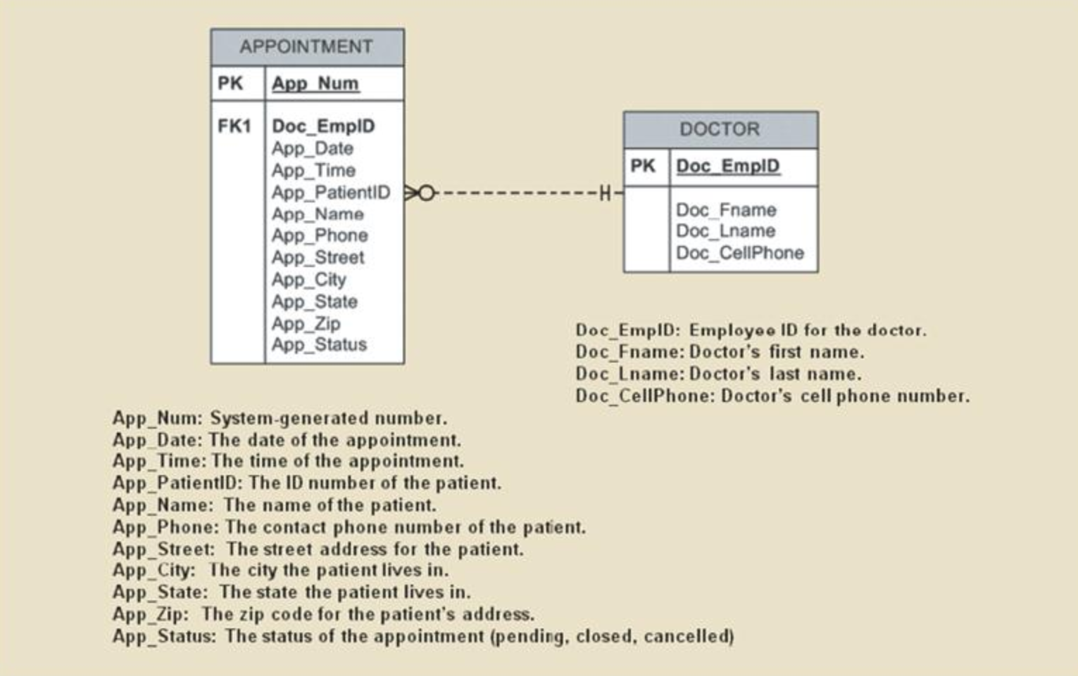

Deliverables
- Complete the Course Project Deliverable
CEIS236 Final Project Rubric

