Course Project

Course Number: CEIS236

Background

Modern daily life is almost inconceivable without databases. Online transactions, course catalogs, search engines, etc all use databases. We depend on databases for many aspects of our lives. It is important that these databases are designed and implemented correctly. With the increase of the Internet of Things and growth of online transactions database design, implementation, and management has many employment opportunities. This project walks through the process of design, development, and implementation of a relational database.
Scenario

Design a database system using ER diagrams and normalization. Create the database in a Relational Database Management System using SQL and create queries to retrieve data from the database.

Module 3: Creating a Database and Single Table Queries

Objectives
- To connect to a DBMS and create a database
- Run a script to create tables
- Run basic queries

Steps
Part 1: Preparation (has to be done before you start working on your query)
You can choose to download the MySQL Workbench on your own machine or use the Virtual Machine. Your instructor will give you instructions on accessing the VM.
- Open MySQLWorkbench. Please note – the instructions below are based on using the VM.

Click this icon

- Close the welcome screen. Double click on the local instance.
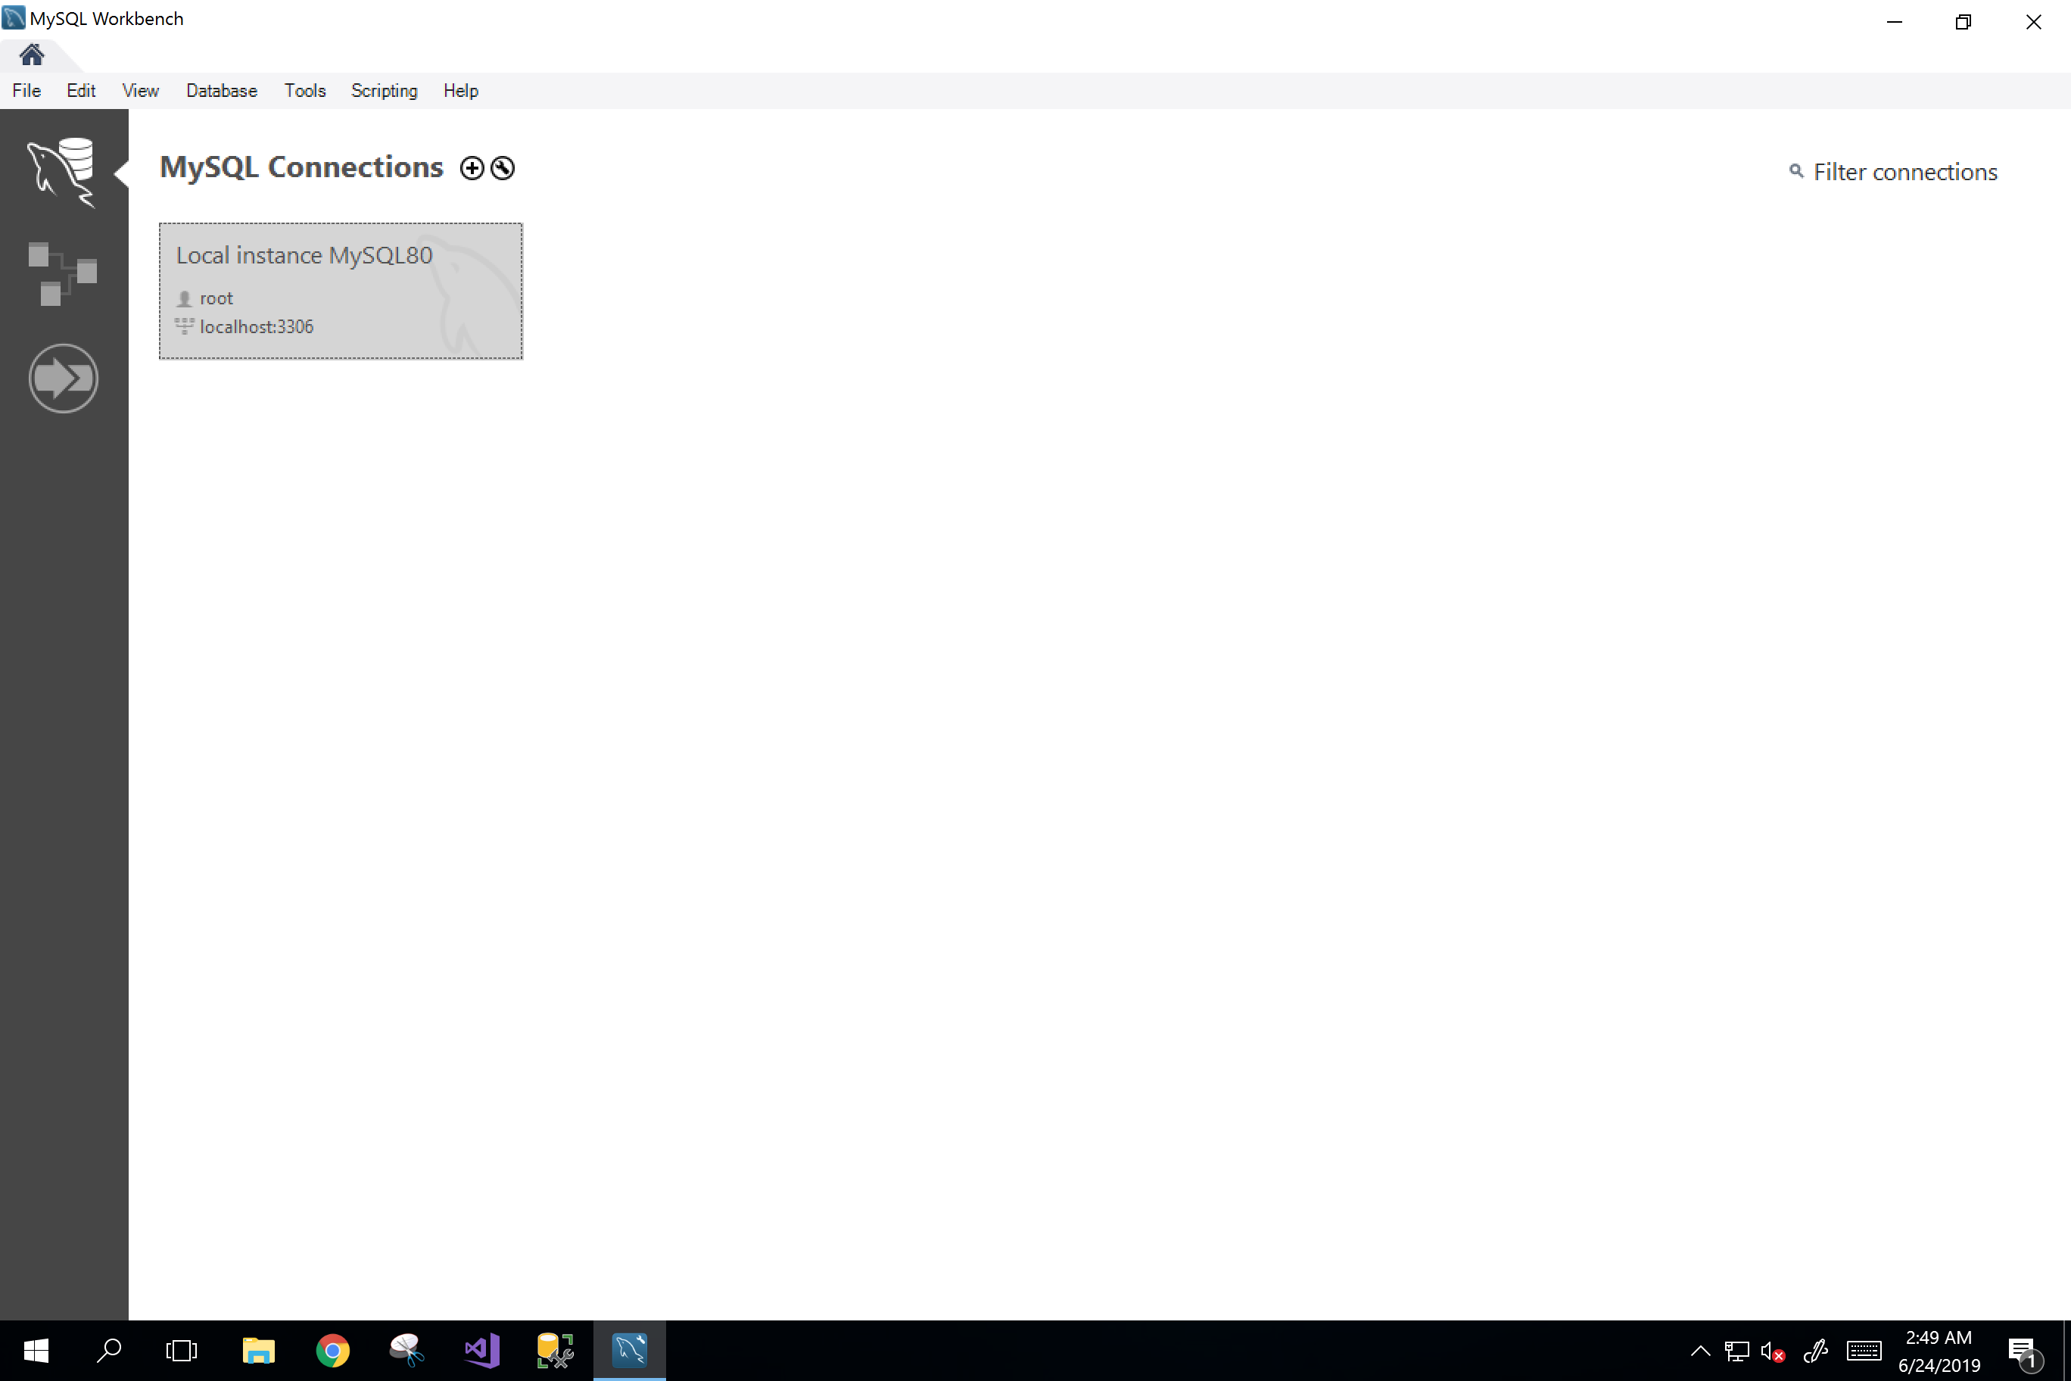
Click this
- Enter password – 123

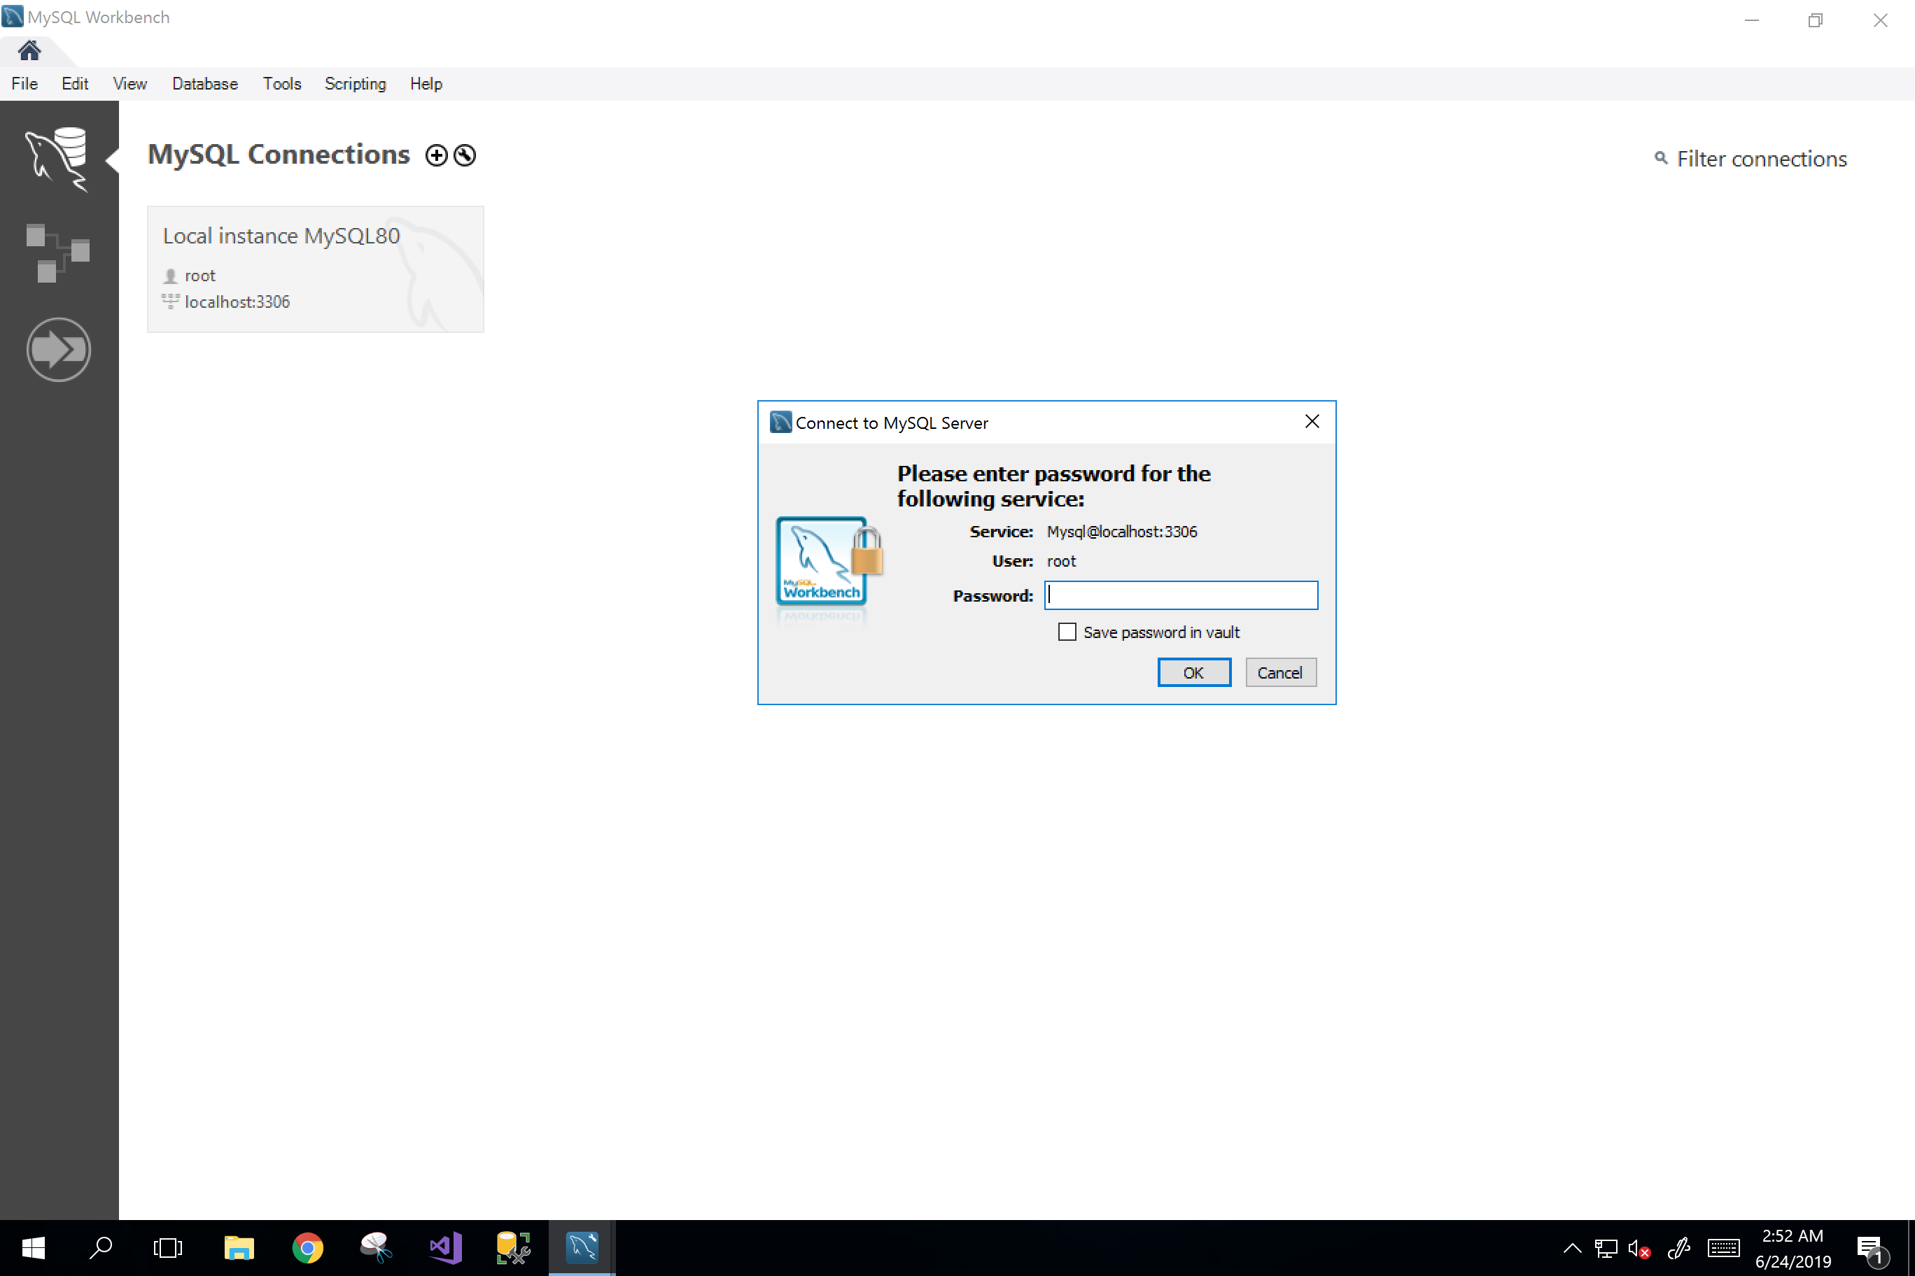

123
- You are now inside your SQL editor and is ready to create a new SQL schema (database). Click on the fourth icon to create a new schema.

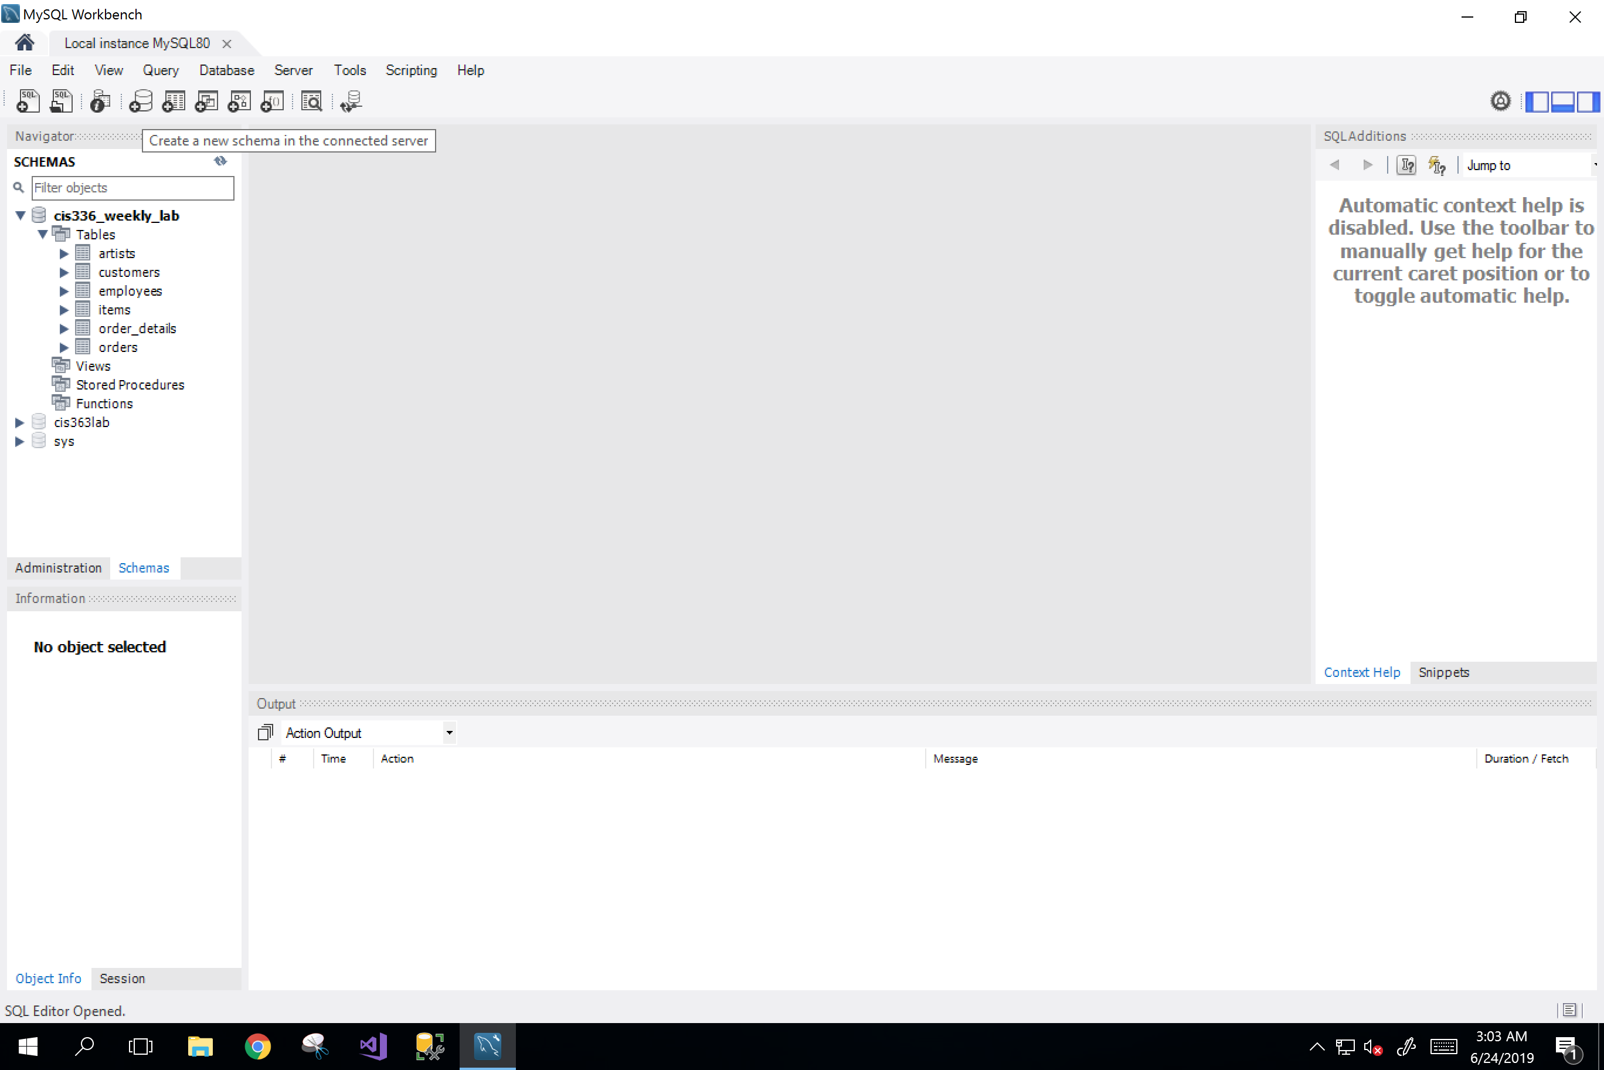
Click the fourth icon to create a new schema
- When the window pops out, give it a name “ceis236courseproject”, then click Apply.

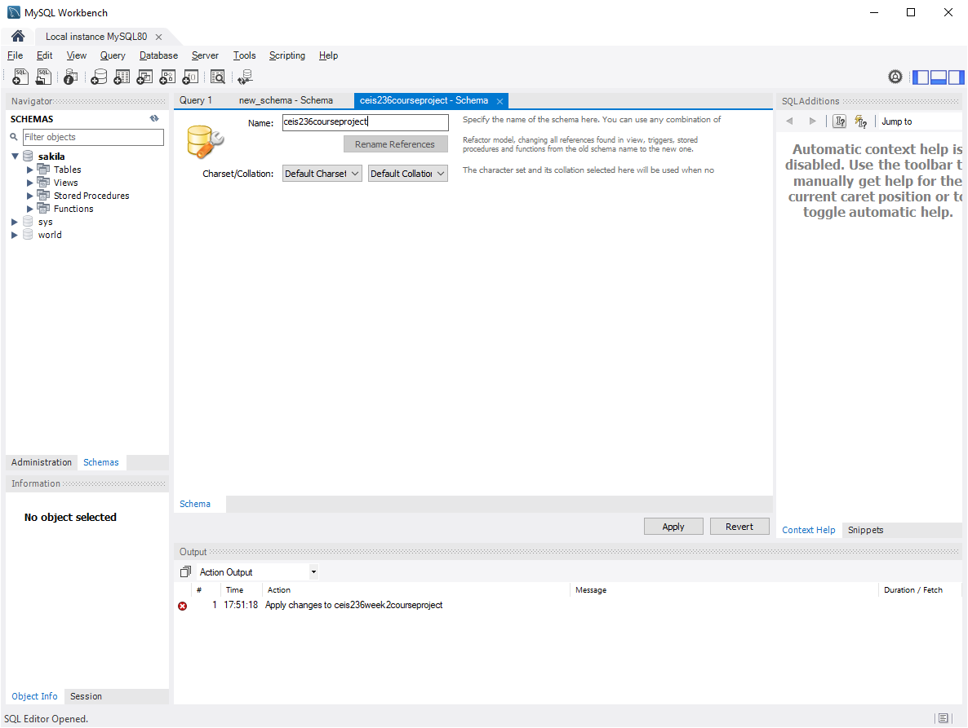
Name your schema here
- On the next review SQL script window, click Apply again.

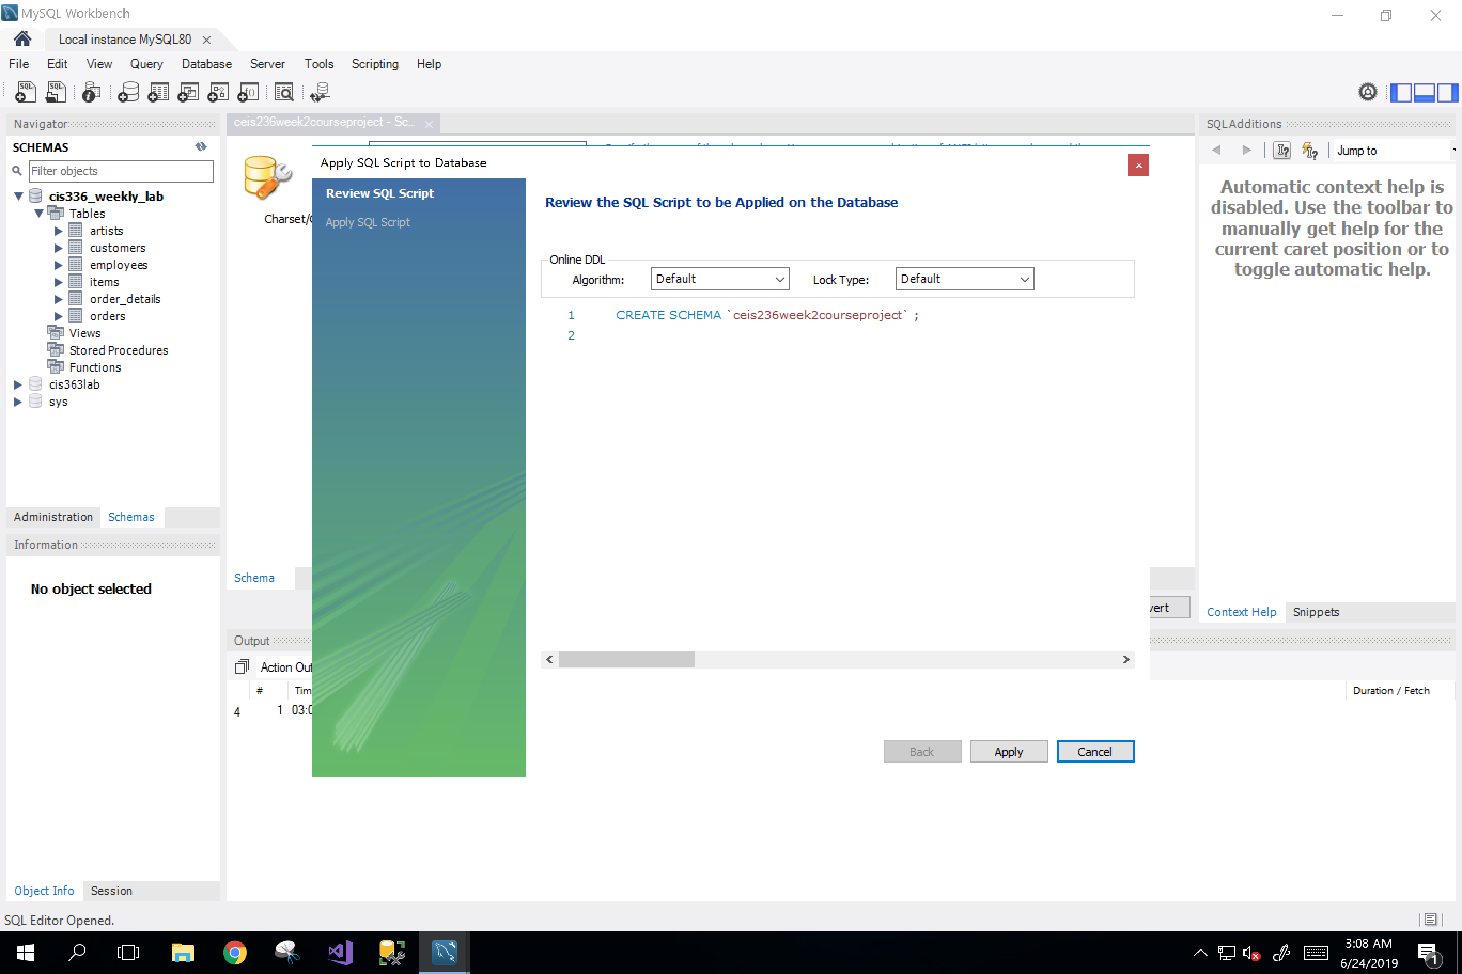
Click
- On the next applying page, click Finish.

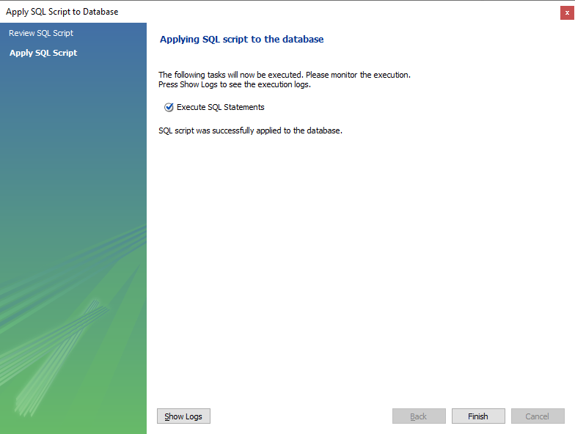

- On your navigator window, you can now see your newly created schema.

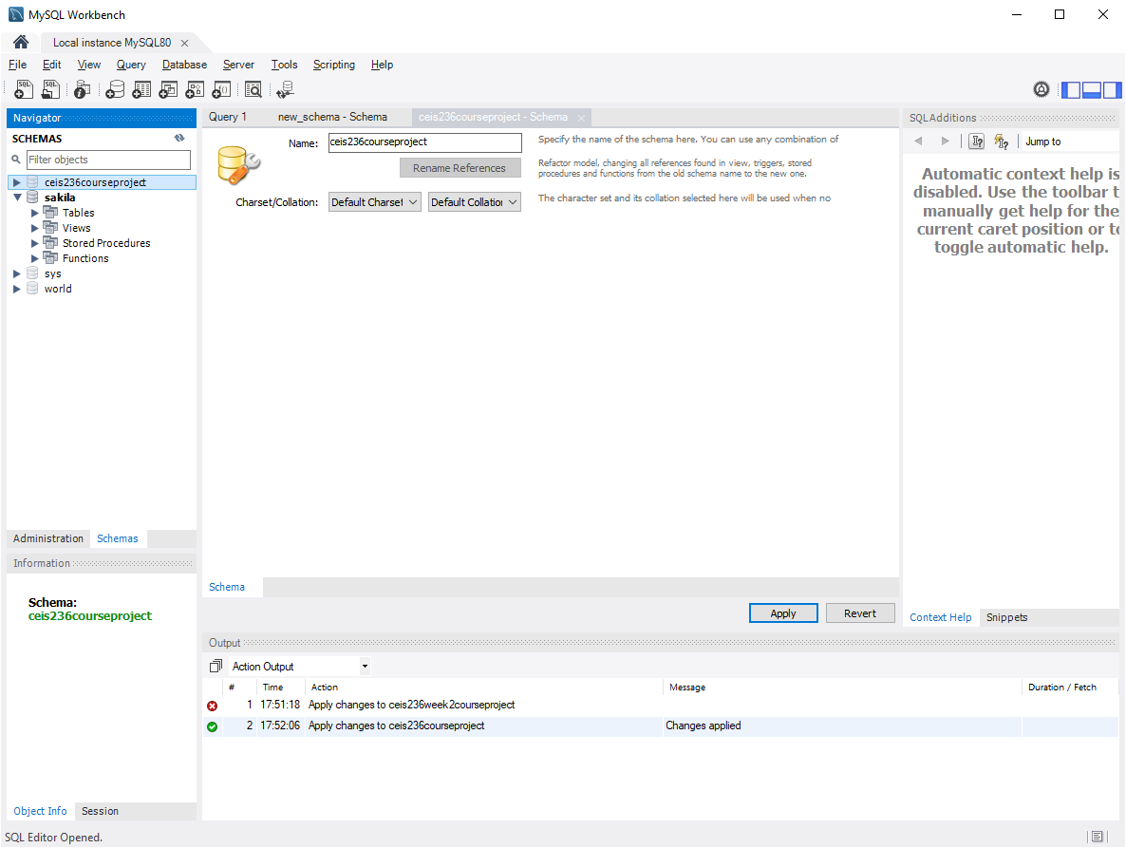
Verify that your schema is created

- Double click on your newly created schema to be sure it is highlighted

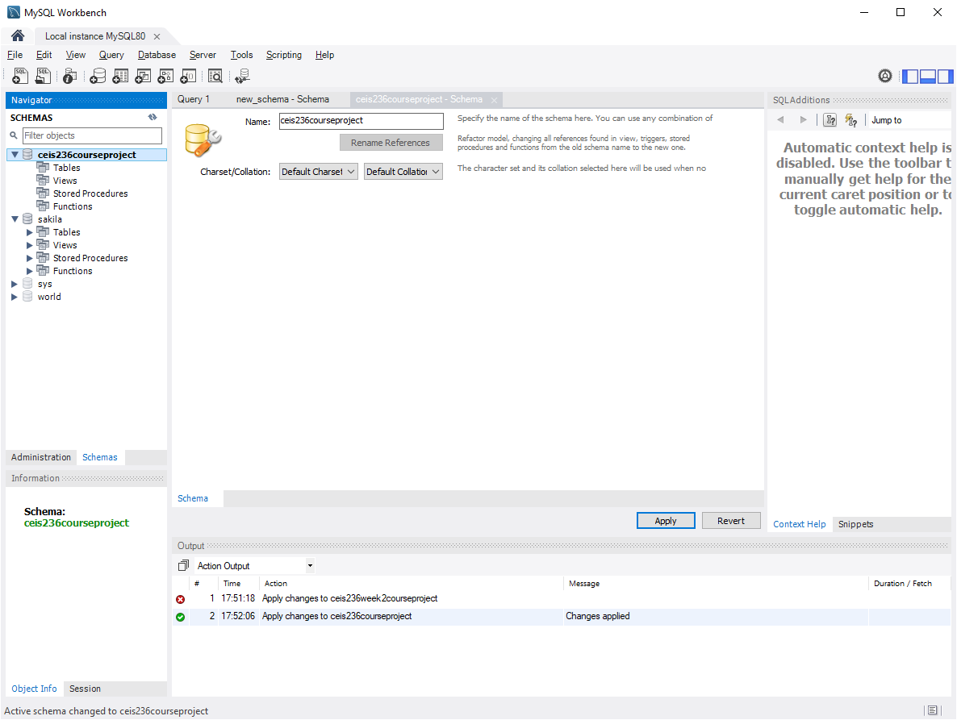

- Click the first icon to create a new SQL tab for executing queries.

Click
- Now we have the SQL editor ready for executing queries. Let‘s make sure we are working under the default schema. Right click the schema to set it as default schema.
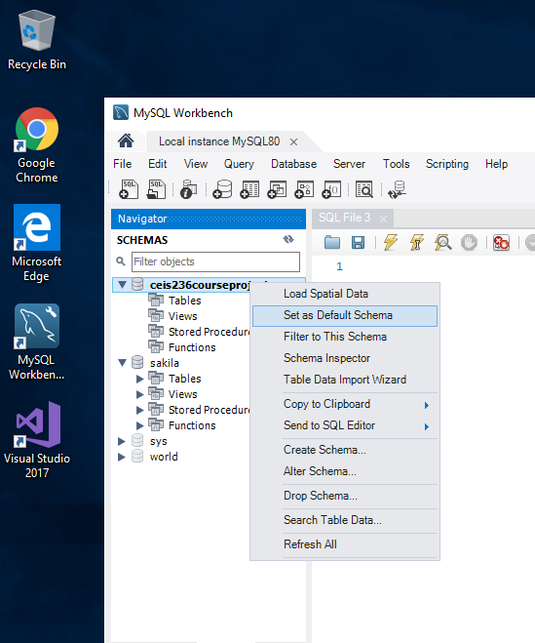

- Copy and paste the following queries into the SQL editor window.

/* This script file creates the following tables: */
/* VENDOR, PRODUCT, CUSTOMER, INVOICE, LINE */
/* and loads the default data rows */

BEGIN;

DROP TABLE IF EXISTS LINE ;
DROP TABLE IF EXISTS INVOICE;
DROP TABLE IF EXISTS CUSTOMER;
DROP TABLE IF EXISTS PRODUCT;
DROP TABLE IF EXISTS VENDOR;
DROP TABLE IF EXISTS EMPLOYEE;
DROP TABLE IF EXISTS EMP;

CREATE TABLE VENDOR (
V_CODE INTEGER,
V_NAME VARCHAR(35) NOT NULL,
V_CONTACT VARCHAR(15) NOT NULL,
V_AREACODE CHAR(3) NOT NULL,
V_PHONE CHAR(8) NOT NULL,
V_STATE CHAR(2) NOT NULL,
V_ORDER CHAR(1) NOT NULL,
PRIMARY KEY (V_CODE));

CREATE TABLE PRODUCT (
P_CODE VARCHAR(10) PRIMARY KEY,
P_DESCRIPT VARCHAR(35) NOT NULL,
P_INDATE DATETIME NOT NULL,
P_QOH INTEGER NOT NULL,
P_MIN INTEGER NOT NULL,
P_PRICE NUMERIC(8,2) NOT NULL,
P_DISCOUNT NUMERIC(4,2) NOT NULL,
V_CODE INTEGER,
CONSTRAINT PRODUCT_V_CODE_FK FOREIGN KEY (V_CODE) REFERENCES VENDOR (V_CODE));

CREATE TABLE CUSTOMER (
CUS_CODE INTEGER PRIMARY KEY,
CUS_LNAME VARCHAR(15) NOT NULL,
CUS_FNAME VARCHAR(15) NOT NULL,
CUS_INITIAL CHAR(1),
CUS_AREACODE CHAR(3),
CUS_PHONE CHAR(8) NOT NULL,
CUS_BALANCE NUMERIC(9,2) DEFAULT 0.00,
CONSTRAINT CUS_UI1 UNIQUE(CUS_LNAME,CUS_FNAME, CUS_PHONE));

CREATE TABLE INVOICE (
INV_NUMBER INTEGER PRIMARY KEY,
CUS_CODE INTEGER NOT NULL,
INV_DATE DATETIME NOT NULL,
CONSTRAINT INVOICE_CUS_CODE_FK FOREIGN KEY (CUS_CODE) REFERENCES CUSTOMER(CUS_CODE));

CREATE TABLE LINE (
INV_NUMBER INTEGER NOT NULL,
LINE_NUMBER NUMERIC(2,0) NOT NULL,
P_CODE VARCHAR(10) NOT NULL,
LINE_UNITS NUMERIC(9,2) DEFAULT 0.00 NOT NULL,
LINE_PRICE NUMERIC(9,2) DEFAULT 0.00 NOT NULL,
PRIMARY KEY (INV_NUMBER,LINE_NUMBER),
FOREIGN KEY (INV_NUMBER) REFERENCES INVOICE (INV_NUMBER) ON DELETE CASCADE,
FOREIGN KEY (P_CODE) REFERENCES PRODUCT(P_CODE),
CONSTRAINT LINE_UI1 UNIQUE(INV_NUMBER, P_CODE));

/* Loading data rows */

/* VENDOR rows */
INSERT INTO VENDOR VALUES(21225,'Bryson, Inc.' ,'Smithson','615','223-3234','TN','Y');
INSERT INTO VENDOR VALUES(21226,'SuperLoo, Inc.' ,'Flushing','904','215-8995','FL','N');
INSERT INTO VENDOR VALUES(21231,'D&E Supply' ,'Singh' ,'615','228-3245','TN','Y');
INSERT INTO VENDOR VALUES(21344,'Gomez Bros.' ,'Ortega' ,'615','889-2546','KY','N');
INSERT INTO VENDOR VALUES(22567,'Dome Supply' ,'Smith' ,'901','678-1419','GA','N');
INSERT INTO VENDOR VALUES(23119,'Randsets Ltd.' ,'Anderson','901','678-3998','GA','Y');
INSERT INTO VENDOR VALUES(24004,'Brackman Bros.' ,'Browning','615','228-1410','TN','N');
INSERT INTO VENDOR VALUES(24288,'ORDVA, Inc.' ,'Hakford' ,'615','898-1234','TN','Y');
INSERT INTO VENDOR VALUES(25443,'B&K, Inc.' ,'Smith' ,'904','227-0093','FL','N');
INSERT INTO VENDOR VALUES(25501,'Damal Supplies' ,'Smythe' ,'615','890-3529','TN','N');
INSERT INTO VENDOR VALUES(25595,'Rubicon Systems' ,'Orton' ,'904','456-0092','FL','Y');

/* PRODUCT rows */
INSERT INTO PRODUCT VALUES('11QER/31','Power painter, 15 psi., 3-nozzle' ,'2017-11-03', 8, 5,109.99,0.00,25595);
INSERT INTO PRODUCT VALUES('13-Q2/P2','7.25-in. pwr. saw blade' ,'2017-12-13', 32, 15, 14.99,0.05,21344);
INSERT INTO PRODUCT VALUES('14-Q1/L3','9.00-in. pwr. saw blade' ,'2017-11-13', 18, 12, 17.49,0.00,21344);
INSERT INTO PRODUCT VALUES('1546-QQ2','Hrd. cloth, 1/4-in., 2x50' ,'2018-01-15', 15, 8, 39.95,0.00,23119);
INSERT INTO PRODUCT VALUES('1558-QW1','Hrd. cloth, 1/2-in., 3x50' ,'2018-01-15', 23, 5, 43.99,0.00,23119);
INSERT INTO PRODUCT VALUES('2232/QTY','B&D jigsaw, 12-in. blade' ,'2017-12-30', 8, 5,109.92,0.05,24288);
INSERT INTO PRODUCT VALUES('2232/QWE','B&D jigsaw, 8-in. blade' ,'2017-12-24', 6, 5, 99.87,0.05,24288);
INSERT INTO PRODUCT VALUES('2238/QPD','B&D cordless drill, 1/2-in.' ,'2018-01-20', 12, 5, 38.95,0.05,25595);
INSERT INTO PRODUCT VALUES('23109-HB','Claw hammer' ,'2018-01-20', 23, 10, 9.95,0.10,21225);
INSERT INTO PRODUCT VALUES('23114-AA','Sledge hammer, 12 lb.' ,'2018-01-02', 8, 5, 14.40,0.05,NULL);
INSERT INTO PRODUCT VALUES('54778-2T','Rat-tail file, 1/8-in. fine' ,'2017-12-15', 43, 20, 4.99,0.00,21344);
INSERT INTO PRODUCT VALUES('89-WRE-Q','Hicut chain saw, 16 in.' ,'2018-02-07', 11, 5,256.99,0.05,24288);
INSERT INTO PRODUCT VALUES('PVC23DRT','PVC pipe, 3.5-in., 8-ft' ,'2018-02-20',188, 75, 5.87,0.00,NULL);
INSERT INTO PRODUCT VALUES('SM-18277','1.25-in. metal screw, 25' ,'2018-03-01',172, 75, 6.99,0.00,21225);
INSERT INTO PRODUCT VALUES('SW-23116','2.5-in. wd. screw, 50' ,'2018-02-24',237,100, 8.45,0.00,21231);
INSERT INTO PRODUCT VALUES('WR3/TT3' ,'Steel matting, 4''x8''x1/6", .5" mesh','2018-01-17', 18, 5,119.95,0.10,25595);

/* CUSTOMER rows */
INSERT INTO CUSTOMER VALUES(10010,'Ramas' ,'Alfred','A' ,'615','844-2573',0);
INSERT INTO CUSTOMER VALUES(10011,'Dunne' ,'Leona' ,'K' ,'713','894-1238',0);
INSERT INTO CUSTOMER VALUES(10012,'Smith' ,'Kathy' ,'W' ,'615','894-2285',345.86);
INSERT INTO CUSTOMER VALUES(10013,'Olowski' ,'Paul' ,'F' ,'615','894-2180',536.75);
INSERT INTO CUSTOMER VALUES(10014,'Orlando' ,'Myron' ,NULL,'615','222-1672',0);
INSERT INTO CUSTOMER VALUES(10015,'O''Brian','Amy' ,'B' ,'713','442-3381',0);
INSERT INTO CUSTOMER VALUES(10016,'Brown' ,'James' ,'G' ,'615','297-1228',221.19);
INSERT INTO CUSTOMER VALUES(10017,'Williams','George',NULL,'615','290-2556',768.93);
INSERT INTO CUSTOMER VALUES(10018,'Farriss' ,'Anne' ,'G' ,'713','382-7185',216.55);
INSERT INTO CUSTOMER VALUES(10019,'Smith' ,'Olette','K' ,'615','297-3809',0);

/* INVOICE rows */
INSERT INTO INVOICE VALUES(1001,10014,'2018-01-16');
INSERT INTO INVOICE VALUES(1002,10011,'2018-01-16');
INSERT INTO INVOICE VALUES(1003,10012,'2018-01-16');
INSERT INTO INVOICE VALUES(1004,10011,'2018-01-17');
INSERT INTO INVOICE VALUES(1005,10018,'2018-01-17');
INSERT INTO INVOICE VALUES(1006,10014,'2018-01-17');
INSERT INTO INVOICE VALUES(1007,10015,'2018-01-17');
INSERT INTO INVOICE VALUES(1008,10011,'2018-01-17');

/* LINE rows */
INSERT INTO LINE VALUES(1001,1,'13-Q2/P2',1,14.99);
INSERT INTO LINE VALUES(1001,2,'23109-HB',1,9.95);
INSERT INTO LINE VALUES(1002,1,'54778-2T',2,4.99);
INSERT INTO LINE VALUES(1003,1,'2238/QPD',1,38.95);
INSERT INTO LINE VALUES(1003,2,'1546-QQ2',1,39.95);
INSERT INTO LINE VALUES(1003,3,'13-Q2/P2',5,14.99);
INSERT INTO LINE VALUES(1004,1,'54778-2T',3,4.99);
INSERT INTO LINE VALUES(1004,2,'23109-HB',2,9.95);
INSERT INTO LINE VALUES(1005,1,'PVC23DRT',12,5.87);
INSERT INTO LINE VALUES(1006,1,'SM-18277',3,6.99);
INSERT INTO LINE VALUES(1006,2,'2232/QTY',1,109.92);
INSERT INTO LINE VALUES(1006,3,'23109-HB',1,9.95);
INSERT INTO LINE VALUES(1006,4,'89-WRE-Q',1,256.99);
INSERT INTO LINE VALUES(1007,1,'13-Q2/P2',2,14.99);
INSERT INTO LINE VALUES(1007,2,'54778-2T',1,4.99);
INSERT INTO LINE VALUES(1008,1,'PVC23DRT',5,5.87);
INSERT INTO LINE VALUES(1008,2,'WR3/TT3',3,119.95);
INSERT INTO LINE VALUES(1008,3,'23109-HB',1,9.95);

COMMIT;

- Execute the script by clicking the symbol 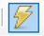

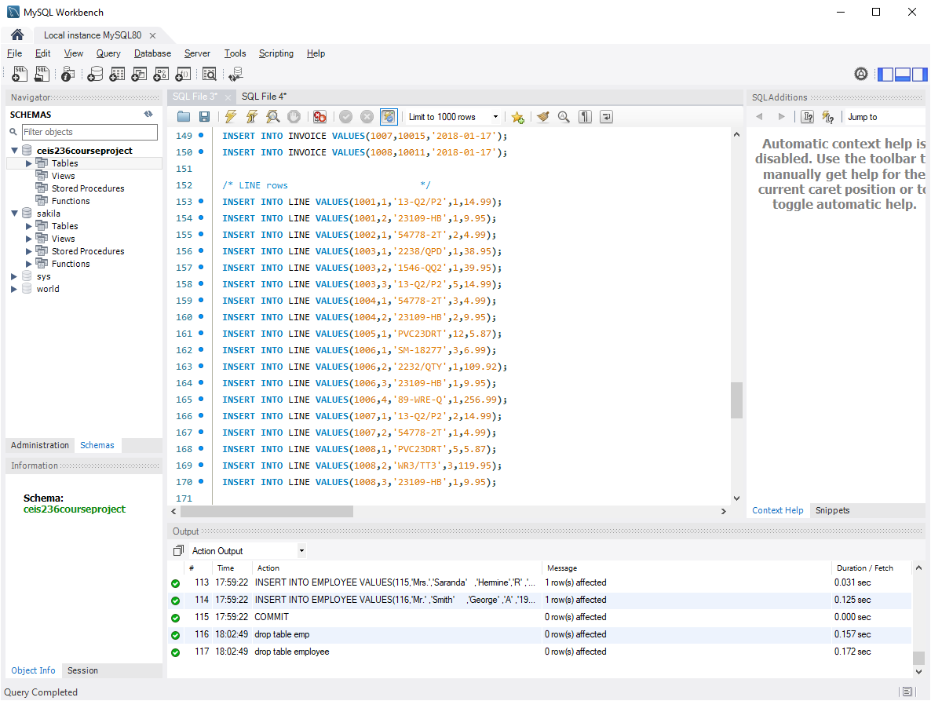
Click

- Now you will have a database with five populated tables. Right click on the tables icon and click Refresh all to see all of the tables listed.

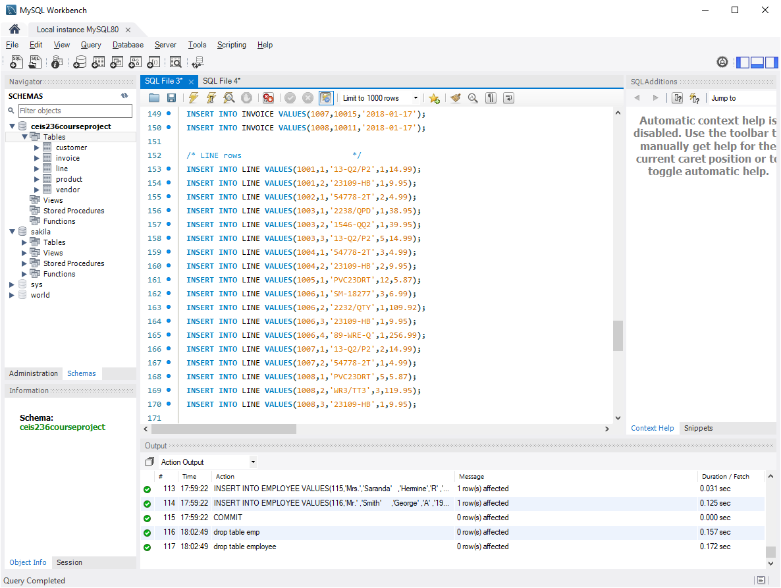

- Now open a new SQL editor and write select * statement to verify all table contents.
select * from customer;
select * from invoice;
select * from line;
select * from product;
select * from vendor;

Take screen print of each fully populated tables need to be submitted as part of project deliverables.

- Highlight each select statement and execute the query to get familiar with each table.
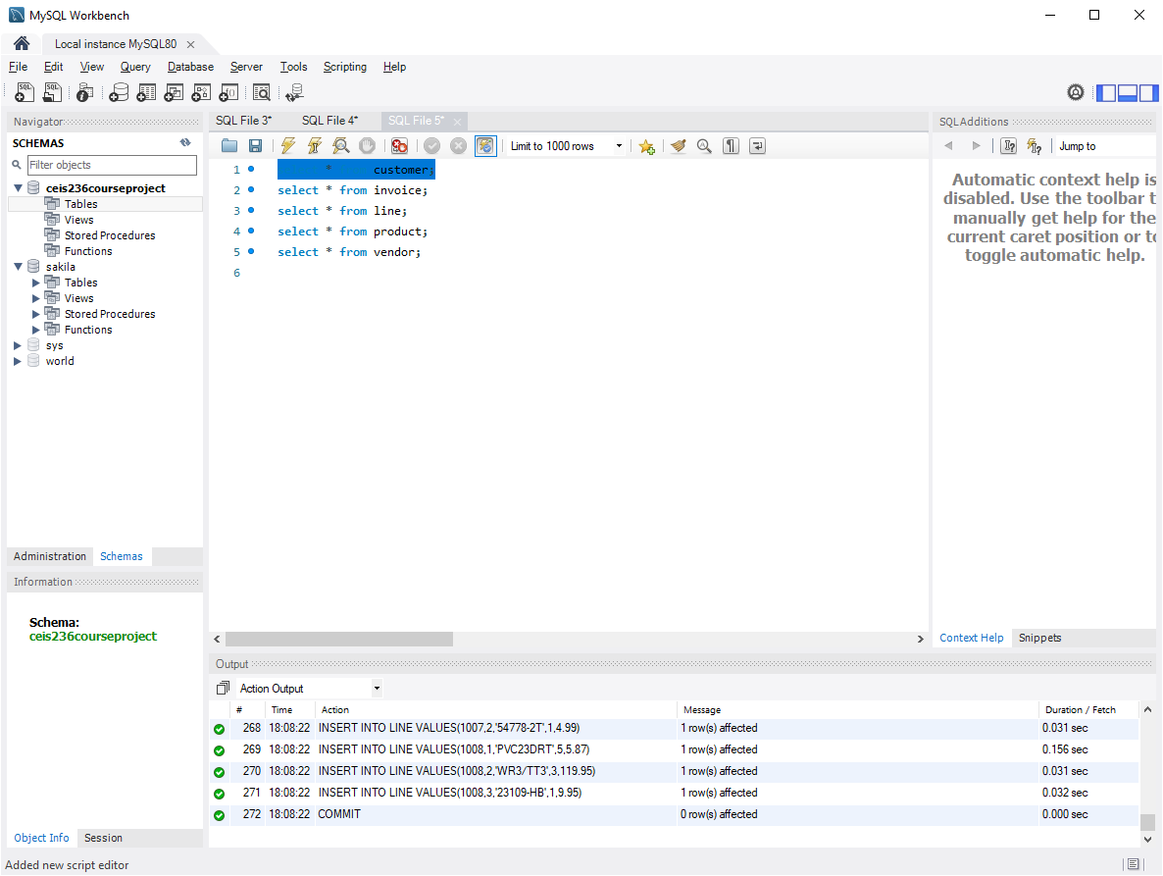
Highlight and then execute the query one by one

- You will see the resulting grid from your query. Take a screenshot of the query and resulting grid. It should look like this for the first query. Do this for all 5 queries:
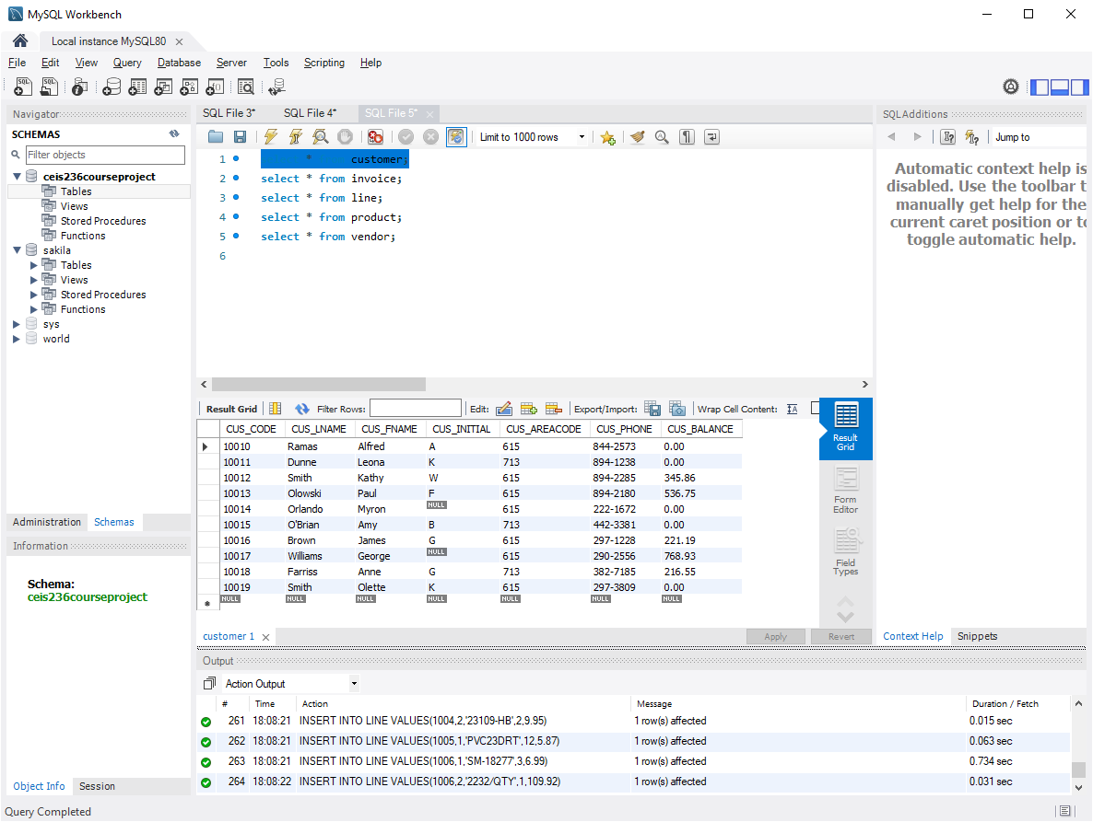

Part 2: Queries - The database ERD is below:
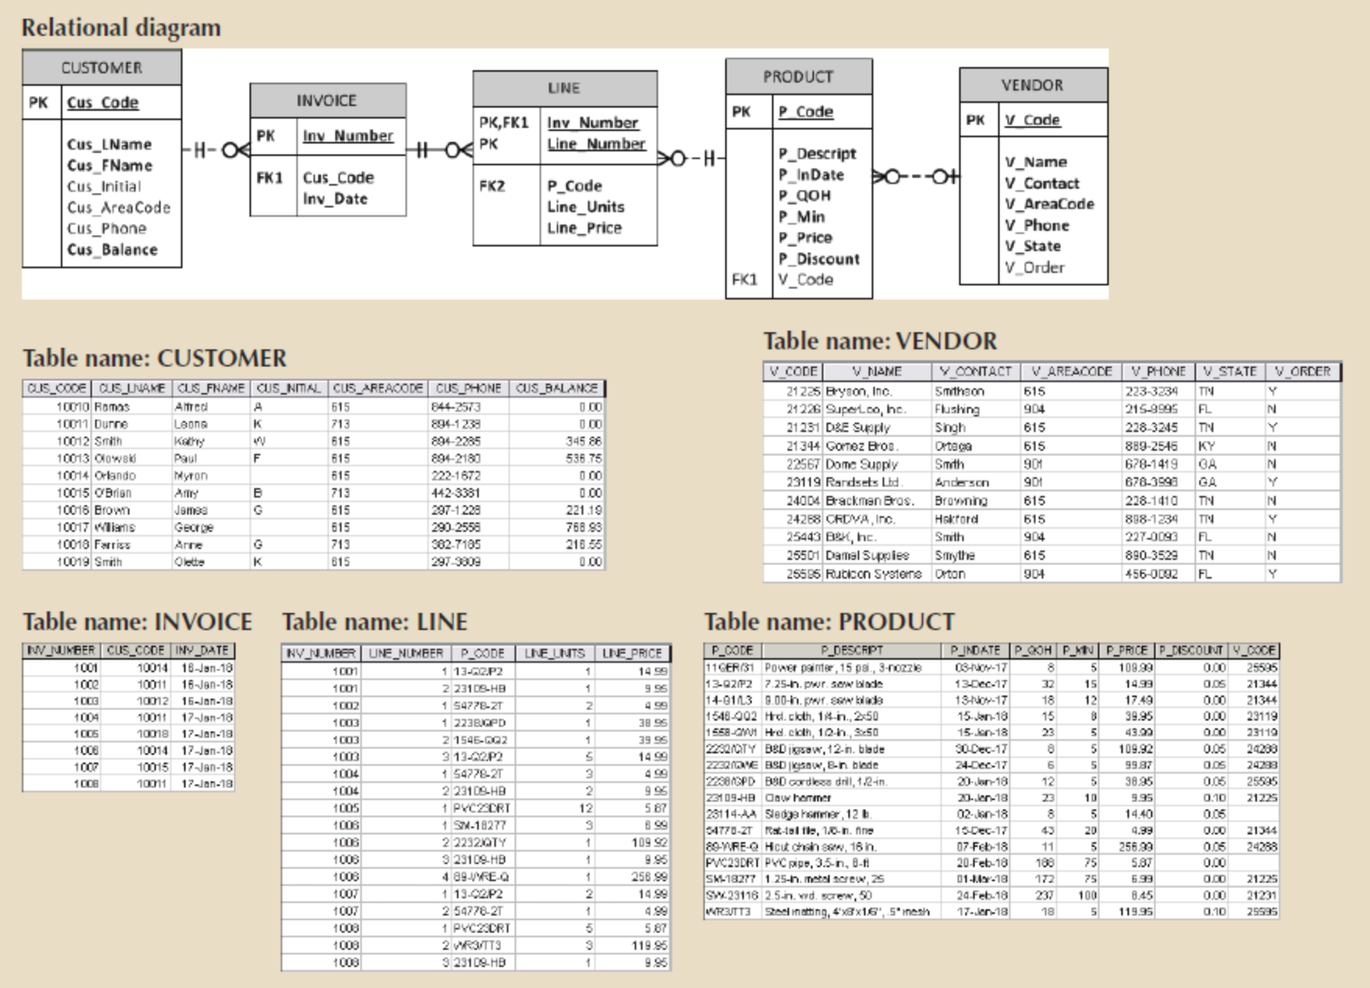
- Complete the following queries:

Problem 1: Write the SQL code required to list the product code, description, and price from the product table. Take a screenshot of your results
Problem 2: Modify the query above to only show those products that cost more than 20. Take a screenshot of your results.
Problem 3: Modify the query above to show the results with price descending. Take a screenshot of your results.
Problem 4: Modify the query above to show products that cost more than 20 and less than 100. Take a screenshot of your results.
Problem 5: Write the SQL code required to list the first name and last name of all customers whose middle initial is G. Take a screenshot of your results (hint – you should get two names)
Problem 6: Write the SQL code required to list the code, first name, last name, and balance of all customers whose last names begin with O. Take a screenshot of your results (hint: you should get 3 names)
Problem 7: Write the SQL code to list only distinct p_codes from the line table

Deliverables
- Complete the Course Project Deliverable with screenshots

To submit your project, copy each query and take screen print of the each running output, pasting both into a single word document. Here is an example:

SELECT *
FROM EMPLOYEE
WHERE JOB_CODE > 500;

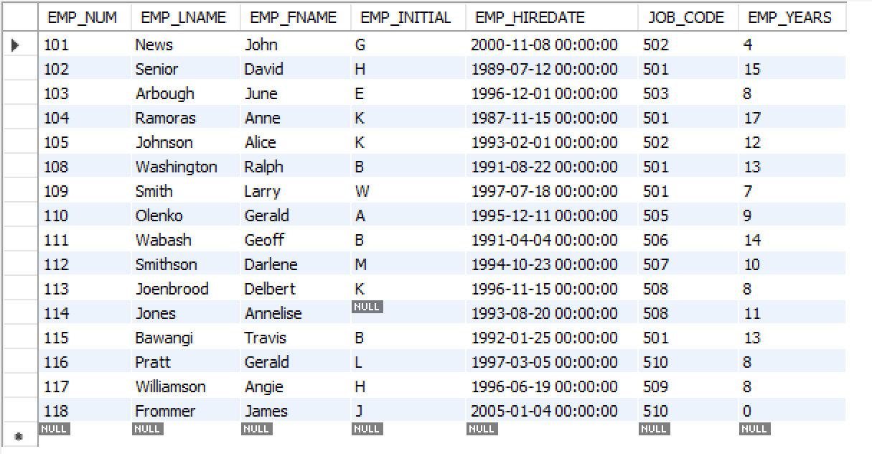

Refer to the grading rubric below to ensure you incorporate the essential elements into your project.

