Course Project

Course Number: CEIS236

Background

Modern daily life is almost inconceivable without databases. Online transactions, course catalogs, search engines, etc all use databases. We depend on databases for many aspects of our lives. It is important that these databases are designed and implemented correctly. With the increase of the Internet of Things and growth of online transactions database design, implementation, and management has many employment opportunities. This project walks through the process of design, development, and implementation of a relational database.
Scenario

Design a database system using ER diagrams and normalization. Create the database in a Relational Database Management System using SQL and create queries to retrieve data from the database.

Module 2: Conceptual Database Design

Objectives
- To understand and develop business rules
- Create ERD
- Create UML class diagrams

Steps
- PART I: Write the business rule(s) that govern the relationship between AGENT and CUSTOMER.
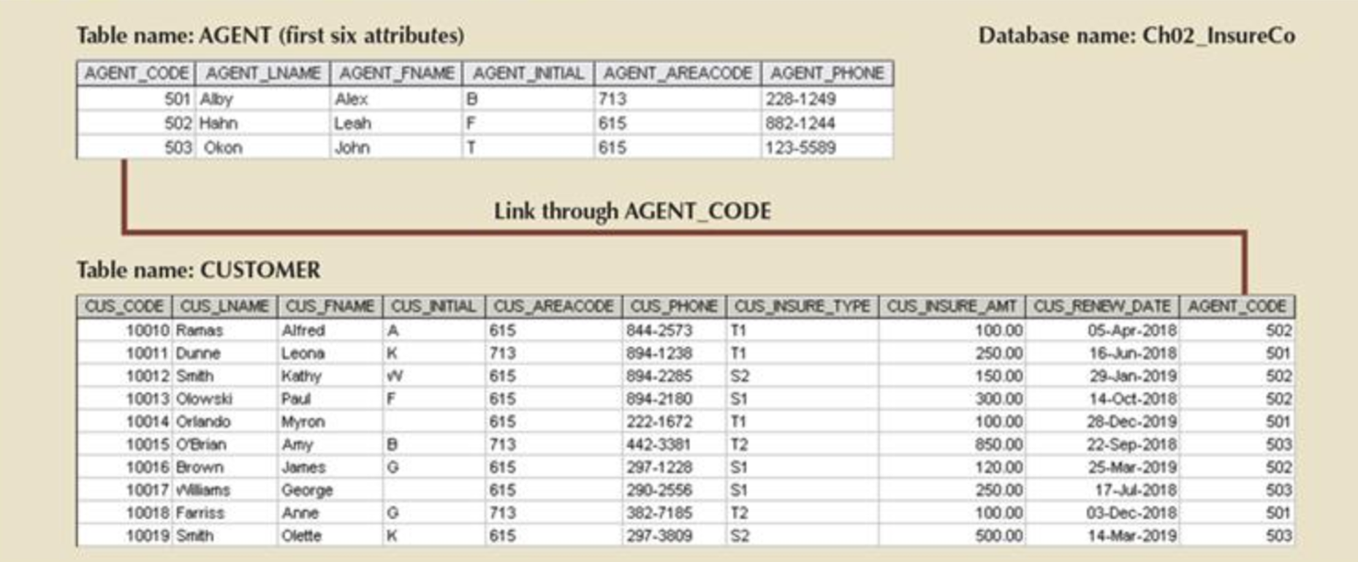

PART II: Given the business rule(s) you wrote in Part 1, create the basic Crow's Foot ERD using Microsoft Visio.

PART III: Using the ERD you drew in Part 2, create the equivalent object representation and UML class diagram. (Use the following figure as your guide.)

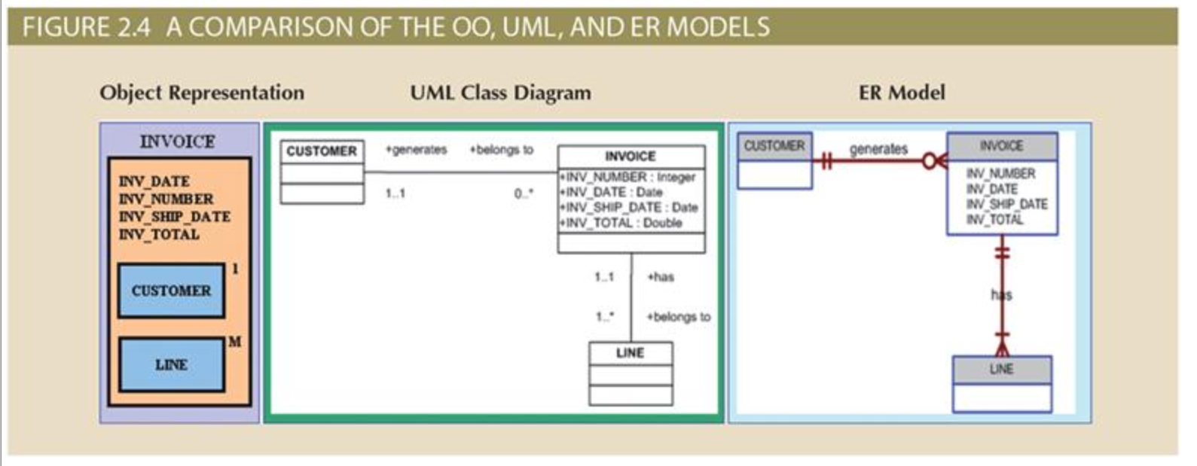

Deliverables
- Complete the Course Project Deliverable

