Course Project - Final Project Component- Option 2
College of Engineering and Information Sciences
Course Number: CEIS114

Part 6: Multiple Traffic Light Controller with Cross Walk and an Emergency Buzzer with a SMART Sensor

Objectives
- To design a traffic light that continuously active in one direction of the major street and always red traffic light on the minor street with less traffic.
- To integrate a motion detector that will activate the minor street traffic light when there is motion (cars) detected.
- Add a push button to activate the cross walk.
- Add a push button to activate the Emergency Signal.

PARTS LIST
- PC running Arduino IDE
- ESP 32 Board
- Two sets of Colored LEDs: Red, Yellow and Green
- One Blue LED
- LCD Unit
- Buzzer
- Push Buttons – 2
- Motion Detector
- Wires
- Breadboard

Deliverables
- Complete the Course Project PowerPoint Deliverable
- Include a picture of your circuit
- Screenshot of Arduino IDE output from your computer
- Screenshot of output in Serial Monitor from your computer

PROCEDURE
Step 1: Motion Detector Interface with the ESP32 or any 3.3V Microcontroller

To operate the motion detector using a 3.3V supply use the following connections:
- Connect the V3.3 power supply rail from the ESP32 to the pin shown in Figure 1
(as Connect 3.3V )
- Connect GND to Breadboard GND
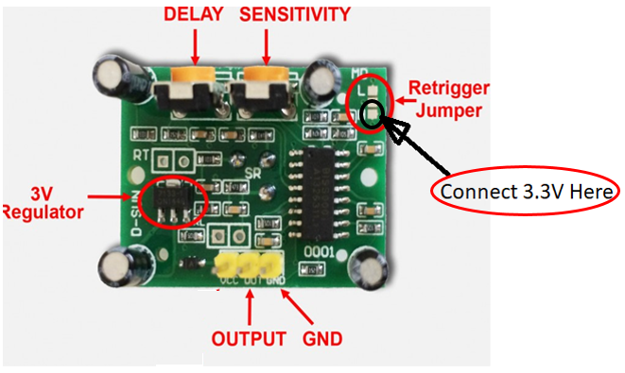
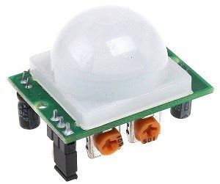
- Connect OUTPUT to GPIO17 on the ESP32
Figure 1
Step 2: Use the same circuit we constructed in week5 with the addition of the blue flashing light, Motion sensor, Push Buttons as shown in the circuit shown in Figure 2.
Circuit Schematic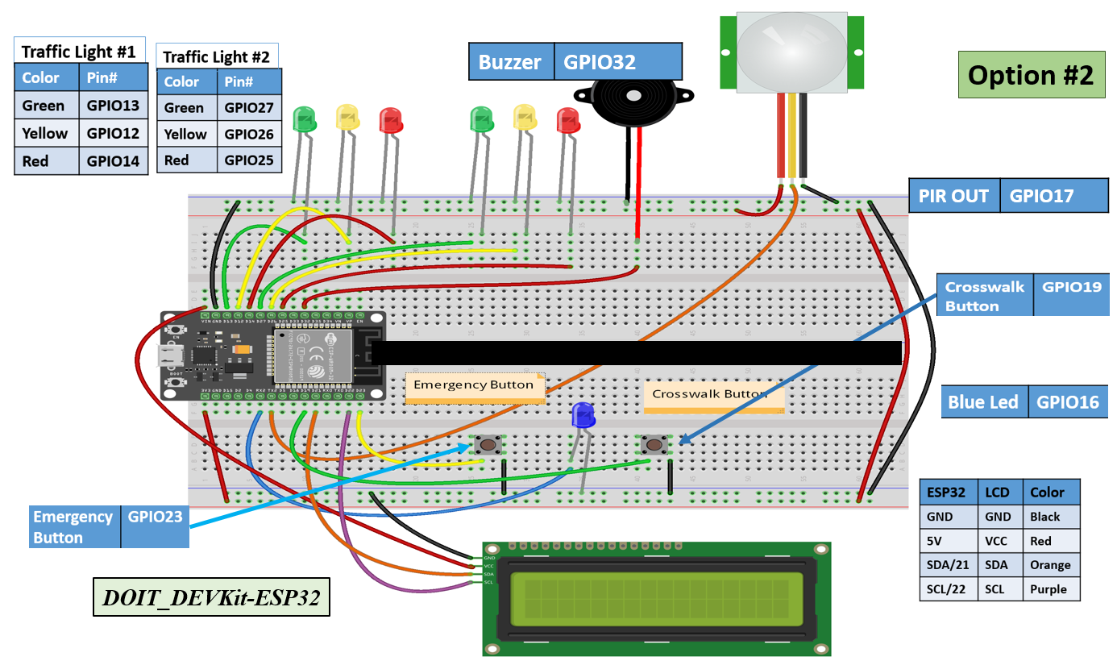
Figure 2
Step 3: Uploading the code

Upload the code in Figure 3 to your ESP32 MCU.

Option#2 Code: Week#6 Final IoT Traffic Light with Motion Detector
// === Replace this text with your Name ====
// Final Project Component – Option 2

#include <Wire.h> //lcd
#include <LiquidCrystal_I2C.h> //lcd
LiquidCrystal_I2C lcd(0x3F,16,2); //set the LCD address to 0x27 for a 16 chars and 2-line display
// if it does not work then try 0x3F, if both addresses do not work then run the scan code below
const int bzr=32; // GPIO32 to connect the Buzzer

// Set GPIOs for LED and PIR Motion Sensor
const int led = 16; // Flashing White (Blue) Led
const int motionSensor = 17;
int pirState = 0 ;
int j,Em_value,Xw_value;

const int Em_button = 23; // Emergency button
const int Xw_button = 19; //Cross Walk button

//==================== LCD ====================
const int red_LED1 = 14; // The red LED1 is wired to ESP32 board pin GPIO04
const int yellow_LED1 =12; // The yellow LED1 is wired to ESP32 board pin GPIO12
const int green_LED1 = 13; // The green LED1 is wired to ESP32 board pin GPIO13
const int red_LED2 = 25; // The red LED2 is wired to Mega board pin GPIO25
const int yellow_LED2 = 26; // The yellow LED2 is wired to Mega board pin GPIO 26
const int green_LED2 = 27; // The green LED2 is wired to Mega board pin GPIO 27

void setup() {
//================Motion Detector initialization =====
// PIR Motion Sensor mode INPUT
pinMode(motionSensor, INPUT);
pinMode(Em_button, INPUT_PULLUP); // 0=pressed, 1 = unpressed button
pinMode(Xw_button, INPUT_PULLUP); // 0=pressed, 1 = unpressed button
pinMode(bzr,OUTPUT);
pinMode(led, OUTPUT);
digitalWrite(led, LOW); // Set Flashing White (Blue) Light to LOW

//=======================================
Serial.begin(115200);
lcd.init(); // initialize the lcd
lcd.backlight();
lcd.setCursor(0,0); // column#1 and Row #1
lcd.print(" === CEIS114 ===");// can be replaced with your name

pinMode(red_LED1, OUTPUT); // initialize digital pin 14 (Red LED1) as an output.
pinMode(yellow_LED1, OUTPUT); // initialize digital pin 12 (yellow LED1) as an output.
pinMode(green_LED1, OUTPUT); // initialize digital pin 13 (green LED1) as an output.

pinMode(red_LED2, OUTPUT); // initialize digital pin 25(Red LED2) as an output.
pinMode(yellow_LED2, OUTPUT); // initialize digital pin 26 (yellow LED2) as an output.
pinMode(green_LED2, OUTPUT); // initialize digital pin 27 (green LED2) as an output.
}

// the loop function runs over and over again forever
void loop() {

// Check the emergency button
int Em_value=digitalRead(Em_button);
if (Em_value == 0){ // Emergency button was pressed so allow about 10 seconds
skipnow: // jump here in case of emergency ====================
Serial.println("Emergency button was pressed ");
// Both sides are RED with flashing White (Blue) light
digitalWrite(yellow_LED1 , LOW); // This should turn off the YELLOW LED1
digitalWrite(green_LED1, LOW); // This should turn off the GREEN LED1
digitalWrite(red_LED1, HIGH); // This should turn on the RED LED1

digitalWrite(red_LED2, HIGH); // This should turn on the RED LED2
digitalWrite(yellow_LED2 , LOW); // This should turn off the YELLOW LED2
digitalWrite(green_LED2, LOW); // This should turn off the GREEN LED2

for (j=0;j<10;j++){ // total of 10 seconds, can be changed
digitalWrite(led,HIGH);
delay(500); //Flashing white (blue) light every .5 sec -- ON
digitalWrite(led,LOW);
delay(500); //Flashing white (blue) light every .5 sec -- OFF
}
} // End of (if) statement for Emergency button

Em_value=digitalRead(Em_button);
int Xw_value=digitalRead(Xw_button);
pirState = digitalRead(motionSensor);

if (Em_value == 1){ // Emergency button not pressed

if (pirState == 1 || Xw_value == 0 ){ // Emergency button not pressed, X-button or motion pressed
// Transition: If a button is pressed, yellow on major street for 1sec. before switching
if(pirState == 1){Serial.println("motion detected");}

delay(500);
digitalWrite(green_LED1, LOW); // This should turn off the GREEN LED1
digitalWrite(yellow_LED1, HIGH); // This should turn on the Yellow LED1
delay(1500);
digitalWrite(bzr, HIGH);
digitalWrite(yellow_LED1 , LOW); // This should turn off the YELLOW LED1
digitalWrite(green_LED1, LOW); // This should turn off the GREEN LED1
digitalWrite(red_LED1, HIGH); // This should turn on the RED LED1
digitalWrite(red_LED2, LOW); // This should turn off the RED LED2
digitalWrite(yellow_LED2 , LOW); // This should turn off the YELLOW LED2
digitalWrite(green_LED2, HIGH); // This should turn on the GREEN LED2

// LED1 is a major street
for (int i=10; i>= 0; i--) {
Em_value=digitalRead(Em_button);// check for emergency button pressing
if (Em_value == 0)goto skipnow; // if so break and execute emergency at skipnow label

Serial.print(" Count = ");
Serial.print(i);
Serial.println(" == Walk == ");
lcd.setCursor(0,1); // set the cursor to column 1, line 2
// lcd.clear(); // clears the display to print new message
lcd.print(" ");
lcd.setCursor(0,1); // set the cursor to column 1, line 2
lcd.print(" == Walk == "); // display Walk characters to the LCD.
lcd.print(i); // Display the count
delay(1000);
digitalWrite(bzr, LOW);
delay(500);
} // End of counter
// clears the display to print new message
// ===== lcd.clear();
lcd.setCursor(0,1); // set the cursor to column 1, line 2
lcd.print(" ");

//====================================
// Transition
digitalWrite(green_LED2 , LOW); // This should turn off the YELLOW LED2
digitalWrite(yellow_LED2 , HIGH); // This should turn off the YELLOW LED2
delay(1000);
} // End of Emergency button not pressed, X-button pressed or Motion was detected
} //End of Emergency button not pressed

//===============================================

// No motion, No Emergency, No crossing, then LED1=Green, LED2=Red always
lcd.setCursor(0,1); // set the cursor to column 1, line 2
lcd.print(" = Do Not Walk ="); // Display Do Not Walk characters to the LCD.

Serial.println(" == Do Not Walk == ");

digitalWrite(yellow_LED1 , LOW); // This should turn off the YELLOW LED1
digitalWrite(green_LED1, HIGH); // This should turn on the GREEN LED1
digitalWrite(red_LED1, LOW); // This should turn off the RED LED1

digitalWrite(red_LED2, HIGH); // This should turn on the RED LED2
digitalWrite(yellow_LED2 , LOW); // This should turn off the YELLOW LED2
digitalWrite(green_LED2, LOW); // This should turn off the GREEN LED2

delay(1000);

//====================End Motion ==========
}// End of loop

Figure 3
Step 4: Testing the project functionality

Use the following steps to test that the project is functioning correctly:
- Normally, the major street traffic light is always green and the miner street traffic light is always Red.
- Wave your hand in front of the motion detector and the minor traffic light will turn Green and the major traffic light will step through yellow light then red
- Press the cross-walk button and it will allow pedestrians to cross the major street and the LCD will display counting down from ten (10) to zero (0) with the message “Walk” displayed. At this time the minor street is also turned green for cars to cross.
- Press the Emergency button and it will force Red lights to turn on in all directions and the blue light will be flashing.
- If you are powering the project from your computer, you can also watch similar activities displayed on the serial monitor.

Appendix A
Pinout for ESP 32 Board.
Name: ESP32 WROOM32 DevKit Pinout
