Course Project – Module 5
College of Engineering and Information Sciences
Course Number: CEIS114

Multiple Traffic Light Controller with Cross Walk

PARTS LIST
- PC running Arduino IDE
- ESP 32 Board
- Two sets of Colored LEDs: Red, Yellow and Green
- Button
- Wires
- Breadboard

Deliverables
- Complete the Course Project PowerPoint Deliverable
- Include a picture of your circuit
- Screenshot of Arduino IDE code from your computer
- Screenshot of output in Serial Monitor from your computer

PROCEDURE
- Assemble the circuit as shown in Figure 1
- Connect all the wires as shown in Figure 1. Make sure to connect the Red, Yellow, and Green wires to the appropriate pins in the ESP32 Board.
- Open the Arduino IDE and load the code shown in Figure 2.
- Connect the ESP32 Board to your computer and check if the board is recognized. Make sure that the port and the board are correctly selected. Also, make sure the upload speed is set to 115200 in the Tools menu.
- Run the code and observe the output in the serial monitor.
- Press the wire for activate the cross walk and observe the output.

Figure 1: Multiple Traffic Lights with Crosswalk Button
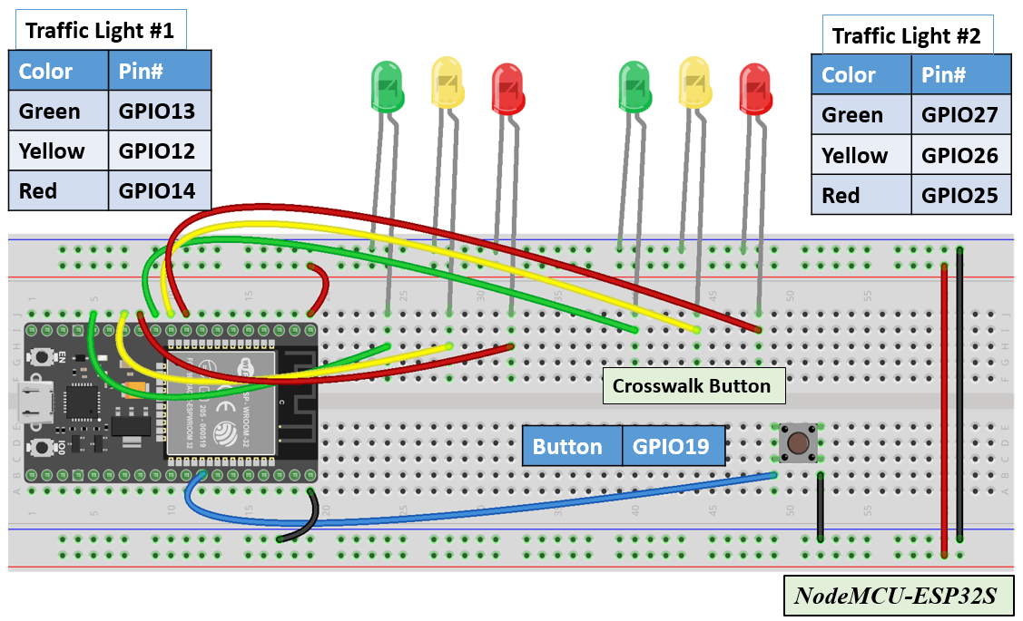

For the button interfacing, please refer to the figure below:

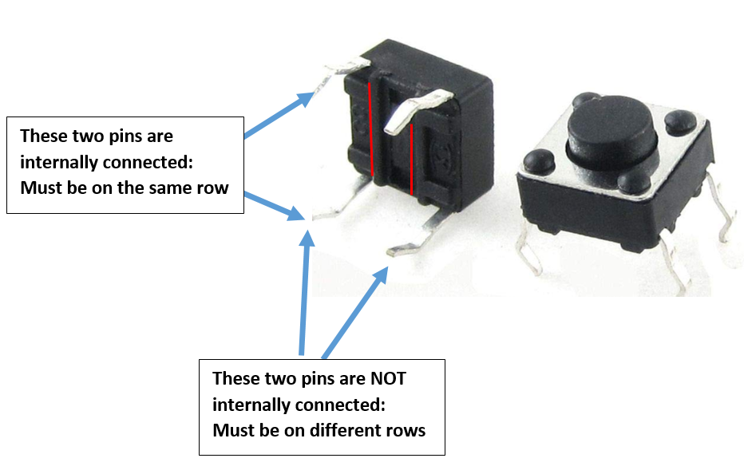

Figure 2: Code for Two Traffic Lights and Crosswalk Button
// === Replace this text with your Name ====
// Module #5 project
const int red_LED1 = 14; // The red LED1 is wired to ESP32 board pin GPIO14
const int yellow_LED1 =12; // The yellow LED1 is wired to ESP32 board pin GPIO12
const int green_LED1 = 13; // The green LED1 is wired to ESP32 board pin GPIO13
const int red_LED2 = 25; // The red LED2 is wired to Mega board pin GPIO25
const int yellow_LED2 = 26; // The yellow LED2 is wired to Mega board pin GPIO 26
const int green_LED2 = 27; // The green LED2 is wired to Mega board pin GPIO 27

int Xw_value;
const int Xw_button = 19; //Cross Walk button

// the setup function runs once when you press reset or power the board
void setup() {

pinMode(Xw_button, INPUT_PULLUP); // 0=pressed, 1 = not pressed button
Serial.begin(115200);
pinMode(red_LED1, OUTPUT); // initialize digital pin 14 (Red LED1) as an output.
pinMode(yellow_LED1, OUTPUT); // initialize digital pin 12 (yellow LED1) as an output.
pinMode(green_LED1, OUTPUT); // initialize digital pin 13 (green LED1) as an output.

pinMode(red_LED2, OUTPUT); // initialize digital pin 25(Red LED2) as an output.
pinMode(yellow_LED2, OUTPUT); // initialize digital pin 26 (yellow LED2) as an output.
pinMode(green_LED2, OUTPUT); // initialize digital pin 27 (green LED2) as an output.
}

// the loop function runs over and over again forever
void loop() {

// read the crosswalk button value:
Xw_value=digitalRead(Xw_button);
if (Xw_value == 0 ){ // if crosswalk button (X-button) pressed
digitalWrite(yellow_LED1 , LOW); // This should turn off the YELLOW LED1
digitalWrite(green_LED1, LOW); // This should turn off the GREEN LED1
digitalWrite(yellow_LED2 , LOW); // This should turn off the YELLOW LED2
digitalWrite(green_LED2, LOW); // This should turn off the GREEN LED2
for (int i=10; i>0; i--){
Serial.print(" Count = ");
Serial.print(i);
Serial.println(" == Walk == ");
digitalWrite(red_LED1, HIGH); // This should turn on the RED LED1
digitalWrite(red_LED2, HIGH); // This should turn on the RED LED2
delay(500); //wait 0.5 seconds
digitalWrite(red_LED1, LOW); // This should turn off the RED LED1
digitalWrite(red_LED2, LOW); // This should turn off the RED LED2
delay(500); //wait 0.5 seconds
} // End of counter
} //

else // No Emergency ===
{
Serial.println(" == Do Not Walk == ");
// The next three lines of code turn on the red LED1
digitalWrite(red_LED1, HIGH); // This should turn on the RED LED1
digitalWrite(yellow_LED1 , LOW); // This should turn off the YELLOW LED1
digitalWrite(green_LED1, LOW); // This should turn off the GREEN LED1

delay(1000); //Extended time for Red light#1 before the Green of the other side turns ON

// The next three lines of code turn on the red LED2
digitalWrite(red_LED2, LOW); // This should turn off the RED LED2
digitalWrite(yellow_LED2 , LOW); // This should turn off the YELLOW LED2
digitalWrite(green_LED2, HIGH); // This should turn on the GREEN LED2

delay(2000); // wait for 1 second

// The next three lines of code turn on the red LED1
digitalWrite(red_LED1, HIGH); // This should turn on the RED LED1
digitalWrite(yellow_LED1 , LOW); // This should turn off the YELLOW LED1
digitalWrite(green_LED1, LOW); // This should turn off the GREEN LED1

// The next three lines of code turn on the red LED2
digitalWrite(red_LED2, LOW); // This should turn off the RED LED2
digitalWrite(yellow_LED2 , HIGH); // This should turn on the YELLOW LED2
digitalWrite(green_LED2, LOW); // This should turn off the GREEN LED2
delay(2000); // wait for 1 second

// The next three lines of code turn on the red LED2
digitalWrite(red_LED2, HIGH); // This should turn on the RED LED2
digitalWrite(yellow_LED2 , LOW); // This should turn off the YELLOW LED2
digitalWrite(green_LED2, LOW); // This should turn off the GREEN LED2

delay(1000); //Extended time for Red light#2 before the Green of the other side turns ON

// The next three lines of code turn on the yellow LED1
digitalWrite(red_LED1, LOW); // This should turn off the RED LED1
digitalWrite(yellow_LED1 , LOW); // This should turn off the YELLOW LED1
digitalWrite(green_LED1, HIGH); // This should turn on the GREEN LED1

delay(2000); // wait for 1 second

// The next three lines of code turn on the yellow LED1
digitalWrite(red_LED1, LOW); // This should turn off the RED LED1
digitalWrite(yellow_LED1 , HIGH); // This should turn on the YELLOW LED1
digitalWrite(green_LED1, LOW); // This should turn off the GREEN LED1

// The next three lines of code turn on the red LED2
digitalWrite(red_LED2, HIGH); // This should turn on the RED LED2
digitalWrite(yellow_LED2 , LOW); // This should turn off the YELLOW LED2
digitalWrite(green_LED2, LOW); // This should turn off the GREEN LED2
delay(2000); // wait for 1 second
}// Emergency Button closing ============
}

Sample Serial Monitor output:

Capture similar Serial Monitor data and submit with your deliverable

54
== Do Not Walk ==
23
Count = 10 == Walk ==
Count = 9 == Walk ==
Count = 8 == Walk ==
Count = 7 == Walk ==
Count = 6 == Walk ==
Count = 5 == Walk ==
Count = 4 == Walk ==
Count = 3 == Walk ==
Count = 2 == Walk ==
Count = 1 == Walk ==
73
== Do Not Walk ==

