Course Project – Module 4
College of Engineering and Information Sciences
Course Number: CEIS114

Creating a Multiple Traffic Light Controller

PARTS LIST
- PC running Arduino IDE
- ESP 32 Board
- Two sets of Colored LEDs: Red, Yellow and Green
- Wires
- Breadboard

Deliverables
- Complete the Course Project PowerPoint Deliverable
- Include a picture of your circuit
- Screenshot of Arduino IDE code from your computer

PROCEDURE
- Connect the ESP32 Board and Check if the board is recognized by the Arduino IDE. If needed, please refer to Module 1 Project for connecting and configuring the ESP32 Board.
- Insert the three LEDs ( Red, Yellow, Green) in the breadboard as shown in Figure 1
- Connect all the wires as shown in Figure 1. Make sure to connect the Red, Yellow, and Green wires to the appropriate pins in the ESP32 Board.
- Open the Arduino IDE and load the code shown in Figure 2

Figure 1. Two Traffic Lights
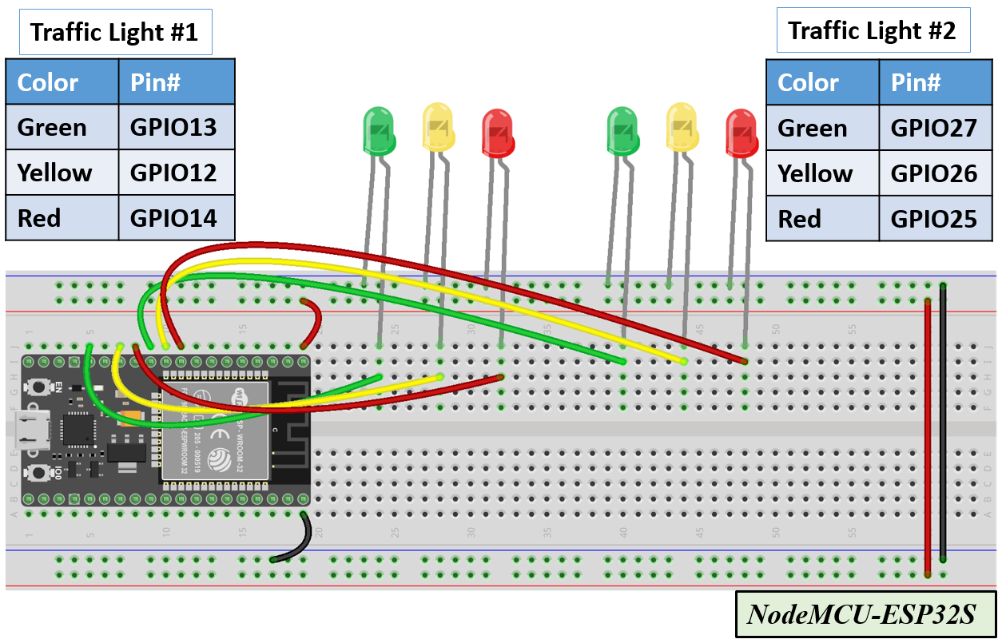

Figure 2. Code for Two Traffic Lights (6 LEDs: Green, Yellow, Red)
// === Replace this text with your Name ====
// Module #4 project

// Define some labels
const int red_LED1 = 14; // The red LED1 is wired to ESP32 board pin GPIO14
const int yellow_LED1 =12; // The yellow LED1 is wired to ESP32 board pin GPIO12
const int green_LED1 = 13; // The green LED1 is wired to ESP32 board pin GPIO13
const int red_LED2 = 25; // The red LED2 is wired to Mega board pin GPIO25
const int yellow_LED2 = 26; // The yellow LED2 is wired to Mega board pin GPIO 26
const int green_LED2 = 27; // The green LED2 is wired to Mega board pin GPIO 27

// the setup function runs once when you press reset or power the board
void setup() {
pinMode(red_LED1, OUTPUT); // initialize digital pin GPIO14 (Red LED1) as an output.
pinMode(yellow_LED1, OUTPUT); // initialize digital pin GPIO12 (yellow LED1) as an output.
pinMode(green_LED1, OUTPUT); // initialize digital pin GPIO13 (green LED1) as an output.
pinMode(red_LED2, OUTPUT); // initialize digital pin GPIO25(Red LED2) as an output.
pinMode(yellow_LED2, OUTPUT); // initialize digital pin GPIO26 (yellow LED2) as an output.
pinMode(green_LED2, OUTPUT); // initialize digital pin GPIO27 (green LED2) as an output.
}

// the loop function runs over and over again forever
void loop() {
// The next three lines of code turn on the red LED1
digitalWrite(red_LED1, HIGH); // This should turn on the RED LED1
digitalWrite(yellow_LED1 , LOW); // This should turn off the YELLOW LED1
digitalWrite(green_LED1, LOW); // This should turn off the GREEN LED1

delay(1000); //Extended time for Red light#1 before the Green of the other side turns ON

// The next three lines of code turn on the green LED2 for 2 seconds
digitalWrite(red_LED2, LOW); // This should turn off the RED LED2
digitalWrite(yellow_LED2 , LOW); // This should turn off the YELLOW LED2
digitalWrite(green_LED2, HIGH); // This should turn on the GREEN LED2

delay(2000); // wait for 2 seconds

// The next three lines of code turn on the red LED1
digitalWrite(red_LED1, HIGH); // This should turn on the RED LED1
digitalWrite(yellow_LED1 , LOW); // This should turn off the YELLOW LED1
digitalWrite(green_LED1, LOW); // This should turn off the GREEN LED1

// The next three lines of code turn on the yellow LED2
digitalWrite(red_LED2, LOW); // This should turn off the RED LED2
digitalWrite(yellow_LED2 , HIGH); // This should turn on the YELLOW LED2
digitalWrite(green_LED2, LOW); // This should turn off the GREEN LED2
delay(2000); // wait for 2 seconds

// The next three lines of code turn on the red LED2
digitalWrite(red_LED2, HIGH); // This should turn on the RED LED2
digitalWrite(yellow_LED2 , LOW); // This should turn off the YELLOW LED2
digitalWrite(green_LED2, LOW); // This should turn off the GREEN LED2

delay(1000); //Extended time for Red light#2 before the Green of the other side turns ON

// The next three lines of code turn on the green LED1
digitalWrite(red_LED1, LOW); // This should turn off the RED LED1
digitalWrite(yellow_LED1 , LOW); // This should turn off the YELLOW LED1
digitalWrite(green_LED1, HIGH); // This should turn on the GREEN LED1

delay(2000); // wait for 1 second

// The next three lines of code turn on the yellow LED1
digitalWrite(red_LED1, LOW); // This should turn off the RED LED1
digitalWrite(yellow_LED1 , HIGH); // This should turn on the YELLOW LED1
digitalWrite(green_LED1, LOW); // This should turn off the GREEN LED1

// The next three lines of code turn on the red LED2
digitalWrite(red_LED2, HIGH); // This should turn on the RED LED2
digitalWrite(yellow_LED2 , LOW); // This should turn off the YELLOW LED2
digitalWrite(green_LED2, LOW); // This should turn off the GREEN LED2
delay(2000); // wait for 1 second
}

