Course Project – Module 2
College of Engineering and Information Sciences
Course Number: CEIS114
Background

The Internet of Things is growing exponentially. New technologies and applications are being developed on a regular basis and this creates an abundance of new job opportunities each with its requisite skill sets. It is important to stay current with the skills required for this evolving job market and to take advantage of the many available learning opportunities currently available. This course project covers the fundamentals topics of IoT and is divided into six parts. Each week builds upon the project resulting in an IoT device that will simulate a traffic controller. The design and development process of the device will include planning, hardware setup, programming, and networking. It will encompass the many aspects of the IoT and prepare you for your future career in technology.
Scenario

Design and develop a two-way traffic light controller with a pedestrian crossing and an emergency signal. The pedestrian crossing will have an LCD display messages whether the pedestrian can or cannot cross the street. When they can cross, the LCD will count down from ten (10) to zero (0) indicating the amount of time they have to cross. The emergency signal will force red lights to turn on in all directions and the blue light will be flashing. The final step is to secure the system so that it could be controlled remotely via a web browser. The alternative final step is a non-internet connection using a motion sensor to allow traffic to continuously flow on major street and only switches to slow traffic street when motion is detected.

Project Plan for IoT Traffic Controller

Objectives
- To introduce the course project
- To prepare materials for course project
- To Install the DOIT_DEVKIT Board in Arduino IDE

Key Performance Indicators:
- Problem solving methodology utilized with no errors
- Communication skills were demonstrated through a report with no errors
- Deliverables were submitted on time with no errors

Overall project PROCEDURE
Design and implement a four-way traffic light controller system with an option for pedestrian crossing utilizing the IoT kit and ESP32 Microcontroller. The required steps to build the traffic controller are as follows:

- Setup ESP32 with one traffic light
- Setup ESP32 with two traffic lights
- Add a pedestrian crossing option for the system
- Display alert signs for the pedestrian to walk or not to walk
- Add an emergency button to emulate police or ambulance control of the traffic lights
- Secure and control the lights via Web application.

Alternatively, the final step in the project could be:

- Develop a non-internet connection option to design a motion detector to allow traffic to continuously flow on major street and only switches to slow traffic street when motion is detected.

Module 2 project PROCEDURE
- Gather the project inventory listed in the Project Template PowerPoint.
- Install the DOIT_DEVKIT Board in Arduino IDE. See Appendix A for the detailed steps.
- Test the installation as described in Appendix B.
- Detailed steps for mounting the DOIT_DEVKIT Board on two breadboards is described in Appendix C.

Module 2 Project Deliverables
- Complete the Course Project PowerPoint Deliverable
- Include a picture of your inventory
- Include a picture of the ESP32 mounted on the breadboard and powered ON
- Include a screenshot of the scanned WiFi networks

Appendix A

Installing the ESP32 Board in Arduino IDE

(Windows instructions)
Important: Before starting this installation procedure, make sure that you have the latest version of the Arduino IDE installed in your computer. If you don’t, uninstall it and install it again. Otherwise, it may not work. Having the latest Arduino IDE software installed from arduino.cc/en/Main/Software, continue with this tutorial.
To download and Install Arduino. Go to : arduino.cc/en/Main/Software
Click on Windows installer as shown below
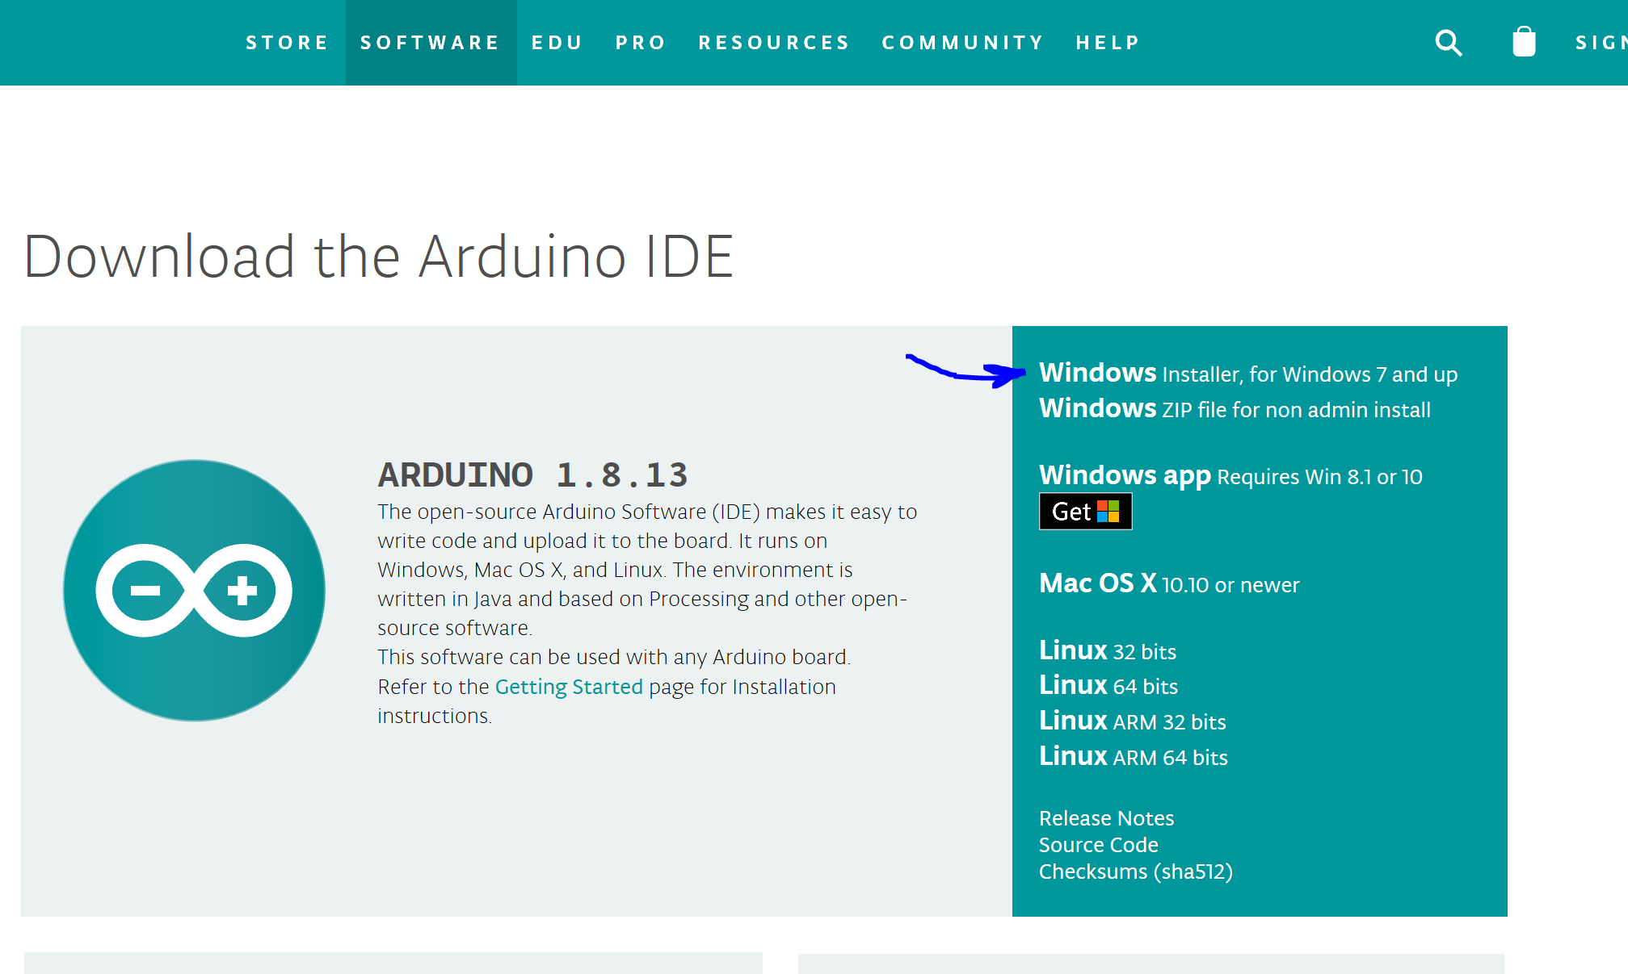
A new window will open (see below) click on Just download as shown below:

IMPORTANT NOTE:
- If this is your first time installing the ESP32 on the Arduino IDE, simply connect your ESP32 to your computer and follow the installation procedure described below:
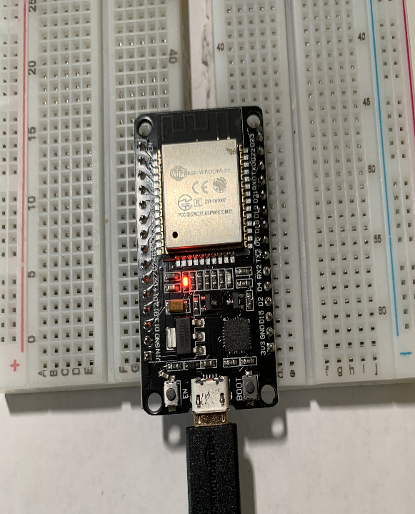
- If you’ve already installed the ESP32 add-on using the old method, you should remove the espressif folder first. Go to the end of this post to learn how to remove the espressif folder.
1. Installing the ESP32 Board
To install the ESP32 board in your Arduino IDE, follow these next instructions:
1) Open the preferences window from the Arduino IDE. Go to File> Preferences
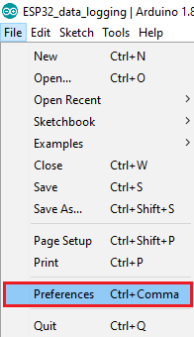

2) Enter https://dl.espressif.com/dl/package_esp32_index.json into the “Additional Board Manager URLs” field as shown in the figure below. Then, click the “OK” button:
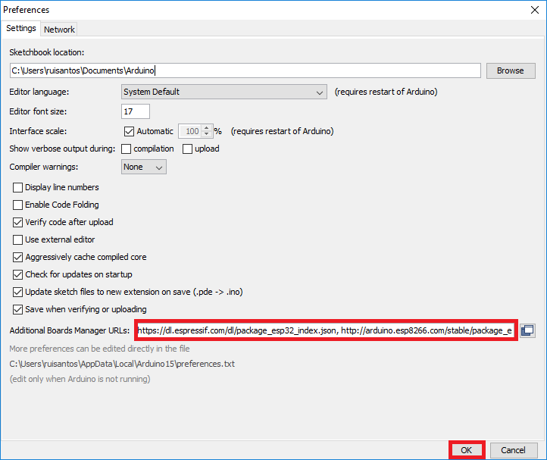
3) Open boards manager. Go to Tools > Board > Boards Manager…
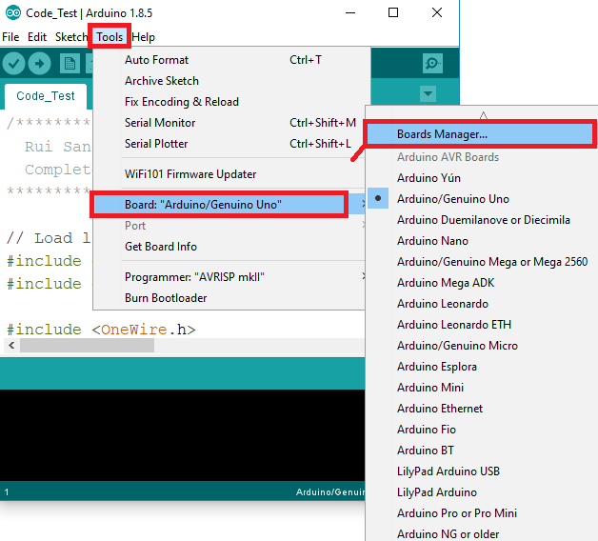
4) Search for ESP32 and press install button for the “ESP32 by Espressif Systems“: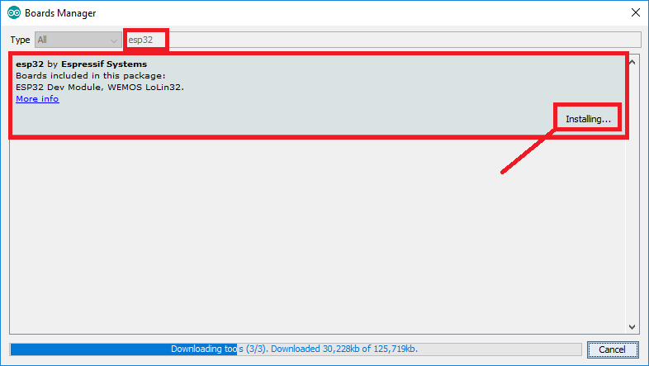
5) That’s it. It should be installed after a few seconds.

Appendix B

Testing the Installation
Plug the ESP32 board to your computer. Then, follow these steps:

1) Open the Arduino IDE
2) Select your Board in Tools > Board menu (in my case it’s the DOIT ESP32 DEVKIT V1)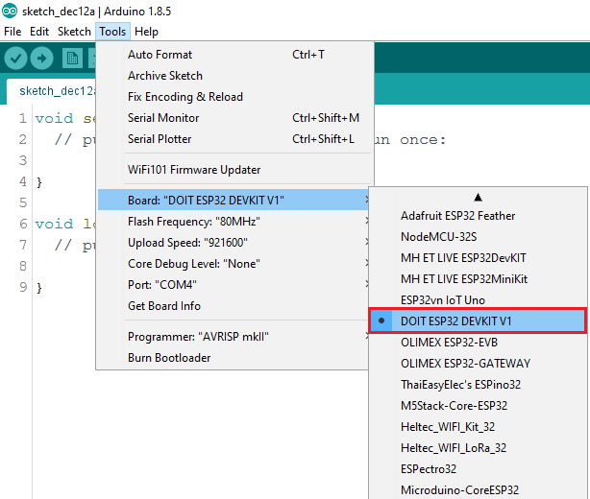
3) Select the Port. Select the Port from the Tools menu. (COM3 listed below – your port number may be different)
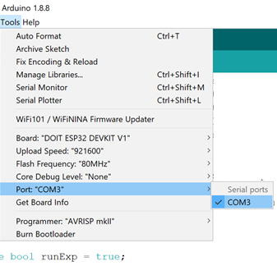
4) If you don’t see the COM Port in your Arduino IDE, you need to download and install the Serial Driver. This ESP32 development module has built in a high-quality Labs CP210x Single-Chip USB to UART Bridge with Micro USB connector that baud rates up to 921600. You can download and install the driver from here: https://www.silabs.com/products/development-tools/software/usb-to-uart-bridge-vcp-drivers
5) Open the following example under File > Examples > WiFi (ESP32) > WiFi Scan
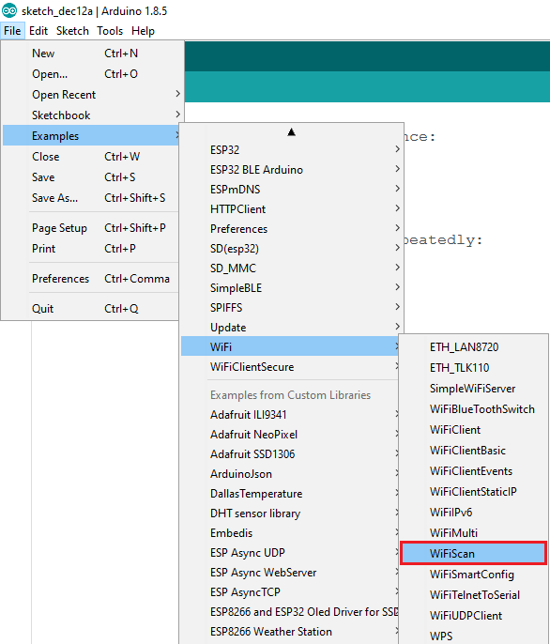

6) A new sketch opens:
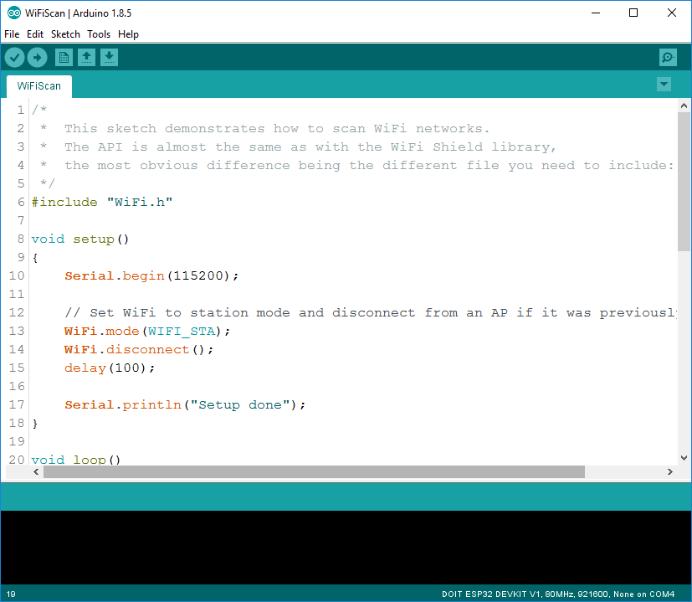
7) Press the Upload button in the Arduino IDE. Wait a few seconds while the code compiles and uploads to your board.
8) If everything went as expected, you should see a “Done uploading.” message.
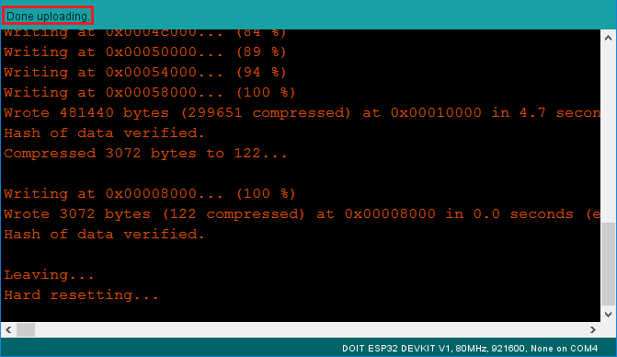

9) Open the Arduino IDE Serial Monitor at a baud rate of 115200:

10) Press the ESP32 on-board Enable button and you should see the networks available near your ESP32:
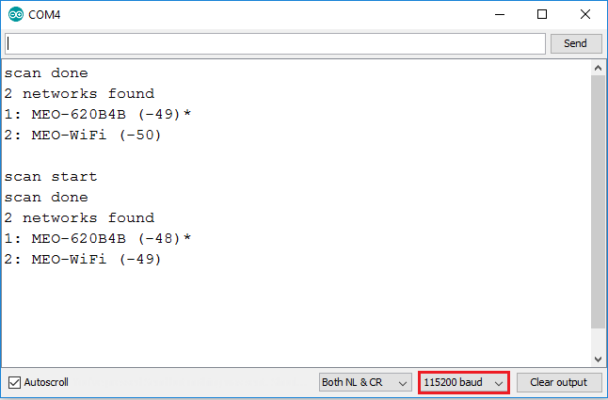

Appendix B

Troubleshooting sketch uploading

A fatal error occurred: “Failed to connect to ESP32: Timed out… Connecting…”
When you try to upload a new sketch to your ESP32 and it fails to connect to your board, it means that your ESP32 is not in flashing/uploading mode.
Given that you have already selected the right board name and COM port, follow these steps:
- Hold-down the “BOOT” button in your ESP32 board

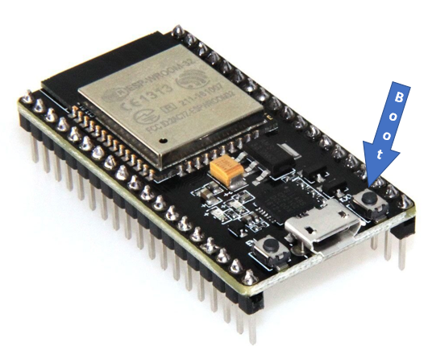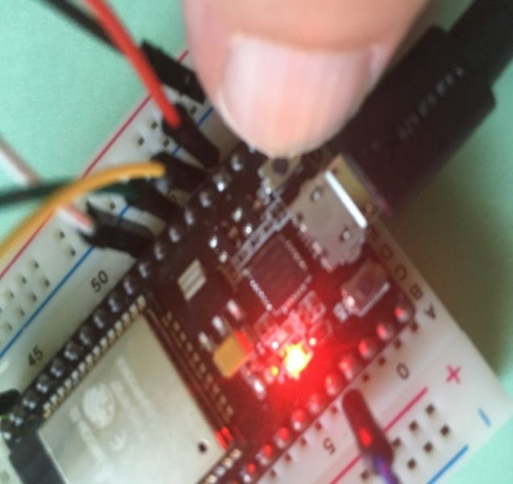

- Press the “Upload” button in the Arduino IDE to upload a new sketch:

- After you see the “Connecting….” message in your Arduino IDE, release the finger from the “BOOT” button:
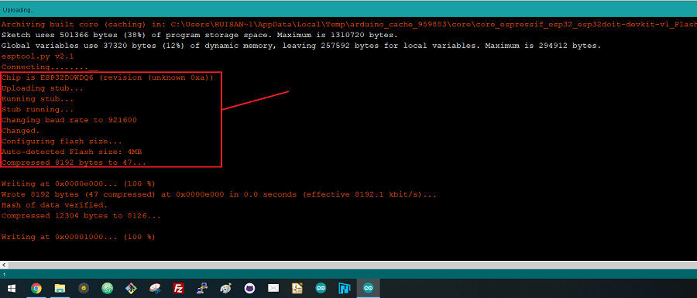
- After that, you should see the “Done uploading” message

Appendix C

Connecting two breadboards together

Some of the ESP32 boards may have a different size in width and would cover a larger area as shown in Figure 3. This would not allow you to make connections to both sides of the ESP board.
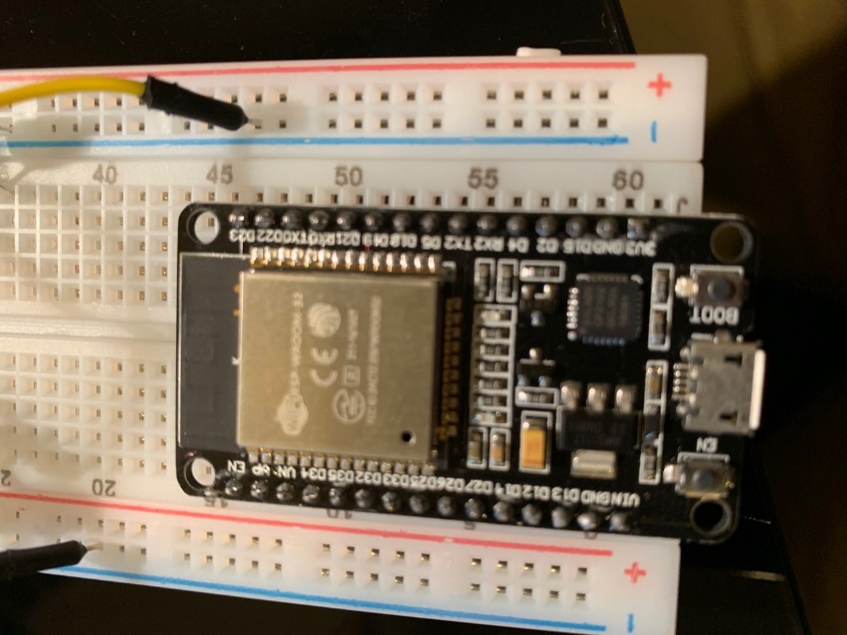
Figure 3
Please follow the following procedure for connecting two breadboards:

1. Remove one edge from both of the breadboards as shown in Figure 4.

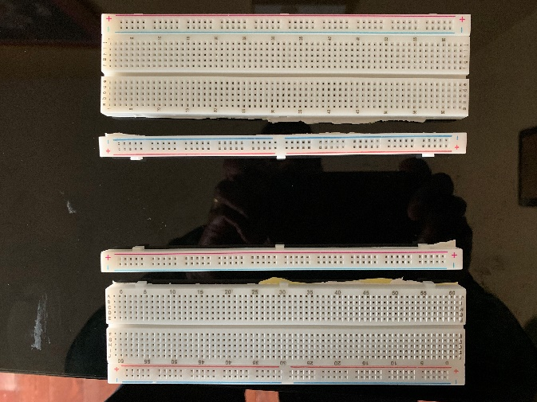
Figure 4

2. Bring the boards closer so that you could install the ESP32 board as shown in Figure 5.

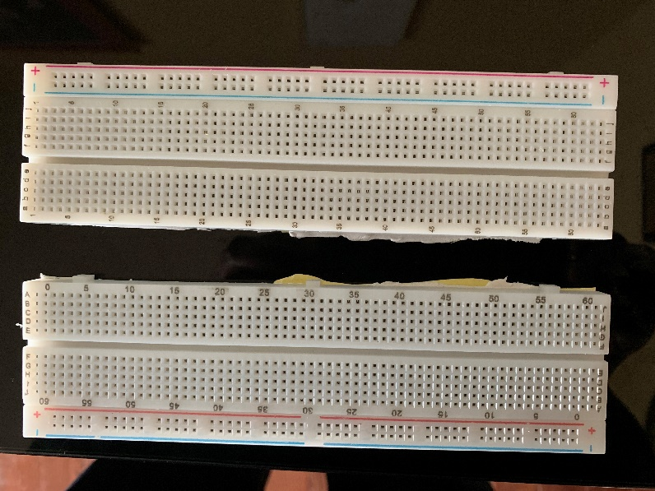
Figure 5

3. Install the ESP32 board as shown in Figure 6.

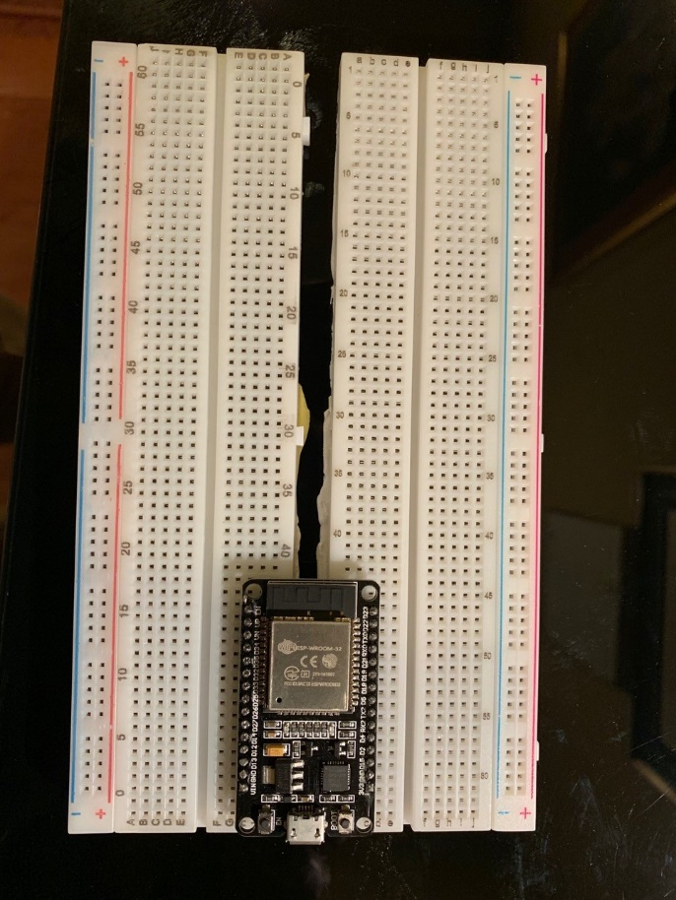
Figure 6

