Course Project

Module 3: Installing the Linux OS

Objectives
- To install Linux on a virtual machine
- To explore the Linux environment
- To understand the terminal window

Introduction

Linux is an open source operating system that is powerful, free, and secure. Due to the availability of Linux, distributions of it are used in many devices including phones, automobiles, and IoT devices. Learning to be familiar with Linux and its commands is a useful skill in any technology career. For this part of the signature assignment, a Linux distribution will be installed on the Virtual Machine. Thus you will have a copy of linux on your computer to use any time you want!

Steps
- Download the linux iso from the Files section of your course. It is named: ubuntu-18.04.1-desktop-amd64.iso This is a distribution of Linux named Ubuntu. Copy the file downloaded to a folder so you will remember where it is stored. I created a folder named Ubuntu and copied the file in there.
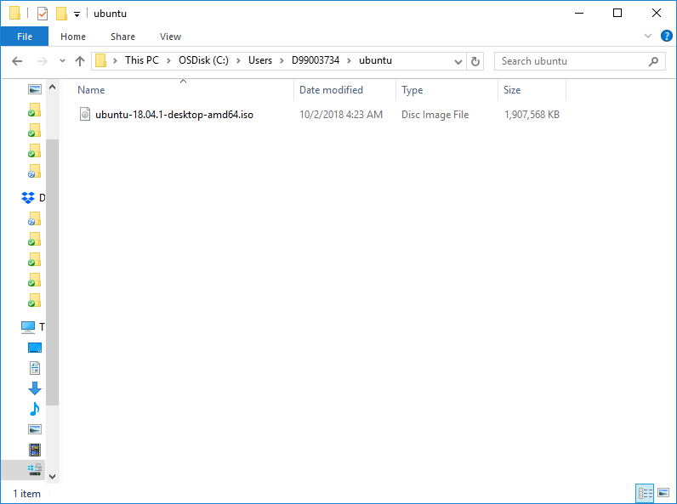
Figure 2: Linux ISO
- Next open VMWare and click the “Create a New Virtual Machine”
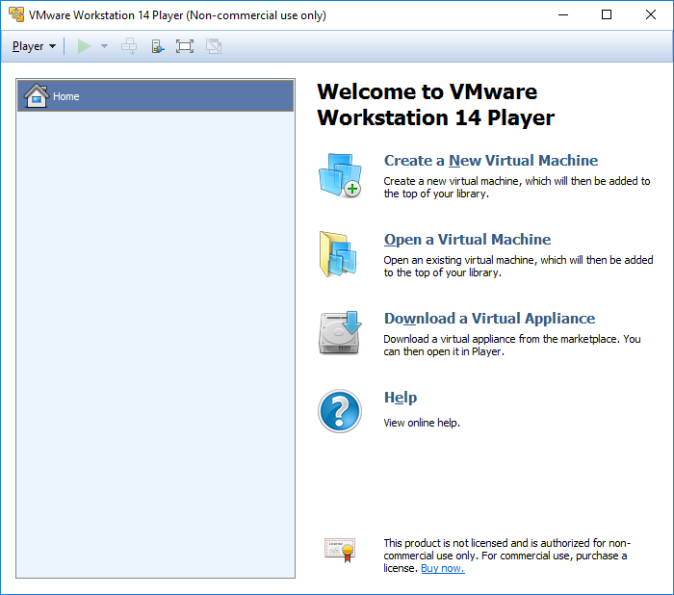
Figure 3: New Virtual machine
- Choose the Installer disk file and browse for the location of Ubuntu:
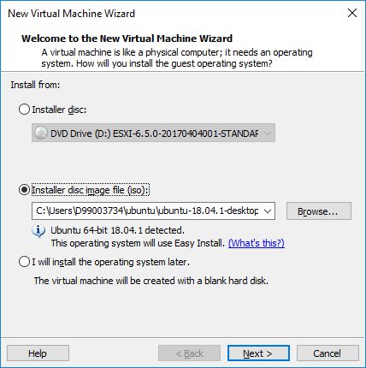
Figure 4: Browse for disc file
- Personalize Ubuntu with your name and password. IMPORTANT: write down your password so you will remember it
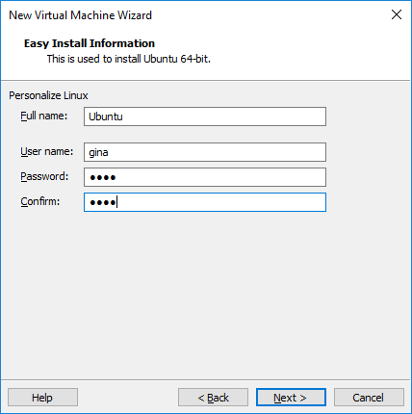
Figure 5: Personalize Linux
- Follow the rest of the defaults to install the Linux image. You may get this virtualization error:
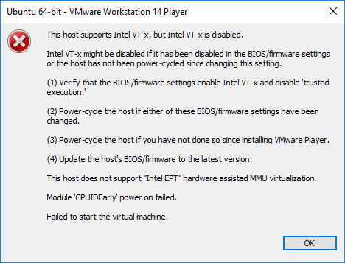
Figure 6: Virtualization error
- If you get this virtualization error, you will need to go to the BIOS and enable virtualization. Directions for this are in the Files section
- Once Linux is installed explore the desktop
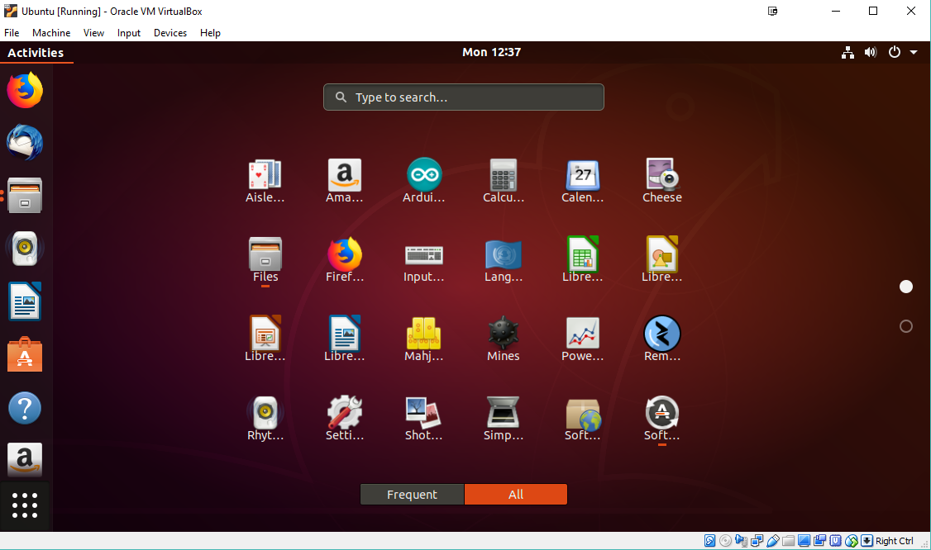
Figure 7: Applications
- Click on the 9 dots on the lower left corner to see all of the applications.
- Answer the following questions:
  - How do you open a terminal window?
  - What browser do you see in Ubuntu?
  - What Office software is installed in Ubuntu?

Deliverables
- Complete the Powerpoint Project deliverable
- Include a screenshot of your vmware with the Ubuntu image.
- Answer the questions

