Course Project

Module 1: Designing the Prototype of your Virtual Machine and Installing the Machine

Objectives
- To introduce the course project
- To introduce flowchart and process chart as design tools
- To develop a process for the course project
- To generate a prototype design of an IoT device
- To install a Virtual machine on your laptop

Introduction

Creating a flowchart: Flowcharts are diagrams used to represent processes or workflows and are often used in programming to graphically represent a problem. Using different shapes, boxes, and connecting arrows, a flowchart represents the solution flow to a given problem. Flowcharts are commonly used to represent programs, algorithms, or any ordered process in various disciplines. A flowchart is created prior to starting a process to determine the logic flow before a project is implemented.

Flowcharts can be hand drawn or created using a number of software applications including Microsoft Word, Visio, LibreOffice, GoogleDocs, and various web applications such as https://www.draw.io/.

Some of the most common flowchart symbols used are shown in the diagram along with their intended purpose for the symbol. Lines with arrows indicate the flow of the problem solving process.
Predefined
Process
Process
Data

Decision
Termination
Connector

Virtual machines: A virtual machine is software that contains an image that behaves as an actual operating system. It is an operating system within an operating system. The files in the virtual machine are partitioned from the rest of the operating system so that it can not affect the actual computer. Virtual machines are useful for testing software, or running software on an operating system it was not intended for. They are used often in industry.

Steps

Develop a process flowchart for this project. The steps include: installing a virtual machine, installing linux on the virtual machine, installing Arduino on the linux image, installing the RTOS library for the Arduino, setting up the Arduino hardware, and running the Arduino from the virtual machine. Using the flowchart, we can check and verify the logical process for the problem. We will create the virtual machine using hardware and software in future weeks.
- Install VMware on your laptop. Download the install files and work through the wizard to install VMware.
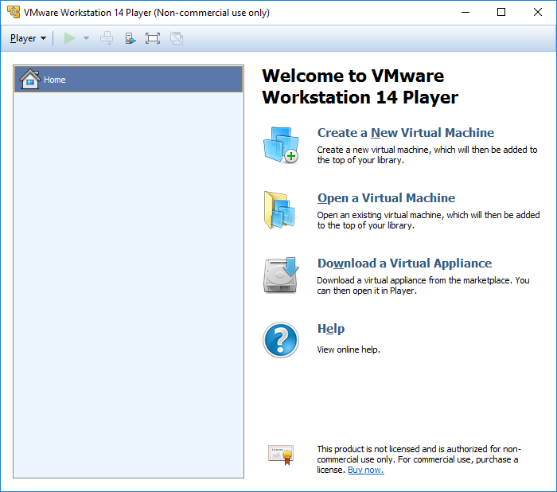
Figure 1:Install VMware

Deliverables
- Powerpoint deliverable
  - Flowchart
  - Screenshot of VMWare installed

