Course Project
DeVry University
College of Engineering and Information Sciences

Module 6: Networking and security

Objectives
- To learn how to install the ESP32 drivers and the board
- To learn how to setup the ESP32 board to use the Arduino IDE
- To learn how to test the ESP32 board in scanning detectable networks
- To learn how to configure the ESP32 board as a soft access point
- To test some of the ESP32 board components
- To practice writing programs using the Arduino IDE

Introduction
This part of the project shows how to install the ESP32 board and drivers and test its WiFi capabilities and on board hardware resources. The intention is to get you started on this board and use this part of the assignment as a reference for future installation of the board. Two main components will be discussed: Arduino Setup for ESP32 on Windows and ESP32 board WiFi and hardware testing. We will create a web server using the ESP32 board to allow you to remotely control a light. In addition, you can also wire the motion sensor as well to the ESP32 board for a full home security system.

Steps

Setting up your Router

- Using an Ethernet cable connect your mini router WAN port to your home router and power your mini router up using the Micro USB cable provided.
- Using your PC connect to your mini router using the default SSID (GL-XXXXX-xxx) written on the router box and the default password (goodlife)
- Go to your browser and type: http://192.168.8.1
- Enter the password when asked
- Choose language and time zone (in our case we use: English for language, and America/Chicago for time zone.)
- Now you will be presented with the following window:

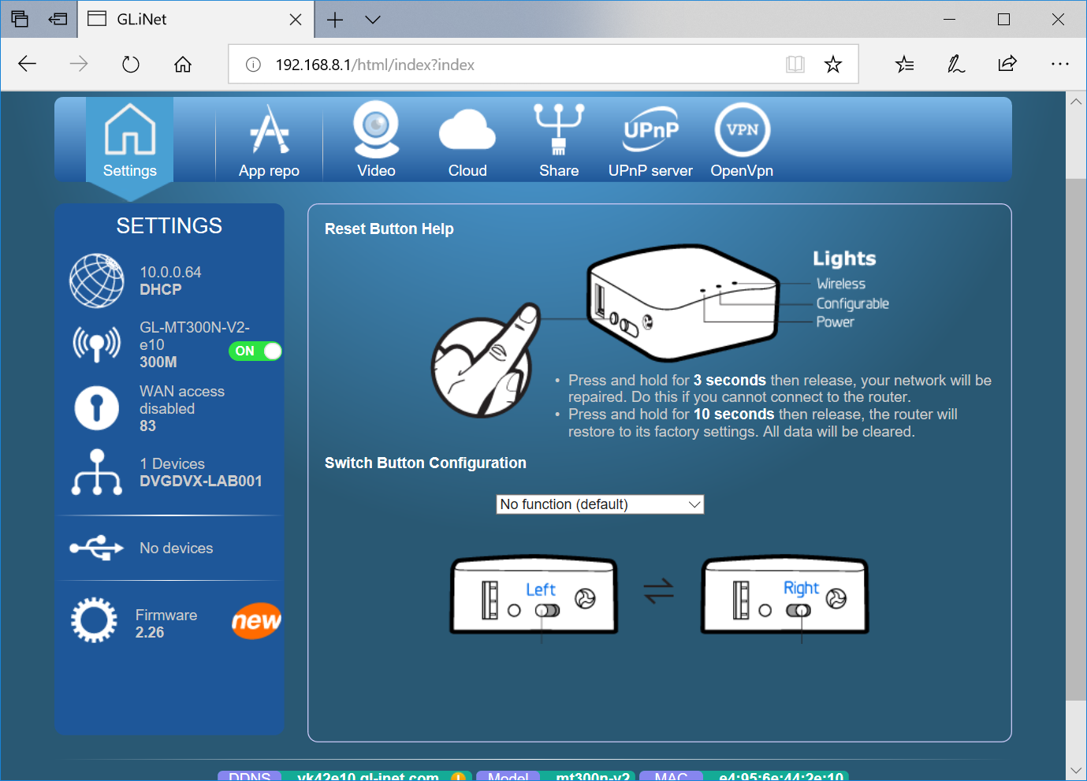
Router page
Click on wireless logo  then this window will open:
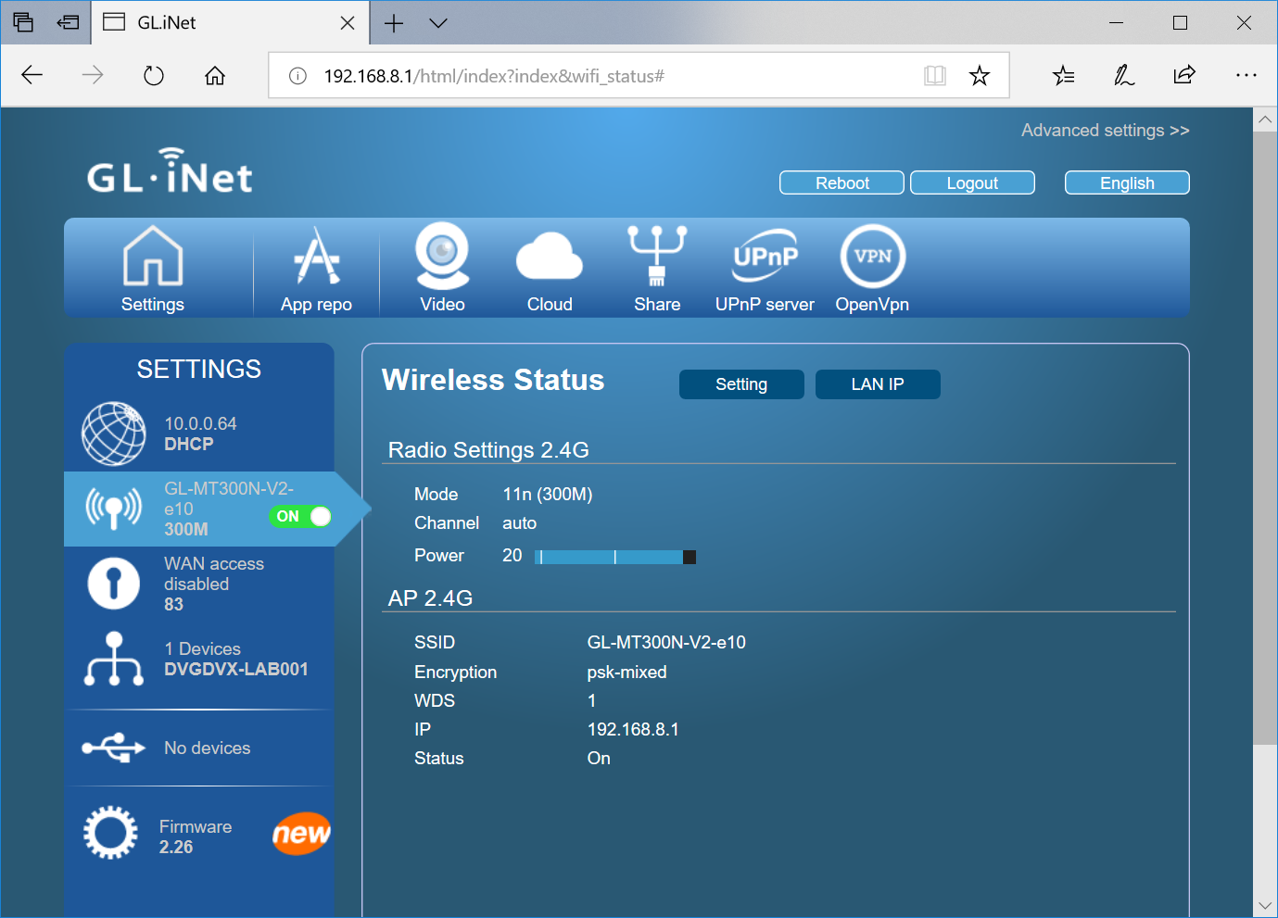
Settings
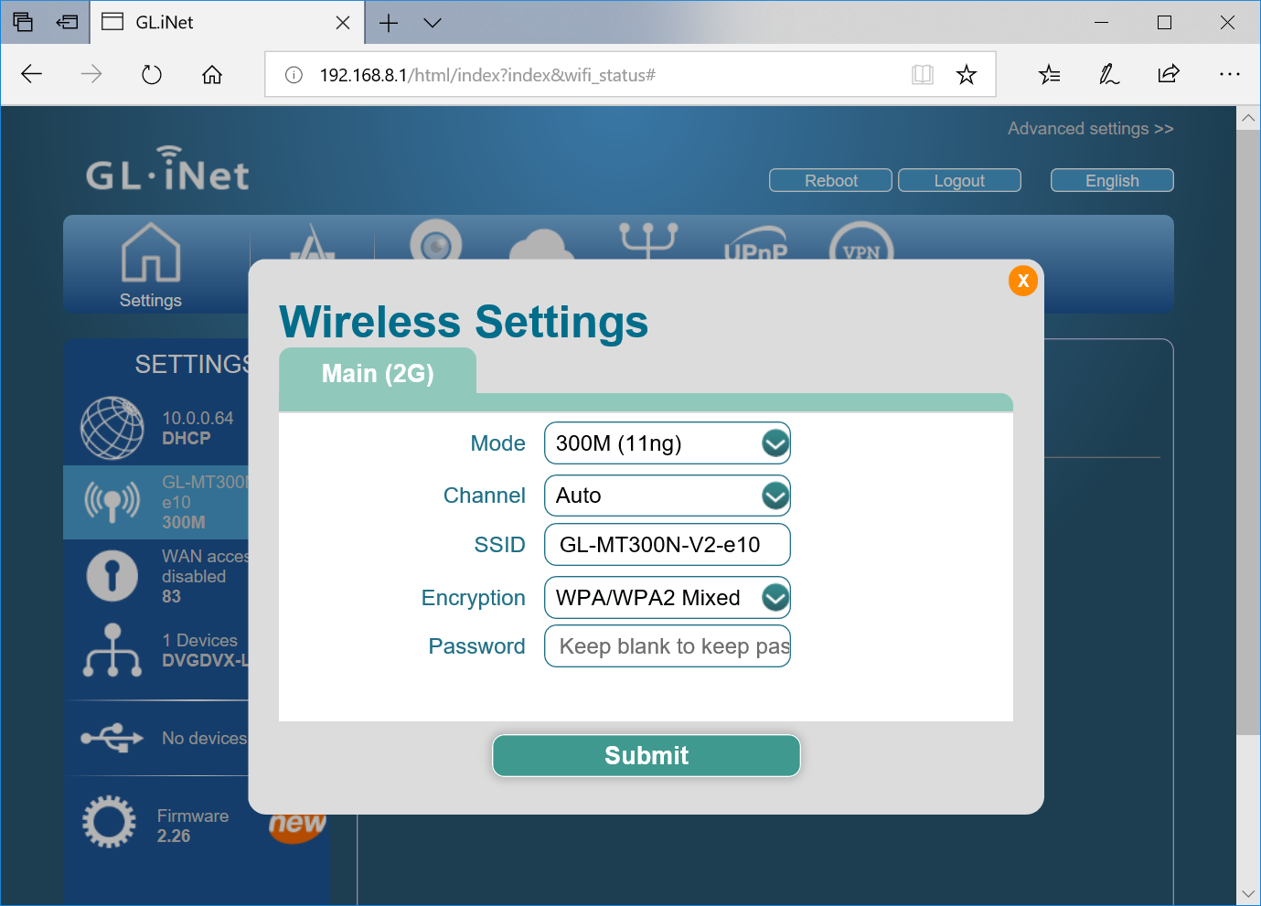
Click on setting: The following window will open where you can enter your own SSID and PW:
Change wireless settings

Change the SSID and Password to your own:
To be able to connect to your own mini router, I suggest that you use your name as part of the mini router’s SSID. In this case OmarCEIS100 is used for my SSID (see below), also choose a password (minimum of 8 characters)

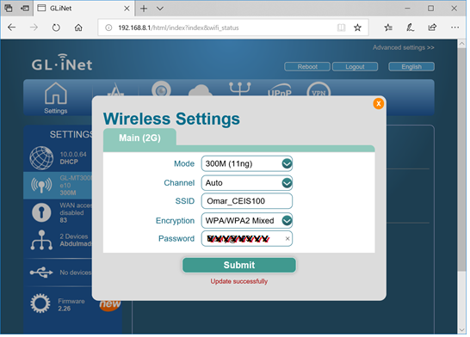
New Wireless settings
Press submit. You should see Update successfully.

Testing your newly configure router network: use your laptop or your smart phone to check the new configuration. Here is a snap shot of my newly configured mini router.

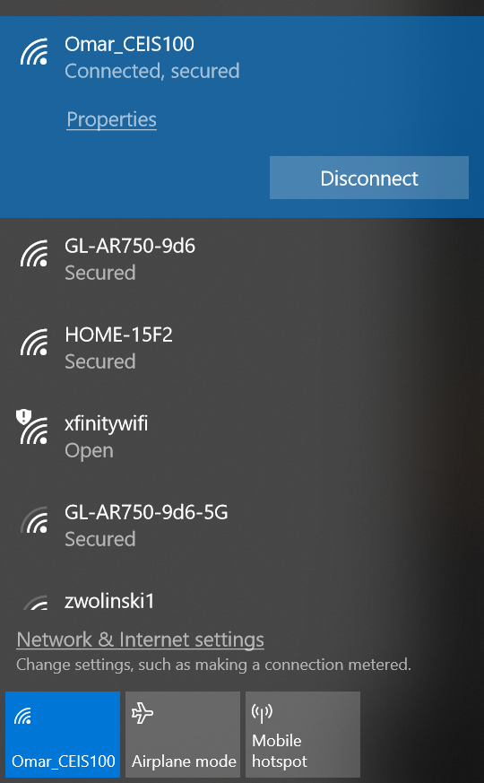
Connect to router

2) Arduino Setup for ESP32 on Windows

IMPORTANT NOTE:
- If this is your first time installing the ESP32 on the Arduino IDE, simply follow the installation procedure described below:

- If you’ve already installed the ESP32 add-on using the old method, you should remove the espressif folder first. Go to the end of this post to learn how to remove the espressif folder.
1. Installing the ESP32 Board
To install the ESP32 board in your Arduino IDE, follow these next instructions:
1) Open the preferences window from the Arduino IDE. Go to File> Preferences
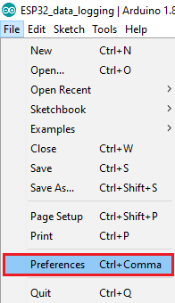
2) Enter https://dl.espressif.com/dl/package_esp32_index.json into the “Additional Board Manager URLs” field as shown in the figure below. Then, click the “OK” button:
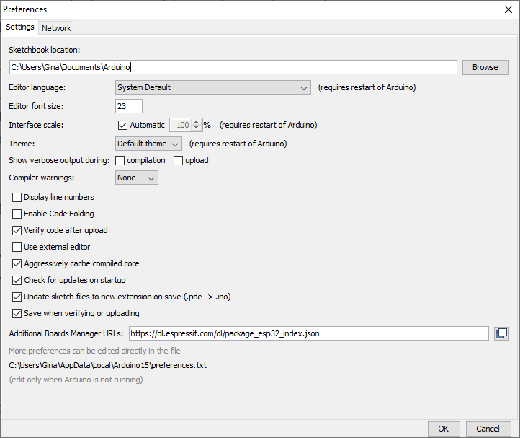
https://dl.espressif.com/dl/package_esp32_index.json
3) Open boards manager. Go to Tools > Board > Boards Manager…
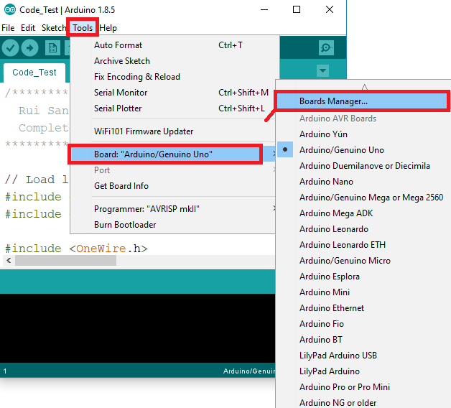
4) Search for ESP32 and press install button for the “ESP32 by Espressif Systems“:
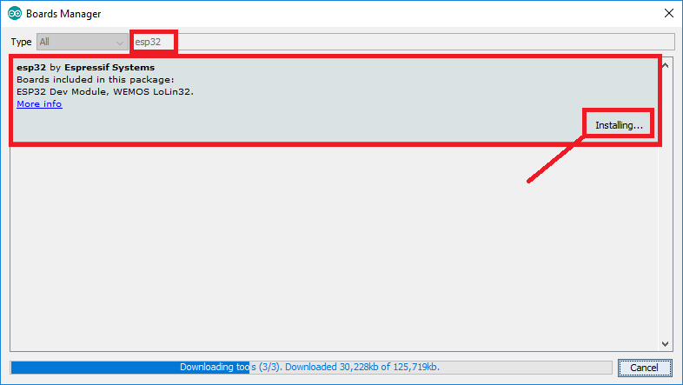
5) That’s it. It should be installed after a few seconds.

Download and Install the Serial Driver to use with the ESP32 board
To program the ESP32 Board, your development platform (PC, Mac, Linux) needs to detect the Serial-To-USB adapter soldered onto the ESP32 module. This ESP32 development module has built in a high-quality Labs CP210x Single-Chip USB to UART Bridge with Micro USB connector that baud rates up to 921600. You can download and install the driver from here: https://www.silabs.com/products/mcu/Pages/USBtoUARTBridgeVCPDrivers.aspx
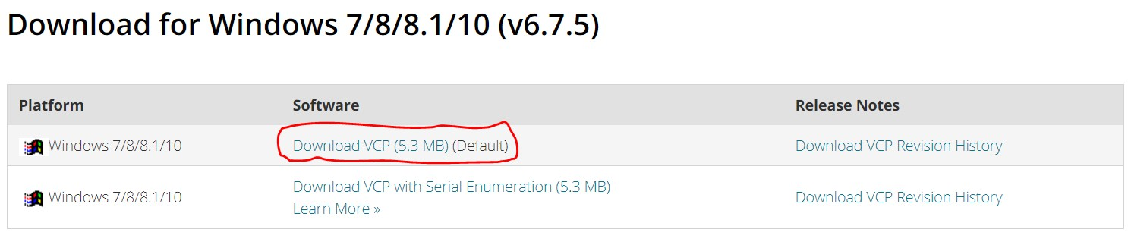
Download Development module

Extract the zipped folder: CP210x_Windows_Drivers
The contents will look like the following:
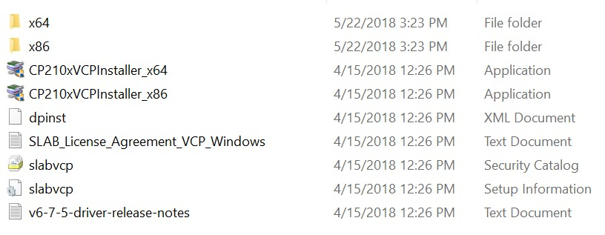
Folder contents

One way to install the driver is to double click on the application file (CP210xVCPInstaller_x64) shown above.
NOTE: You can also download this folder from the Files section of the course.

Testing the ESP32 board

- Open a new Arduino Sketch in the Arduino IDE
- To add the ESP32 board, go to Tools > Board > DOIT ESP32 DEVKIT V1
- Add the correct port. With the ESP32 board firmly connected to the breadboard, connect the ESP32 board to your computer using a USB cable. Go to device manager and note the com port listed there (COM4 listed below).
- 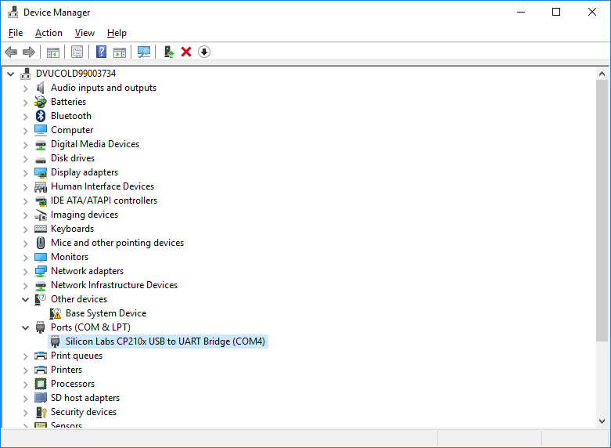
Device manager
- 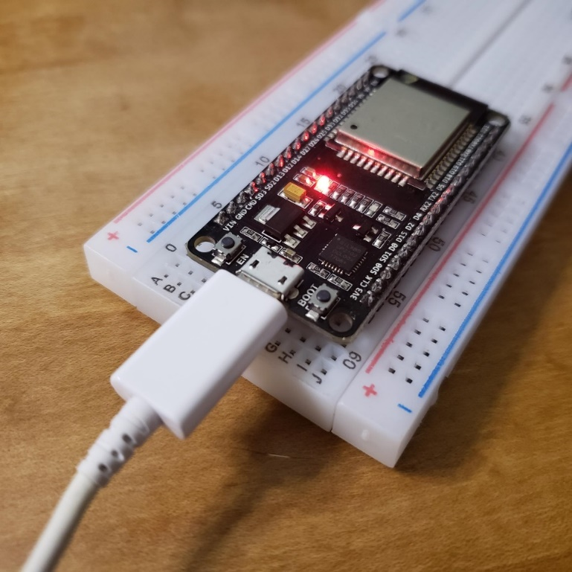
ESP32 attached to breadboard
Next connect an LED light to the breadboard. The negative side to the blue rail and the positive side connect to pin D13 on the ESP32 board. Connect the GND (ground) to the blue rail as shown below.
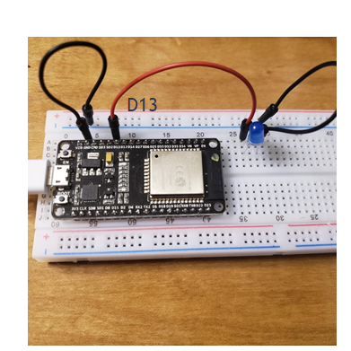
Figure 40: ESP32 with light
That is all, you should now be ready to use your ESP32 board.
-Make sure the upload speed is 115200
-Make sure the board is the DOIT ESP32 DEVKIT V1
-Be sure you have the correct com port selected. Note - the com port option will not appear until you connect the board to your laptop
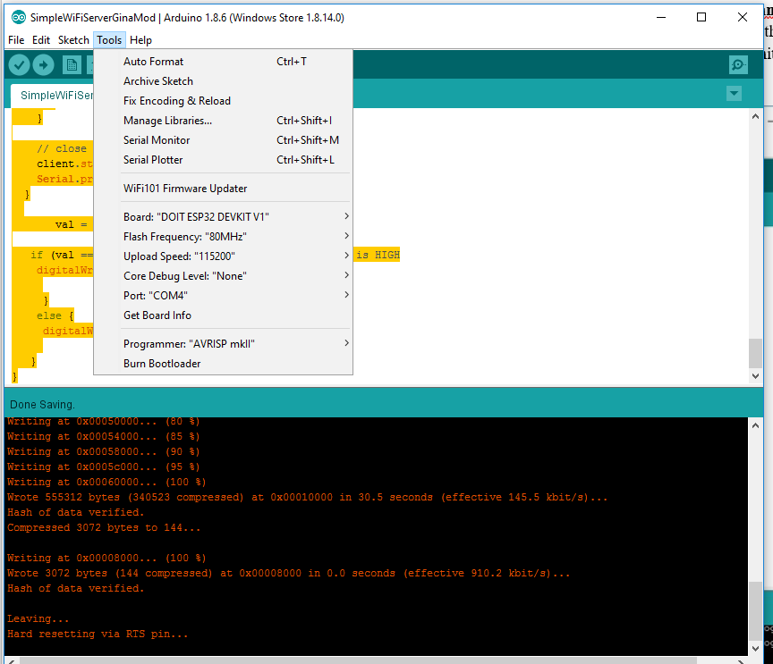
Figure 43: Board setup

Testing the WiFi Setup
- Test the WiFi Scanner using the following sketch: File > Examples > WiFi > WiFiScan . Verify, upload, and run. Important: While you are uploading the sketch, press and hold the boot button down until you see “Done Uploading” On the output display. Then open the Serial Monitor. Next press the EN button to reset. You will see a list of networks showing.
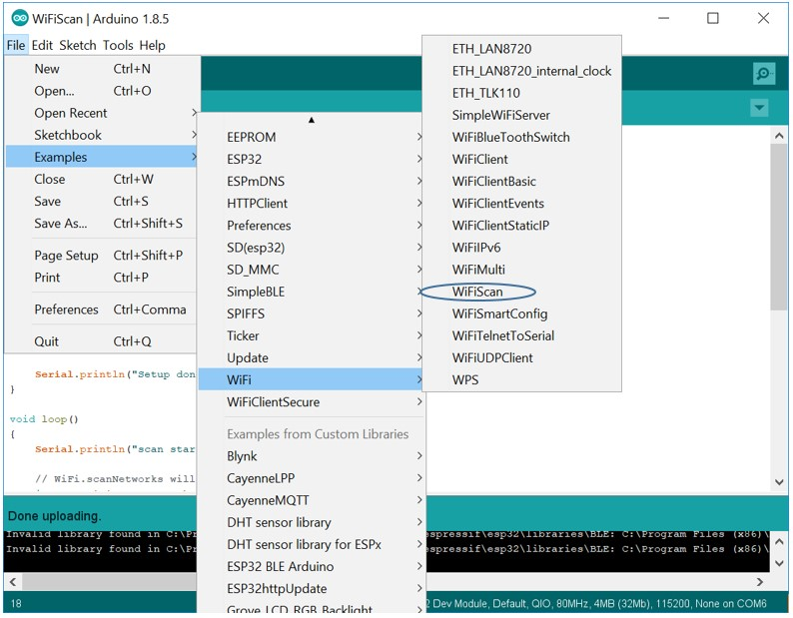
Figure 44: Test wifi scan

Wait until you see the writing list at 100% to stop holding the boot button:
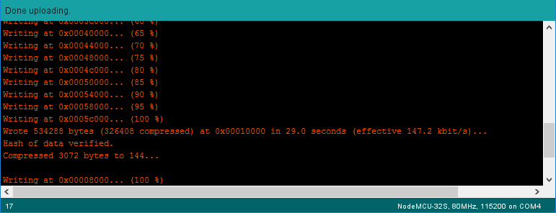
Figure 45: WifiScan
Then open the Serial Monitor and change the baud rate to 115200 and copy and paste the list of discovered networks
Sample Result:
scan start
scan done
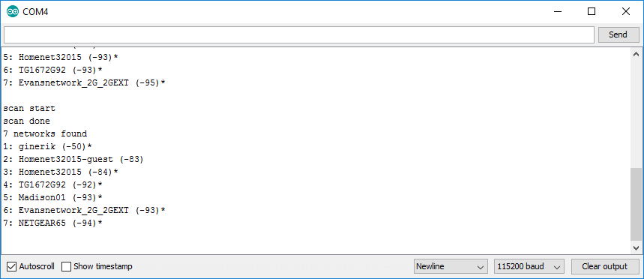
Figure 46: Serial monitor showing networks
Note: if you try to open the serial monitor while the code is uploading you will get the following error. Also be sure the baud rate in the lower corner is set to 115200.
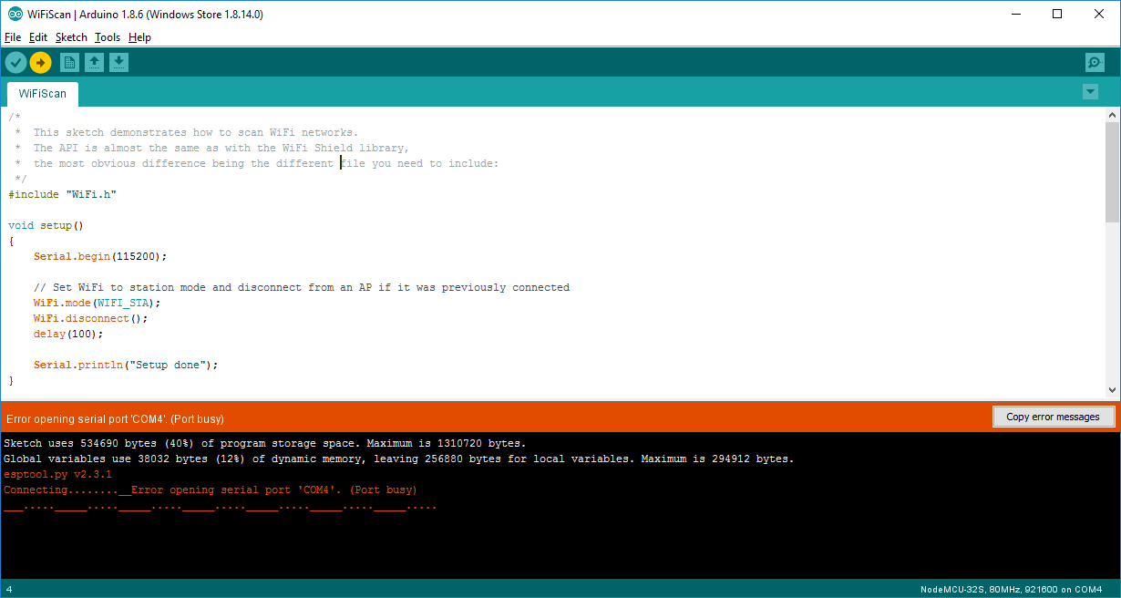
Figure 47: Possible error
- Create a web server. We will be using the following code and your home network however you will need to make some changes:
- You can use the instructions at the end of this document to set up your router and use your own router for the following code.
- In this code you will see the following commands
const char* ssid = "*******";
const char* password = "*********";
- You will need to change the SSID to your own network. You can use the SSID of your home wifi network or the router.
- Change the password to your own password on your router. You should have a password on your router. Be sure your settings match those below:
- Board = DOIT ESP32 DEVKIT V1
- Upload Speed: 115200
- Port: COMx where x is greater than 2. You will see an option for the board com port once you plug it in.
- Change the “Your Name” in the first line of the web site to your own name. In the code below:
client.print("Welcome to Your Name website!<br>"); Replace with your name
#include <ETH.h>
#include <WiFi.h>
#include <WiFiAP.h>
#include <WiFiClient.h>
#include <WiFiGeneric.h>
#include <WiFiMulti.h>
#include <WiFiScan.h>
#include <WiFiServer.h>
#include <WiFiSTA.h>
#include <WiFiType.h>
#include <WiFiUdp.h>

/*
WiFi Web Server

A simple web server that lets you blink an LED via the web.
This sketch will print the IP address of your WiFi Shield (once connected)
to the Serial monitor. From there, you can open that address in a web browser
to turn on and off the LED on pin 13.

If the IP address of your shield is yourAddress:
http://yourAddress/H turns the LED on
http://yourAddress/L turns it off

This example is written for a network using WPA encryption. For
WEP or WPA, change the Wifi.begin() call accordingly.

Circuit:
* WiFi shield attached
* LED attached to pin 13

*/

const int LED=13;
const char* ssid = "********"; //Change the SSID of YOUR network
const char* password = "*********"; //Change to the password of YOUR network
int status=WL_IDLE_STATUS;
WiFiServer server(80);
int val = 0;
void setup()
{
Serial.begin(115200);
pinMode(LED, OUTPUT); // set the LED pin mode

delay(10);

// We start by connecting to a WiFi network

Serial.println();
Serial.println();
Serial.print("Connecting to ");
Serial.println(ssid);

status=WiFi.begin(ssid, password);

while (status != WL_CONNECTED) {
Serial.println(WiFi.status());
delay(3000);
Serial.print(".");
status= WiFi.begin(ssid, password);
}

Serial.println("");
Serial.println("WiFi connected.");
Serial.println("IP address: ");
Serial.println(WiFi.localIP());

server.begin();

}

int value = 0;

void loop(){
WiFiClient client = server.available(); // listen for incoming clients

if (client) { // if you get a client,
Serial.println("New Client."); // print a message out the serial port
String currentLine = ""; // make a String to hold incoming data from the client
while (client.connected()) { // loop while the client's connected
if (client.available()) { // if there's bytes to read from the client,
char c = client.read(); // read a byte, then
Serial.write(c); // print it out the serial monitor
if (c == '\n') { // if the byte is a newline character

// if the current line is blank, you got two newline characters in a row.
// that's the end of the client HTTP request, so send a response:
if (currentLine.length() == 0) {
// HTTP headers always start with a response code (e.g. HTTP/1.1 200 OK)
// and a content-type so the client knows what's coming, then a blank line:
client.println("HTTP/1.1 200 OK");
client.println("Content-type:text/html");
client.println();

// the content of the HTTP response follows the header:
client.print("Welcome to Your Name website!<br>"); //Change to your name
client.print("Click <a href=\"/H\">here</a> to turn the LED on.<br>");
client.print("Click <a href=\"/L\">here</a> to turn the LED off.<br>");

// The HTTP response ends with another blank line:
client.println();
// break out of the while loop:
break;
} else { // if you got a newline, then clear currentLine:
currentLine = "";
}
} else if (c != '\r') { // if you got anything else but a carriage return character,
currentLine += c; // add it to the end of the currentLine
}

// Check to see if the client request was "GET /H" or "GET /L":
if (currentLine.endsWith("GET /H")) {
digitalWrite(LED, HIGH); // GET /H turns the LED on
}
if (currentLine.endsWith("GET /L")) {
digitalWrite(LED, LOW); // GET /L turns the LED off
}
}
}

// close the connection:
client.stop();
Serial.println("Client Disconnected.");
}

}

Save this code as WifiServer and upload this code to the board with your ESP32. Hold the boot button while it is uploading and let go once you see “Done Uploading”. Open the serial monitor. Then press the EN button to reboot. You should see the following:
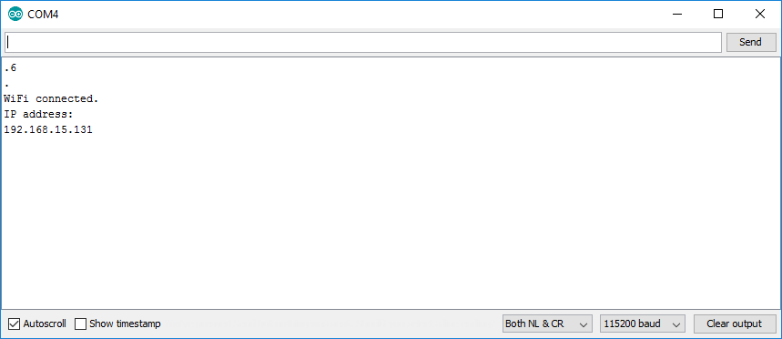
Figure 48: Web server

This means your web server is located at the address above. The address for this example is 192.168.15.131

Now open a web browser. Put the address of your web server with http:// in front in the address bar. Example: http://192.168.15.131
Now click the buttons to turn the LED on from your browser. You can also use your phone.

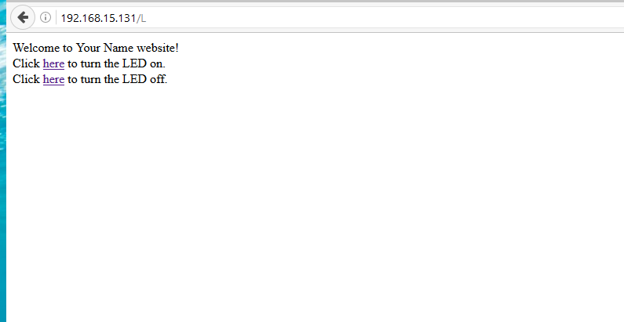
Figure 49: Using the web server
You can also attach your motion sensor and buzzer to this circuit as well. Connect the VIN on the ESP32 board to the red positive rail. Connect the positive side of the motion sensor to the red positive rail. Connect the middle wire of the motion sensor to D14 on the ESP32 board and connect the negative wire of the motion sensor to the blue negative rail. Attach the buzzer to the breadboard. Connect the negative side of the buzzer to the negative rail of the breadboard. Attach the positive side of the buzzer to D12. Keep the LED the same. Save and upload the following code. You can control the light from the web server and pass your hand over the motion sensor to activate the buzzer. Congratulations! You have created an IoT home security system.
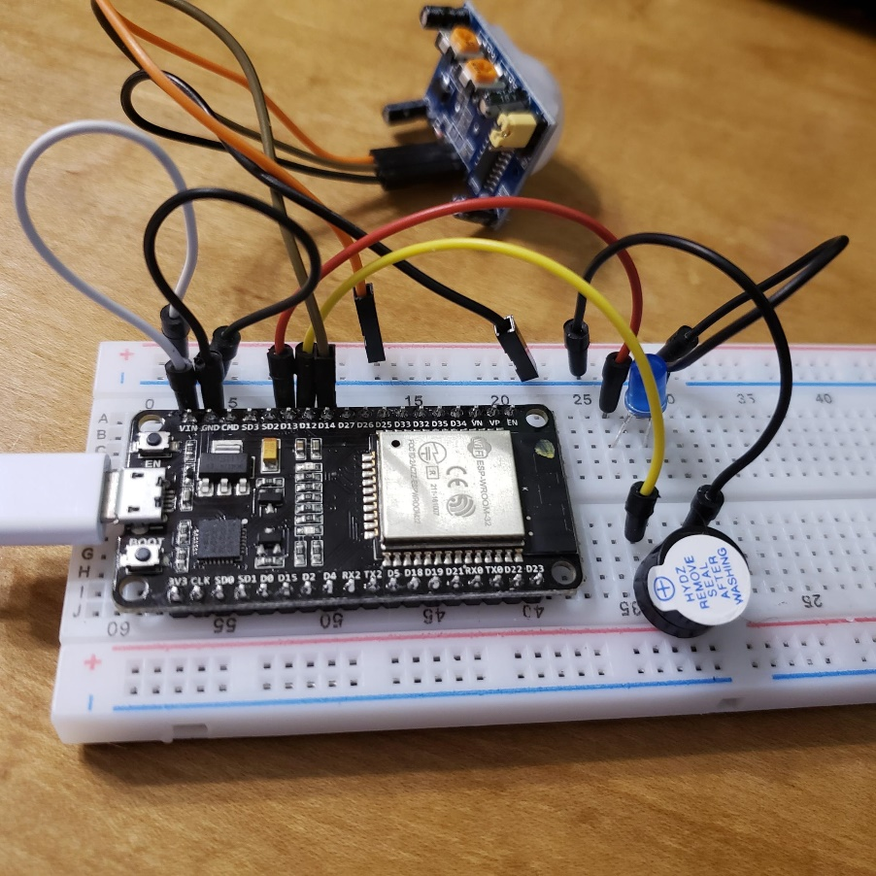
Figure 50: Buzzer and Motion sensor connection
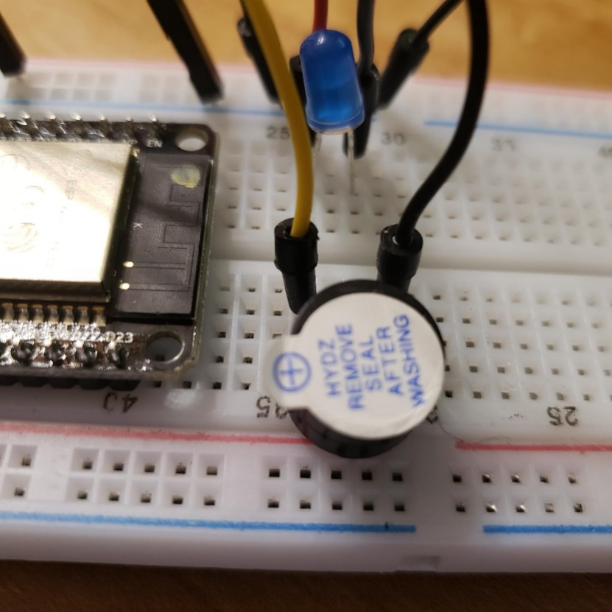
Figure 51: Closeup on buzzer

#include <ETH.h>
#include <WiFi.h>
#include <WiFiAP.h>
#include <WiFiClient.h>
#include <WiFiGeneric.h>
#include <WiFiMulti.h>
#include <WiFiScan.h>
#include <WiFiServer.h>
#include <WiFiSTA.h>
#include <WiFiType.h>
#include <WiFiUdp.h>

/*
WiFi Web Server

A simple web server that lets you blink an LED via the web.
This sketch will print the IP address of your WiFi Shield (once connected)
to the Serial monitor. From there, you can open that address in a web browser
to turn on and off the LED on pin 13.

If the IP address of your shield is yourAddress:
http://yourAddress/H turns the LED on
http://yourAddress/L turns it off

This example is written for a network using WPA encryption. For
WEP or WPA, change the Wifi.begin() call accordingly.

Circuit:
* WiFi shield attached
* LED attached to pin 13
*Buzzer attached to 12
*PIR attached to 14

*/

const int LED=13;
const int buzzer=12;
const int PIR=14;
const char* ssid = "********"; //Change the SSID of YOUR network
const char* password = "*********"; //Change to the password of YOUR network
int status=WL_IDLE_STATUS;
WiFiServer server(80);
int val = 0;
void setup()
{
Serial.begin(115200);
pinMode(LED, OUTPUT); // set the LED pin mode
pinMode(buzzer, OUTPUT); // declare buzzer as output
pinMode(PIR, INPUT); // declare sensor as input

delay(10);

// We start by connecting to a WiFi network

Serial.println();
Serial.println();
Serial.print("Connecting to ");
Serial.println(ssid);

status=WiFi.begin(ssid, password);

while (status != WL_CONNECTED) {
Serial.println(WiFi.status());
delay(3000);
Serial.print(".");
status= WiFi.begin(ssid, password);
}

Serial.println("");
Serial.println("WiFi connected.");
Serial.println("IP address: ");
Serial.println(WiFi.localIP());

server.begin();

}

int value = 0;

void loop(){
WiFiClient client = server.available(); // listen for incoming clients

if (client) { // if you get a client,
Serial.println("New Client."); // print a message out the serial port
String currentLine = ""; // make a String to hold incoming data from the client
while (client.connected()) { // loop while the client's connected
if (client.available()) { // if there's bytes to read from the client,
char c = client.read(); // read a byte, then
Serial.write(c); // print it out the serial monitor
if (c == '\n') { // if the byte is a newline character

// if the current line is blank, you got two newline characters in a row.
// that's the end of the client HTTP request, so send a response:
if (currentLine.length() == 0) {
// HTTP headers always start with a response code (e.g. HTTP/1.1 200 OK)
// and a content-type so the client knows what's coming, then a blank line:
client.println("HTTP/1.1 200 OK");
client.println("Content-type:text/html");
client.println();

// the content of the HTTP response follows the header:
client.print("Welcome to Your Name website!<br>"); //Change to your name
client.print("Click <a href=\"/H\">here</a> to turn the LED on.<br>");
client.print("Click <a href=\"/L\">here</a> to turn the LED off.<br>");

// The HTTP response ends with another blank line:
client.println();
// break out of the while loop:
break;
} else { // if you got a newline, then clear currentLine:
currentLine = "";
}
} else if (c != '\r') { // if you got anything else but a carriage return character,
currentLine += c; // add it to the end of the currentLine
}

// Check to see if the client request was "GET /H" or "GET /L":
if (currentLine.endsWith("GET /H")) {
digitalWrite(LED, HIGH); // GET /H turns the LED on
}
if (currentLine.endsWith("GET /L")) {
digitalWrite(LED, LOW); // GET /L turns the LED off
}
}
}

// close the connection:
client.stop();
Serial.println("Client Disconnected.");
}

val = digitalRead(PIR); // read input value

if (val == HIGH) { // check if the input is HIGH
digitalWrite(buzzer, HIGH); // turn buzzer ON

}
else {
digitalWrite(buzzer, LOW); // turn Buzzer OFF

}
}
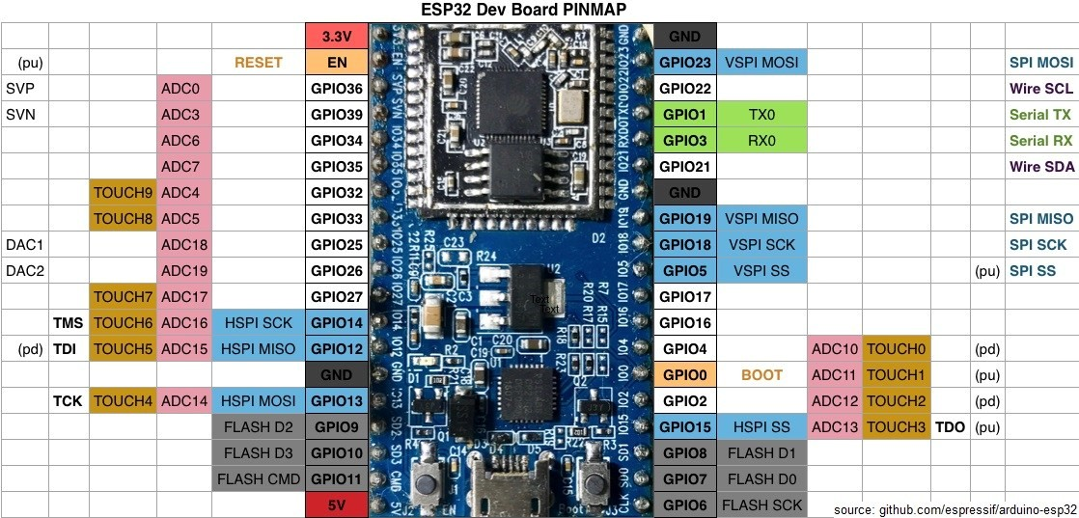
Figure 52: Pin mapping

Deliverables
- Complete the Course Project Powerpoint Deliverable
- Include a picture of your circuit
- Screenshot of router main page
- Screenshot of web server

