You can also attach your motion sensor and buzzer to this circuit as well. Connect the VIN on the ESP32 board to the red positive rail. Connect the positive side of the motion sensor to the red positive rail. Connect the middle wire of the motion sensor to D14 on the ESP32 board and connect the negative wire of the motion sensor to the blue negative rail. Attach the buzzer to the breadboard. Connect the negative side of the buzzer to the negative rail of the breadboard. Attach the positive side of the buzzer to D12. Keep the LED the same. Save and upload the following code. You can control the light from the web server and pass your hand over the motion sensor to activate the buzzer. Congratulations! You have created an IoT home security system.
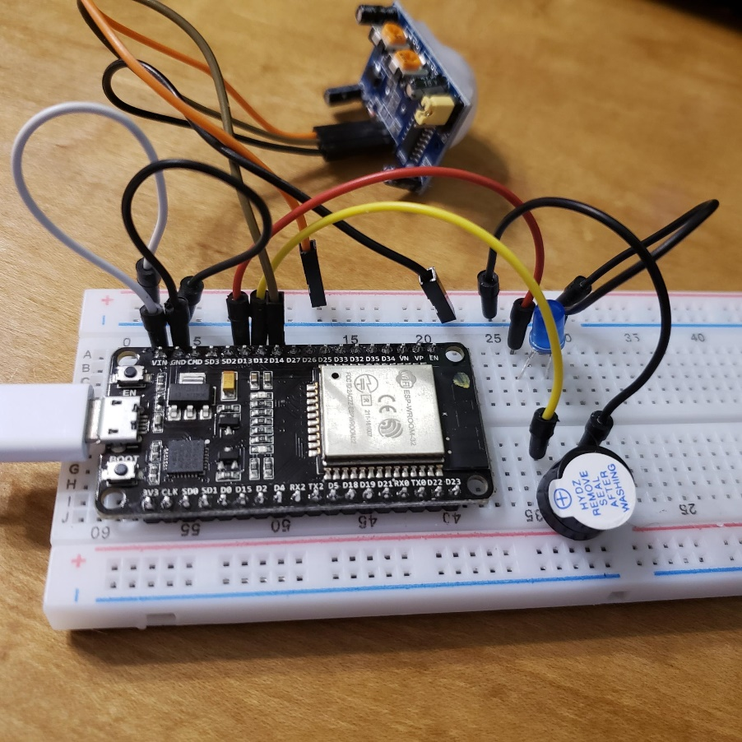
Buzzer and Motion sensor connection
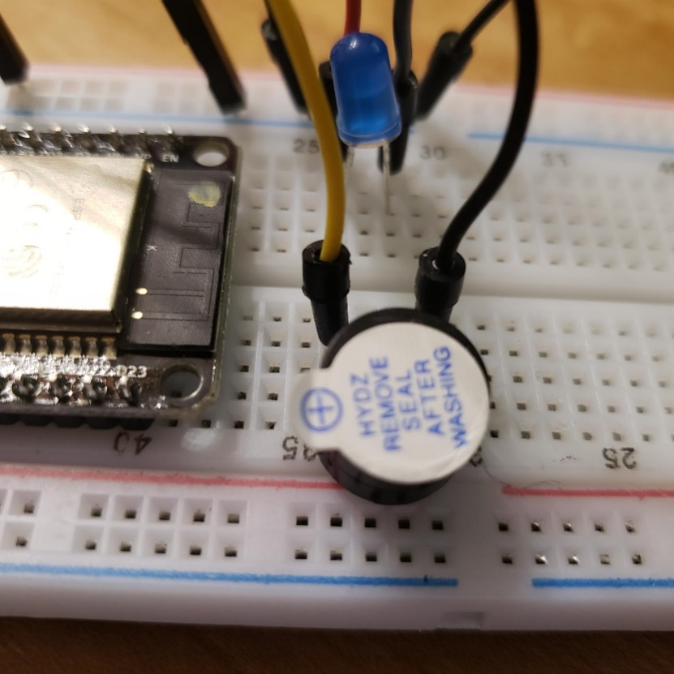
Closeup on buzzer

#include <ETH.h>
#include <WiFi.h>
#include <WiFiAP.h>
#include <WiFiClient.h>
#include <WiFiGeneric.h>
#include <WiFiMulti.h>
#include <WiFiScan.h>
#include <WiFiServer.h>
#include <WiFiSTA.h>
#include <WiFiType.h>
#include <WiFiUdp.h>

/*
WiFi Web Server

A simple web server that lets you blink an LED via the web.
This sketch will print the IP address of your WiFi Shield (once connected)
to the Serial monitor. From there, you can open that address in a web browser
to turn on and off the LED on pin 13.

If the IP address of your shield is yourAddress:
http://yourAddress/H turns the LED on
http://yourAddress/L turns it off

This example is written for a network using WPA encryption. For
WEP or WPA, change the Wifi.begin() call accordingly.

Circuit:
* WiFi shield attached
* LED attached to pin 13
*Buzzer attached to 12
*PIR attached to 14

*/

const int LED=13;
const int buzzer=12;
const int PIR=14;
const char* ssid = "********"; //Change the SSID of YOUR network
const char* password = "*********"; //Change to the password of YOUR network
int status=WL_IDLE_STATUS;
WiFiServer server(80);
int val = 0;
void setup()
{
Serial.begin(115200);
pinMode(LED, OUTPUT); // set the LED pin mode
pinMode(buzzer, OUTPUT); // declare buzzer as output
pinMode(PIR, INPUT); // declare sensor as input

delay(10);

// We start by connecting to a WiFi network

Serial.println();
Serial.println();
Serial.print("Connecting to ");
Serial.println(ssid);

status=WiFi.begin(ssid, password);

while (status != WL_CONNECTED) {
Serial.println(WiFi.status());
delay(3000);
Serial.print(".");
status= WiFi.begin(ssid, password);
}

Serial.println("");
Serial.println("WiFi connected.");
Serial.println("IP address: ");
Serial.println(WiFi.localIP());

server.begin();

}

int value = 0;

void loop(){
WiFiClient client = server.available(); // listen for incoming clients

if (client) { // if you get a client,
Serial.println("New Client."); // print a message out the serial port
String currentLine = ""; // make a String to hold incoming data from the client
while (client.connected()) { // loop while the client's connected
if (client.available()) { // if there's bytes to read from the client,
char c = client.read(); // read a byte, then
Serial.write(c); // print it out the serial monitor
if (c == '\n') { // if the byte is a newline character

// if the current line is blank, you got two newline characters in a row.
// that's the end of the client HTTP request, so send a response:
if (currentLine.length() == 0) {
// HTTP headers always start with a response code (e.g. HTTP/1.1 200 OK)
// and a content-type so the client knows what's coming, then a blank line:
client.println("HTTP/1.1 200 OK");
client.println("Content-type:text/html");
client.println();

// the content of the HTTP response follows the header:
client.print("Welcome to Your Name website!<br>"); //Change to your name
client.print("Click <a href=\"/H\">here</a> to turn the LED on.<br>");
client.print("Click <a href=\"/L\">here</a> to turn the LED off.<br>");

// The HTTP response ends with another blank line:
client.println();
// break out of the while loop:
break;
} else { // if you got a newline, then clear currentLine:
currentLine = "";
}
} else if (c != '\r') { // if you got anything else but a carriage return character,
currentLine += c; // add it to the end of the currentLine
}

// Check to see if the client request was "GET /H" or "GET /L":
if (currentLine.endsWith("GET /H")) {
digitalWrite(LED, HIGH); // GET /H turns the LED on
}
if (currentLine.endsWith("GET /L")) {
digitalWrite(LED, LOW); // GET /L turns the LED off
}
}
}

// close the connection:
client.stop();
Serial.println("Client Disconnected.");
}

val = digitalRead(PIR); // read input value

if (val == HIGH) { // check if the input is HIGH
digitalWrite(buzzer, HIGH); // turn buzzer ON

}
else {
digitalWrite(buzzer, LOW); // turn Buzzer OFF

}
}

