Course Project
DeVry University
College of Engineering and Information Sciences

Module 5: Adding a serial monitor and calculated data display to notify an intruder alert

Objectives
- To learn how to display data on the serial monitor
- To learn how to do calculations in the Arduino IDE
- To display both calculations and data on the serial monitor
- To practice wiring a resistor to the breadboard
- To experiment with resistors and display voltage to the serial monitor
- To practice writing programs using the Arduino IDE

PARTS LIST
Equipment:
- PC running Arduino IDE
- Mega 2560 Board
- Motion Sensor
- Buzzer
- Wires
- 220Ω resistor
- 10kΩ resistor
- Breadboard
- USB cable

INTRODUCTION

Serial Monitor
The Serial monitor is used for data display. The following functions are some that you will use with the serial monitor.

Serial.begin()
Sets the data rate in bits per second (baud) for serial data transmission. For communicating with the computer, use one of these rates: 300, 600, 1200, 2400, 4800, 9600, 14400, 19200, 28800, 38400, 57600, or 115200. Example is:
Serial.begin(9600); // open the serial port at 9600 bps:
Serial.print()
Prints data to the serial port as human-readable ASCII text. Example is:
Serial.print("This course: "); // prints a label
Serial.println()
Prints data to the serial port as human-readable ASCII text followed by a carriage return character (ASCII 13, or '\r') and a newline character. Example is:
Serial.println("is an IoT based course"); // carriage return after the last label

In order to display text or data on the serial monitor we have to initialize the serial port and set up the transmission rate (bits per second) in the code below.

Serial monitor for Arduino Mega 2560:
Keep your hardware circuit the same from last week and copy and paste the following code into a new project.

int buzzerPin = 7; // choose the pin for the buzzer
int inputPin = 8; // choose the input pin (for PIR sensor)
int pirState = LOW; // we start, assuming no motion detected
int val = 0; // variable for reading the pin status
int count=0;
void setup() {

pinMode(buzzerPin, OUTPUT); // declare buzzer as output
pinMode(inputPin, INPUT); // declare sensor as input

Serial.begin(9600);
}

void loop(){
val = digitalRead(inputPin); // read input value
if (val == HIGH) { // check if the input is HIGH
digitalWrite(buzzerPin, HIGH); // turn buzzer ON
if (pirState == LOW) {
// we have just turned on
count=count+1;
Serial.println("Motion detected!");
Serial.println(count);

// We only want to print on the output change, not state
pirState = HIGH;
}
} else {
digitalWrite(buzzerPin, LOW); // turn buzzer OFF
if (pirState == HIGH){
// we have just turned of
Serial.println("Motion ended!");

// We only want to print on the output change, not state
pirState = LOW;
}
}
}

Example Serial Monitor: 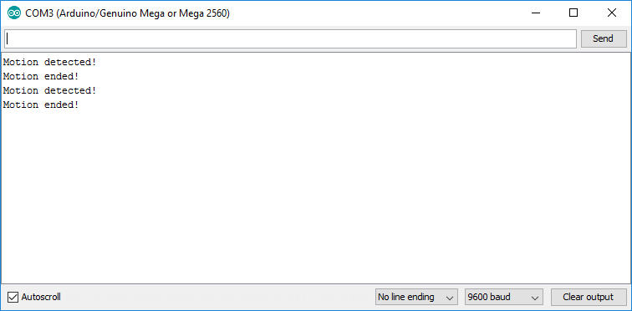
Figure 1: Example Serial Monitor
Close the serial monitor after use. You may get an error if you connect your Arduino board when the serial monitor is open. Add the following code to the setup(). Compile and upload the modified code. Do you see your name listed?

Serial.println(“Code written by ----------------“;// add your name

Using the Serial Monitor to Display Calculations and Voltage
The serial monitor can also display calculations performed using the sensors or counters. This example will display the number of times the motion detector was activated. When the motion sensor is powered, the state of the pin will be LOW. We can use the Arduino as a voltmeter to observe what happens when the PIR detects motion. The analog PINs A0 and A1 on the Arduino board can be connected to the positive and negative sides of the buzzer. (Use A0 as positive and A1 as negative).

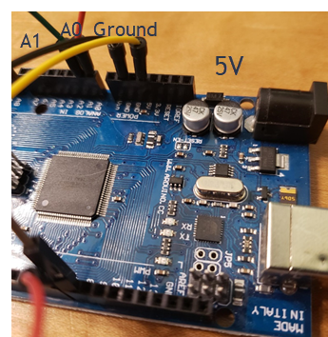
Figure 2:Arduino close up
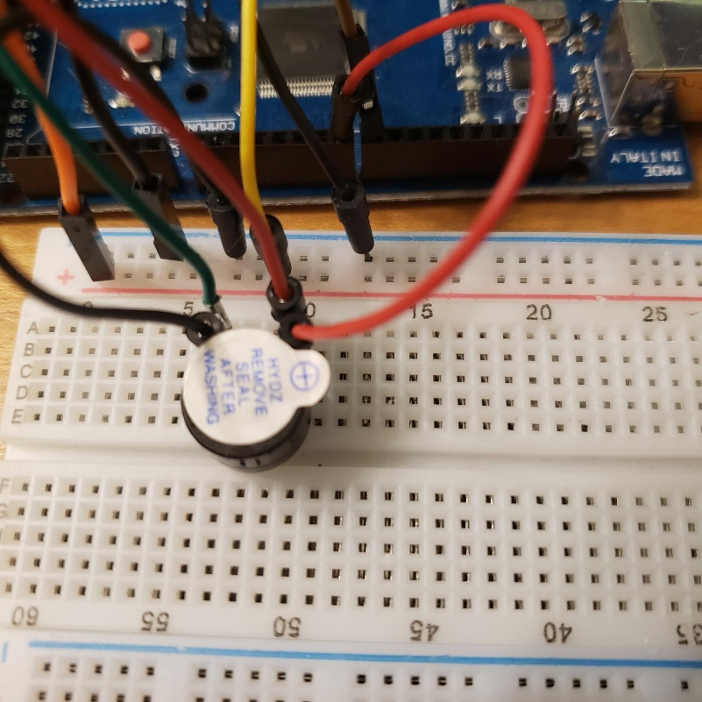
Figure 3: Buzzer connection

Use the following code to output on the serial monitor the voltage difference and how many times motion was detected:

int positive =0;
int negative =1;

int buzzerPin = 7; // choose the pin for the buzzer
int inputPin = 8; // choose the input pin (for PIR sensor)
int pirState = LOW; // we start, assuming no motion detected
int val = 0; // variable for reading the pin status
int count=0;
void setup() {

pinMode(buzzerPin, OUTPUT); // declare buzzer as output
pinMode(inputPin, INPUT); // declare sensor as input

Serial.begin(9600);
}

void loop(){
val = digitalRead(inputPin); // read input value
if (val == HIGH) { // check if the input is HIGH
digitalWrite(buzzerPin, HIGH); // turn buzzer ON
if (pirState == LOW) {
// we have just turned on
int val1=analogRead(positive);
int val2=analogRead(negative);
float v1=val1*5.0/1023;
float v2=val2*5.0/1023;

count=count+1;
Serial.print("Motion detected!");
Serial.println(count);
Serial.print(v1);
Serial.print(" ");
Serial.print(v2);
Serial.println();

// We only want to print on the output change, not state
pirState = HIGH;
}
} else {
digitalWrite(buzzerPin, LOW); // turn buzzer OFF
if (pirState == HIGH){
// we have just turned of
Serial.println("Motion ended!");

// We only want to print on the output change, not state
pirState = LOW;
}
}
}

Example:

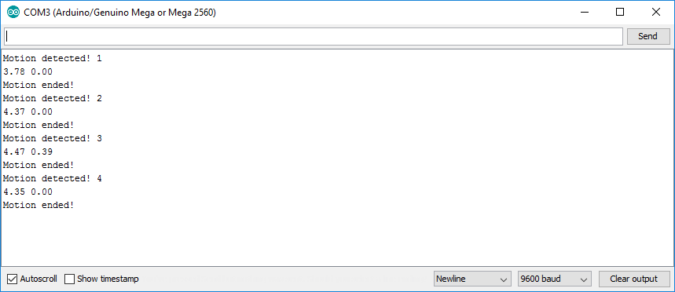
Figure 4: Serial monitor

Next let us add a resistor. In the same row as the positive lead of the buzzer add one leg of a 220 Ω resistor. Connect the other leg of the resistor to the Arduino. In the same row as the other leg of the resistor connect to A1 on the Arduino.
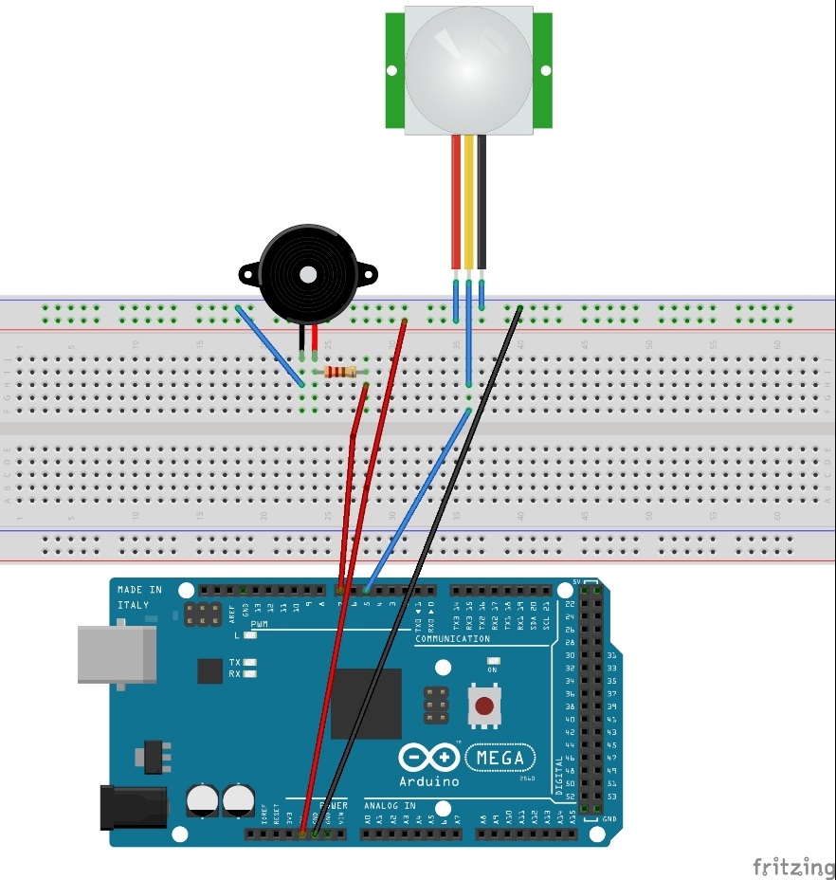
Figure 5: PIR with Buzzer and resistor schematic

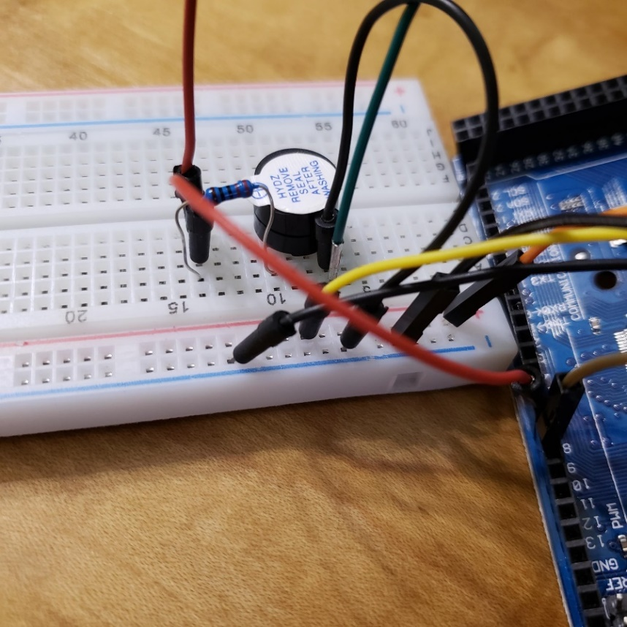
Figure 6: Buzzer and resistor
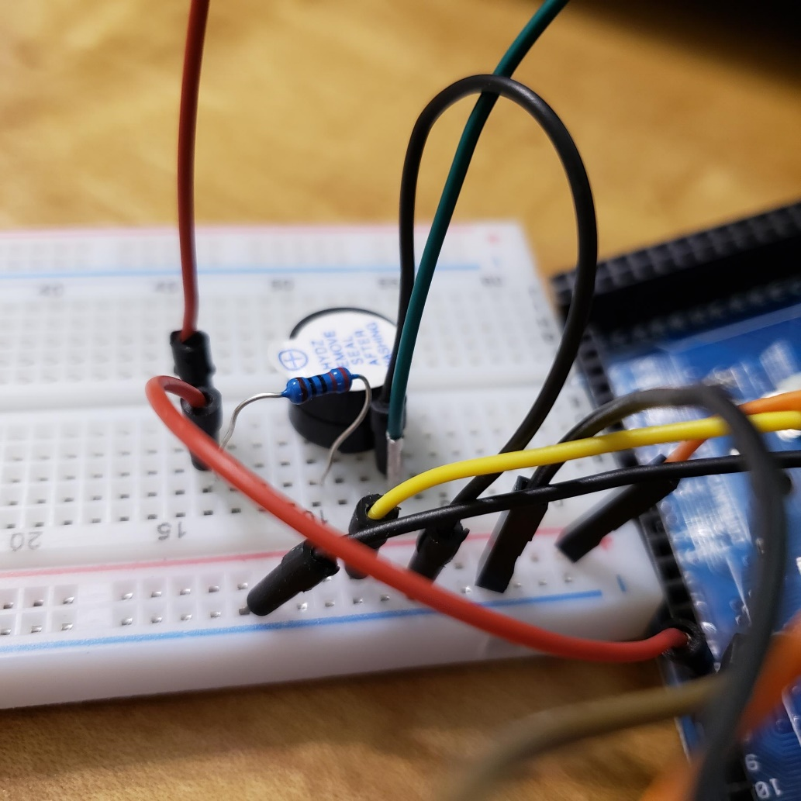
Figure 6: Breadboard

Connect the Arduino, and upload the same code. View the Serial monitor. Do you notice a difference? Is the buzzer quieter?

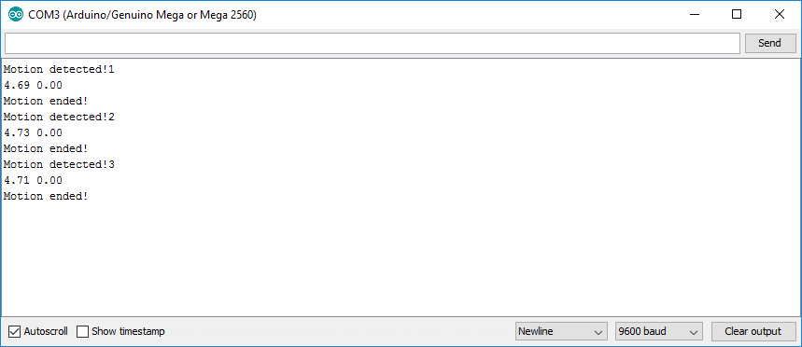
Figure 7: Serial monitor
Unplug the Arduino and replace the resistor with a 10k Ω resistor. What changes did you notice in the serial monitor?

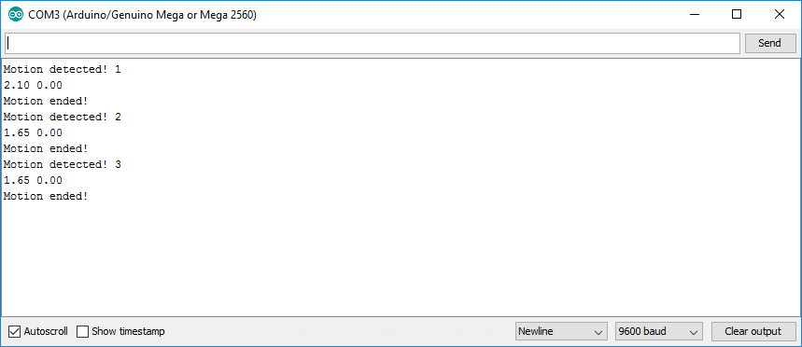
Figure 8: Serial monitor with different resistor

Deliverables
- Complete the Course Project Powerpoint Deliverable
- Include a picture of your circuit
- Include a screenshot of code
- Answer questions

