Course Project
DeVry University
College of Engineering and Information Sciences

Module 4: Adding a Motion Detector and Buzzer

Objectives
- To learn how to wire a motion sensor to the Mega 2560 board
- To learn how to write code that uses a motion sensor
- To learn how to integrate the motion sensor and an LED
- To learn how to integrate the motion sensor and a buzzer
- To practice writing programs using the Arduino IDE

PARTS LIST
- PC running Arduino IDE
- Mega 2560 Board
- Motion Sensor
- Buzzer
- Wires (both male to female and male to male)
- Breadboard
- Colored LEDs: Red, Yellow and Green
- USB cable

Motion Sensor
We will be creating a home security system that will detect motion. To do this we will use a PIR (Passive Infra-Red) to detect motion. This is a digital sensor that will drive a pin high when motion is detected and keep it low when no motion is detected. Another similar sensor in your kit is the Ultrasonic Distance Sensor. Read about this sensor and research the differences between the PIR and the Ultrasonic Distance Sensor. Wire the PIR sensor as shown below:

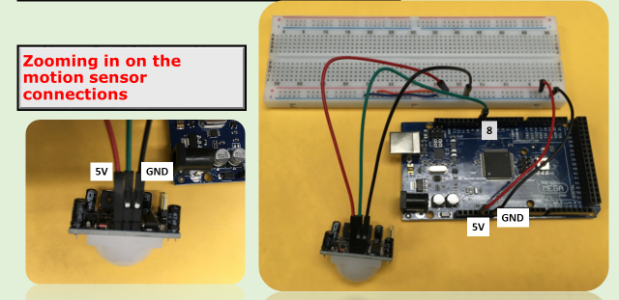
Figure 1: Motion sensor connections
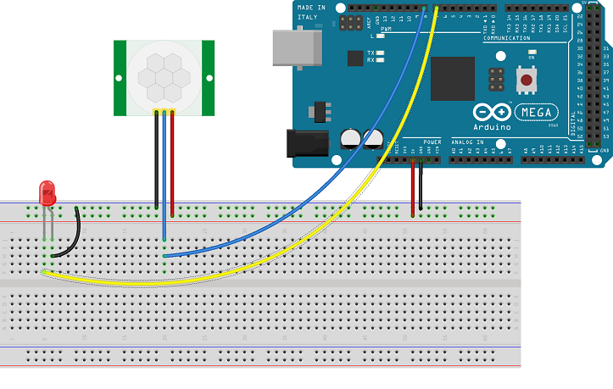
Figure 2: Motion Sensor Sketch

Open a new sketch then copy and paste the code shown below:

int LEDPin = 7; // choose the pin for the LED
int inputPin = 8; // choose the input pin (for PIR sensor)
int pirState = LOW; // we start, assuming no motion detected
int val = 0; // variable for reading the pin status

void setup() {

pinMode(LEDPin, OUTPUT); // declare buzzer as output
pinMode(inputPin, INPUT); // declare sensor as input

}

void loop(){
val = digitalRead(inputPin); // read input value
if (val == HIGH) { // check if the input is HIGH
digitalWrite(LEDPin, HIGH); // turn buzzer ON

}
else {
digitalWrite(LEDPin, LOW); // turn Buzzer OFF

}
}

Upload the code to your Mega board and verify that if motion is detected, the LED will turn on. If no motion is detected, the LED will stay off.

Adding a Buzzer to the Motion Sensor

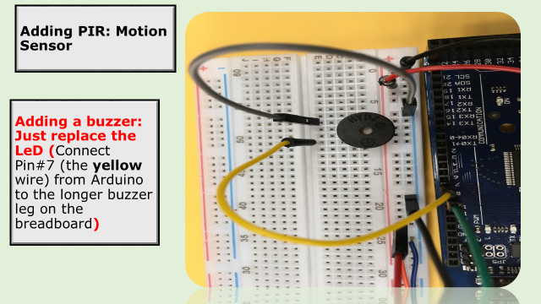
Figure 3: Adding PIR Motion Sensor
Please note – the above buzzer does not have the sticker on top. Your buzzer may have the sticker on it. Also since the buzzer is wider than the LED, you will have to move one of the wires so it matches up in the same row as the buzzer leg.

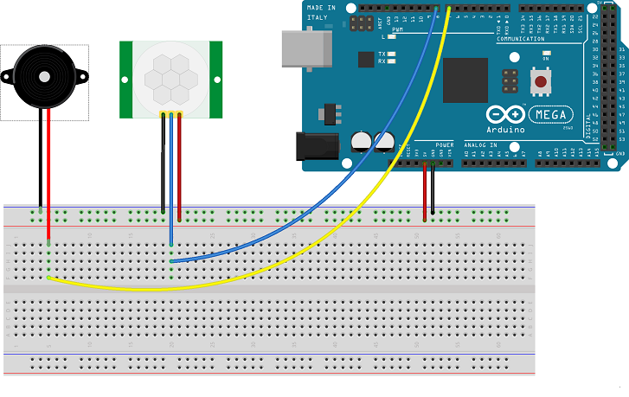
Figure 4: Sketch
Wire the buzzer to the Mega and motion sensor as shown above.
Notice that the wiring is very similar to what we have done above except that the LED was replaced with a buzzer. Hence use the same code after replacing the Led with the buzzer.

Note that the range of the PIR sensor is fairly short. It works anywhere from 3 cm to 3 m. However a little bit of experimentation is really necessary to get a very good idea as to the range of the motion sensor.

int buzzerPin = 7; // choose the pin for the buzzer
int inputPin = 8; // choose the input pin (for PIR sensor)
int pirState = LOW; // we start, assuming no motion detected
int val = 0; // variable for reading the pin status

void setup() {

pinMode(buzzerPin, OUTPUT); // declare buzzer as output
pinMode(inputPin, INPUT); // declare sensor as input

}

void loop(){
val = digitalRead(inputPin); // read input value
if (val == HIGH) { // check if the input is HIGH
digitalWrite(buzzerPin, HIGH); // turn buzzer ON

}
else {
digitalWrite(buzzerPin, LOW); // turn Buzzer OFF

}
}
Upload the code to your Mega board and verify that the buzzer makes sound when motion is detected and stays silent when no motion is detected.

Deliverables
- Complete the Course Project Powerpoint Deliverable
- Include a picture of your circuit
- Include a screenshot of the code
- Include code explanation

