Course Project

Module 3: Setting up the Arduino
This part of the course project gives you a high level overview of Microcontrollers as they relate to the IoT system architecture. A list of topics that will be addressed include the following:
- Types of microcontroller interfaced signals: Analog I/Os and Digital I/Os, Serial, Timer,… etc
- Introduction to the Integrated Development Environment (Arduino’s IDE)
  - Downloading and Installing the Arduino IDE software and driver
  - Main components of a basic program
  - Selecting Board and Com Port used
  - Compiling and uploading programs
  - Writing simple programs

Arduino Mega Board Hardware Resource Overview:
The Arduino Mega board shown below shows the main resources and their locations. This should help us locate different types of interfaces that will be used to interface sensors and actuators.
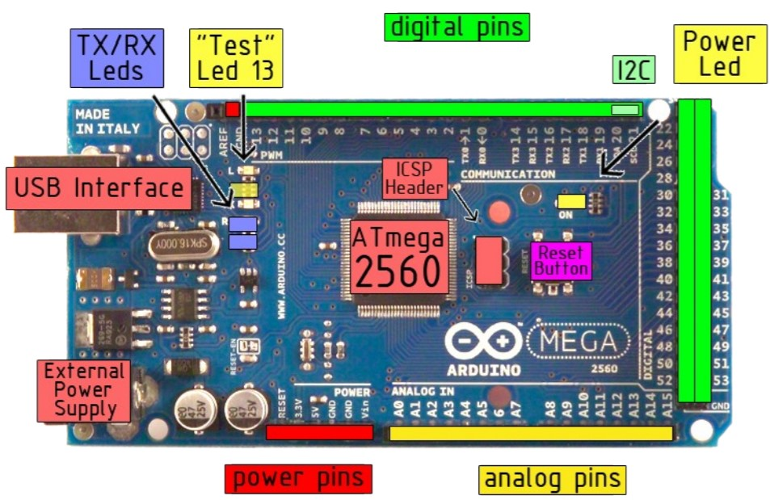
Figure 1: Arduino

Objectives
- To introduce a microcontroller as it applies to the IoT system architecture
- To learn about microcontroller main hardware components
- To learn about the software development environment
- To learn how to install the Arduino IDE and Arduino Mega drivers
- To become familiar with C programming for the Arduino Mega Microcontroller
- To learn how to select communication port and development board
- To learn how to compile and run programs on Arduino Mega board
- To practice writing programs using the Arduino IDE

Parts List
Equipment:
- PC running Arduino IDE
- Arduino Mega Board
- A USB Cable
Locate your Arduino kit:
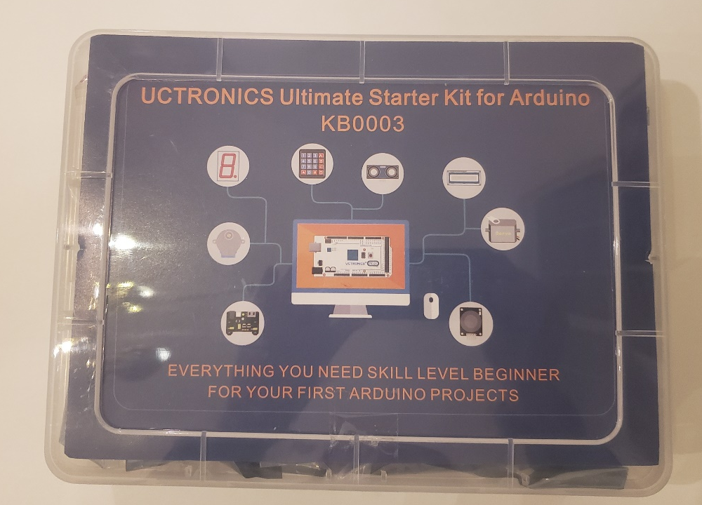
Figure 2: Arduino kit

Inside you will find many IoT components. Locate your Arduino board in the kit. It will be the circuit board with several pins with the word “MEGA”. You will also find the cable to connect it to your computer, LED lights, resistors, wires and the breadboard. We will be using these items quite a bit.
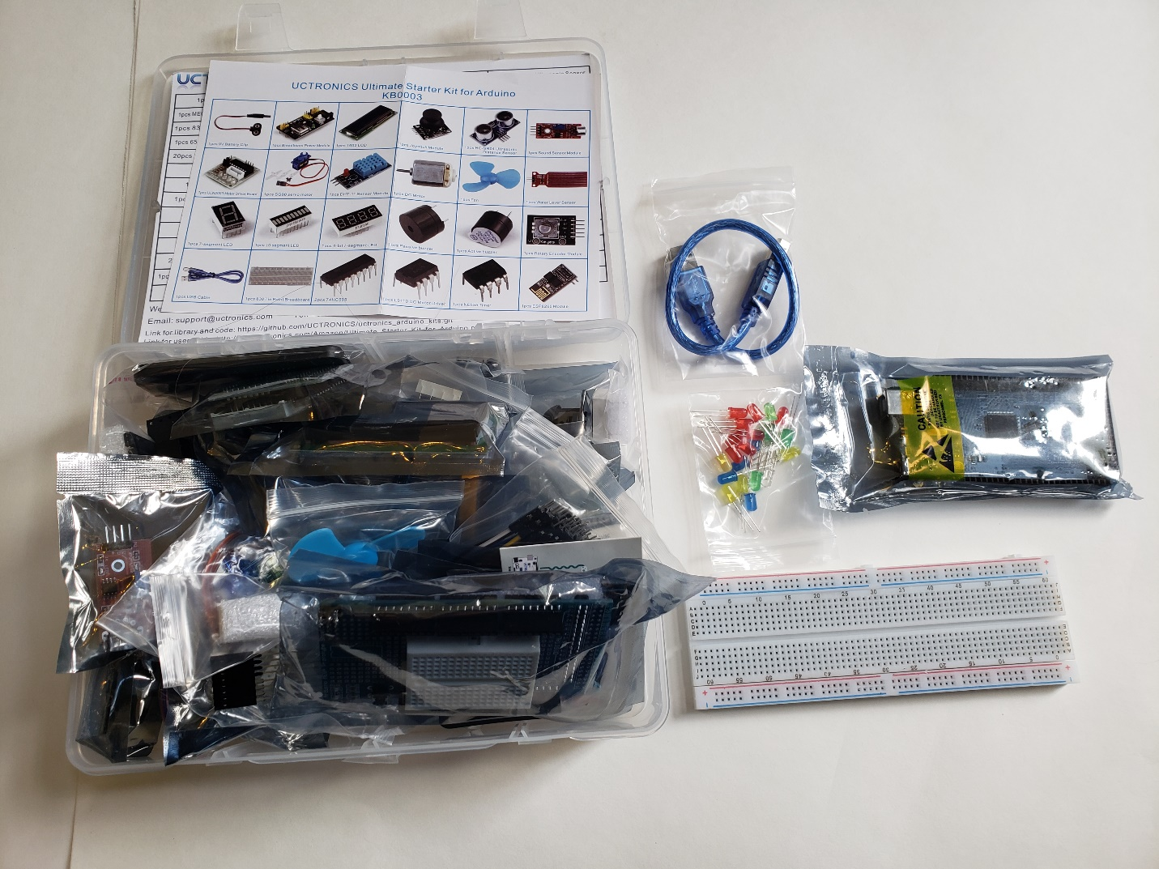
Figure 3: Arduino kit open
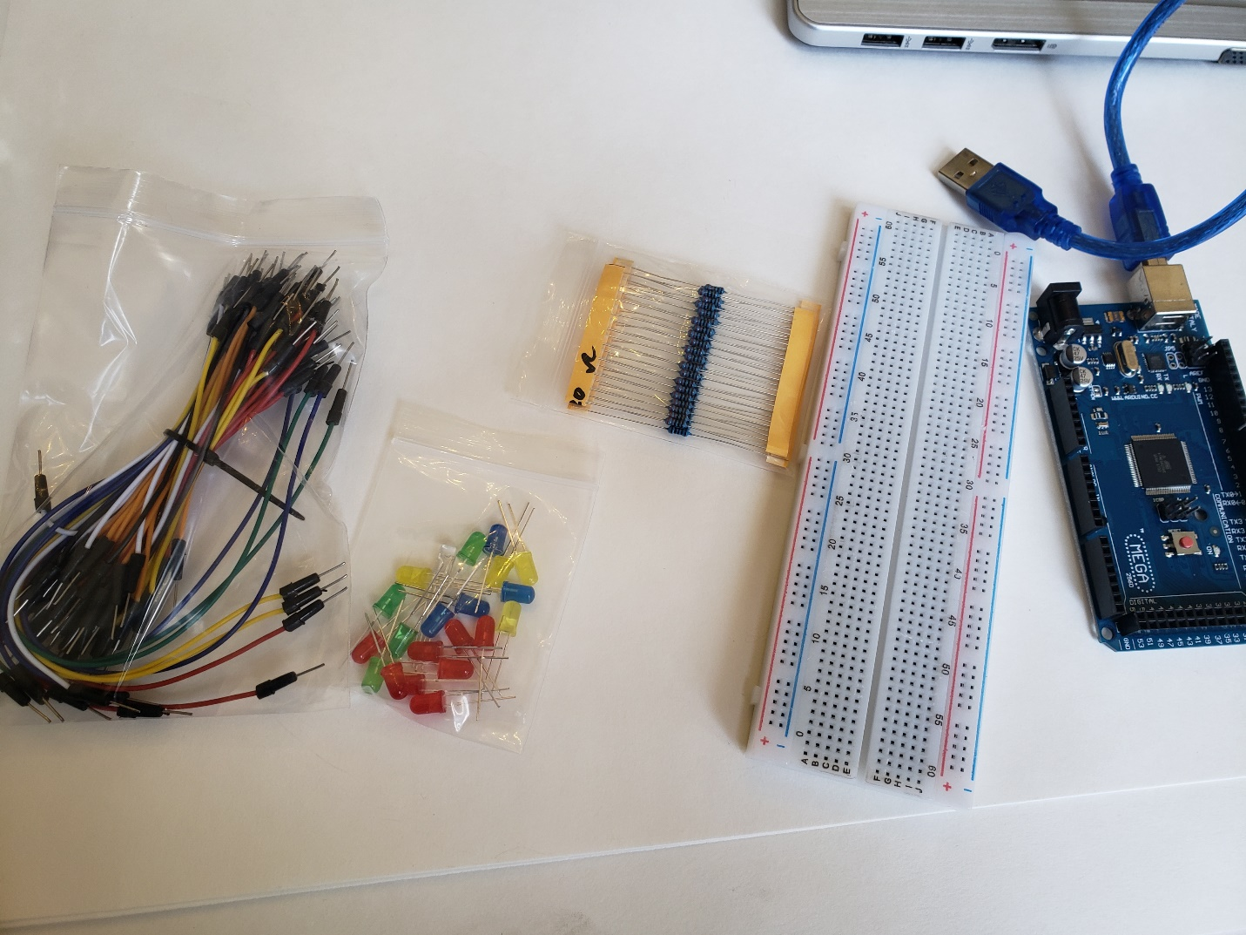
Figure 4: Wires, Breadboard, Arduino, Resistors

Our first activity will be getting one of the LED lights to blink. You will connect the Arduino board to your computer with a USB port using the cable that comes in the kit. See below:
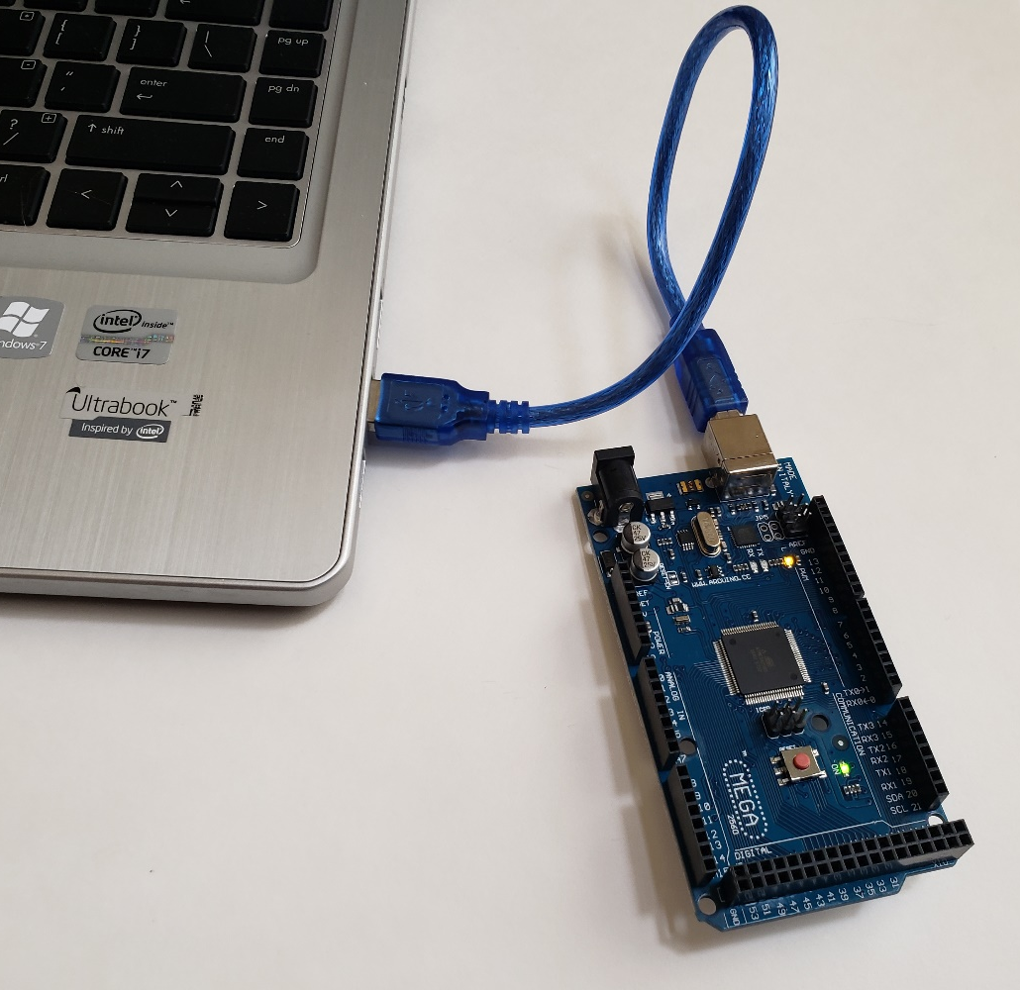
Figure 5: Connecting arduino to laptop

Steps

1) Downloading and Installing Arduino’s Software
(This step may be skipped if you already have the software installed or are using a University computer). To download, go to https://www.arduino.cc then click on the Software tab > Downloads (Figure 1). It will take you to the download page where you can select Windows Installer (Figure 2). Download the software and then install it. This will install both the Arduino IDE (Integrated Development Environment) and the drivers. Click on the Just Download option to start the installation (Figure 3).
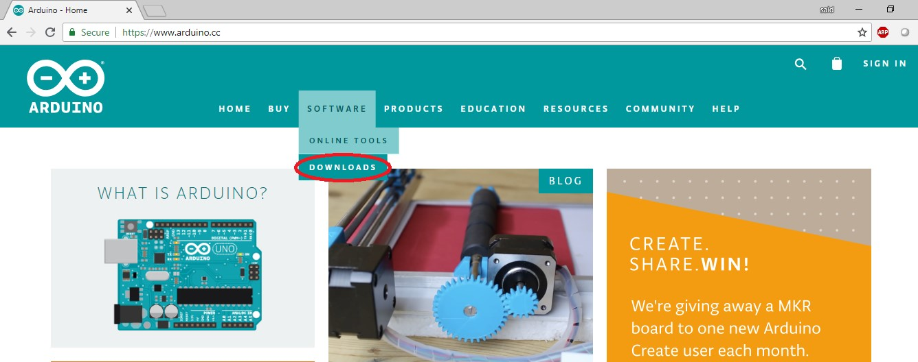
Figure 6: Arduino homepage

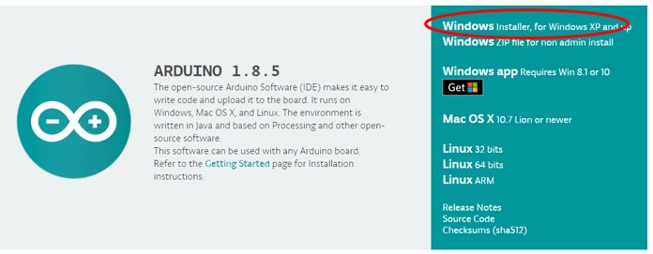
Figure 7: Windows installer


2) Understanding the Arduino Software (IDE) Components and Overview
Below is a screenshot of the Arduino Software (Figure 4). The numbered list corresponds to each item in the Arduino Software interface:
- Verify: Compile and check your code.
- Upload: Send your code to the MCU board.
- New: Start new code window tab.
- Open: Open an existing sketch.
- Save: Save the currently active sketch
- Serial Monitor: Open a window that displays any serial information your MCU is transmitting
- Sketch Name: The name of the active sketch is displayed here.
- Code Area: Area where you write the code for your sketch
- Message Area: If errors are generated, a message will be displayed here.
- Text Console: Complete error messages are displayed here.
- Board and Serial Port: Board and serial port selections are displayed here.
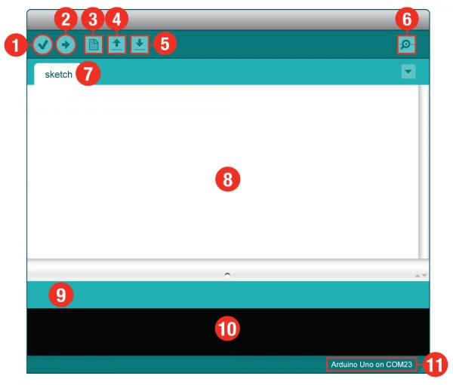
Figure 9: Arduino interface

3) Board and Port Selection
Two settings must be done before you can use your Arduino IDE correctly.
- Select your Board: This step is required to tell the Arduino IDE which of the many Arduino boards we have. Go up to the Tools menu, then hover over Board and select your board (e.g. Arduino Mega) (Figure 5).
- Select a Serial Port: This step is needed to tell the Arduino IDE which of our computer’s serial ports our board is connected to. For this, again go up to Tools, then hover over Port (Serial Port in older Arduino versions) and select your Board’s serial com port.
Note for Windows Users: This is likely to be com3 or higher (COM1 and COM2 are usually reserved for hardware serial ports). To find out, you can disconnect your Board and re-open the menu; the entry (COM) that disappears should be that of your Board. Reconnect the board and select that serial port. See Figure 6 for an example.

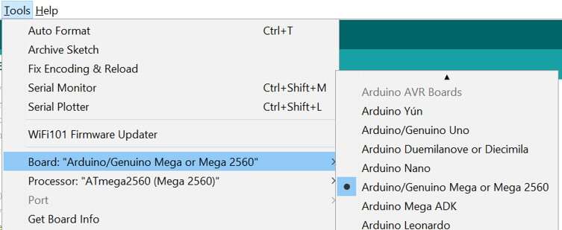
Figure 10: Board Selection

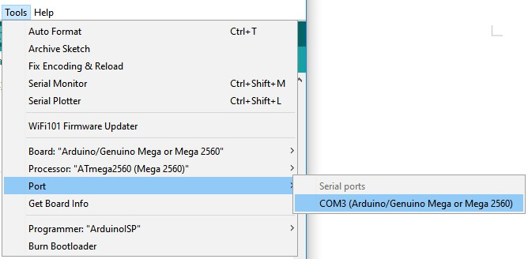
Figure 11: Port selection

4) Getting Started and Getting Help
For getting started and using Tutorials and Arduino programming instructions, visit the Arduino Homepage at https://www.arduino.cc/.

Step 2: Writing an Arduino Sketch (Program)

1) Introduction
Once you’ve successfully installed Arduino IDE, it’s time to start coding. The source code files for Arduino are called sketches. The Arduino programming language is based off C/C++ and is very similar. Open Arduino IDE and a new blank sketch will appear on your screen (see figure below).
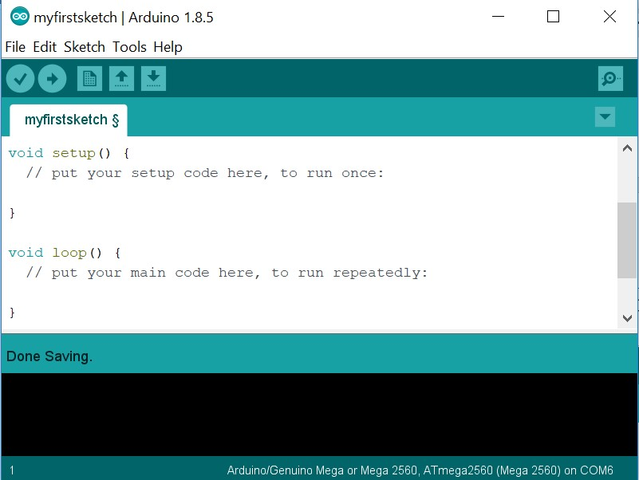
Figure 12: First sketch

The sketch is divided into two program parts
- Setup; and
- Loop
These programming parts are called functions. A function (otherwise known as a procedure or sub-routine) is a named piece of code that can be used from elsewhere in a sketch. For example, the definition of the setup() and loop() functions as defined in the above window.

2) Setup() and loop() Functions
There are two special functions that are part of every Arduino sketch: setup() and loop(). The setup() is called once, when the sketch starts. It's a good place to do setup tasks like setting pin modes or initializing Serial port and libraries. The loop() function is called over and over and is heart of most sketches. You need to include both functions in your sketch, even if you don't need them for anything.

3) Program Comments
It is a good practice to add a header to all your source code, giving the code a title, date, description, and version if necessary as shown in the figure below.
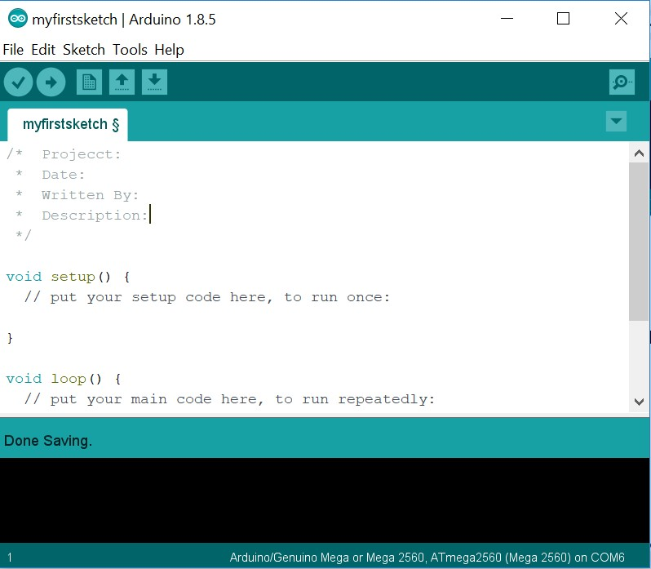
Figure 13: Adding comments
Everything between the /* and */ is ignored (comments) by the Arduino when it runs the sketch (the * at the start of each line is only there to make the comment look better, and isn't required). It's a good practice to comment your sketches, and to keep the comments up-to-date when you modify the code. This helps other people to learn from or modify your code.
There's another style for short, single-line or in-line comments. These start with // and continue to the end of the line. For example, in the line:
int ledPin = 13; // LED connected to digital pin 13
the message "LED connected to digital pin 13" is a comment.

4) Function Examples and their Usage
pinMode()
The pinMode() function configures a pin as either an input or an output. To use it, you pass it the number of the pin to configure and the constant INPUT or OUTPUT. When configured as an input, a pin can detect the state of a sensor like a pushbutton. As an output, it can drive an actuator like an LED.
pinMode(5, OUTPUT); // Configure pin #5 as an output pin
digitalWrite()
The digitalWrite() functions outputs a value on a pin. For example, the line:
digitalWrite(ledPin, HIGH); // Makes ledPin HIGH
delay()
The delay() causes the Arduino to wait for the specified number of milliseconds before continuing on to the next line. There are 1000 milliseconds in a second, so the line:
delay(1000); //creates a delay of one second.
Serial.begin()
Sets the data rate in bits per second (baud) for serial data transmission. For communicating with the computer, use one of these rates: 300, 600, 1200, 2400, 4800, 9600, 14400, 19200, 28800, 38400, 57600, or 115200. Example is:
Serial.begin(9600); // open the serial port at 9600 bps:
Serial.print()
Prints data to the serial port as human-readable ASCII text. Example is:
Serial.print("IoT0"); // prints a label
Serial.println()
Prints data to the serial port as human-readable ASCII text followed by a carriage return character (ASCII 13, or '\r') and a newline character. Example is:
Serial.println("is a technology of the future"); // carriage return after the last label

Procedures
In the following procedure, you will be guided to explore some of the programming capabilities and the Arduino Mega resources. In future sections, you will further explore how to interface sensors and actuators and process collected data and draw conclusions.
Using the Built-in LED Connected to pin #13:

We will wire up a simple circuit and see it work. The instruction booklet that came with the Arduino kit has several interesting projects to try. The wiring diagrams show how to connect the components to the breadboard and Arduino. For this first exercise, we will connect an LED light to the LED_BUILTIN pin hole on the Arduino board. For our board this is pin 13. Then we will run an example program to make the light blink. First we will create the following circuit. A few things to keep in mind:
1. You can use a 220Ω resistor (they will be labeled).
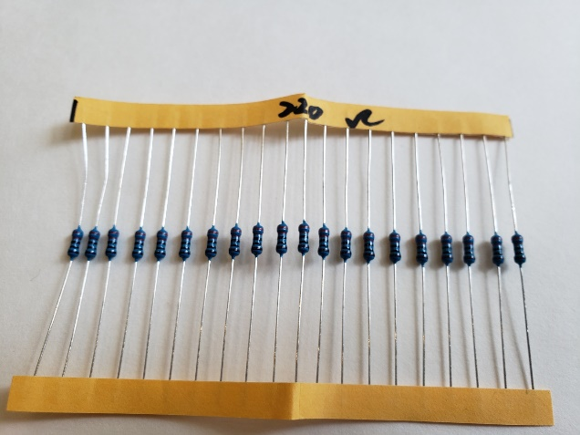
Figure 14: Resistor
2. The short side of the LED light is the cathode (negative). The long side is the anode (positive)
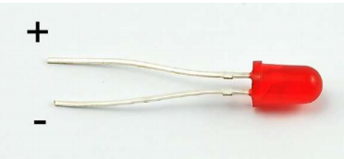
Figure 15: LED
- The resistor resists the flow of electricity. It is needed so that the bulb does not burn out! The unit of resistance is the Ohm.
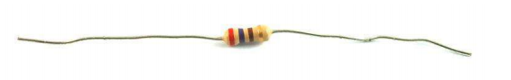
Figure 16: Resistor

4. The breadboard is a grid of holes in a plastic block. There is an electrical connection between holes in the shorter rows. By pushing the legs of two different components in the same row you will join them electrically. For example, in the picture below in the section a-e, everything in row 1 is connected electrically. The ravine in the middle is useful for chips. The – and + rows along the ends are power rails that are all connected.
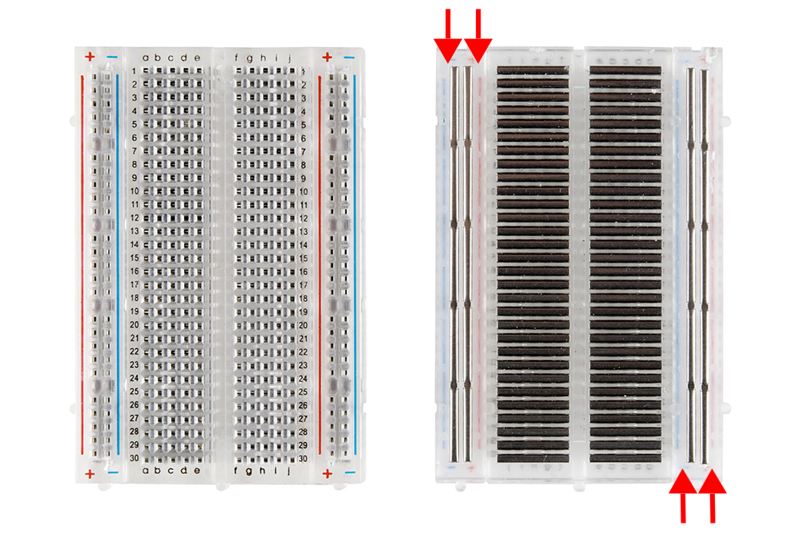
Figure 17: Breadboard
5. We will connect the circuit with the two pictures as shown below. Push the pins of an LED light into the breadboard. Connect a wire from the GND pin to the same row as the short leg of the light. It is important that you connect wires and objects in the same row and in the same section of your breadboard so they will be connected electrically. Connect one leg of a 220Ω resistor to the long leg of the LED light. In the same column as the other leg of the resistor use a wire to connect from the breadboard to the Arduino pin 13. This is LED_BUILTIN.
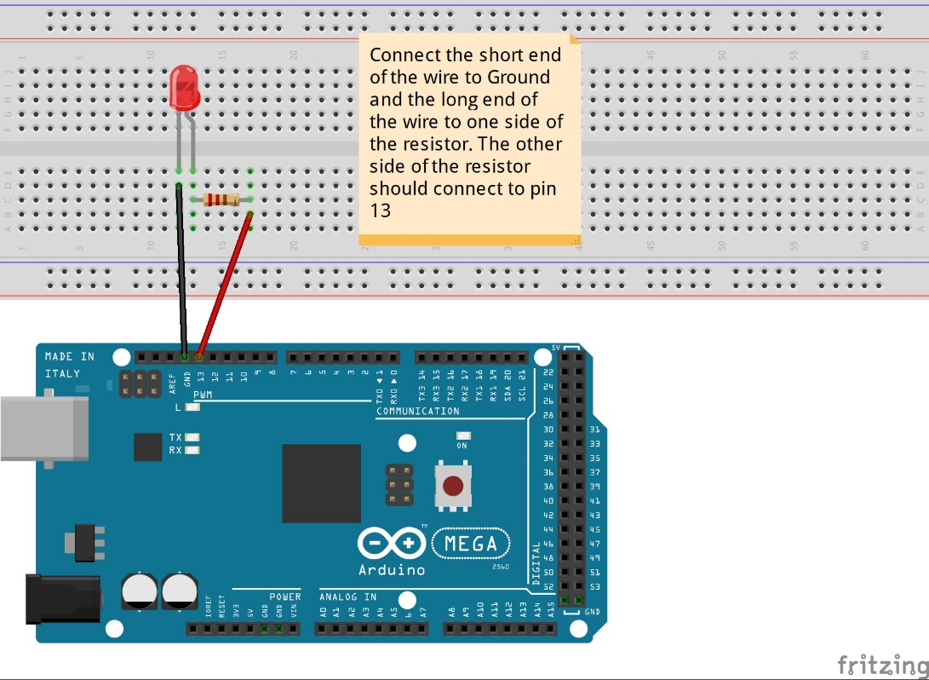
Figure 18: LED connected
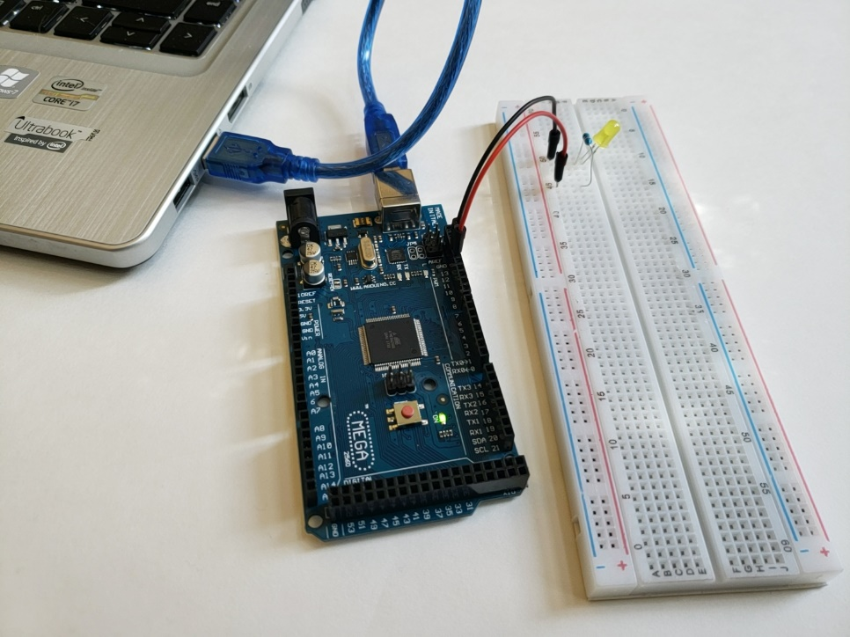
Figure 19: LED connected to laptop

6. Now using the USB cable, connect the Arduino to your computer.
- On your computer open the Arduino IDE. Open a new sketch (File > New)
- Erase all the file contents and replace it with the following code (be sure to include the last curly bracket):
// the setup function runs once when you press reset or power the board
void setup() {
pinMode(13, OUTPUT); // configure pin 13 as an output
}
// the loop function runs over and over again forever
void loop() {
digitalWrite(13, HIGH); // turn the LED on (HIGH is the voltage level)
delay(1000); // wait for a second
digitalWrite(13, LOW); // turn the LED off by making the voltage LOW
delay(1000); // wait for a second
}
- Make sure that the right board and port are selected. The board is the Arduino Mega or Mega 2560
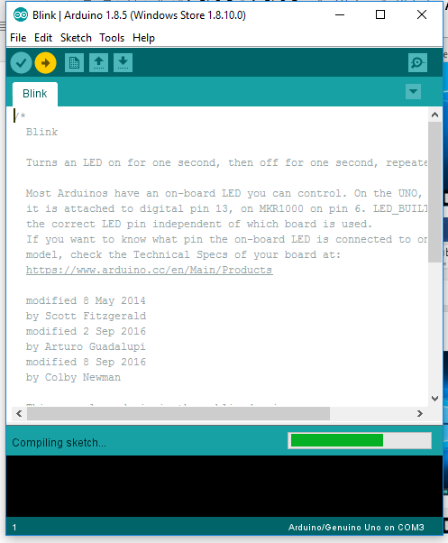
Figure 20: Upload Sketch
- Upload the sketch using the arrow (yellow in the above figure)
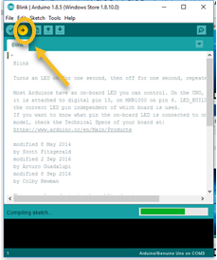
Figure 21: Uploading sketch
9. The code will load and you will see the following – the light is blinking!
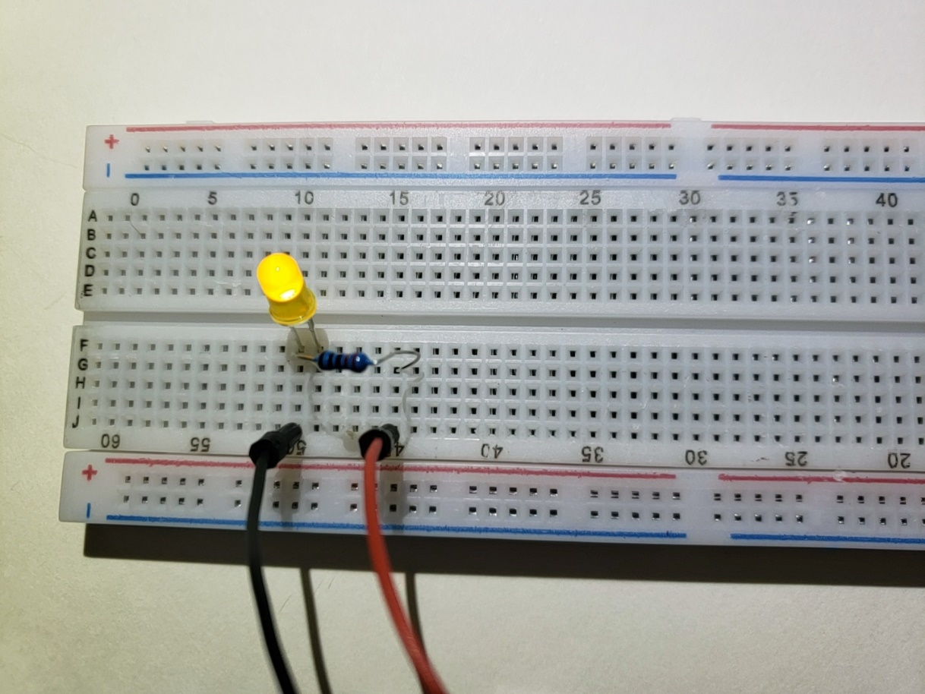
Figure 22: Breadboard with LED

Take a picture of your Arduino and breadboard and a screenshot of the Arduino IDE.

Deliverables
- Complete the Course Project Powerpoint Deliverable
- Include a picture of your circuit
- Include a screenshot of the Arduino IDE

