Course Project

Course Number: CEIS101

Background

The Internet of Things is growing exponentially. New technologies and applications are being developed on a regular basis and this creates an abundance of new job opportunities each with its requisite skill sets. It is important to stay current with the skills required for this evolving job market and to take advantage of the many available learning opportunities currently available. This course project covers the fundamentals topics of IoT and is divided into six parts. Each week builds upon the project resulting in an IoT device that will simulate a home security system. The design and development process of the device will include planning, hardware setup, programming, and networking. It will encompass the many aspects of the IoT and prepare you for your future career in technology.
Scenario

Develop an IoT home security system by designing the prototype, setting up the Arduino, adding a motion sensor and buzzer, adding the capability of data display, using networking to create a web server, and develop a presentation showing your design.

Module 1: Inventory and Preparation

Objectives
- To inventory all course materials
- To organize parts needed for the IoT home security system

Steps

1) Determine if you have the Arduino Software IDE on your machine.
- Inventory all the course materials you received for the tech core.
- Organize the pars needed for this course.

Locate your Arduino kit:

Figure 2: Arduino kit

Inside you will find many IoT components. Locate your Arduino board in the kit. It will be the circuit board with several pins with the word “MEGA”. You will also find the cable to connect it to your computer, LED lights, resistors, wires and the breadboard. We will be using these items quite a bit.
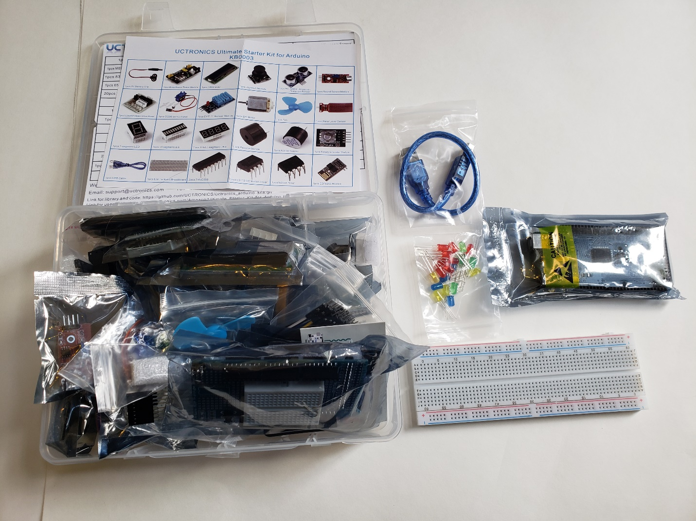
Figure 3: Arduino kit open
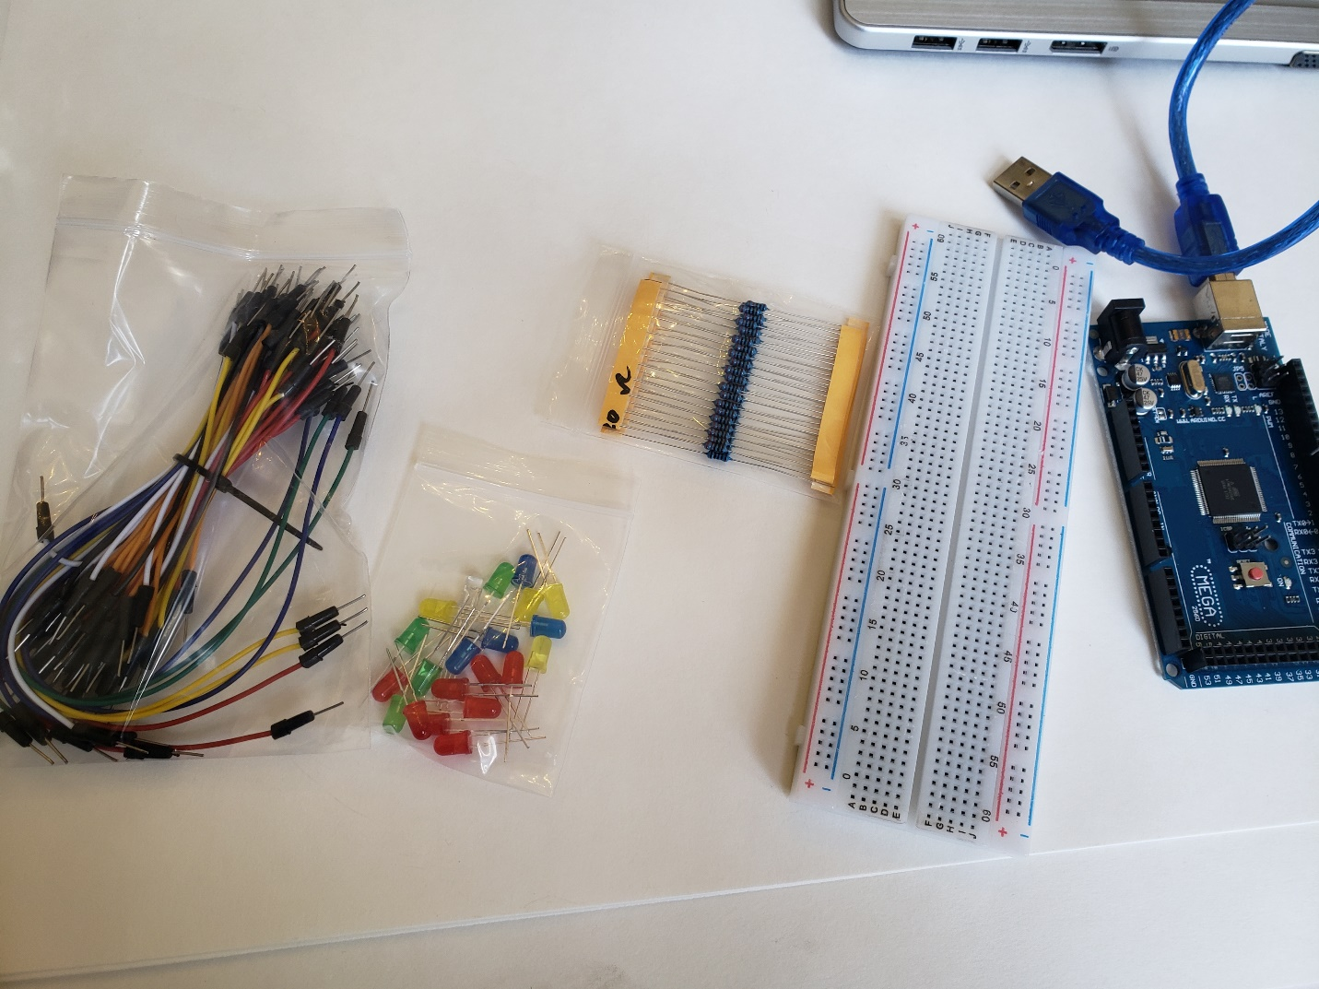
Figure 4: Wires, Breadboard, Arduino, Resistors

Deliverables
- Complete the Course Project Powerpoint Deliverable
- Include a picture of the inventory you organized
- Include a picture of the parts needed for this project

