Accessing the BIOS to determine if you have Virtualization Enabled on a Windows 10 machine
- Navigate to Settings by going to the Start menu and clicking on settings:
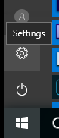
- Click on Update and Security
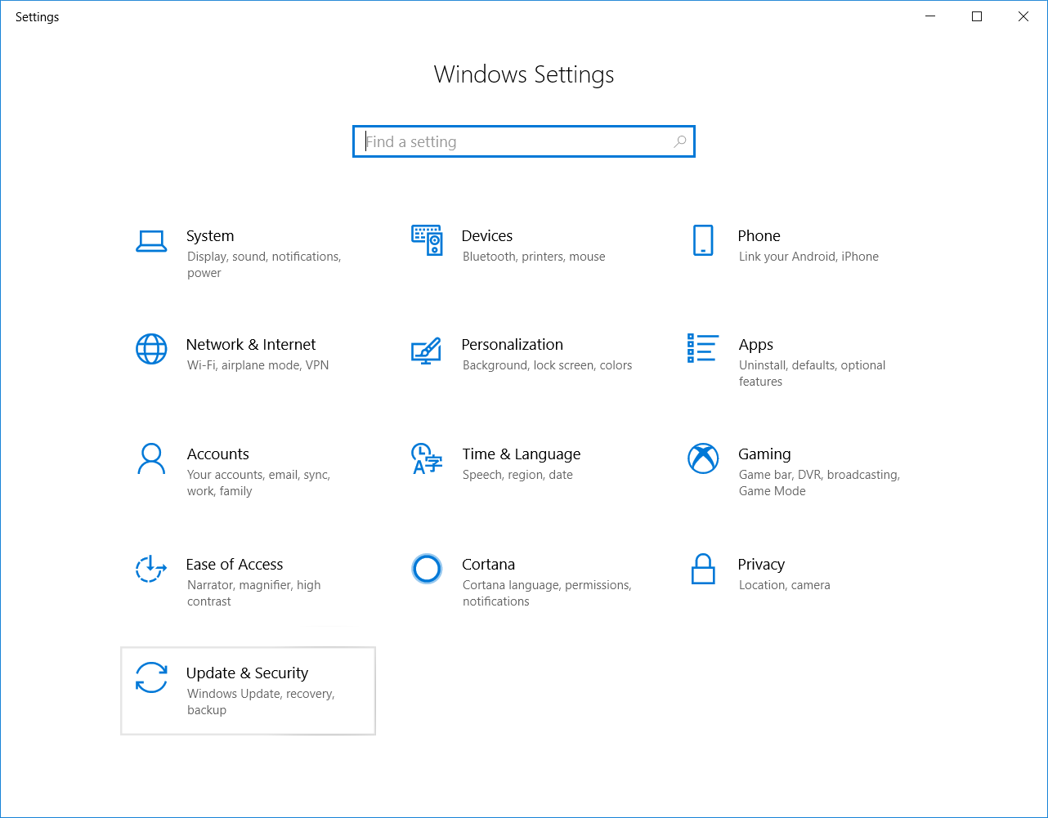
- Choose Recovery
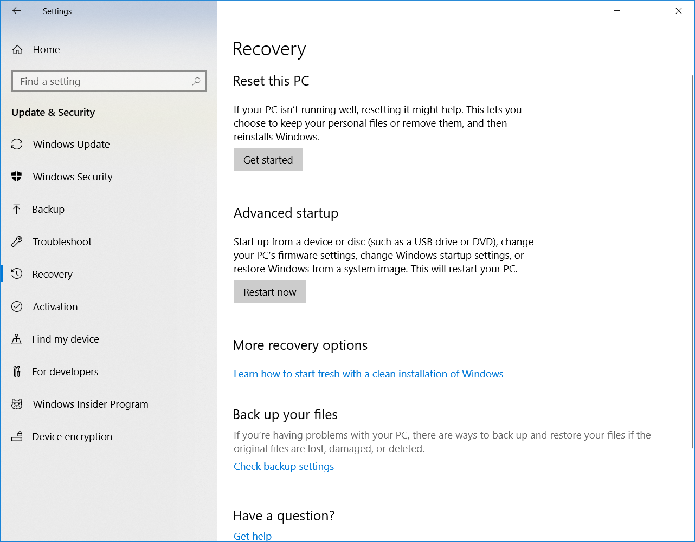
- Click on Restart Now – this will restart the system
- Click on Troubleshoot
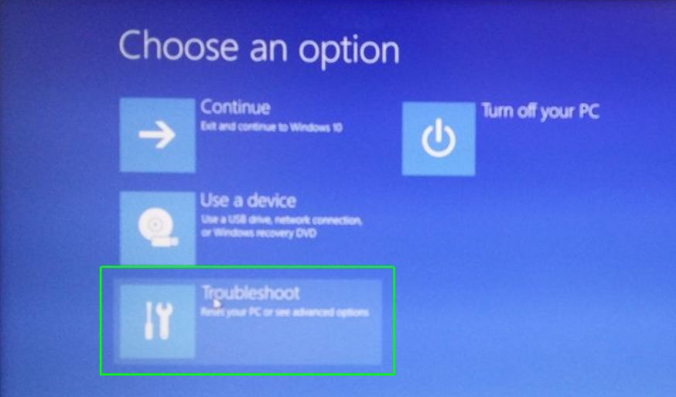
- Pick Advanced options
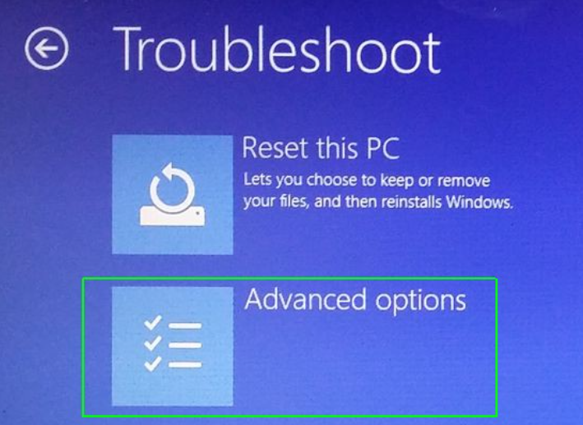
- Pick UEFI Firmware Settings
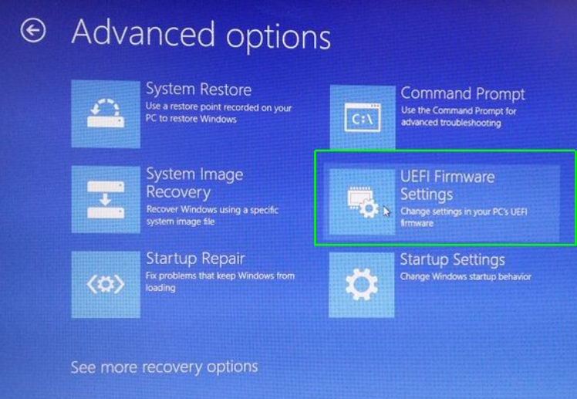
- You will need to restart
- BIOS Setup
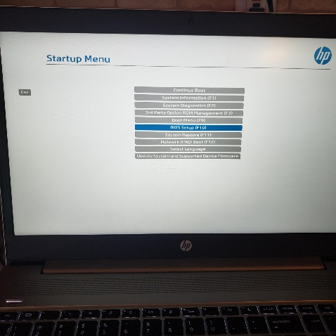
- On an HP ProBook -> Choose Advanced

- Choose System Options

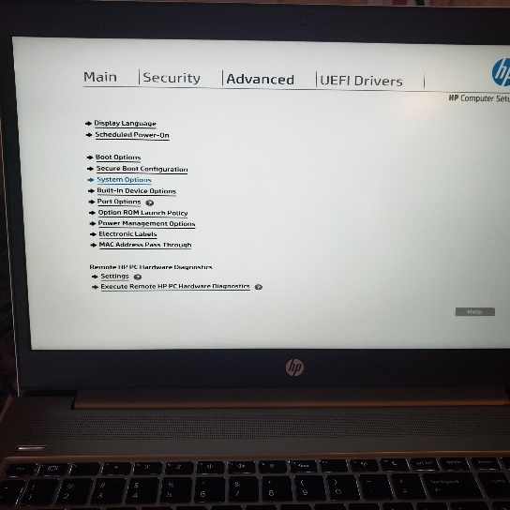
- If you see Virtualization checked that means it is enabled! If not, check the box and save the changes.
